What is the most effective (hydrogen-carbon yield) and efficient (cost and time) photocatalyst that can be used to convert Carbon Dioxide from the atmosphere into liquid petrochemicals such as diesel and petrol, through carbon dioxide electrolysis?

Which mechanical method is the most effective process to extract lipid oil from Chlorella (microalgae) for algal fuel production: the use microwaves or ultrasonic assisted extraction (sound waves)?

SIGNIFICANCE OF RESEARCH
The best viable solution that is currently in place to produce fuel, is through the use refinement and synthesis of non-renewable resources such as crude oil or coal. Due to such practices, air pollution and the resultant impacts on the environment has ceased the attention of environmentalists and numerous governments. Statistics show that for every 1 tonne of Carbon burnt in fossil fuels, close to 3.5 tonnes of Carbon Dioxide is released (Buis, 2019). Consequently, enhanced greenhouse effect takes place. This is when the excess of carbon dioxide leads to the 'gradual' increase in average climate temperature. This can be further explained by the following diagram.

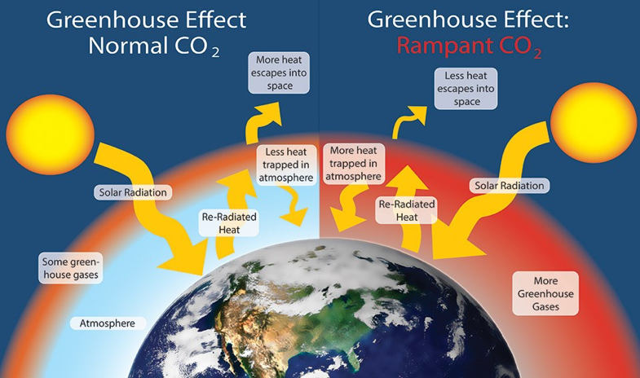
(Elder, 2019)

Even more concerning is the fact that it has been estimated that the amount of pure coal available is only enough to sustain all of humanity for 150 years. In addition to this, oil reserves are also predicted to run out in a mere 53 years, that is at the current rate of usage (Ecotricity.co.uk, n.d.). Therefore, in the near future, a 'general disequilibrium' in the market occurs, where the quantity demanded, exceeds quantity supplied or produced.

Therefore, due to such reasons, it has become a necessity that alternative renewable energy sources must be used extensively to safeguard. One of which is, energy production through the use of microalgae. Through unique processes and careful refinement microalgae can be used to produce biodiesel or alternate forms as required by the public. This method of energy source can be used as a temporary solution, until other means of energy sources such as hydrogen fuel, have been adequately researched an commercialised. In addition, the fact that microalgae consume carbon dioxide directly from the atmosphere makes this method of energy production almost carbon-neutral, therefore, all the more reason to employ this method (Energy 101 | Algae-to-Fuels, 2012).

The idea extends that within large pools or farms of algae, micro-organisms are used to convert sunlight to energy, and store the converted energy as oil. As the next step, the cell wall of the structure is required to be ruptured in order to extract the pre-stored oil. This oil is then processed and refined into ethanol which can be used as fuels for vehicles. The aim of this research is to establish which method optimises the extraction of lipids oils with respect to time. Subsequently, there are three distinct types of processes that can be employed for the extraction of lipids: Mechanical, Chemical (through the use of solvents) and in addition to these are the newer alternatives such as Osmotic pressure and isotonic extraction processes that are yet to undergo further testing (Kumar, Rao and Arumugam, 2015). The use of chemical processes is unwise in this application since, the ultimate aim is to increase the bioethanol or biodiesel production, however, chemical processes demand the use of various hydrocarbons such as ethanol or methanol which is irrational since they are the desired products themselves. On the other hand, another method is also commonly used on an industrial scale, namely, the Bligh and Dyer method which works through the use of Chloroform/methanol solvents. Yet this method is not advisable due to its acute toxicity and health hazards.

This research focuses on the alternative, that is the mechanical approach to extract oil, and in particular two widely used processes: ultrasonic assisted extraction and microwaves to disrupt the cell wall structure to release oil content. The question being which process is the most effective, the amount of oil released will be measured through thin-layer chromatography (Chen et al., 2018)
and recorded it terms of ml/100g of microalgae which will be analysed graphically. Upon these findings, the most effective process can be concluded to ultimately optimise the production of biofuels.

Ethics:

Biases:
Due to the fact that this research requires the completion of an experiment, various biases are inevitable. An example includes inclusive biass

References:
- Ecotricity.co.uk. (n.d.). The end of fossil fuels. [online] Available at: https://www.ecotricity.co.uk/our-green-energy/energy-independence/the-end-of-fossil-fuels.
- Buis, A. (2019). The Atmosphere: Getting a Handle on Carbon Dioxide – Climate Change: Vital Signs of the Planet. [online] Climate Change: Vital Signs of the Planet. Available at: https://climate.nasa.gov/news/2915/the-atmosphere-getting-a-handle-on-carbon-dioxide/.
- Elder, W. (2019). Greenhouse Effect. [image] Available at: https://www.nps.gov/goga/learn/nature/climate-change-causes.htm.
- Kumar, R., Rao, P. and Arumugam, M. (2015). Lipid extraction methods from microalgae: a comprehensive review. [online] Frontiers in Energy Research. Available at: https://www.frontiersin.org/articles/10.3389/fenrg.2014.00061/full.
- National Center for Biotechnology Information. PubChem Database. Chloroform, CID=6212, https://pubchem.ncbi.nlm.nih.gov/compound/Chloroform
- Energy 101 | Algae-to-Fuels. (2012). [video] Available at: https://www.youtube.com/watch?v=IxyvVkeW7Nk&feature=emb_logo.
- Chen, Z., Wang, L., Qiu, S. and Ge, S. (2018). Determination of Microalgal Lipid Content and Fatty Acid for Biofuel Production. [online] Hindawi. Available at: https://www.hindawi.com/journals/bmri/2018/1503126/.
- Vries, S. (2017). 5 Types of Bias in Data & Analytics - Cmotions. [online] Cmotions. Available at: https://cmotions.nl/en/5-typen-bias-data-analytics/.

