Name: Vishnu Prasad SIVAKUMAR
Student ID: 18256138X
Teacher: Ms Lianora Taralrud-Bay
Word count: 2760

JOhn Monash Science School
Which pre-treatment enhances solvent-based extraction of lipids from the microalgae Chlorella vulgaris: thermal heating or osmotic shock?
VCE Extended Investigation

Contents
Acknowledgements 2
Abstract 3
1 Introduction 4
1.1 Biodiesel 4
1.2 Choice of Plant Material - Microalgae (Chlorella vulgaris) 5
1.3 Methods of Total Lipid Extraction 6
1.4 Methods of Pre-treatment 6
1.5 Current Gaps in Knowledge 8
1.6 Aim, Hypothesis & Variables in Research 9
2 Methodology 10
2.1 Isolation and Preparation of Microalgae Culture 10
2.2 Thermal heating (Microwaves) 10
2.3 Osmotic Shock 11
2.4 Method of Analysis 12
2.5 Ethics 13
3 Results & Discussion 14
3.1 Experimental Findings 14
3.2 Evaluation of Results 15
3.3 Limitations 16
3.4 Sources of Errors 17
3.5 Future Directions 17
4 Conclusion 19
5 Glossary 20
6 Bibliography 21

Note: Refer to the glossary for more information on key terminology

Acknowledgements
I would like to acknowledge and show my gratitude for the following individuals and institutions for their support and assistance throughout this investigation:

- Extended Investigation Teacher
I would like to thank Ms Lianora TARALRUD-BAY for constantly supporting me ever since the start of my research.

- Laboratory Technicians
I would like to take this opportunity to thank Ms Ericka TRICKETT and Ms Anna ZONNEVALD for their guidance and support.

- Staff from VCE Chemistry of John Monash Science School
I would like to express my appreciation to all of the teachers teaching Chemistry at JMSS as they have collectively helped to the best of their ability to assist me with my research and experiments.

- Monash University School of Chemistry
Last but not least, my sincere thanks to Dr George KHAIRALLAH from Monash who kindly analysed my samples on behalf of me.

Abstract
It is impossible to imagine a world without energy. In the current era of excessive energy consumption, production rates of energy are becoming inconsistent with communal demands. Furthermore, the majority of contemporary methods used to produce energy are non-renewable, meaning that they cannot be readily replaced. In addition to this, energy sources such as fossil fuels are a prominent contributor to global pollution, ultimately leading to climate change. As an alternative to such harmful sources of energy, microalgal lipids can be used to artificially synthesize biodiesel which can, in turn, be used as a source of energy itself. To boost the yield of lipids extracted from microalgae, numerous chemical, mechanical and enzymatic pre-treatments methods can be employed. This investigation evaluates two widely used pre-treatment methods; osmotic shock (chemical) and thermal heating (mechanical); to determine their effectiveness and feasibility in industrial environments. Based on results from scientific experiments, thermal pre-treatment proved to be the most effective at increasing the yield of lipids. Although, while thermal pre-treatment is more effective, it also consumes significantly higher amounts of energy to apply. Consequently, posing osmotic shock as the more feasible and effective method. The findings of this research will assist industrialists and chemical engineers in selecting the most applicable pre-treatment method in the process of extracting lipids from microalgae.

Introduction

Fossil fuels are still the primary source of energy in Australia (fig 1.1). The rapid increase in global warming and immediate demand for energy has catalysed the search for an alternate means of energy production, specifically, renewable energy resources.
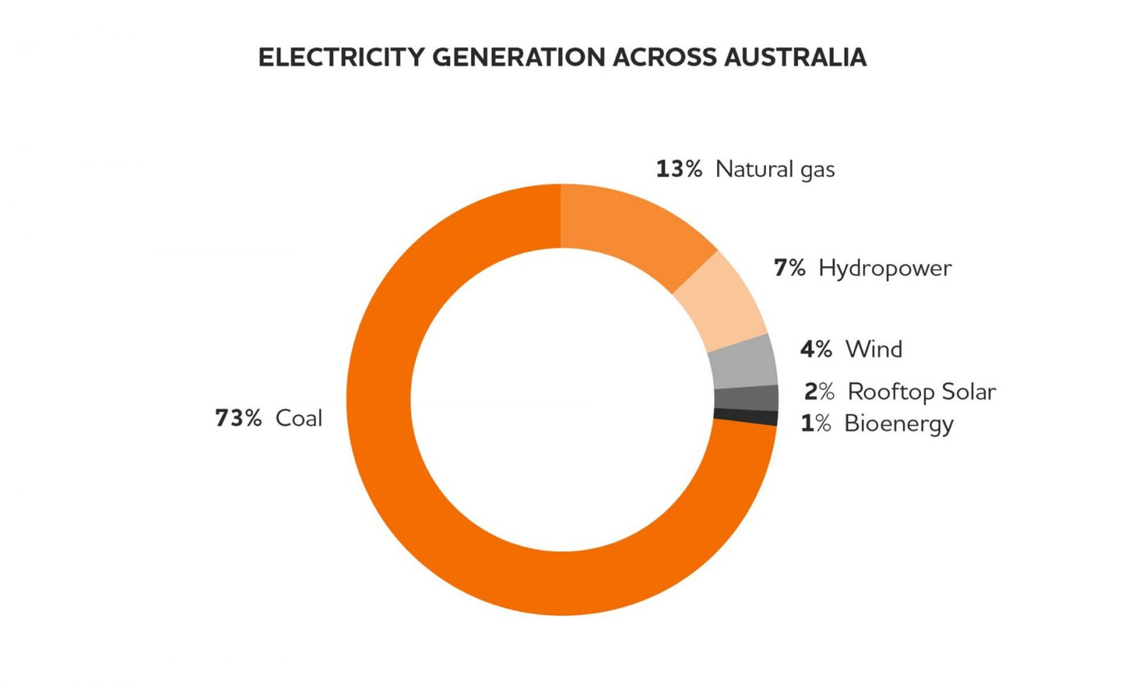
Figure 1.1: Electricity Generation Across Australia. Retrieved from (Origin Energy, 2018)

Biodiesel

Among other renewable energy resources, biodiesel is a promising alternative to fossil fuels since it can directly be used in cars with diesel engines. However, a study shows that biodiesel when compared to Petro diesel increases fuel consumption by up to 11%. Regardless of this, biodiesel still produces 78% less carbon dioxide than conventional diesel fuel (Buyukkaya, 2010; National Renewable Energy Laboratory [NREL], 2005). In addition to this, it can be synthesised from lipids (hydrocarbons composed of fats and oils) obtained from plant materials (fig 1.2.), hence making it a renewable energy source.

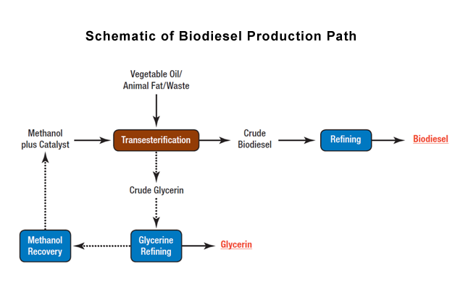
Figure 1.2: Schematic of Biodiesel Production Path. Retrieved from (Alternate Fuels Data Centre, n.d.)

As stated by the U.S Department of Energy, approximately 100 pounds (45 kg) of biodiesel can be produced by appropriately reacting 100 pounds (45 kg) of oils and fats (fatty acid methyl esters - FAME) with 10 pounds (4.5 kg) of a short-chain alcohol. In addition to biodiesel, only one co-product is produced, glycerine, a type of sugar that is used in pharmaceutical and cosmetic products ("Alternative Fuels Data Centre: Biodiesel Production and Distribution", n.d.).

Choice of Plant Material - Microalgae (Chlorella vulgaris)

In comparison to various plants, microalgae are preferred due to its high lipid content per dry weight, swift growth rate and minimalistic land area requirement (He, 2016; Mata et al, 2009; Ramkumar & Kirubakaran, 2016). Chlorella vulgaris was chosen as the microalgae culture for this study since it was readily available in school (Lavars, 2019). Moreover, Chlorella vulgaris has the highest carbon dioxide sequestration rates among any other organic plant at around 0.1 - 0.7 g/litre/day (Lavars, 2019).

Methods of Total Lipid Extraction

Conventionally, lipids are extracted through the use of organic solvents. Common extraction methods include Floch method, Bligh & Dyer method and the Soxhlet technique (Kumar et al., 2015; Uduman et al., 2010). However, these methods pose a dangerous threat to the environment and humans due to the use of hazardous solvents and high energy consumption (Taher et al., 2014). Recently, researchers have found a novel approach to extract lipids from microalgae through the use of supercritical carbon dioxide (SC-CO2). Unlike the previously mentioned methods, SC-CO2 is an inert, nontoxic and an inexpensive fluid hence proving to be a better alternative in large scale industrial productions. However, due to limitations in the availability of equipment at school, organic solvent extraction was opted for this research. This does not affect the outcome of this study as the primary extraction method is a controlled variable.

Methods of Pre-treatment

Regardless of the primary extraction method used, there are a few problems associated with direct lipid extraction from microalgae, one being the relatively low yield of lipids. To solve this issue, scientists have found that pre-treating microalgae before extraction can potentially increase the amount of lipids obtained. By pre-treating microalgae, cell lysis occurs (disintegration of a cell by the rupture of the cell wall or membrane) which exposes the cytoplasm (a constituent within the cell that contains lipids and other essentials to protect it from being damaged). Following this solvents can then be introduced to dissolve exposed lipids in the aqueous phase.
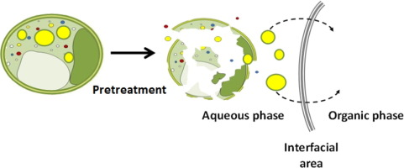
Figure 1.3: Effect of Pre-treatment. Retrieved from (Angles, Jaouen, Pruvost & Marchal, 2017)

The process of which can be visualised by following figure 1.3, where on the left is an intact cell matrix containing lipids (yellow circles), that is subjected to a particular type of pre-treatment. As a result, the cell disintegrates, consequently releasing its contents (middle). After which, an organic solvent can be introduced to dissolve lipids present in the cell (right).

All pre-treatment methods can be classified as mechanical or non-mechanical. Whereby, non-mechanical can further be subdivided into chemical and enzymatic. Figure 1.4 displays some of the concurrent methods used in a laboratory and/or industrial environment.
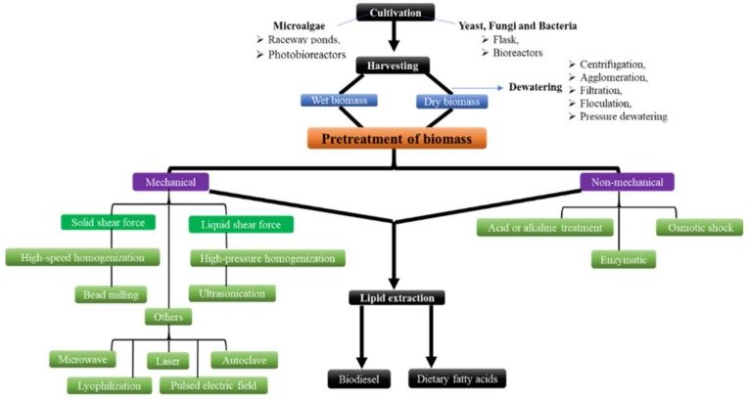
Figure 1.4: Types of Pre-treatment Methods. Retrieved from (Patel, Mikes & Matsakas, 2018)

Thermal pre-treatment subjects microalgal cells to microwaves for rapid heating which increases the internal temperature. Therefore, the pressure gradient acting on the cell wall enhances mass transfer rates without lipid degradation (Uquiche et al., 2008). Alternatively, ‘osmotic shock’ is also equally advantageous where the abrupt exposure to lower osmotic pressure than in the cells, forces water to enter the cell structure. This increases the internal cell pressure causing cell lysis (Stanbury et al., 2017).

Current Gaps in Knowledge

Although there is a whole range of pre-treatments, very few studies compare the effects of chemical and mechanical pre-treatments. Furthermore, industrial compatibilities of each pre-treatment have not yet been properly evaluated in terms of the total energy applied to the system and the total amount of energy released in return, which is an important aspect to be considered when being used at an industrial scale. Moreover, the effects of pre-treatments and its efficiency vary depending on the specific microalgae culture implemented upon.

Aim, Hypothesis & Variables in Research

This study aims to provide an insight into two main pre-treatment methods under chemical and mechanical: osmotic-shock (chemical) and thermal/microwave-assisted (mechanical). In addition to this, part of this research is to also investigate the ease of application and industrial implication of each pre-treatment method.

Hypothesis:
There will be no significant difference in the wt.% of lipids extracted between each of the two pre-treatments: osmotic shock and thermal heating. Although each method utilises a different scientific phenomenon, ultimately, both should disintegrate the cell structure. Hence, there should only be a negligible amount of difference in wt.% of lipids extracted due to natural differences in the amount of lipids present in each cell.

Variables to be Considered:
Independent Variable | Dependent Variable | Controlled Variable
- Pre-treatment Used | - Lipid yield (wt.%)  - FAME contents | - Type of microalgae  - Primary extraction Method

Methodology

The method used to conduct this research is a quantitative scientific experiment. Part of the scientific experiment was conducted in school laboratories under the supervision of trained laboratory technicians. Once the lipids were extracted, they were transferred to the Monash onsite campus situated in Clayton, where they were further analysed qualitatively and quantitatively using gas chromatography coupled with mass spectra analysis (GC-MS).
Three distinct sets of experiments will be carried out:
- Thermal (microwave) pre-treatment before solvent-based extraction
- Osmotic Shock pre-treatment before solvent-based extraction
- Organic Solvent extraction (controlled) without any pre-treatment

Isolation and Preparation of Microalgae Culture

Vials of microalgae dissolved in the growth media were collected and were centrifuged at 4500 rpm for five minutes. Following this, the growth media was deleted and the remaining contents in the vial were homogenised (the process of attaining uniformity throughout the solution). Subsequently, the contents in all of the vials were filtered using a standard Büchner funnel, with a filter paper of pore size: 7 micrometres. This was carried out to remove residual traces of microalgae growth media. Once thoroughly filtered, the filter paper, carrying the microalgae culture, was placed in a desiccator for one day, to evaporate water.

Thermal heating (Microwaves)

This procedure was performed using a classical microwave oven. The power output of the microwave was fixed at 1000W with a frequency of 2450 MHz. Upon completion, these can be compared against the increase in the percentage of lipids extracted using a bar chart to reveal the effects of various power outputs. 100 ± 0.05g of pre-dried microalgae was weighed using a balance and was set in a Pyrex bowl. It was then placed into the microwave oven and was treated over six cycles: samples were placed in a microwave for 1 min and were then allowed to be cooled to 25 ℃ (temperature was tracked using an infrared temperature gun), to ensure that the cells did not completely disintegrate (Dejoye et al., 2011).

Osmotic Shock

After harvesting microalgae from the growth media through centrifugation, the sample was added to a 500 ml shot bottle containing 200 ml pure deionised water and was left to rest until the salt concentration within deionised water was constant. The concentration of salt within the solution was measured using a LAQUA twin compact conductivity meter as shown in figure 2.1. A total of ten measurements were recorded over a span of 40 minutes with a gradual increase in the time difference (summarised in figure 2.2). Once the measured concentration was approximately constant, lipid extraction was immediately executed to prevent lipase proteins from breaking down exposed lipids.
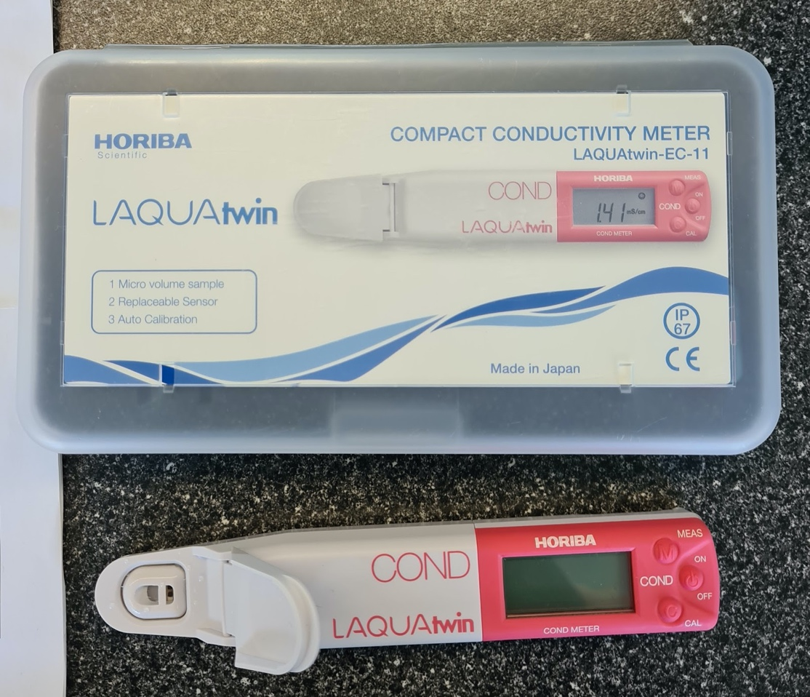
Figure 2.1: Conductivity Meter

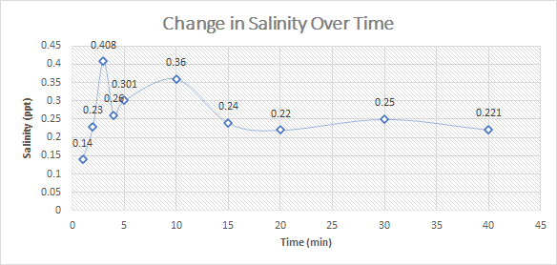
Method of Analysis
Figure 2.2: Salinity measurements

The extracts were analysed using gas chromatography since it offers high sensitivity and mainly because it can provide qualitative and quantitative insight into the composition of the lipid extract. The required apparatus for gas chromatography was provided by the Monash faculty. The column used was Helium and iso-octane was used as the primary carrier gas at a flow rate of 36 cm/s, split ratio 1:20, injector and detector temperature was set to 250 ℃. The oven temperature was programmed to 50 ℃ during the first minute, then was increased to 150 ℃ at a rate 10 ℃/min, and from 150 ℃ to 230 ℃ at a rate of 3 ℃/min, 5 min isothermal (held at constant temperature), then from 230 ℃ to 240 ℃ at a rate of 20 ℃/min and finally 10 minutes isothermal. Mass spectra were then acquired in m/z range 50-360 (Dejoye et al., 2011). The contents of the lipid extract were then identified by comparing their mass spectra using the NIST (National Institute of Standards and Technology) libraries and were also quantified by comparing the peak areas of known quantities. This information was then simplified for non-specialized public and was represented using a bar chart accompanied by a table to display the different constituents in the lipid extract and the quantity in which they were present.

Ethics

The microalgae culture used in this study: Chlorella vulgaris is not a pathogenic species. In other words, it poses no threat to human beings. A risk assessment was also conducted on ‘Student RiskAssess’ to evaluate any dangers in the experiments conducted. This experiment was rated at medium risk, for which extra precautionary measures were taken, such as, using appropriate safety apparatus and watching demonstrations on the handling procedures of Hexane and Methanol.

On the other hand, a serious ethical concern is that a new battle may emerge for land usage between food and fuel. This is because land is a finite resource and once it's used to cultivate microalgae it cannot, at a later stage, be used to grow crops. However, this can be potentially mitigated, since microalgae can also be grown in wastewater land. Although, more research must be done to test the effects of doing so.

Results & Discussion

Experimental Findings
 | Pre-treatment Method
 | Control | Osmotic Shock | Thermal Heating
Crude Lipid Yield (wt.%) | 1.56 (± 0.28) | 1.92 (± 0.26) | 2.11 (± 0.23)
FAME composition (%)
Octanoic acid | 2.25 | 2.29 | 2.35
Decanoic acid | 3.30 | 3.56 | 3.27
Dodecanoic acid | 71.58 | 71.01 | 70.98
Tetradecenoic acid | 14.70 | 14.73 | 14.71
Hexadecenoic acid | 3.55 | 3.62 | 3.90
Stearic acid | 1.39 | 1.26 | 1.40
FAME Yield (wt.%) | 1.50 (± 0.28) | 1.85 (± 0.26) | 2.06 (± 0.23)

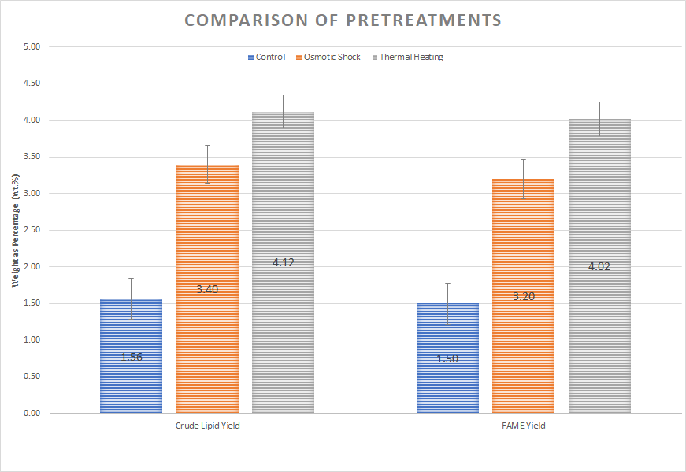
Figure 3.1: Graphical representation of the impacts of Osmotic Sock and Thermal Heating

Evaluation of Results

According to figure 3.1, pre-treatment methods did indeed have a positive effect on the amount of lipids extracted, since the wt.% yield was significantly higher than what was measured in the controlled group. Furthermore, thermal pre-treatment also had a notable difference when compared to osmotic shock as it increased the yield by 2.56% whereas osmotic shock had only increased it by 1.84%. Through literature review, it was found that this could not have occurred due to natural differences between samples used in each experiment. Therefore, the hypothesis can be confirmed to be negative since the experimental results prove that there is a difference between the effectiveness of each of the pre-treatment methods applied. In accordance with the aim of this research, to “investigate the ease of application”, it was found that osmotic pressure method consumed the least amount of energy or close to zero since water is an infinite resource and energy was not required to be added to the system. Although, strictly pure deionised water must be used, for which energy may have been consumed in a desalination plant. On the other hand, thermal heating consumed significantly more energy since:

Power = Energy/Time
Where:
Power (P) is in Watts
Energy (E) is in Joules
Time (t) is in Seconds

In this application:
Power = 1000 Watts
Time = 60 *6 seconds

Energy consumed = P*t = 1000 * (60 * 6) = 360 kJ

Although, energy gained cannot be accurately measured in this experiment since the microwave oven used was capable of treating more than the sample size used in this experiment. While the power output can be set proportionally to match the mass of microalgae to be treated, the microwave oven used in this experiment was fixed.

Further analysis of results shows that the FAME composition of the lipid extract from each experiment are admissibly similar. From which it can be established that by pre-treating microalgae before lipid extraction, the impact lies largely on the quantity and not the quality.

Limitations

Due to the lean supply of microalgal culture, only one trial for each experiment was conducted, which negatively affects the precision and accuracy of this study since outliers were/could not be distinguished and omitted. Furthermore, abrupt closures in school meant that microalgae cells could not be inspected under a microscope, hence the integrity of cell walls post each pre-treatment method could not be determined and was assumed to be completely disintegrated instead. In addition to this, extremely small total volumes of lipids were produced (Approximately < 1 microliter) since the sample size for each experiment was a mere 200 milligrams. Consequently, since the detection limit of the GC-MS system is 1 ppb (parts per billion), any compounds present in the analyte with a concentration of less than 1 ppb would not have been detected.

Sources of Errors

Since these experiments were conducted in a non-specialised laboratory, most of the measurement apparatus used were analogue. Hence, random parallax error may have occurred, which could have potentially positively or negatively skewed the data. Furthermore, lipid standards were not analysed as part of the GC-MS analysis. Thereby, calibration error of the GC apparatus could have occurred, which could have, again, positively or negatively affected the results. Moreover, samples could have been contaminated during the stages of separation and weighing. Since the separating funnel itself was exposed to the atmosphere while containing the solvent and microalgal culture. Additionally, an unsealed weigh scale was used for most experiments (a sealed weigh scale was used only for the controlled experiment due to its availability at the time). In addition to this, the vial used to store the lipid extract may have contained a residual amount after the lipids were transferred, causing the results to be underestimated.

Future Directions

Outcomes from this research can be used to provide a better insight into the effects of pre-treatments and the efficiency of both, osmotic shock and thermal heating. Although, more research is required to understand the effects of pre-treatments across different microalgal cultures. Since the effects can vary depending on the unique cell characteristics of each microalgal species.

In addition to this, more trials for each experiment must be conducted to increase precision. Subsequently, pre-treated microalgae cells must be inspected under a light microscope to determine the integrity of its structure to provide a better insight into the impacts of each pre-treatment.

While this investigation attempts to explore one major problem in the application of using microalgae to produce biodiesel, numerous other questions still remain unanswered. One being, how does the growth environment affect the volume of lipids present? Understanding of this is significant, as it can be yet another way of increasing the volume of lipids obtained.

Conclusion

Research Question: Which pre-treatment enhances solvent-based extraction of lipids from the algae Chlorella vulgaris: thermal heating or osmotic shock?

Throughout this investigation, two commonly used methods of pre-treatments were compared, assessing their effectiveness and practicality.

This study has found that thermal heating is superior in terms of its ability to boost the yield of lipids when compared to osmotic shock. However, in the context of practicality, osmotic shock is more preferred due to its simplicity and cost-efficiency.

Although thermal heating returns a higher yield of lipids it is negated by the fact that it consumes a remarkable amount of energy to apply. In addition to this, this method is highly impractical in an industrial sense since the equipment itself can be expensive.

For reasons as mentioned above, this investigation recommends the use of osmotic shock over thermal heating.

Glossary

- Aqueous – when a chemical compound is dissolved in water.

- Biodiesel - a fuel derived immediately from living matter.

- Cytoplasm – A fluid complex within a cell, containing lipids and other important compounds required for survival.

- Hydrogen – a compound of hydrogen and carbon atoms.

- Lipase – An enzyme that breaks down fats.

- Lipids – any of a class of organic compounds that are fatty acids. These include natural oils, waxes and steroids.

- Cell Lysis – Refers to the breaking down of cells.

- Non-renewable Resource – an energy source that will eventually run out or will not be replenished in our lifetimes, such as coal and other fossil fuels.

- Organic Solvents – Any solvent that is carbon-based or consists a carbon backbone.

- Renewable Resource – an energy source that can be used repeatedly and does not run out because it is naturally replaces, such as water.

- Sequestration – the process of removing a chemical from the environment.

- Supercritical Carbon Dioxide – when carbon dioxide is held at or above its critical temperature and pressure.

Bibliography

Alternate Fuels Data Center. Schematic of Biodiesel Production Path [Image]. Retrieved from https://afdc.energy.gov/assets/images/fuels/Biodiesel-production-schematic-f282d90a.png

Alternative Fuels Data Center: Biodiesel Production and Distribution. Retrieved 16 September 2020, from https://afdc.energy.gov/fuels/biodiesel_production.html#:~:text=Biodiesel%20is%20produced%20from%20vegetable,and%20glycerin%20(a%20coproduct).&text=Glycerin%2C%20a%20co%2Dproduct%2C,manufacture%20of%20pharmaceuticals%20and%20cosmetics.

Angles, E., Jaouen, P., Pruvost, J., & Marchal, L. (2017). Wet lipid extraction from the microalga Nannochloropsis sp.: Disruption, physiological effects and solvent screening [Image]. Retrieved from https://ars.els-cdn.com/content/image/1-s2.0-S2211926416306221-fx1.jpg

Buyukkaya, E. (2010). Effects of biodiesel on a DI diesel engine performance, emission and combustion characteristics. Fuel, 89(10), 3099–3105. https://doi.org/10.1016/j.fuel.2010.05.034

Dejoye, C., Vian, M. A., Lumia, G., Bouscarle, C., Charton, F., & Chemat, F. (2011). Combined extraction processes of lipid from chlorella vulgaris microalgae: Microwave prior to supercritical carbon dioxide extraction. International Journal of Molecular Sciences, 12(12), 9332-9341. doi:http://dx.doi.org.ezproxy.lib.monash.edu.au/10.3390/ijms12129332

He, B. (2016). Advances in emission characteristics of diesel engines using different biodiesel fuels. Retrieved 1 May 2020, from https://www-sciencedirect-com.ezproxy.lib.monash.edu.au/science/article/pii/S1364032116001234?via%3Dihub

Kumar, R., Rao, P. and Arumugam, M. (2015). Lipid extraction methods from microalgae: a comprehensive review. [online] Frontiers in Energy Research. Available at: https://www.frontiersin.org/articles/10.3389/fenrg.2014.00061/full.

Lavars, N. (2019). Algae-fueled bioreactor soaks up CO2 400x more effectively than trees. Retrieved from https://newatlas.com/environment/algae-fueled-bioreactor-carbon-sequestration/

Mata, T., Martins, A., & Caetano, N. (2009). Microalgae for biodiesel production and other applications: A review. Retrieved 1 May 2020, from https://www-sciencedirect-com.ezproxy.lib.monash.edu.au/science/article/pii/S1364032109001646?via%3Dihub

National Renewable Energy Laboratory (2005). Biodiesel–Clean, Green Diesel Fuel [Ebook] (1st ed., p. Page 2). America. Retrieved from https://afdc.energy.gov/files/pdfs/30882.pdf

Origin Energy. (2018). Electricity Generation Across Australia [Image]. Retrieved from https://www.originenergy.com.au/blog/wp-content/uploads/diagram-elect-gen-aust-1600x981.jpg

Patel, A., Mikes, F., & Matsakas, L. (2018). Pre-treatment Methods for Lipid Extraction [Image]. Retrieved from https://www.ncbi.nlm.nih.gov/pmc/articles/PMC6100488/bin/molecules-23-01562-g001.jpg

Taher, H., Al-Zuhair, S., Al-Marzouqi, A., Haik, Y., Farid, M., & Tariq, S. (2014). Supercritical carbon dioxide extraction of microalgae lipid: Process optimization and laboratory scale-up. Retrieved 1 May 2020, from https://www-sciencedirect-com.ezproxy.lib.monash.edu.au/science/article/pii/S0896844613003963?via%3Dihub

Uduman, N., Qi, Y., Danquah, M., Forde, G., & Hoadley, A. (2010). Dewatering of microalgal cultures: A major bottleneck to algae-based fuels. Retrieved 1 May 2020, from https://aip.scitation.org/doi/full/10.1063/1.3294480?casa_token=_SvXhv3c480AAAAA%3A2CU9EIVqX8adGtiwCktNnHzWl1NDiZW8fl4I28NVcOdCVF9kqAchDTLa3dXYqFrSI_Oonf62cN82oQ

Uquiche, E., Jeréz, M., & Ortíz, J. (2008). Effect of pre-treatment with microwaves on mechanical extraction yield and quality of vegetable oil from Chilean hazelnuts (Gevuina avellana Mol). Retrieved 28 April 2020, from https://www-sciencedirect-com.ezproxy.lib.monash.edu.au/science/article/pii/S1466856408000519

