Organic Molecule Scavenger Hunt

Find the following substances around the home. You will need to complete the table to upload a photo of the substance (or container it is stored/transported/delivered in), draw the semi-structural, structural and skeletal formula. Then a reaction involving the substance the type of reaction has been written for you (please note the substance maybe a product or reactant of the reaction)
NOTE: you may need to research what the IUPAC name of the substance is to help with the structures.
NOTE: 4 photos must be taken as a selfie with the substance to prove that you have taken the photo – note select the non-toxic substances to get a photo with.

Substance | Semi-structural formula | Structural formula (ensure every bond and atom is drawn) | Skeletal formula  (you can find an image on the internet to upload) | Photo  (Four must be a selfie with the substance to prove you have taken it) | Reaction
Paracetamol | NA | 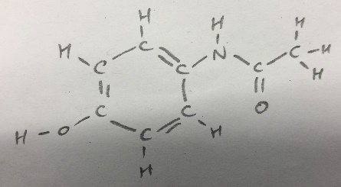 | 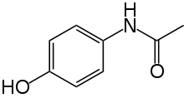 | 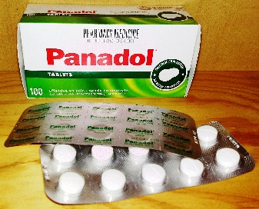 | 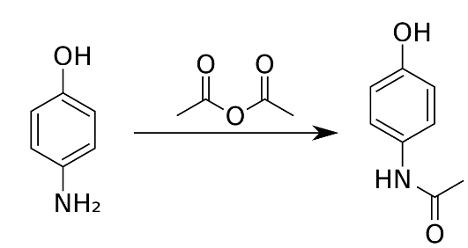  Condensation reaction
Methylated spirits |  |  |  |  | Substitution of a haloalkane
Natural Gas | CH₄ | 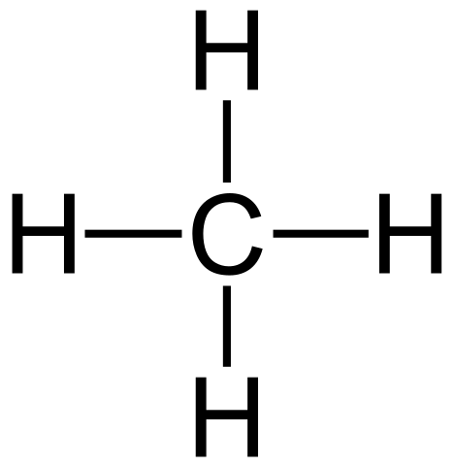 | NA | 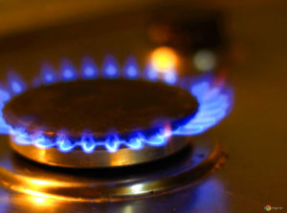 | Combustion
Acetone | (CH₃)₂CO | 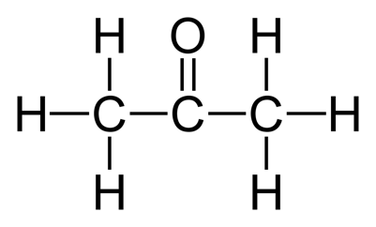 | 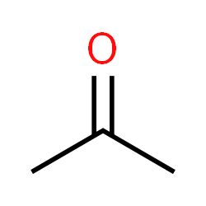 | 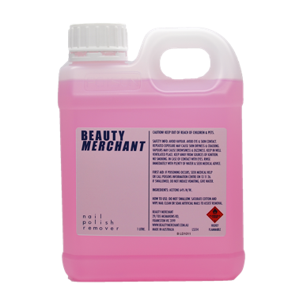 | Oxidation of a secondary alcohol
Petrol | CH3(CH2)6CH3 | 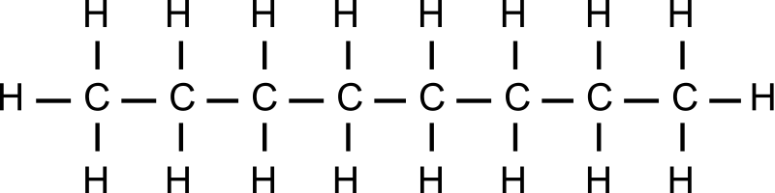 | 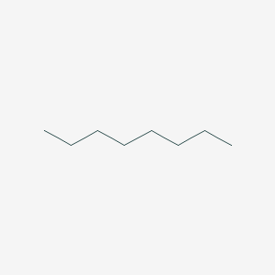 | 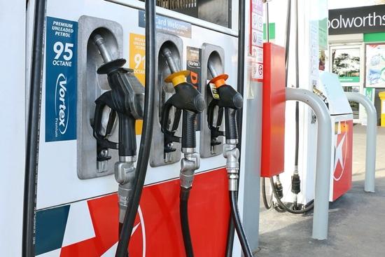 | Combustion
Coconut Oil (main fatty acid – Lauric acid) | CH ₃(CH ₂) ₁₀COOH |  | 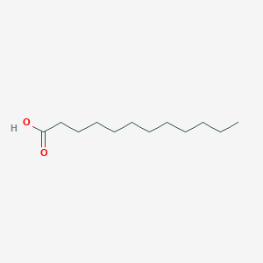 |  | Oxidation of a primary alcohol
Sugar (glucose) | NA |  |  |  | Condensation forming a disaccharide
Aspirin | NA |  |  |  | Esterification
Epinephrine | NA |  |  |  | NA
Caffeine | NA |  |  |  | NA
Vitamin C | NA |  |  |  | NA

