

PHYSICS

Unit 1 AOS 2 2019

Electric Circuit Exploration

Resistor Colour Code

Resistors used in electronic circuits are so small that it is difficult to label them with their resistance value. Instead, a colour code is used, giving not only the resistance, but also the accuracy of the stated value of the resistor (its tolerance).

The first coloured band gives the value of the first digit, the second band the second digit. The third band indicates the number of zeros that are to be added to the first two numbers to give the value of the resistance (in ohms). The forth band shows whether the value of actual resistance is within 5% or 10% of the stated value.

1st colour band  1st digit | 2nd colour band  2nd digit | 3rd colour band  number of zeros | 4th colour band  tolerance
black 0 | black 0 | black no zeros
brown 1 | brown 1 | brown one zero
red 2 | red 2 | red two zeros | gold 5%
orange  3 | orange  3 | orange three zeros | silver 10%
yellow 4 | yellow 4 | yellow four zeros
green 5 | green 5 | green five zeros
blue 6 | blue 6 | blue six zeros
violet 7 | violet 7 | violet seven zeros
grey 8 | grey 8 | grey eight zeros
white 9 | white 9 | white nine zeros

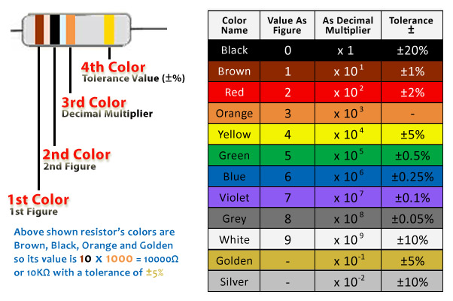

Examples:

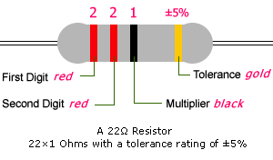

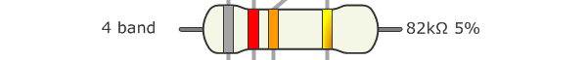

Index

Expt 1: Voltage Drops Around a Circuit
Voltage - Current Characteristics
Expt 2: Ohmic Resistors
Expt 3: Series & Parallel Circuits
Expt 4: Resistance of a 12 V Light Globe Filament
Expt 5: The Diode
Expt 6: The Light Dependent Resistor
Expt 7: The Thermistor
Article of Solar Cells

Experiment #1

VOLTAGE DROPS AROUND A CIRCUIT

In this experiment you will investigate how the voltage changes as the current passes through various components that make up a circuit.

Theory
You will need to understand the meaning of voltage and current as they relate to charge, the meaning of electromotive force of a battery, and be able to connect a multimeter to correctly function as an ammeter and a voltmeter and also use it to measure the resistance of a fixed resistor (ohmmeter).

Equipment
• a DC variable power supply
• two 47 ohm resistors
• connecting wires
• two multimeters
• a switch.

Your task will be to construct various circuits and measure voltages and the current using a multimeter.

Procedure
1. Connect up the circuit shown.
2. Set the DC variable power supply to 6V
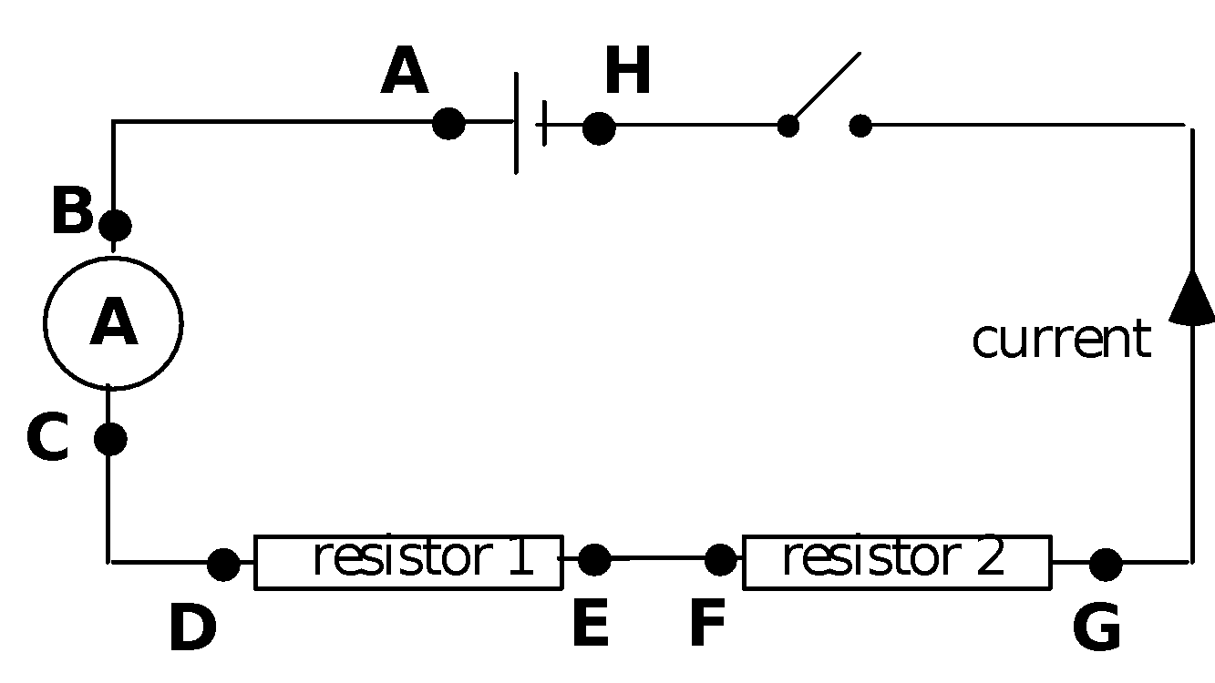

2. With the switch closed, use the multimeter set as a voltmeter to measure the voltage drop between the following points on the circuit. Note: Some readings will be zero!
a) A to B ...0......... volts b) B to C .......2.984......... volts
c) C to D ........0...... volts d) D to E .......1.37......... volts
e) E to F .........0....... volts f) F to G ........1.38........ volts
g) G to H .........0....... volts h) A to H ........5.67........ volts
i) D to G ........2.77........ volts j) Ammeter ..........21.38......milliamps

3. Looking at the measurement for a), c), e) and g), can you suggest how much energy is used in the connecting wires?
0J of energy.
4. How much energy is transferred by 1 coulomb of charge passing through Resistor 1?
1.37J
5. Reconnect the circuit with the multimeter set as an ammeter between the resistors. What do you notice about the reading?
It produces the same reading as it did in it’s previous position, that is 21.38mA.

Now disconnect the circuit and connect the voltmeter across the variable DC power supply. The reading of the voltmeter is a measure of the EMF (Electromotive Force) of the power supply.

EMF of the battery is 6.68V

6. What does this measurement say about how much energy is supplied to each coulomb by the power supply?
Each coulomb is supplied with 6.68J of energy.

7. What can you say about the EMF and the total energy transferred in all the circuit components?
EMF total energy supplied and is the sum of the all of the measured voltages across each individual components, in this case it is 6.68V.

8. Now sketch a graph in the space below of how the voltage changes in each section, A - B, B - C, etc, as the current goes around the circuit, use your answers from Question 2.

9. Your answer to question 6 is how much energy the charge has as it leaves the battery.
Your answers to questions 2 and 8 show how much energy is converted from electrical energy to other forms in each section of the circuit.

Now draw a graph of how much energy the 1 C of charge would have as it goes around the circuit, starting with maximum at the beginning and finishing with nothing by the end.

Unsure…

Energy level of 1 C of charge (J)

A B C D E F G H
Experiment #2
VOLTAGE-CURRENT CHARACTERISTICS OF VARIOUS ELECTRONIC COMPONENTS

Introduction

When a voltage is applied across a component, the amount of the current going through it depends on its physical properties. How the current changes as the voltage is increased, also depends on the particular component.
Some components even respond differently, depending on which end is connected to the positive end of the battery.
In this next series of experiments you will be investigating the voltage-current characteristics of a selection of components and how these components combine together.

Ohmic Resistor

In this experiment you will be using a resistor, whose characteristics are similar to the metals that make up wires and the heating elements in electrical appliances.

Equipment:
2 - 12V variable DC power supply
2 x Multimeters
47 ohm resistor
Connecting wires
Banana plugs and alligator clips
Switch

Construct the circuit below using a power supply. Record the current for voltages from 0 volts to 12 volt settings of the power supply.

Note that the voltage settings on the power supply only give a rough guide and the voltmeter should be used to give an accurate reading of the supply voltage. Also, the current will be small, so use the milliamp scale.
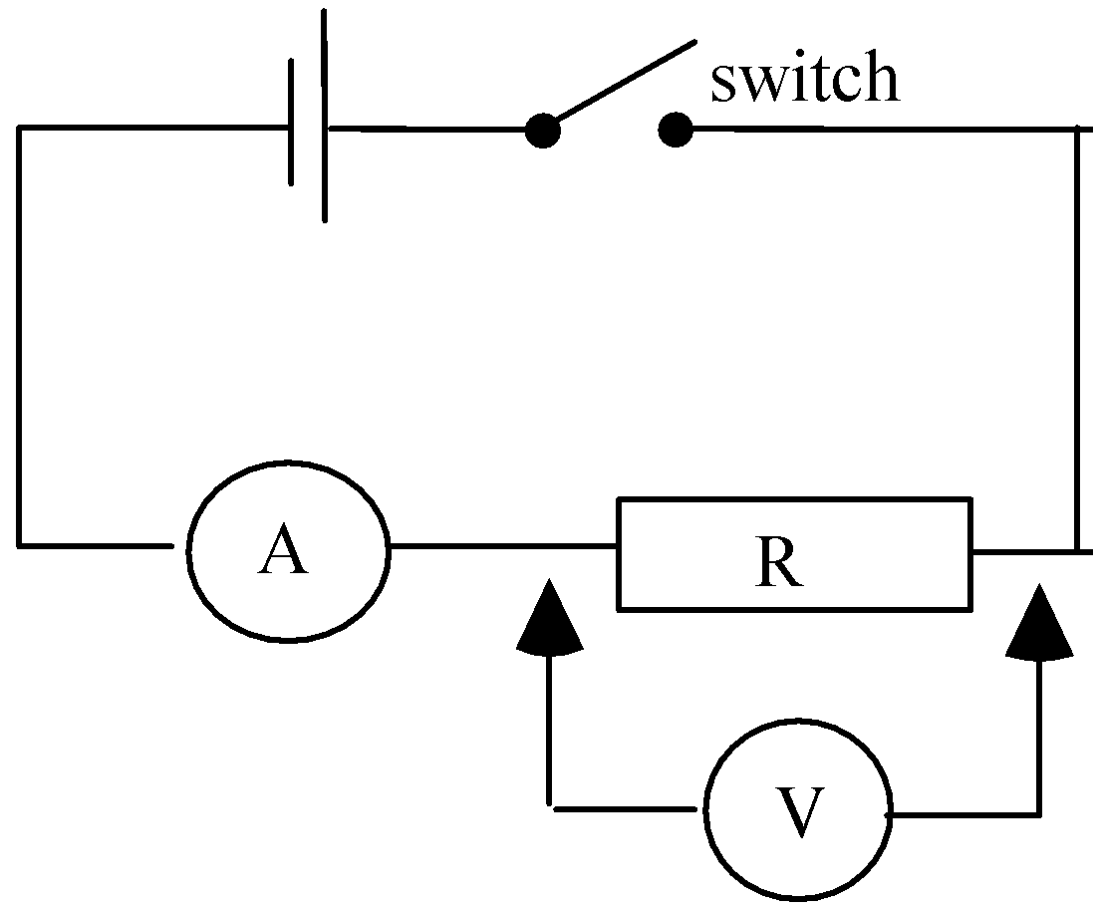

Voltage (V) | 2.14 | 3.88 | 5.63 | 7.65 | 9.56 | 11.67
Current (A) | 0.045 | 0.083 | 0.121 | 0.165 | 0.206 | 0.251

Now plot the Voltage (Y - axis) against the Current in Amps on (X - axis) in the space over the page, and draw a line of best fit through the origin.

- The gradient of this line is called the Resistance. Calculate from your graph the resistance of your resistor.
47 Ohms

2. Write down a relationship between Voltage, Current and Resistance.
V = I * R, where (V) is voltage/potential difference measured in volts, (I) is current measured in Amperes and (R) is the resistance measured in Ohms.
3. On your graph, draw a line you may get for a higher value resistance.

4. The unit of resistance is the "ohm", what would be the equivalent unit in terms of volts and amps?

1 Ohm = 1 Volt/Ampere

Experiment #3
SERIES AND PARALLEL CIRCUITS

For any electrical conductor, a graph can be drawn showing the current flowing versus the voltage across it.

In this experiment you will:-
- plot a voltage – current characteristics of two resistors on the one set of axes, then
- you will use the two graphs to predict the effective resistance if the two resistors were combined in series, and finally
- measure the current and voltage for the combined resistors and seeing if your measurements match your predicted graph.

And then repeat the last two steps for the two resistors connected in parallel.

Because you know that the resistors obey Ohm’s Law, you only need to take three sets of readings to draw the voltage - current graphs for the resistors.

Equipment
2 - 12V DC variable power supply Switch
2 x Multimeters Connecting wires
Two resistors 1 x 100 ohm and 1 x 150 ohm Banana plugs and crocodile clips

Procedure
1. Set up a circuit to measure the voltage across and current through each resistor in a single series circuit - do not put them together yet - two circuits with one resistor in each and take the measurements.. Draw your circuit below. (See the previous experiment if you are not sure)

B
2. Record 3 readings of Voltage and Current for each resistor ( R1 and R2).
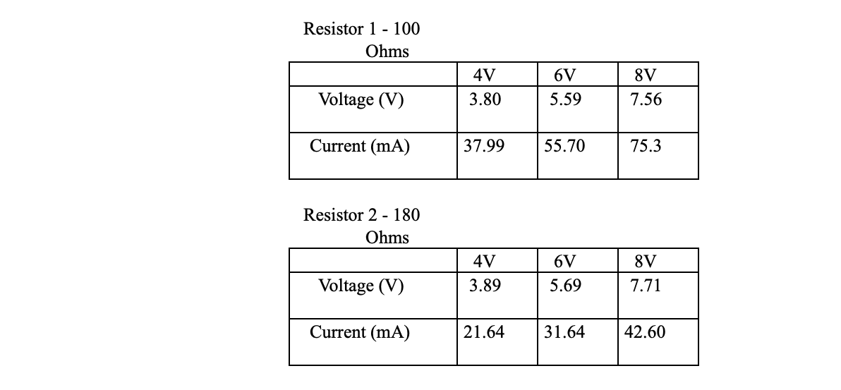

3. Graph the Voltage and Current values for BOTH resistors on the one set of axes, putting the Voltage on the Y-axis.

In the Series Circuit, both conductors carry the same current.
This information can be used to predict the Voltage - Current graph for a Series connection.

4. Construct your prediction of the line for the Voltage-Current relationship for the Series Connection.

To do this, you use that fact that the current through each resistor is the same, but the total voltage drop is just the sum of the individual voltages across each resistor.

To plot the line, first select a current and go up your graph until you hit each line. This gives you the voltage drop across each resistor. Now add together these voltages and plot this value further up with the current line you started with.
Do this with other current values. Now draw your line for the predicted Voltage- Current relationship for the series connection.

5. Now to test your prediction. Place the two resistors in Series in your circuit and measure a set of Voltage and Current values.

Resistor 1 - 100 Ohms
 | 4V | 6V | 8V | 10V | 12V
Voltage (V) | 1.404 | 2.039 | 2.754 | 3.482 | 4.20
Current (mA) | 13.97 | 20.30 | 27.5 | 34.70 | 41.8

Resistor 2 - 180 Ohms
 | 4V | 6V | 8V | 10 | 12
Voltage (V) | 2.540 | 3.680 | 4.94 | 6.24 | 7.57
Current (mA) | 14.08 | 20.40 | 27.36 | 34.63 | 41.9

6. Plot these results with a • on your previous graph.

- Do the experimental results agree with your prediction?
Yes, although the experimental data indicates that there was an additional 1 Ohm of resistance, this may be due to the resistance of the wires and the multimeters.

8. Explain how you could use this method to find the effective resistance of three resistances in series.
Measure the current and voltage across all the three the resistors combined and plot these results where voltage is on the y – axis and current is on the x-axis. The gradient of the linear trendline where the intercept is set to 0, is the total effective resistance.


In a Parallel Circuit, both resistors have the same voltage drop across them.

This information can be used to predict the Voltage - Current graph for a Parallel connection.

9. Construct your prediction of the line for the Voltage-Current relationship for the Parallel Connection.

To do this, you use that fact that the voltage drop across each is the same, but the current coming in is just the sum of the individual currents going through each resistor.

To plot the line, first select a voltage and go across your graph until you hit each line. This gives you the current in each resistor. Now add together these currents and plot this value further across with the voltage line you started with. Do this with other voltage values. Now draw your line for the predicted Voltage-Current relationship for the parallel connection.

10. Now to test your prediction. Place the two resistors in Parallel in your circuit and measure a set of Voltage and Current values.

 | 4V | 6V | 8V | 10V | 12V
Voltage _{S} (V) | 3.91 | 5.57 | 7.71 | 9.72 | 11.76
Voltage _{R2} (V) | 3.80 | 5.48 | 7.47 | 9.37 | 11.36
Voltage _{R1} (V) | 3.79 | 5.52 | 7.47 | 9.37 | 11.39
Current_{R1} (mA) | 38.17 | 54.3 | 74.9 | 93.7 | 114.1
Current_{R2} (mA) | 21.32 | 30.94 | 42.0 | 53.0 | 63.7
Current_{Total} (mA) | 58.8 | 85.2 | 115.8 | 145.3 | 176.3

11. Plot these results with an X on your previous graph.

12. Do the experimental results agree with your prediction?
Yes, although there is a slight difference which may be caused due to a calibration error of the multimeters used.

Experiment #4

Light Globe Filament Resistance

In this experiment, you will replace the resistor in the circuit from experiment #2 with a 12 V light globe and remove the switch. Obtain the 12 volt globe from the trolley. Because the current drawn by the light is larger, you will need to use the amp range of the ammeter.

Equipment
2-12 V DC variable power supply
2 x multimeters
12 volt globe
Connecting wires
Banana plugs and alligator clips

Nominal EMF (V) | 2.073 | 3.831 | 5.59 | 7.58 | 9.60 | 11.59
Voltage (V) | 2.034 | 3.799 | 5.550 | 7.54 | 9.57 | 11.55
Current (A) | 0.159 | 0.229 | 0.286 | 0.341 | 0.390 | 0.434

- Plot your graph with Voltage on the X - axis as it is the independent variable. That is, the voltage and the properties of the component determine the size of the current.
- Draw a smooth curve through your set of data. Describe the shape of your line.
The shape of the line follows that of a square-root graph or a log graph.

3. The resistance of the globe is given by the Voltage divided by the Current that it produces. Calculate the resistance of the globe at voltages of 4, 8 and 12 volts.

R4V = 17.0 Ohms R8V = 22.7 Ohms R12V = 27.0 Ohms

4. Describe how the resistance of the globe changes as the voltage is increased?
Since voltage is increased, the resistance is simultaneously increased, since it shines brighter each time the voltage is increased and therefore uses more energy.

5. Give an explanation for your answers to Question 2 & 3.

6. Is a light globe an Ohmic or Non-Ohmic device? Explain.
A light globe is a non-ohmic device since it does not follow a linear trend. Although, it evidently begins at the origin, an ohmic device must both, follow a linear trend and start at the origin.
Experiment #5
The Diode

The Diode is a Semiconductor component made of Silicon doped with Phosphorus and Aluminium. It is an example of a device whose characteristics are not symmetrical, i.e. the size of the current depends on which way the current is going through the component.

The diode only needs a small voltage to operate and it can handle only a small current, so the circuit will need to be redesigned. Ensure that the power supply is set on 2 volts. To control the voltage or potential drop across the diode, you will be using a variable resistor called a rheostat.. This allows you to select the amount of voltage you want by sliding the contact from the left end to the right end.

Equipment
DC variable power supply set at 2 volts
switch
Diode
2 x Multimeters one set as an ammeter (milliamp scale) and the other as a voltmeter
Rheostat (the sliding contact of the rheostat corresponds to the arrowed connection in the diagram below)

Rheostat

A

V

1. Connect the circuit together and ask your teacher to check it before you press the switch. Note that the diode has a band at one end, this corresponds to the line in the diagram above.

2. Slowly adjust the control on the rheostat and measure several values of current and voltage.
Voltage (V) | 0.950 | 1 | 1.05 | 1.1 | 1.15 | 1.2 | 1.25 | 1.3 | 1.35 | 1.4 | 1.45 | 1.5 | 1.55 | 1.6 | 1.65 | 1.7 | 1.75 | 1.8 | 1.85 | 1.9
Current (mA) | 0.01 | 0.10 | 0.4 | 0.94 | 1.71 | 2.53 | 3.55 | 4.65 | 5.82 | 6.86 | 8.28 | 9.78 | 11.05 | 12.42 | 13.92 | 15.36 | 16.85 | 18.29 | 19.92 | 21.45

- Turn the diode over so that the end with the band goes to the positive of the battery. Now repeat step 2 above.
Note: My partner and I didn’t have enough time to experimentally attain the data required for this question, therefore I created the results below, using theoretical knowledge.
Voltage (V) | 0.95 | 1.00 | 1.05 | 1.10 | 1.15 | 1.20 | 1.25
Current (mA) | 0 | 0 | 0 | 0 | 0 | 0 | 0

4. Graph both sets of results on the one set of axes. Draw the axes in the middle of the page.
Graph the data in step 3 as negative voltage and negative current, i.e. in the third quadrant.

