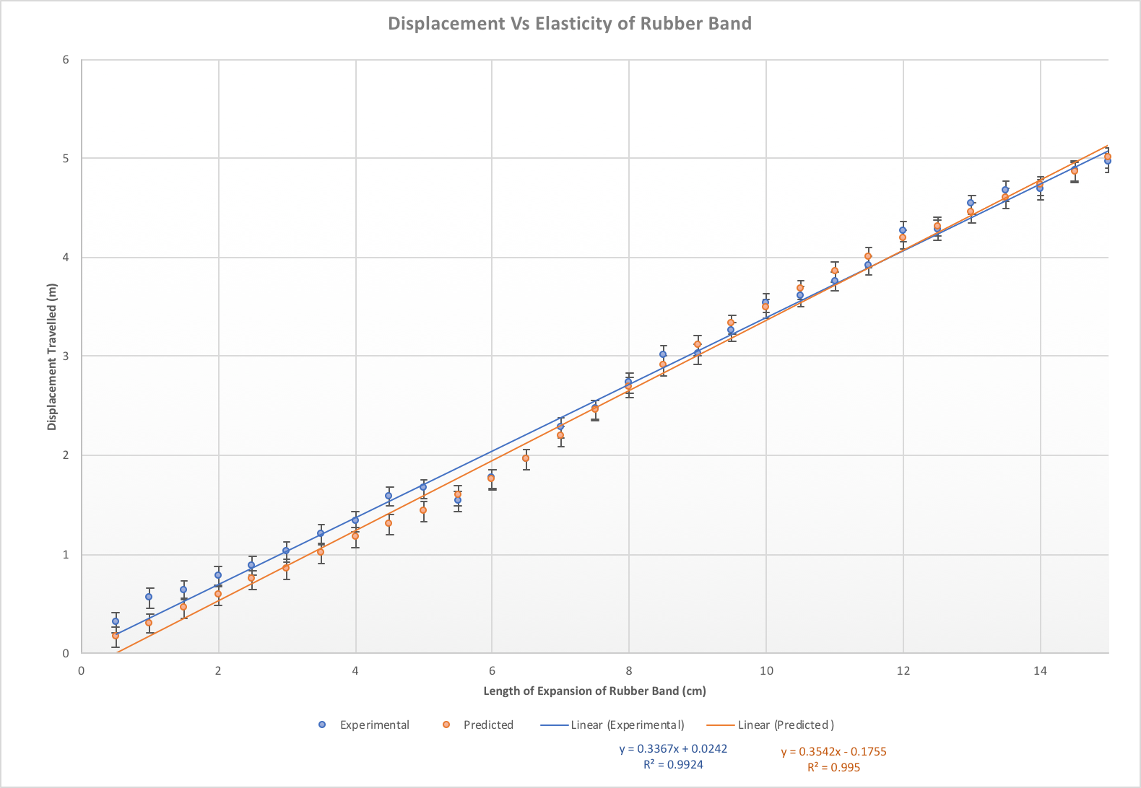
Benson, T. (2014). The Drag Equation. Retrieved from https://wright.nasa.gov/airplane/drageq.html
Chegg.com. (2018). Retrieved from https://www.chegg.com/homework-help/questions-and-answers/typical-rubber-band-spring-constant-88-n-m-un-stretched-length-80-mm-band-break-stretched--q25755767
Drag of Blunt Bodies and Streamlined Bodies. (2018). Retrieved from https://www.princeton.edu/~asmits/Bicycle_web/blunt.html
Hall, N. (2015). The Lift Equation. Retrieved from https://www.grc.nasa.gov/www/k-12/airplane/lifteq.html
Hall, N. (2015). The Drag Coefficient. Retrieved from https://www.grc.nasa.gov/www/k-12/airplane/dragco.html
How does centre of pressure change with angle of attack?. Retrieved from https://aviation.stackexchange.com/questions/33398/how-does-centre-of-pressure-change-with-angle-of-attack
LiftCurve.gif. (2016). Retrieved from http://gtae6343.wikia.com/wiki/File:LiftCurve.gif
wing?, W. (2017). What is the performance of a flat plate wing?. Retrieved from https://aviation.stackexchange.com/questions/21391/what-is-the-performance-of-a-flat-plate-wing

https://drive.google.com/file/d/13ywmZgi3cjQnGtX93ZG1rcR7FQhArTie/view?usp=sharing

 | Expansion of Rubber Band (cm)
Number of trials | 0.50 | 1.00 | 1.50 | 2.00 | 2.50 | 3.00 | 3.50 | 4.00 | 4.50 | 5.00
 | Displacement (m)
1 | 0.34 | 0.58 | 0.79 | 0.91 | 0.91 | 1.07 | 1.24 | 1.39 | 1.62 | 1.53
2 | 0.28 | 0.46 | 0.57 | 0.79 | 0.99 | 0.95 | 1.16 | 1.32 | 1.63 | 1.74
3 | 0.25 | 0.47 | 0.57 | 0.76 | 0.79 | 0,94 | 1.14 | 1.41 | 1.52 | 1.74
4 | 0.36 | 0.65 | 0.58 | 0.72 | 0.95 | 1.09 | 1.17 | 1.17 | 1.51 | 1.72
5 | 0.31 | 0.64 | 0.67 | 0.70 | 0.78 | 1.07 | 1.29 | 1.29 | 1.62 | 1.56
Mean | 0.31 | 0.56 | 0.64 | 0.78 | 0.88 | 1.02 | 1.20 | 1.33 | 1.58 | 1.66
Predicted | 0.16 | 0.30 | 0.46 | 0.59 | 0.74 | 0.85 | 1.01 | 1.17 | 1.30 | 1.43

 | Expansion of Rubber Band (cm)
Number of trials | 5.50 | 6.00 | 6.50 | 7.00 | 7.50 | 8.00 | 8.50 | 9.00 | 9.50 | 10.00
 | Displacement (m)
1 | 1.53 | 1.76 | 1.96 | 2.24 | 2.57 | 2.66 | 2.93 | 3.05 | 3.22 | 3.55
2 | 1.64 | 1.62 | 2.04 | 2.19 | 2.37 | 2.68 | 3.06 | 3.07 | 3.32 | 3.59
3 | 1.77 | 1.92 | 2.05 | 2.40 | 2.36 | 2.80 | 3.01 | 2.95 | 3.31 | 3.49
4 | 1.77 | 1.86 | 2.14 | 2.37 | 2.46 | 2.77 | 3.07 | 3.08 | 3.21 | 3.60
5 | 1.62 | 1.82 | 2.07 | 2.20 | 2.54 | 2.73 | 2.95 | 2.94 | 3.18 | 3.45
Mean | 1.67 | 1.82 | 2.05 | 2.28 | 2.46 | 2.73 | 3.00 | 3.02 | 3.25 | 3.54
Predicted | 1.59 | 1.75 | 1.96 | 2.19 | 2.45 | 2.69 | 2.90 | 3.11 | 3.32 | 3.48

 | Expansion of Rubber Band (cm)
Number of trials | 10.50 | 11.00 | 11.50 | 12.00 | 12.50 | 13.00 | 13.50 | 14.00 | 14.50 | 15.00
 | Displacement (m)
1 | 3.68 | 3.65 | 4.01 | 4.18 | 4.33 | 4.57 | 4.77 | 4.81 | 4.96 | 4.85
2 | 3.70 | 3.88 | 3.84 | 4.15 | 4.49 | 4.56 | 4.76 | 4.72 | 4.82 | 4.89
3 | 3.55 | 3.87 | 3.94 | 4.39 | 4.26 | 4.71 | 4.61 | 4.56 | 4.82 | 5.07
4 | 3.54 | 3.68 | 3.95 | 4.30 | 4.15 | 4.36 | 4.59 | 4.58 | 4.79 | 5.01
5 | 3.55 | 3.70 | 3.84 | 4.26 | 4.18 | 4.45 | 4.63 | 4.73 | 4.97 | 4.94
Mean | 3.60 | 3.76 | 3.92 | 4.26 | 4.28 | 4.53 | 4.67 | 4.68 | 4.87 | 4.95
Predicted | 3.67 | 3.85 | 4.00 | 4.18 | 4.31 | 4.45 | 4.60 | 4.72 | 4.86 | 5.00

