Data Visualisation (Part Two)

Data Visualisation:
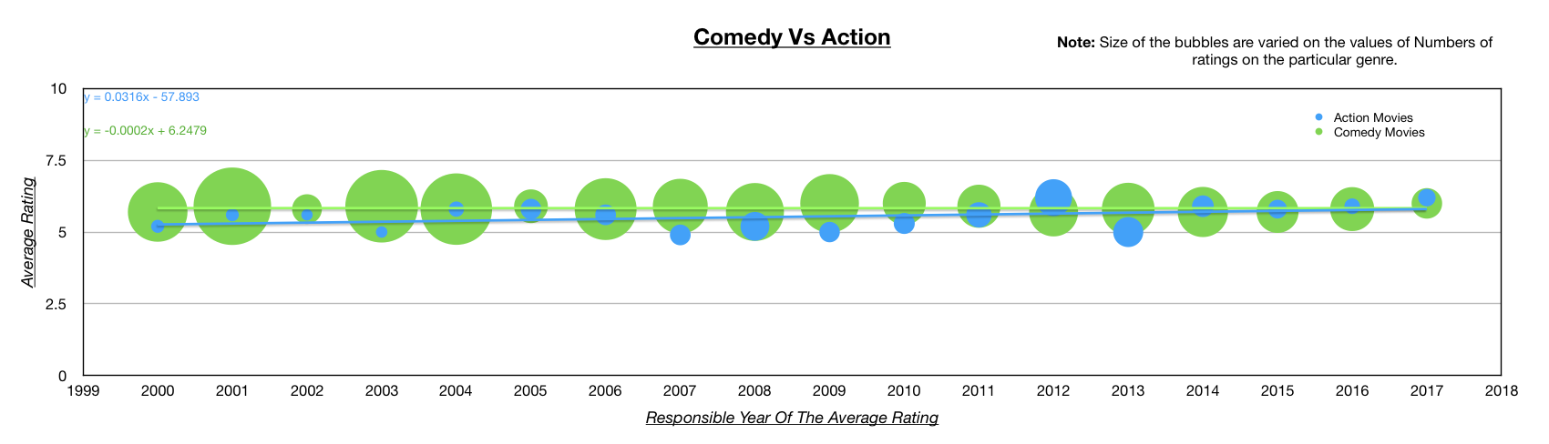

Discussion:
When looked upon the data obtained from the IMDb records, it is evident that the overall trend of action movies over the years ranging from 2000 – 2017, is generally increasing regardless of the few drops, occurring among the data set. On the other hand, comedy movies are decreasing. Therefore, when compared with the hypothesis, it has proved to be positive: action movies have a positive gradient trendline whereas comedy movies are slightly negative. A bubble chart was used to represent this information, since, it is a form of scatter plot and therefore, shows that the values present are discrete. Moreover, this particular type of graph can be used to merge two different data sets onto the same axis. In addition, a bubble chart can help display three sub-sets of data, in this case: year, average rating and the average number of ratings. As a substitution to Excel and Numbers software, another program (Gapminder) was attempted, however wasn’t compatible with my computer, therefore, the final data visualisation was completed using Numbers program. Furthermore, the number of ratings for comedy movies were displayed to provide an estimated value for the scale size of the bubbles although this was not shown in the case of action movies since it isn’t necessary as both genres have been graphed on the same axes. The following results were obtained using python to filter the raw IMDb data file into the desired categories which are the four channels of information: ratings, year produced, genre and the number of ratings for the particular movie. This information was then written onto another CSV file where additional sorting and filtering was required. The columns were sorted ascending to descending, then the average rating for each genre and year were calculated using numbers and were produced in a separate table, from which the graph was created. The average ratings over the years had to be manually calculated since processing it through code was not thought, although I had attempted to incorporate it into my python code, however, I was unsuccessful. The major resources used to complete the data visualisation include ‘Numbers’ and ‘Python’. Additionally, this investigation may be biased since the number of ratings for each genre is significantly different. Due to this, the data may be skewed. To improve accuracy, only movies with a specific number of user ratings may be used. To help reduce the sheer amount of manual work undertaken, it is advised, to include an algorithm within python to automatically sort the ratings for comedy and action and calculate the average for each year and writing this to the final edited document. Overall, the aim to investigate the general trend of the ratings of action movies and comedy movies between the years 2000 – 2017 were achieved.

