Data Visualization (Part One)

Question:
What is the trend of user ratings of action and comedy movies since the year 2000?

Hypothesis:
It can be hypothesised that the general trend of average rating of action movies are increasing. Whereas for comedy movies, the trend of average rating is decreasing.

Data Specification:
- Filter data through python for action and comedy movies, produced later than the year 2000, and their ratings
- Open the csv file and sort for the 2nd column (years) , ascending to descending.
- Delete the rows which has a value of less than 2000 for the 2nd column.
- Sort the 1st column, ascending to descending.
- Calculate the average rating for each year from each genre and make another table with 2 tables, one for action movies and the other for comedy movies, with two columns (year and Ave Rating) and 18 rows (title, list the years from 2000 to 2017). Following table.

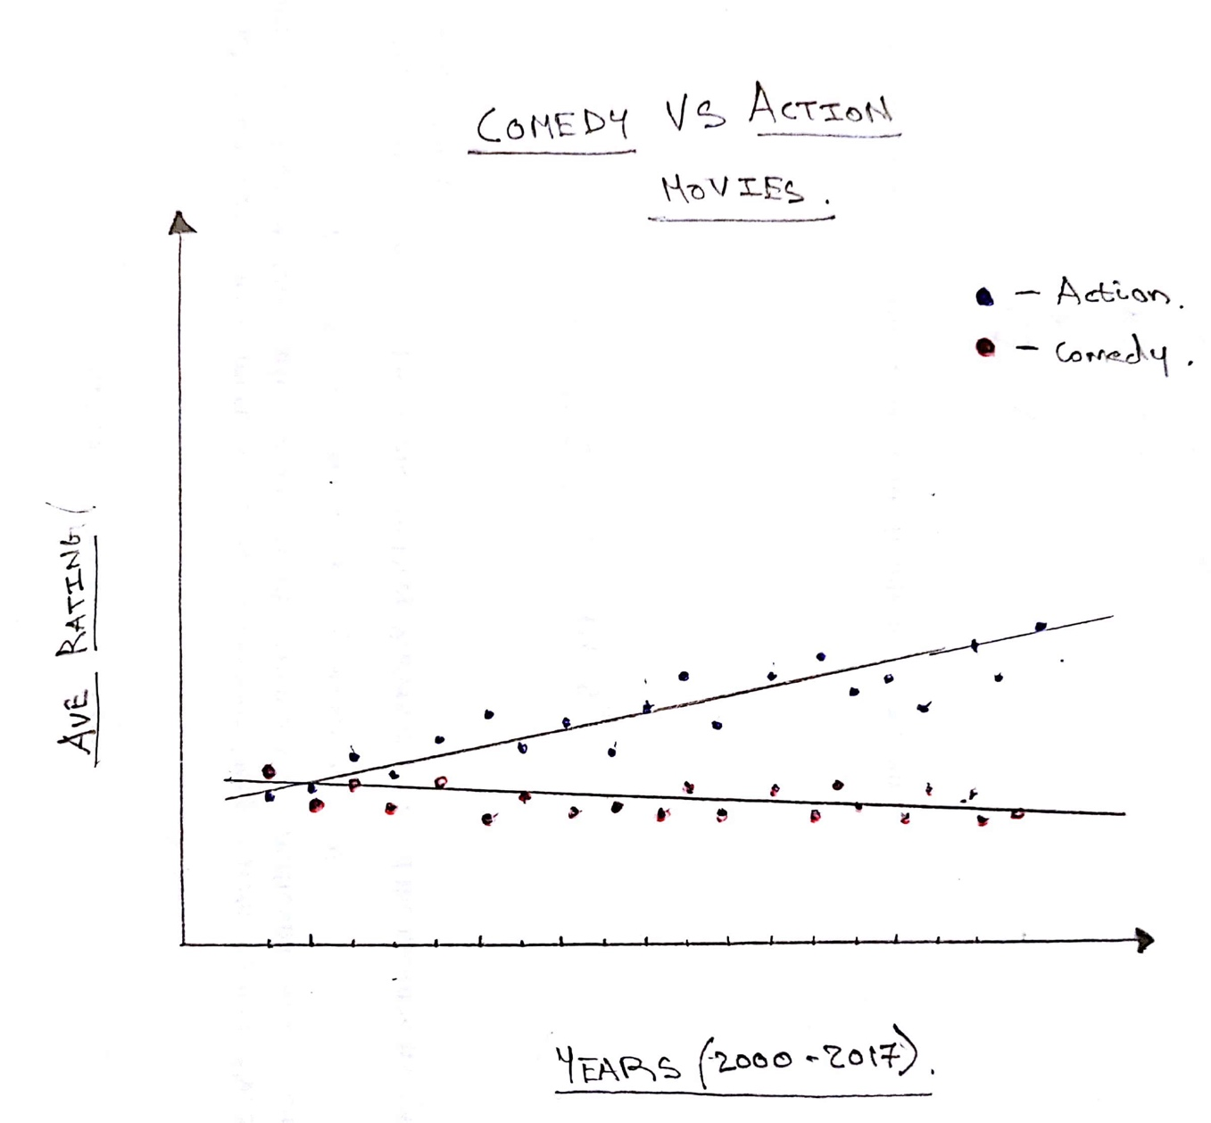
Visualization Mock-up:

Three Channels of Information:
- Time (x-axis)
- Average rating over the years (y-axis)
- Genres: Comedy & Action

