ART C.A.T

Step 1 – I intend to create a two-point perspective drawing depicting a typical farm house.
Why I choose this idea – I have chosen this idea as I feel more comfortable drawing a house and I think it looks more realistic and cool.
Step 2 – T-square, set square, drawing board, pencil, rubber, sticky tape, A3 size paper.
Step 3 –
Step 4 -
Picture | Reason
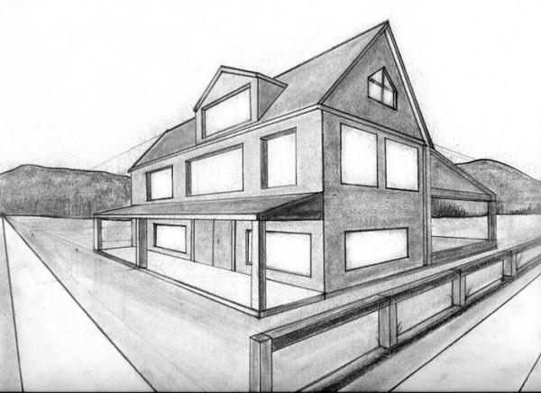 | - A window peeking out of the roof.  - Shelter
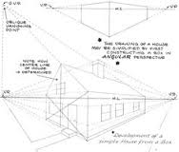 | - Windows  - Door
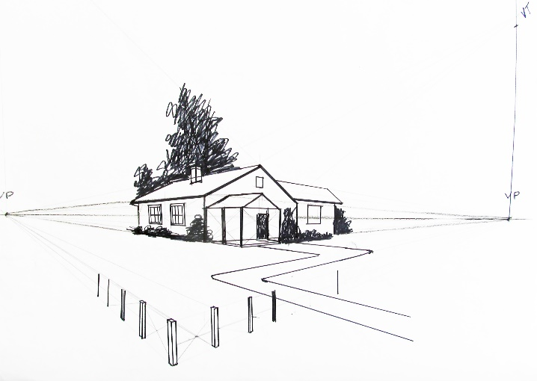 | - The path or road
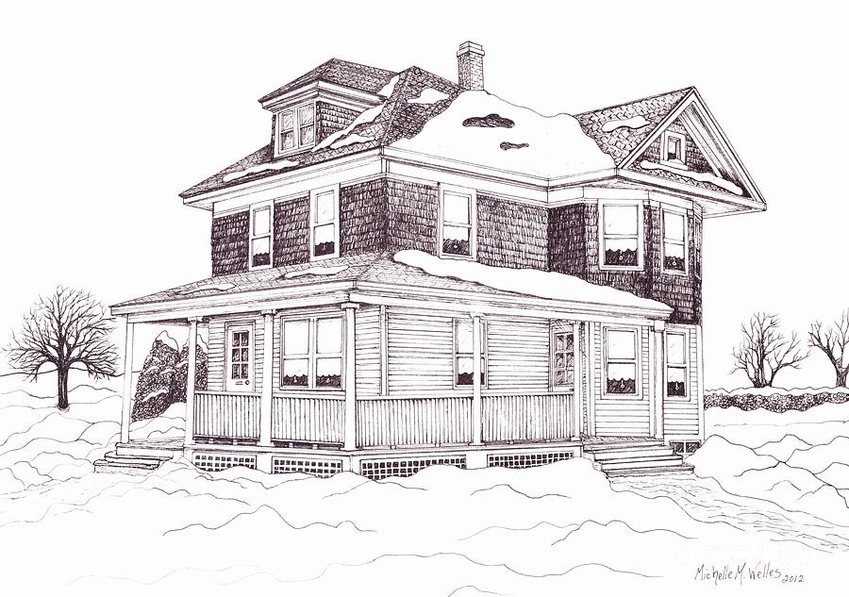 | - Trees  - Roof
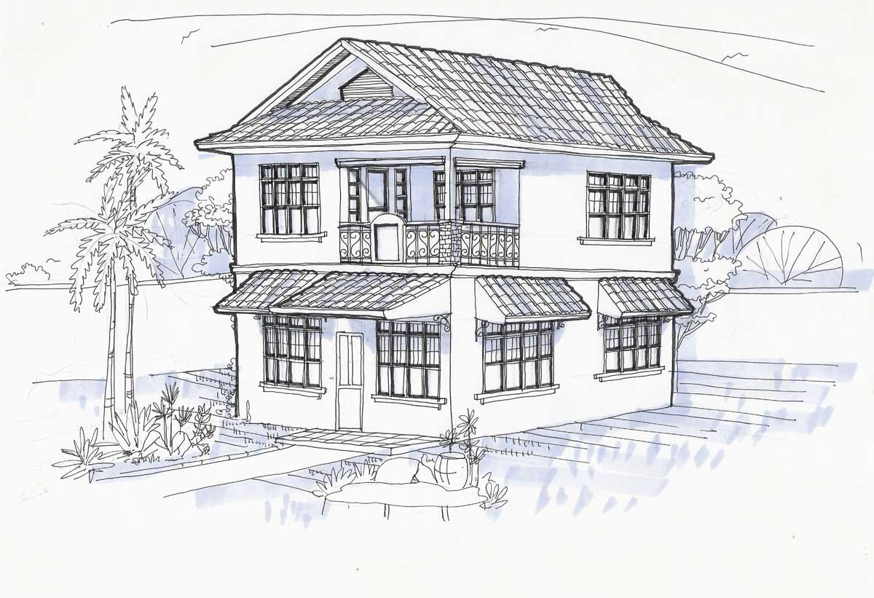 | - Trees  - Roof  - Skirts on top of the windows
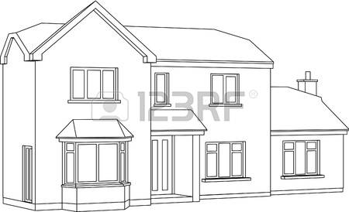 | - Part which I have highlighted
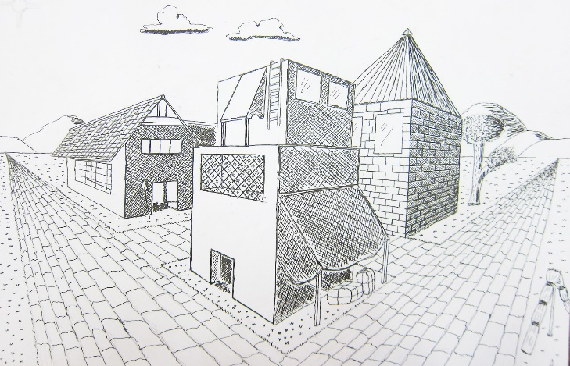 | - Tiles on the path
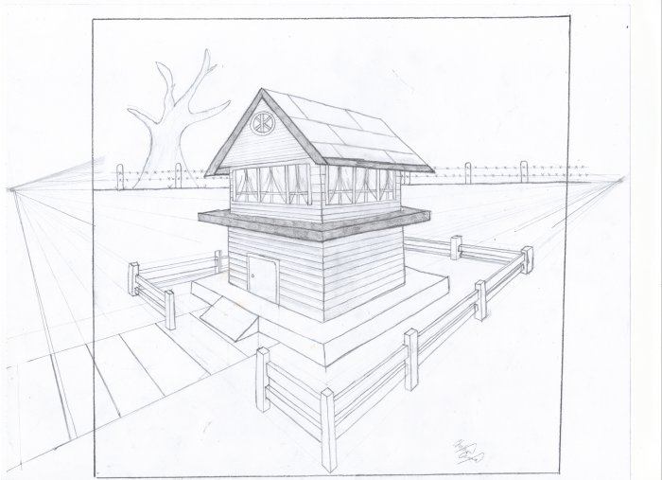 | - Fence  - Tree

