Common Assessment Task

LED Picture Frame

Student Name: ____________________________________________

Date: ____________________ Teacher: ____________

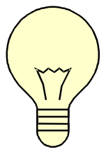

This is your Common Assessment task for this semester. This task will help you to see what you have learnt and understood well in this subject. It will also give your teacher evidence of your learning so she/he can attribute you a grade result.
The task is designed in three stages. You need to start at the beginning and work your way through.

Each time you complete a section, you must use your rubric to evaluate your work and make adjustments. You must also see your teacher to receive feedback on your work, BEFORE you move to the next section.

Section One completed:  Checked against the rubric  Checked with my teacher | Section Two completed:  Checked against the rubric  Checked with my teacher | Section three completed:  Checked against the rubric  Checked with my teacher

Section 1 begins here: There are Four (4) steps to this section. Make sure you complete them all

Design Brief

You are required to create a LED picture frame which can be A4 size or smaller. You have to decide on the front cover, which can be a printed photo, an image of the internet or a hand drawing.

Constraints and Considerations of your chosen design have to have the following:

Pine Frame: You will need:
2 x 290mm x 50mm pine lengths
2 x 170mm x 50mm pines lengths

This will form the frame which we will BUTT JOIN it together, using 20mm nails and PVA (poly-vinyl acetate). This join and 4 others will have to be researched at the next stage in this CAT

Initial Designs Activity
In Technology we have four stages. These are Investigate, Design, Create and Evaluate.
On your laptops, please investigate the 5 joints you must research.

Step 1. Investigation
- Find a picture for each join in the table in box 1 and show in box 2,3and 4how to construct the joint (including tools used)

Butt Joint | Insert join 2 here | Insert join 3 here | Insert join 4 here | Insert join 5 here
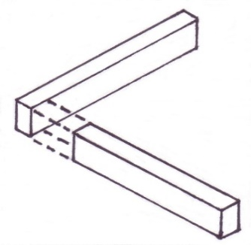  1 | 1 | 1 | 1 | 1
2 | 2 | 2 | 2 | 2
3 | 3 | 3 | 3 | 3
4 | 4 | 4 | 4 | 4

Focus Question: The Invention and development of LED Lights
Sources | Question 1  Where LED’S originated and why were they made? | Question 2  How they were created? Was it an accident? | Question 3  Insert a timeline of the date they were invented to now the current day. | Question 4  What are the different types and uses of LED’s in today’s environments? | Question 5  Insert a timeline of the date they were invented to now the current day with dates of the advancements along the way
Internet
Library Books/Magazines
Family members
Lighting stores, JayCar and Electrical retailers catalogues.
You must fill all these boxes in the table.

b) Use the information from the research grid to help you write your Information Report. The frame below will help you to structure your report

Introduction: Write what the report will be about. For example:
This report will give information about……. (all the areas you researched about your chosen instrument)
Paragraph 1: Use
all the information from your research grid to write this paragraph
Where LED’s originated from and what contribution they have made so far to improving society.

Paragraph 2:
Why and how were they created? Was it an accident?

Paragraph 3:
Insert a timeline of the date they were invented to now the current day?
Paragraph 4:
What are the different types and uses of LED’S in today’s environments? And what other uses do you see them completing in future years
Paragraph 5:
Conclusion of report summarise all of your ideas and thoughts. End the paragraph with some conclusions you mentioned in paragraph 1.

Step 2: Design

You are now to draw your final design from your investigation grid (where you got your initial images of all the joints). Show how you will colour your final piece and any designs you will place on your LED frame to make it an look as you want it. Place labels on your diagram to further describe how it will look when finished e.g. colour lights etc.

Step 3: Create

There will be teacher led demonstrations on the construction methods for each step of the creation of your picture frame.
In addition use the written method below to support your construction.

Construction Method:

The frame is a softwood pine frame and has the dimensions of an A4 piece of paper, you do have the option to make it smaller, and that’s purely YOUR DECISION.
- So your teacher will give you a 60mm wide piece of timber (pine) and you will have to mark out two 170mm lengths and two 270mm long lengths. REMEMBER!!! You will have to put a 5mm gap in between your measurements which is where you will cut your timber so the distance between the lines (after you disc sand them) will be exact.
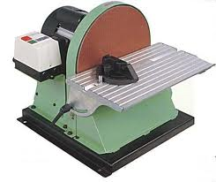

- After they are sanded to the correct length you will measure a 19mm line on each end of the long (290mm) pieces, this is where we will pre nail the nails in and is 19mm in as this is the thickness of the timber we use. Pre nailing is so the nail goes through the first piece of timber and this makes it easier for us to be accurate.

- Put your small piece in the bench vice and apply PVA Glue to the end, smear this around with your finger so the end is all covered in glue, then hold your pre nailed piece over this and nail together.

- Cut a piece of cardboard and then get it stapled to your frame making sure you have picked the worst side, as this will now be hidden by the card.

- This is where you need to print out a COLOUR photograph/picture to mount to the front of the frame; after it is printed you need to NEATLY GLUE STICK it to the cardboard.

This now is the first stage done. Now we move onto the circuitry and electronics

Circuitry
- Get a 4.5mm or 5mm drill bit, flip your photo over and use your fingers to twist the drill through the paper in the places where you want the lights to be.
- Choose ONE COLOUR of LED Light to go on your picture, cut the negative wire (Shorter one) in half, get a 40ohm resistor and twist it onto the positive end of the LED and solder it on.
- Place the LED into the holes you made with the drill bit and position them so the positive resistor end faces the centre to give you more room as this end is longer.
- Then get a hot glue gun and put a dollop on the back of the LED so that it cannot fall out
- Now to connect the POSITIV.E Cut some red wire to two resistors together, strip the wire, twist it around the resistor and solder it to the resistor. Repeat the process till all the resistors are joined up
- Now we connect the NEGATIVE together with black wire. Repeating the process from point 5 above
- Now we connect a switch and a power supply to the circuit
- Lastly we hot glue gun the switch to the side of the frame so we can turn it on and off, also hot glue gun the battery pack to the inside base of the frame so it can’t be seen.
Frame Finishing
- Nail punch your nails beneath the surface so that we can fill the hole with pine coloured putty and hide the nails.
- We then sand it to get a smooth finish, starting with 60 grade sandpaper, then 120 grade and then 240 grade to finish.
- Then we paint our frame, making sure to only apply enough paint so it can dry in less than 1 minute, then put on a few more coats to get a better finish.

Step 4: Evaluate.

Musical Instrument Project Evaluation

- Write a list of the tools that you used in this project in the order that you used them. HAND DRAW pictures of them to refine your graphics skills.
Check Paper.
- Write a VOCABULARY LIST (including the meaning) of any new words or processes (like buffing) that you learnt during the making of your model
- Butt Joint – a simple way of connecting 2 separate pieces.
- What are the safety requirements when using each of the tools you used?
- Wearing the safety glasses when soldering.
- Maintaining a safe distance with the solder.
- Keeping your hand at a safe position when hammering.
- Holding the solder and giving it to others safely.
- What were the step by step procedures that enabled you to complete your project? Draw the steps IN BOXES so someone could recreate your finished task. Extra marks will be given for shaded and coloured drawings.
- Cut 2 pieces of Radiata Pine wood  2 x 290mm x 50mm pine lengths  2 x 170mm x 50mm pines lengths  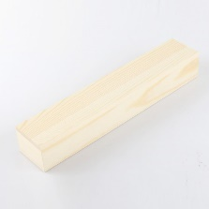 | - Form a rectangular box and hammer 2 9mm nails so that the 2 pieces stay intact.  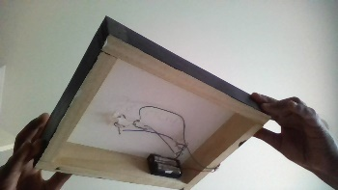 | 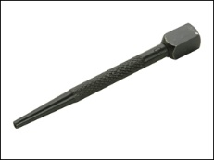  - Using a nail puncher hammer the nail about 5mm in. | 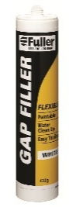  - Using the gap filler, apply the paste into the hole using your hands.
- Use a paper cutter to cut plaster board measuring 290mm x 170mm  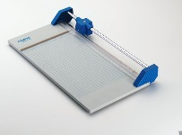 | - Staple the plaster board to the wood using a wall stapler.  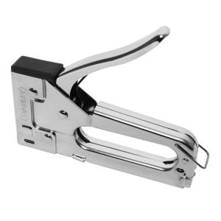 | - On a device select an A4 picture.   | - Copy the picture to word and print it.  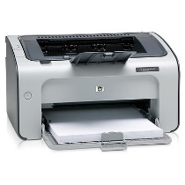
- Cut the picture so that it matches your picture frame. | - Use a glue stick to glue your selected picture into place. | - Using a 5 size drill bit drill holes on the plaster board where you want your LED lights to go (make sure you don’t drill the wood). | - Get the number of LEDs you want and place it facing up.
- Use the glue gun to glue the LEDs in its place. | - Twirl a resistor on the positive side of every LED. | - Solder the resistors the positive end of the LED diode. | - Use a stripper to cut and strip a bit of insulation on both ends of the green wire.
- Twirl one end of the wire to the other end of the resistor and twirl the opposite end of the wire to the following resistor, do this for all until everything is connected. | - Cut and strip another long piece of wire and twirl it to the first or the last resistor in the sequence. | - Solder all the wires to the resistors. | - Cut and strip both ends of the pieces required, this is for the blue wire.
- Connect all the negative ends by twirling the ends of the blue wire. | - Solder all the wires to the inlets on the LED diode. | - Put the loose end of the green wire into the middle socket of the switch. | - Place the red wire from the battery pack through either, the right or the left slots on the switch.
- Solder both the wires to the switch. | - Glue the switch to an easily accessible position with a glue gun. | - Twirl the black wire from the battery pack to the end or the start of the negative sequence. | - Solder the black wires and check for any loose contact.

- Did your project turn out as your final idea looked when you drew it? Why or why not? Draw how it looks now its completed you can draw this either orthographically (Birds Eye View etc.) or Isometrically (45 degree angle)
- How would you do this project differently if you were to make it again?
I.e. what mistakes did you make?

- What material/s was your project made out of? And what other products did you use to join and finish it? (Hinges, screws, nails etc.)
- What were the main things you learnt whilst making this project?
- If you were to try and get another class to make this project, how would you do it differently to make it easier?

Section 2 ( Second Exit) begins here
You must complete section 1 satisfactorily, before you can start this section
Check with your teacher to ensure you are ready for this work.

In this section you are required to use the organiser provided (or negotiate a different method with your teacher) to compare and contrast the method you used to make your LED Frame, to the method you used. You may consider things like: suitability of materials used, strengths of materials (how will you test the materials?), tools used, time it took to make the frame and circuit, etc. This information can be taken from your research in section 1. You may wish to do additional research to make your work stronger.

Compare and Contrast Chart Graphic Organizer

Method you used to make your Frame | Advanced method

How are the two methods alike?

How are they different?

Section 3 (exit 3) begins here

You must complete section 2 satisfactorily, before you can start this section
Check with your teacher to ensure you are ready for this work.

In this section, you are required to make judgements about the impact of modern technologies and materials, people skills and knowledge, (e.g plastic moulding) on the construction of your LED picture frame

This is how modern technologies help to make my LED Frame more effectively:
This is how modern materials contribute to the successful production of my project:

This is how people skills and knowledge help to make my LED Frame effectively:

