NAME:
ART CRITIQUE
ARTIST: Roy Lichtenstein TITLE : Drowning Girl DATE: 1963

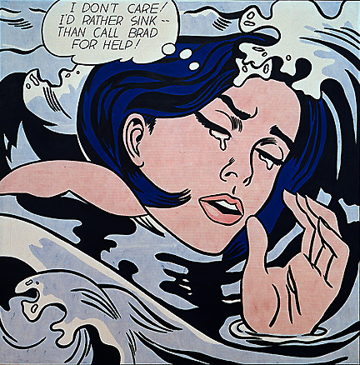

For each of the following four steps, write paragraphs using full sentences using the questions as prompts. This will ensure you successfully critique the artwork above.

1.DESCRIBE
What do I see? What colours are used? What shapes are visible? Where is the scene? Are there any unknown objects?
I am able to see a women in tears, drowning. The few colors used are black, blue, brown and grey. There are no regular shapes but rather irregular shapes.

2. ANALYSE
How are the elements in the artwork being used? How are lines used, how are the shapes working, how are the textures effective? How does the viewers eye move around the piece? Are certain colours being used for specific or symbolic reasons?
The elements used are color, texture, line and space. Lines are used draw the water swirls, colors are used to make the painting more realistic, texture is used to make the waves seem real and space is used to make the girl stand out and the water overlapping her. The two certain colors that are being used for a specific reason are blue and brown (Skin), blue for the water and brown for the skin.

3.INTERPRET
What is going on in the artwork? Ask yourself: What do I see happening? How does this make me feel? What is the most important part of the piece? Why did the artist create this piece? What does this art ‘say’ to me?
In the art work is a girl drowning in the water while in tears. I think the most important piece of the writing is the speech bubble that notes, ‘I don’t care/I would rather sink than call brad for help’, as this represents the women’s state and feeling when she is drowning. A valid reason for the creation of this piece of art would be to inform the pain of the women.

4. DECIDE
What do I like about this piece of art? What did the artist do best? What do I dislike about this piece? What would I change if I were the artist?
Something I like about the artwork are the colors used and the water effect. The artist did best at make the picture feel 3-D.

