 | year 8 ECONOMICS 2016
HUMANITIES | ECONOMICS: BEING A SAVVY CONSUMER NAME:_______________________________

TABLE OF CONTENTS

Resource Materials ……………………………………… 2-8
Guaranteed Consumer Rights ………………… 2
What If…..? ………………………………………….. 3-4
Repair or Replace? ………………………………… 5
Receipts ………………………………………………. 6
What Is A Warranty? ……………………………. 7-8
Activities ………………………………………………….. 9-18
Consumer Rights & Warranties …………….. 9-11
Camp Chaos ………………………………………… 12-13
Consumer Power ………………………………….. 14

Ling’s Fish Shop ………………………………… 15-16

WHAT ARE MY GUARANTEED CONSUMER RIGHTS?
Consumer Guarantees:
As a consumer, the Australian Consumer Law automatically provides you with guarantees on certain goods and services sold, hired or leased to you. These are called consumer guarantees.
You are guaranteed that the goods you buy, including those that are second-hand:
- are of ‘acceptable quality’, that is, fit for their intended purpose, acceptable in appearance and finish, free from defects, safe and durable. Goods that have a fault should be labelled as ‘seconds’ or ‘damaged stock’
- are and remain free of debt, charges or mortgages (have ‘clear title’), unless this debt is disclosed or known to you before you agree to buy the goods
- match the description or demonstration model/sample
- suit a particular purpose if you have made a specific purpose known to the seller and have relied on the seller’s skill or judgement
- comply with any express warranty
- have repair facilities and spare parts reasonably available.

Goods bought at auction are not covered by all the consumer guarantees. However, the seller is obliged to provide ‘clear title’ unless any debt, charge or mortgage is communicated or known to you before you agree to buy the goods.

You are guaranteed that the services you buy are:
- provided with due care and skill
- fit for purpose
- supplied within a reasonable time.

Consumer guarantees apply to:
- any type of goods or services costing up to $40,000
- goods or services costing more than $40,000, and purchased for personal, domestic or household use
- vehicles and trailers.

Goods and services not covered:
Consumer guarantees do not apply to goods or services that:
- were bought before 1 January 2011 (these are covered under previous laws)
- were bought from one-off sales by private sellers, such as garage sales and school fetes
- were bought at auctions where the auctioneer acts as agent for the owner
- cost more than $40,000 and normally for business use
- a person buys to on-sell or re-supply
- a person wants to use, as part of a business, to manufacture, produce or repair something else
- are for the transportation or storage of goods for a business, trade, profession or occupation
- are insurance contracts.

If the goods or services fail to meet a guarantee, you have rights against the seller, and in some cases the manufacturer, who will have to provide a remedy.

TIP: Always keep your receipts as you may need them if you want to return, repair or exchange the goods.
To find out more about Australian Consumer Law (ACL) of consumer guarantees, visit the ACL website at www.consumerlaw.gov.au
WHAT IF ………….?

I CHANGE MY MIND ABOUT SOMETHING I BOUGHT?
Traders do not have to give a refund if you simply change your mind about a product.
HOWEVER, traders can have a store policy to offer a refund, replacement or credit note when this happens. If so, they must abide by this policy.
Some stores have an in-store policy to offer you a refund, exchange or credit note if you change your mind. If so, this policy should be clearly displayed at the point of sale, so you can see it before you buy anything.
It is OK for an in-store policy to have some limits, such as:
- 'No change-of-mind refunds on sale items'
- 'No change-of-mind refunds after seven days'.
However, you have a right to a refund when there is a major problem with something you bought. An in-store policy cannot take away this right.
Example:
Mrs Nguyen purchased a handbag as a gift for her daughter, but discovered the next day that her daughter had also purchased a similar handbag. She returned to the retailer, who told her that as there was nothing wrong with the handbag, they were not prepared to give her a refund, exchange or store credit.
The retailer is not legally obliged to provide a refund. There has been no breach of a consumer guarantee.
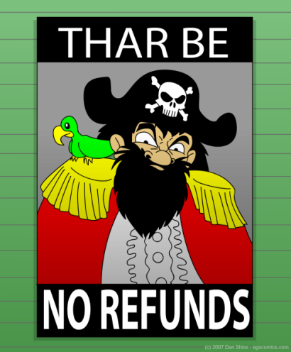
THERE IS A SIGN IN THE STORE THAT SAYS ‘NO REFUND’?
Generally, these signs are against the law:
- 'No refund'
- 'No refund on sale items'
- 'No refunds after seven days'
- 'Refunds on unworn items only'
- 'We will only exchange, repair or give credit notes'
Generally, you have a right to a refund when there is a major problem with something you bought. Stores cannot take away this right by claiming they have a ‘no refund’ policy or displaying a ‘no refund’ sign.
A store may display a sign saying ‘No refunds will be given if you have simply changed your mind’.

THE PRODUCT DOES NOT MATCH THE DESCRIPTION?
Generally, a product must match its description (for example, on the label or in a TV commercial).
Even if you inspected the product before buying it and could have noticed a difference between the product and its description, the product must still match that description.
If the product is significantly different from the description, this may be considered a major problem and you are entitled to a refund.

Example:
Nicki buys a scarf described as ‘woollen’ in the store’s promotional catalogue. When she gets home, she discovers the scarf is actually acrylic. The product does not match its description, so Nicki has the right to return it.

THE PRODUCT DOES NOT MATCH THE SAMPLE OR DEMO MODEL?
Generally, when you buy something based on a sample or demo model, the product must match that sample. The store must give you a reasonable amount of time to compare the product with the original sample, where available. If the product is significantly different from the sample or demo model, this may be considered a major problem and you are entitled to a refund.

Example:
Angelo orders a couch based on a sample of fabric. When his new couch arrives, it is a different colour from the sample. Angelo is entitled to return it and get a refund.

THERE IS A MAJOR PROBLEM WITH MY PRODUCT?
A problem must be major or unable to be fixed before you can ask the store for a refund or replacement. A major problem is one where:
- if you had known about the problem, you never would have bought the product
- the product is significantly different from a sample, description or demonstration model
- the product cannot do what you told the salesperson you needed it to do or what it is normally supposed to do, and this problem cannot be fixed quickly or easily, or
- the product is unsafe.
Even if there is a major problem with the product, you will not be able to return it if too much time has passed, or if you have destroyed or lost it, or if you have attached the product to something and it cannot be removed without damaging it.
If this happens, you can still keep the product and ask to be compensated for any drop in its value.
If a problem is not major and can be fixed in a reasonable time, you cannot demand a refund. The store can choose whether to repair the product, replace the product or provide a refund.

THE PRODUCT DOES NOT DO WHAT I ASKED FOR?
You can generally ask for a refund or replacement when a product does not do a specific job or achieve a specific purpose, if:
- before buying, you told the store or salesperson what you wanted the product to be able to do, and
- you relied on the store’s advice when choosing the product.
The problem with the product must be major or unable to be fixed.

Example:
Dylan tells a car dealer he wants a car that can tow his boat. The dealer sells him a car, saying it will do the job. That night Dylan reads the safety manual and discovers the new car cannot safely tow the type of boat that he owns. Dylan is entitled to return the car to the dealer.


WILL MY PRODUCT BE REPAIRED OR REPLACED?

REPAIRS
Generally, it is the store’s responsibility to return products to the manufacturer for repair. This may include products that are under warranty.
If the store cannot arrange repairs (for example, because the manufacturer does not have the necessary parts) or cannot do so within a reasonable time, you can:
- have the product fixed elsewhere and claim reasonable costs from the store that sold you the product, or
- ask for a refund or replacement.

Example:
Several buttons came off Rohan’s new shirt due to poor stitching. The tailor who made the shirt could not supply matching buttons. Rohan is entitled to ask for a replacement or refund.

REPLACEMENTS
If you are entitled to a replacement product, the store must provide a product that is identical, or of similar value. If this is not available, the store can choose to give you a refund or repair the product within a reasonable time.
Your refund and repair rights apply to the replacement product in the same way as the original product.

Example:
Maya buys a new mobile phone. Due to a problem, the store replaces it. If there is a problem with the replacement phone, Maya can take it back to the store. She has the same rights to a refund, replacement or repair as if it were a new mobile phone.





WHY DO I NEED TO KEEP MY RECEIPTS?
Your receipt is very important. It is the evidence you may need to prove things like:
- When you purchased an item
- Where you purchased an item
- How much you paid for that item

And a great deal more important information

If you purchased an item but do not have a receipt, you may be asked to show other proof of where the product was purchased. For example, you can do this by using a:
- lay-by agreement
- confirmation or receipt number provided for a telephone or internet transaction
- warranty card showing the supplier's or manufacturer's details and the date or amount of the purchase
- serial or production number linked with the purchase on the supplier's or manufacturer's database
- credit card statement
- copy or photograph of the receipt.
Sometimes you may need to provide more than one of these things to support your claim – for example, when a credit card statement does not clearly itemise the product.
Electronic copies and digital photographs are valid proofs of purchase; however, they must be clear enough to show the purchase details. It may be helpful to take a printed copy with you. If you are not able to do so, it is sufficient to provide the proof in electronic form.
If you cannot show where the product was purchased, the store or manufacturer is not obliged to accept your claim, but may still choose to do so.

Gifts

If you received a product as a gift, you have the same rights to a refund or return as a person who has bought the product directly. However, you must still be able to prove where the gift was purchased.

WHAT IS A WARRANTY?
Under the Australian Consumer Law (ACL), automatic consumer guarantees apply to many products and services you buy regardless of any other warranties suppliers sell or give to you. However, it is still important to understand how these warranties apply to goods or services you buy.

WHAT IS A WARRANTY?
A warranty is a voluntary promise offered by the person or business who sold the product or service to you. Once you buy the product or service, the promise becomes a right that can be enforced under the ACL.
Warranties are separate from your automatic consumer guarantees. The consumer guarantees which apply regardless of any warranties suppliers sell or give to you, apply for a reasonable time depending on the nature of the goods or services. This means consumer guarantees may continue to apply after the time period for the warranty has expired.

COMMON WARRANTIES
Businesses sometimes make extra promises or representations verbally or in writing generally about the quality or standard of a good. For example, they may refer to:
- the quality, state, condition, performance or characteristics of the good
- what the good can do and for how long
- the availability of servicing, supply of parts or identical goods.
If a manufacturer or supplier provides such a warranty, there is a consumer guarantee under the ACL that the manufacturer or supplier will comply with that warranty. If the supplier or manufacturer fails to comply with the warranty you will have rights against them under the consumer guarantees.

Example
You buy a book shelf and the sales person tells you that it can hold up to 100 kilograms. This is a statement about what the bookshelf can do and it must meet this standard.

WARRANTY AGAINST DEFECTS
Some businesses will also provide a warranty against defects, also called a manufacturer’s warranty. This is a representation to a consumer, made at or around the time that goods are supplied, that if the goods (or part of them) are defective, the business will:
- repair or replace goods (or part of them)
- resupply or fix a problem with services (or part of them)
- provide compensation to the consumer.
A warranty against defects is usually limited by time.
All suppliers, manufacturers and service providers that provide you with a warranty against defects must comply with that warranty. If they do not, you may bring an action against the person or business who provided the warranty, either under the ACL or for breach of contract.
A promise about what the supplier or manufacturer will do if something goes wrong can be a warranty against defects even if it is not provided in a formal document. Any material with writing on it could evidence a warranty against defects, for example wording on the packaging or on a label, if those words contain such a promise.
A warranty against defects is provided in addition to the consumer guarantees and does not limit or replace them.

EXAMPLE
You buy a motor vehicle that comes with a three-year or 100,000 km written warranty outlining what the manufacturer will do if there are certain problems with the vehicle. This is a warranty against defects.

WARRANTIES IN PLAIN LANGUAGE
From 1 January 2012, written warranties against defects must be in language that’s easy to read and understand and include:
- the name, business address, phone number and email address of the person or business giving the warranty
- what you must do to make a claim under the warranty, and what the person or business must do to honour the warranty
- a statement that the warranty is given in addition to consumer guarantees and cannot exclude them.

EXTENDED WARRANTIES OR CARE PACKAGES
Retailers sometimes offer to sell you an extended warranty or care package to extend the length of time of the manufacturer’s warranty. Some may tell you that an extended warranty provides extra protections you wouldn’t usually get. This isn’t necessarily true, as you automatically have consumer guarantees that suppliers must comply with, regardless of what they say or any warranties they offer.
You don’t have to buy an extended warranty – it is optional.
Suppliers risk breaching the law if they:
- put undue pressure on you or use unfair tactics to get you to buy an extended warranty
- mislead you into paying for the rights that you already have under the consumer guarantees.

DO YOUR RESEARCH BEFORE PAYING EXTRA FOR AN EXTENDED WARRANTY
Before buying an extended warranty, always ask the supplier to list what it gives you over and above your automatic consumer guarantees.

GUARANTEED CONSUMER RIGHTS AND WARRANTIES

- What is the name of the law that automatically provides you with guarantees on certain goods and services sold, hired or leased to you?
The name of the law that automatically provide you with guarantees is Australian Consumer Law (ACL).

- Give three examples of your guaranteed consumer rights when it comes to purchasing goods:
  - ______________________________________________________________________________________________________________________________________
  - ______________________________________________________________________________________________________________________________________
  - ______________________________________________________________________________________________________________________________________

- Do your guaranteed consumer rights count when purchasing second-hand goods? Explain your answer.
____________________________________________________________________________________________________________________________________________________________________________________________________________________________________________________________________________________________________

- What are sellers obliged to do when it comes to selling goods at auction? Why do you think this is the case?
__________________________________________________________________________________________________________________________________________________
______________________________________________________________________________________________________________________________________________________________________________________________________________________________________________________________________________________________________________________________________________________________________________________________________________________________________________________
__________________________________________________________________________________________________________________________________________________

- If I paid someone $45,000 for a car for my own personal use, do I have guaranteed consumer rights? Explain your answer.
____________________________________________________________________________________________________________________________________________________________________________________________________________________________________________________________________________________________________

- If the car is going to be mainly used for my business, do I have guaranteed consumer rights? Explain your answer.
____________________________________________________________________________________________________________________________________________________________________________________________________________________________________________________________________________________________________

- If your goods fail to meet the guarantee, who do you have rights against?
__________________________________________________________________________________________________________________________________________________

- What do they need to provide you with?
__________________________________________________________________________________________________________________________________________________

- Why should you always keep your receipt?
____________________________________________________________________________________________________________________________________________________________________________________________________________________________________________________________________________________________________

- Where can you go for more information about your guaranteed consumer rights?
__________________________________________________________________________________________________________________________________________________

- What is a warranty?
__________________________________________________________________________________________________________________________________________________
__________________________________________________________________________________________________________________________________________________

- How is a warranty separate from your automatic consumer guarantee?
____________________________________________________________________________________________________________________________________________________________________________________________________________________________________________________________________________________________________

- What does a manufacturer’s warranty protect you against?
____________________________________________________________________________________________________________________________________________________________________________________________________________________________________________________________________________________________________

- What can you do if the manufacturer does not comply with the conditions of the warranty?
____________________________________________________________________________________________________________________________________________________________________________________________________________________________________________________________________________________________________

- What must warranties from January 1, 2012 have included?
____________________________________________________________________________________________________________________________________________________________________________________________________________________________________________________________________________________________________

- What is an extended warranty?
__________________________________________________________________________________________________________________________________________________
__________________________________________________________________________________________________________________________________________________

- I am purchasing a big screen TV. Do I have to buy an extended warranty? Explain your answer.
__________________________________________________________________________________________________________________________________________________
__________________________________________________________________________________________________________________________________________________

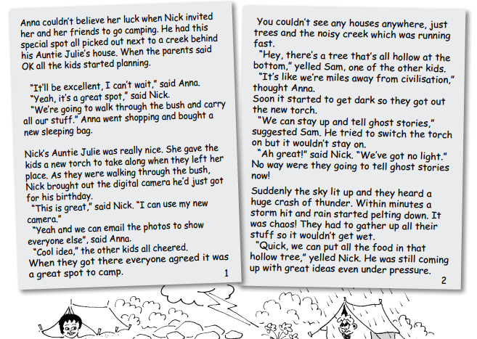
CAMP CHAOS
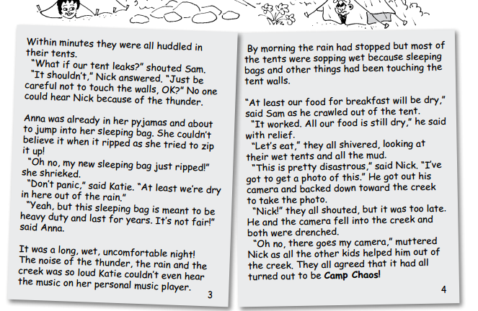

CAMP CHAOS QUESTIONS
- What went wrong with the items that the children took on the camping trip?
  - Tent _________________________________________________________________________________________________________________________________________________________________________________________________________
  - Camera _________________________________________________________________________________________________________________________________________________________________________________________________________
  - Sleeping Bag _________________________________________________________________________________________________________________________________________________________________________________________________________
  - Torch _________________________________________________________________________________________________________________________________________________________________________________________________________
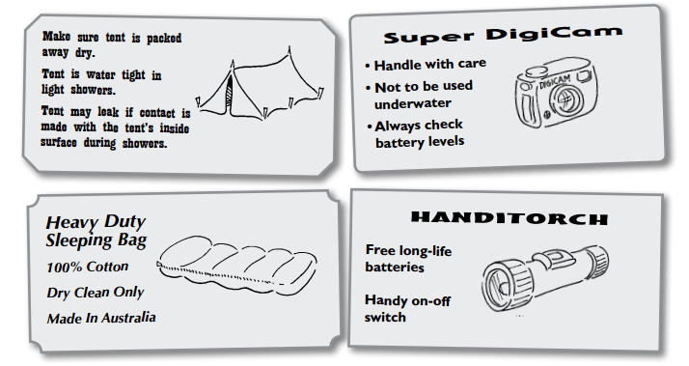

- Do they have a right to take any of the items back to the shop? Complete the following table
 | YES/NO | WHY?
TENT
CAMERA
SLEEPING BAG
TORCH

CONSUMER POWER – ADVICE LINE
- Lee’s parents gave her money to buy a pair of really great coloured jeans to go with the jacket that she got for her birthday. She didn’t take the jacket when she went shopping. Seeing the jeans with the jacket now, she doesn’t think they go together. Is she entitled to a refund or exchange? Explain your answer.
_____________________________________________________________________________________________________________________________________________________________________________________________________________________________________________________________________________________________________________________________________________________________________________
- Your mother buys a snack for your three-year-old brother. The snack makes him very ill and your mother said the snack had a terrible smell. Your mother tries to find our why he became ill so she can prevent this happening to any other children. Can you suggest what she should do? Who might she talk to?
_____________________________________________________________________________________________________________________________________________________________________________________________________________________________________________________________________________________________________________________________________________________________________________

- Anna and Phillip got new mountain bikes last week from the same shop – same brand and everything. They use them after school. Phillip’s bike is OK but Anna’s gears are no longer working. What can Anna do?
_____________________________________________________________________________________________________________________________________________________________________________________________________________________________________________________________________________________________________________________________________________________________________________

- Shane decided to be helpful. He put his new woollen jumper in the washing machine – with disasterous results. It shrank. If he had read the label, he would have seen that his jumper should have been washed by hand. Is there anything Shane can do?
_____________________________________________________________________________________________________________________________________________________________________________________________________________________________________________________________________________________________________________________________________________________________________________

LING’S FISH SHOP

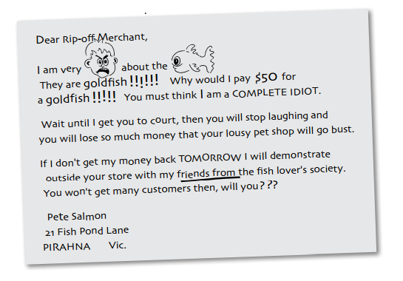
- Read the following letter of complaint:

- What is wrong with the letter?
The letter is informal and it does not have a proper structure. He is threatening the business owner. Also uses rude language.

- Re-write a better version of the letter. Key facts to help:
  - The owner of the pet shop is Mrs Emma Ling
  - You ordered a rare Patagonian Rainbow Fish which usually costs $50
  - You were sold a Common Goldfish which usually sells for $2
  - You were still charged for the Goldfish
  - You bought the fish last Saturday
  - You know it is your consumer right to ask for a refund, exchange or credit note.
Include the following in your letter:
  - Why you are writing
  - What happened
  - When you bought the product
  - What you want to happen
  - How much you paid
  - What you know about your rights and responsibilities
  - If this is not resolved, you will contact Consumer Affairs Victoria

Re-Write your letter here:

Dear Mrs Emma Ling,

I am writing to you regarding my recent purchase made last Saturday from your fish shop. First of all I am very disappointed as I ordered a rare Patagonian Rainbow fish which is priced $50 but I was sold a common gold fish that was worth $2.

I am requesting for a refund tomorrow or else there will be consequences for what happened.

Pete Salmon,
21 Fish Pond Lane
PIRAHNA, VIC

