The samurai
Warriors were influential throughout Japanese history but they gained special importance during feudal times. Under feudalism, society was based on military power. Although the daimyo were powerful warlords, their power depended on the fighting skills of the samurai under their control. These warriors swore an oath of loyalty to their daimyo. They controlled his lands for him when he was away in the capital and fought on his behalf when he came into conflict with other daimyo.
The daimyo and samurai
During the Classical and shogunate periods in Japan, the emperors found it increasingly difficult to control all of the country. Although the daimyo swore allegiance to the emperor, many of them were actually more powerful than the emperor. They had their own power bases in the provinces and had large numbers of vassals in their service. At first the men who served them were members of their own families but the daimyo soon gathered vassals who were not related to them by blood. These men were known as samurai, which means ‘a person who serves a noble’. Later, some of the more powerful vassals challenged the authority of their lords and used military force to seize lands for themselves. They too became daimyo and built alliances by granting land to their followers.
The warrior code
A true samurai had to follow the warrior code of bushido. His first duty was to be loyal and obedient to his daimyo lord. A samurai was expected to defend to the death his own family honour and the honour of his daimyo. Under bushido, a samurai was required to learn seven martial arts: archery, the spear, fencing, horse riding, military strategy, use of firearms and techniques of jujutsu.
The Buddhist religion encouraged the samurai to adopt an attitude of ‘carelessness’ with life through full control of body and mind. Samurai practised special meditation, so they would know what to do in battle without being confused by thoughts or feelings.
Rank
Hierarchy and rank were very important in Japanese society. Some daimyo had higher status than others due to their noble ancestry or the value of their land. There were also ranks within samurai, just as there is in an army. It was possible to advance in rank, and a daimyo might reward a loyal samurai with promotion or a grant of land.
Source 1 - A scene from the film The Last Samurai, set in the late nineteenth century, when the influence of the samurai was in decline
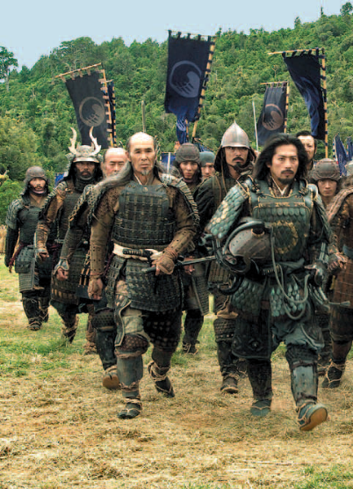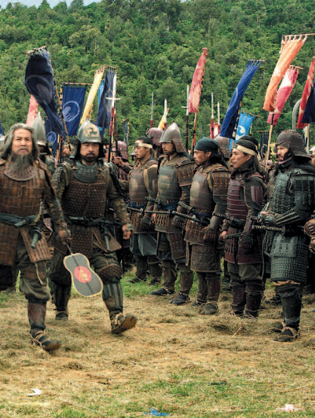

Source 2- A beautifully crafted sword from the Kamakura period
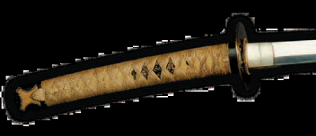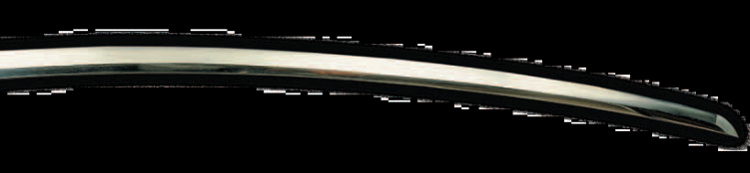

Samurai life
Samurai boys were raised to become professional soldiers in a lord’s service. Soon after they were born, they were given a small sword in a special ceremony. From a very early age they were taught archery, horse riding and sword fighting as well as unarmed combat. They learned these skills not only from their fathers and senior samurai but often by attending martial arts schools. They had to learn to read and write as well, for they were expected to be educated people who could assist their lord in the governing of his domain. Their two main responsibilities were often described as ‘the pen and the sword’. A samurai woman was also required to demonstrate courage and honour. However, instead of military training, the emphasis in a girl’s education was on becoming a faithful wife and mother.
Her education prepared her for managing a household as a future samurai wife. When her husband was away at war, she was expected to keep everything in order until he returned.

Source 3 - Samurai armour varied greatly during the shogunate period.
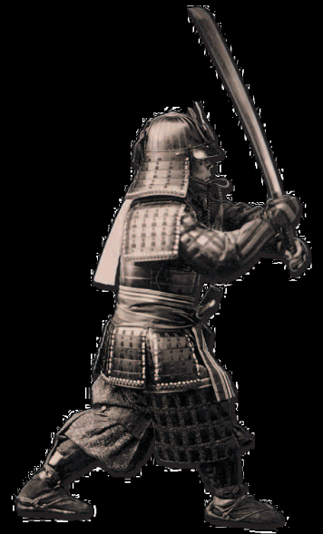
Ronin
If a daimyo lost his land in battle or had his domain confiscated by the government, his samurai became masterless. They were considered ronin or ‘wave men’ floating on the sea of life. At various times in history, Japanese society had many of these unemployed warriors.
Some of them simply ran away to begin a new life. Others joined new commanders or became farmers. But some ronin became bandits or mercenary soldiers who terrorised the countryside.

Source 5 - The tale of the 47 ronin — a true story
At Japanese New Year, it was the custom for the emperor to send greetings to the court of the shogun, Japan’s military ruler. The shogun appointed Lord Asano as one of his representatives to attend the ceremonies. Unaware of the proper behaviour and dress required, Lord Asano asked Lord Kira for advice, but was greatly embarrassed when the information proved to be false. Outraged, Lord Asano drew his sword and attacked Lord Kira in the shogun’s palace. This was an extremely serious offence and the shogun ordered Asano to commit suicide. After saying goodbye to his family and faithful samurai, Lord Asano plunged a short sword into his stomach and cut it open in the ritual suicide called seppuku. In the world of the warrior, this was an honourable way to die. Having lost their master, Lord Asano’s samurai were now ronin and 47 of them plotted revenge. It took them two years of planning, but finally one snowy night in 1703, they attacked and killed Lord Kira. The shogun was furious because he had personally forbidden revenge. He demanded that all 47 ronin commit seppuku. Having avenged their dead master, the ronin all did as the shogun ordered. By committing seppuku, they paid the highest debt both to their lord and to their ruler.
Source 4 - The graves of the 47 ronin
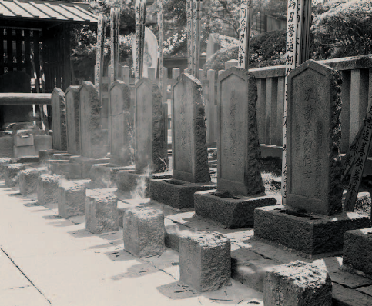

REFERENCE: History Alive 8 for the Australian Curriculum

