PART 2. GENERATE DESIGN IDEAS
A) RESEARCH- Answer the following questions
Reference: - Page 111 Text book
1. a) How many serves of vegetables should you eat daily?
b) Complete the following table
Vegetable | One Equal Serve of Vegetable
Potato | 1 potato
Cooked peas, lentils or dried beans | ½ cup
Cooked mixed vegetables | ½ cup
Salad Vegetables | 1 cup

2. List a wide variety pf ingredients that could be suitable to use as toppings on a pizza.
Sauce | Vegetables | Meats | Cheese | Herbs | Flavourings | Other
Hot sauce | Hot banana peppers | Chicken | Extra Cheese | Basil | Mayo
Garlic sauce | Olives | Ham | Fetta Cheese | Oregano | Sour cream
Italian Sauce | Pineapple | Pepperoni | Parmesan Cheese | Thyme | Yoghurt
BBQ Sauce | Mushrooms | Salami | Four cheese blend | Garlic
Chipotle BBQ Sauce | Onion | Roasted chicken | Mozzarella | Dried Chilli Powder
Sweet Chilli Sauce | Capsicum | Bacon | Provolone Cheese | Parsley

3. Select one of the vegetables you have identified in your table above.
Use the following website to answer the questions relating to your chosen vegetable.
http://www.freshforkids.com.au/ Click on the purple Fruit and Veg drop down box and select vegetables.
- Name the vegetable you are researching.
Onion
- Include a picture of your vegetable.
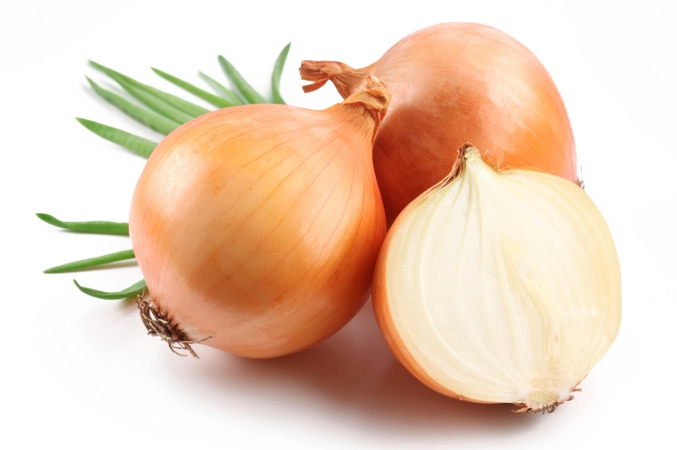
- What months of the year is your vegetable available?

All year.
- Choose one did you know fact.
It is your acid which makes you cry when you peel us.
- Why is your vegetable good to eat?
We have no fat and most types have around 125kJ/100g.
- Explain how you know if your vegetable is ripe to eat.
Select those which are firm, well-shaped with small necks and dry, paper skin.
- What is the classification of your vegetable? Use the following website to help.
(http://www.vegetables.co.nz/vegetable_know_how/classifications.asp)
Bulbs

4. Identify the four sections of the Healthy Eating Pyramid and list three examples of foods contained in each section. Page 59-61 textbook. You might like to present your answer in the shape of a pyramid or a table.
Section | Examples
1 | Avocadoes, butter and coconut oil
2 | Milk, meat and nuts
3 | Bread, pasta and oatmeal
4 | Watermelon, pineapple and capsicum

B) DESIGN OPTIONS
1. Design two pizzas using some different ingredients in each one. These should be drawn, in colour, with each ingredient used clearly labelled on your design. Use an A4 page for each design. Give each pizza design an interesting name.
For example:
