IF YOU HAVE COMPLETED ALL ACTIVITIES, THE FOLLOWING ACTIVITIES MAY ENABLE YOU TO ACHIEVE A ‘B’ OR ‘A’ GRADING. THESE MUST BE COMPLETED IN ORDER.
Show your work to the teacher before you move onto the next task.

B Task
Problem – while preparing for your friends to come over, you realise that you are not going to have time to prepare the pizza base from scratch, even though it is simple. Find two alternative products that you could use in place of a traditional pizza base and compare the positive and negative factors associated with the use of each.

Alternative 1:_________________ Alternative 2:___________________

Which alternative would make the most suitable replacement?
______________________________
Discuss, in detail, why you have chosen this option rather than the other.
______________________________________________________________________
______________________________________________________________________
______________________________________________________________________
______________________________________________________________________
______________________________________________________________________
______________________________________________________________________
______________________________________________________________________
______________________________________________________________________
______________________________________________________________________
______________________________________________________________________

Congratulations you have finished Task ‘B’, make sure you show your work to the teacher before moving onto the next task.

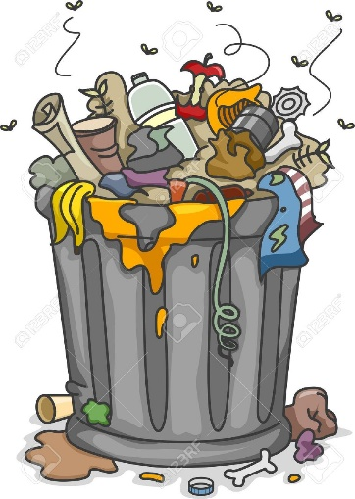
Task ‘A’- FOOD WASTAGE
Question
You have been asked to prepare a short article for the school newsletter to highlight the problems of Food Waste in your community and ways to prevent food waste.
You can use the following information to help your research.
http://www.worldbank.org/en/news/press-release/2014/02/27/food-loss-waste-barrier-poverty-reduction
http://www.foodwise.com.au/foodwaste/food-waste-fast-facts/

Consider the following points to include in your article
- What is food waste?
- How much food do Australian households throw out each week/year?
- Why is food wasted?
- What are the problems associated with food wasted?
- How can food waste be prevented?

If you have included information from other websites you must include the web address for that information.
