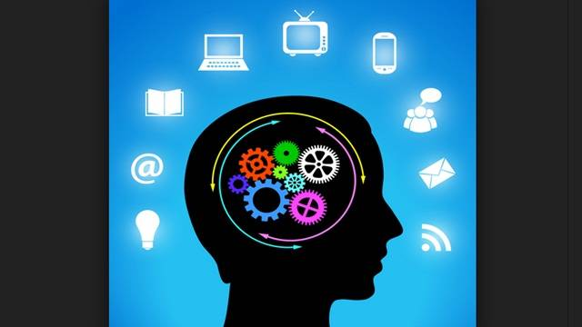






MY LIFE WITHOUT TECHNOLOGY!

I am Vishnu Sivakumar, I live in Australia but was born and bought up in India, a place where the technological development hasn’t come about yet. However, I was very involved in technology from when I was in grade 2, the first IT class, in which they taught us about how to save a file and create new folders. I was fascinated by the fact that we were able to save a file many days ago and be able to see it after many days. That’s when the admiration or passion for technology started, even with the lack of technology in my house in India, I was able to build my interest and develop my knowledge. Every Tuesday period three, I had computer classes, the whole week I used to look forward for that class.

Fortunately, I was given the opportunity to further enjoy my passion; my parents had bought my sister and me to Australia. I saw this place as a land of opportunity. My first school was Dandenong Primary School, I was able to explore and use all the different types of computers, laptops, IPad on a daily basis. Therefore, I became more susceptible to technology addiction, hence, I did get addicted. My parent had bought me a Mac and an Ipad to use at home, as part of finding more new knowledge.

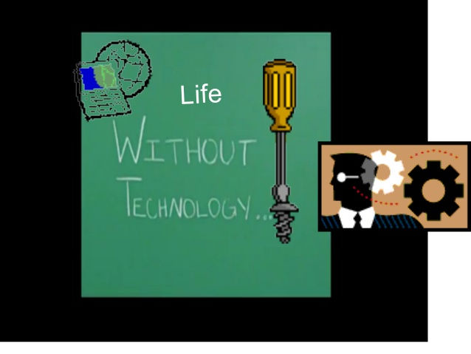
Unfortunately my father lost interest in his job and wanted to return back to India. This is when my life had a turning point, the place wasn’t new to me, and I was familiar. However, the fact that there was no technology to feed my passion. My parents weren’t willing to equip the house with Internet, as the need for it didn’t exist. Even though, I tried to convince myself to live happily with what I had, I just couldn’t sacrifice my desire.

As a child from one of the typical Asian countries, parents had more say in my education then myself. I decided keep aside my desires and satisfy my parents and fulfill their dreams to see me as an engineer. I know my passion for learning about technology wouldn’t fade away no matter how old I grow. But fulfilling my parents’ dreams can only be done now. Hence, I am fulfilling my parents dreams now, later I will spend the rest of my life to work with my passion.

WRITING ANTHOLOGY PERSONAL PIECE: MY ADDICTIVE HOBBY

In our current society, technology has become a part of life and it is ultra-common for teenagers to continuously chat with their restless friends. These days even young infants know how type the password on the phone and browse various apps. Who knows what the future is. Similar to the modern world even my life has been impacted by technology and it has of course affected me in both ways good and bad.

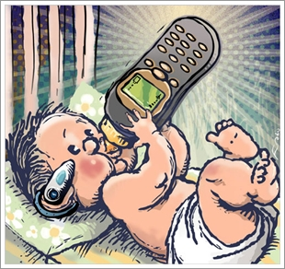
A recent survey proves that an average teenager spends at least five hours a day on different pieces of technology and the most popular out of them is phone and even I spend ‘A LOT’ of time on my entertaining phone, in fact I spend more than five hours a day just on my laptop. The main purpose of my time on phone is to message my friends or peers, however I shall never forget the games I play. On my laptop I mostly study. As you can see right now, I have already had so much of impact. After I come home, it is my routine to have free time until 5pm, and during this period I would enjoy myself by watching my favourite series ‘The Flash’ or play video games on my computer or as another option I would watch news. After this I usually study where I again make use of a laptop. I believe that a world without technology is a world without light. I use technology to educate myself, know what is happening around the globe and keep myself engaged.

In parent’s point of view, technology is a bad and spoils their children’s education, well this is in most case. My parents utterly hate to see my look at my phone after 5pm. If I need access to any piece of technology I have to go to the kitchen use it and return it to the same place and then go, which is just hopeless. I feel that this is not a good opinion towards technological resources. They must understand that it can be good and bad.
No matter what but it is my addictive hobby and I will not change myself for any misunderstandings. Technology is certainly part of my life and so far I have had more positive effects than negative effects. It is my life and I must decide what is good for me more than my parents.

INSTRUCTIONAL ESSAY

Feel like out-dated? Don’t know what is going on around you? It does happen, today’s world is very dependent on technology and without this, not just you but everyone is behind in time. In this modern world you can ask someone about what their friend did over the weekend, which is on the other side of the globe, and they can even say at what time they did it! Got to admit, this is fascinating. You may think it is boring to just be gazing at a phone for sickening segments of time but this is simply not the case, it can be immensely interesting indeed. Today is just another day on how you can become more modern.
Volume 1:
As the start for your ‘modern’ adventure, throw your old phone out and buy a trendy phone such as I-phone 6 or a Samsung s7. It will be very expensive and take this as a warning as you will have to spend lots of money as part of becoming more modern. Be mindful, of the data allowance included in your sim only plan, you will need at least six gigabytes. Phone is the key to a modern world.
Volume 2:
There are many social networks and the most famous one out of them is ‘Facebook’, this allows you to post your status, pictures of your wish, video chat with your friends or even just message. Download the Facebook app from ‘Play store’ or ‘App store’ (depending on your phone software). Create an account and just update your private page. Finally, don’t forget to MAKE FRIENDS!
Volume 3:
If it was your habit to listen to your radio or cassettes, erase it this very moment. From here on, it is only from your phone that you have access to music. Matter of fact, it is actually convenient as you can listen to music anytime, anyplace as long as you have your friendly phone with you. You can download music apps and an open suggestion would be spotify. If you have an I-phone I would recommend you to buy a pair of beats headphones, this will give you ultimate music experience.
Volume 4:
As part of entertainment, phone plays a major role, it is up to you to make use of the benefits. A great source would be the app store or play store, this allows you to download apps for free as well as money. As a start, you can download games and you should especially download Asphalt 8, it is a fantastic car racing game for youngsters that give you real life driving experience. If you are a ‘chess champion,’ then what are you waiting for? DOWNLOAD CHESS!
Phone is a way to get you moving, in other words it is a key to another world. So now instead of having no idea what to do when you are bored you can cheer yourself up by spending time on your ‘friendly’ phone.

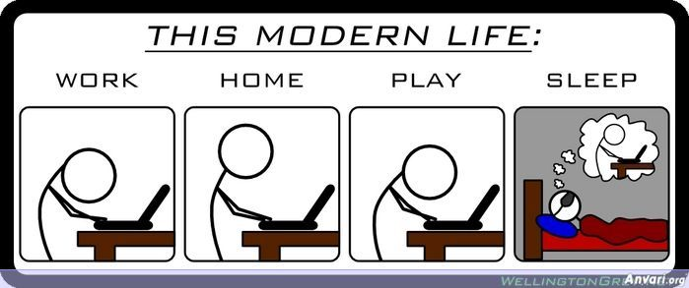
WRITING ANTHOLOGY POTERY

Free verse:
In near future
Would my attentive body
Be filled with wires instead of nerves?
Diluted oil
Rather than pure red blood

Will there be pipes
Instead of calcium brimmed bones?
A miniature memory chip
In place of my BRAIN!

What if my pumping heart
Is replaced with a rechargeable battery?
Who knows?
How technology will change our lives.

Cinquain:
Terrorists
without guns
inside your systems
their neatly planted viruses
sleeping

Haiku:
My poor tired eyes
Versus this bright glaring screen
I must continue

Acrostic:
T – technical
E – Entertainment
C – Computer
H – Hard drive
N – Numerical
O – Online
L – Logitech
O – Operating system
G – Gigabytes
Y –

ARGUMENTATIVE ESSAY: SHOULD TECHNOLOGY BE ALLOWED IN CLASSROOMS?

“Technology can become the ‘wings’ that will allow the educational world to fly further and faster than ever before – if we allow it.” Technology has seriously caught the attention of mass media and nowadays it has become a major question whether to allow any piece of technology in classrooms. There are a few disadvantages of the use of tech – in classrooms, however advantages outrun them. While every channel considers its duty to remind people the damage caused by technology, they fail to remind them the benefits and the future advantages of tech. For example, how do channels inform the public about technology? THROUGH THE USE OF TECHNOLOGY! It is important that we educate the younger generation using technology rather than restricting the use of it and where do students spend most of their time? In schools. Yet there are some schools that are delaying this imminent future of using technology in the classroom as the valuable learning tool it is.

Integrating technology in education everyday helps students stay engaged and it is a fact that today’s students love technology so they are sure to be interested in learning is they can use the tools they love. A classroom is a place to learn for six-hours and fifteen minutes a day and the first requirement for learning is interest. Especially, students cannot be in a place where they have to write not because they are interested but they have no other option.

5 FACTS ABOUT TECHNOLOGY

- There are 6.8 billion people on the planet and 4 billion people use a mobile phone. But only 3.5 billion of them use a toothbrush.
- Ninety one percent of all adults have their mobile phone within arm’s reach every hour of every day.
- Microsoft and apple have one not so obvious thing in common- they were all started in a garage.
- Of the 60 million emails that are sent on a daily basis, 97 percent are considered spam
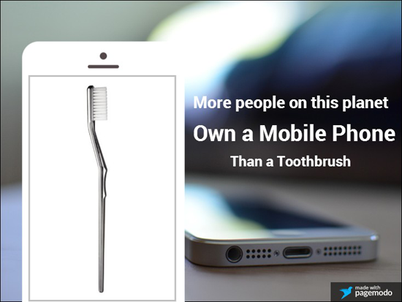
- The man known as the Father of Information Theory, Claude Shannon, invented the digital circuit – the foundation of the magic that provides us all access to the Internet today - during his master’s degree program, when he was just 21 years old.

UNITS OF MEASUREMENT

1 Bit = Binary Digit
8 Bits = 1 Byte

1000 Bytes = 1 Kilobyte
1000 Kilobytes = 1 Megabyte
1000 Megabytes = 1 Gigabyte
1000 Gigabytes = 1 Terabyte
1000 Terabytes = 1 Petabyte
1000 Petabytes = 1 Exabyte
1000 Exabyte = 1 Zettabyte
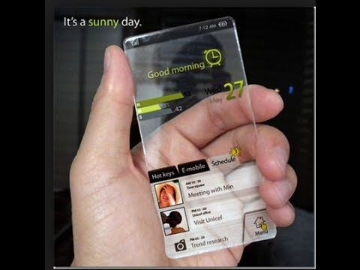
1000 Zettabytes = 1 Yottabyte
1000 Yottabytes = 1 Brontobyte
1000 Brontobytes = 1 Geopbyte

BIBLIOGRAPHY

- http://didyouknow.org/fastfacts/technology/
- http://myessaypoint.com/the-importance-of-technology-in-education
- http://cooltext.com/Render-Image?RenderID=184549235000646&LogoId=1845492382
- http://www.websitemagazine.com/content/blogs/posts/archive/2014/05/18/23-cool-tech-facts.aspx
- https://au.pinterest.com/pin/511651207642288012/
- http://www.build-creative-writing-ideas.com/free-creative-writing-prompts-technology.html

