Shots | Type of Shots | Description
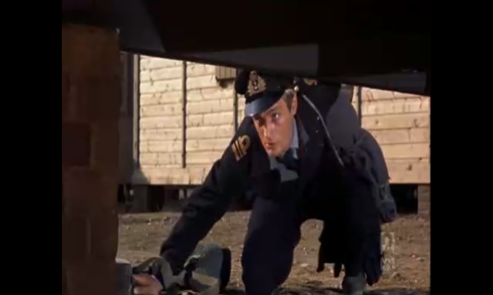 | Close - up Shot | This shot is taken when James garner looks under the huts to check if he can escape.
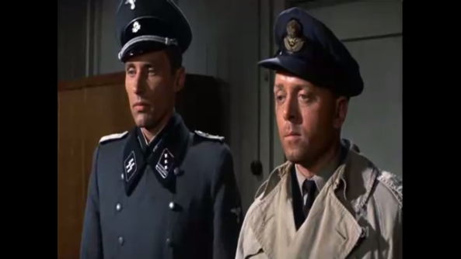 | Close – up Shot | This is when roger had to report to the main office.
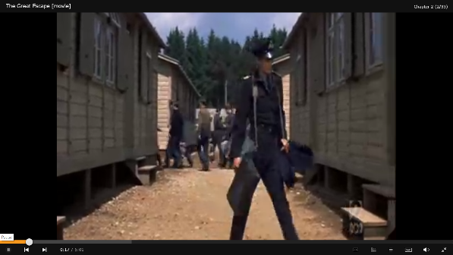 | Long Shot | This is also when James Garner was looking for a way to escape.
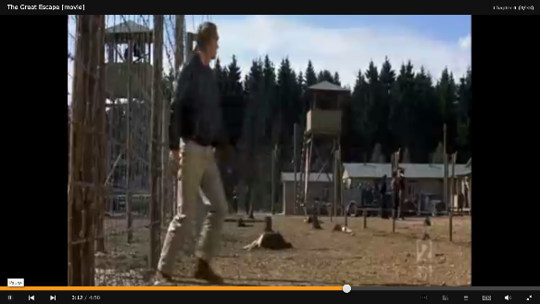 | Long Shot | When Hilts is testing out his theory of the blackout zone.
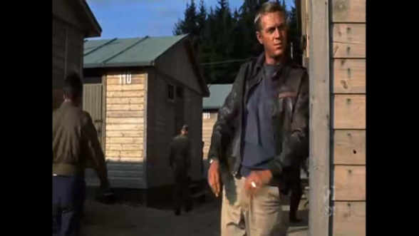 | Medium Shot | When Hilts is just looking around the area.
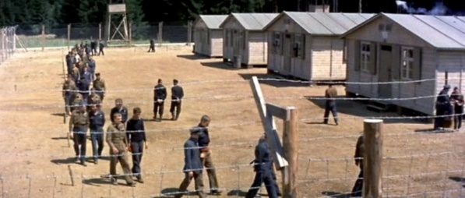 | Long Shot | When everyone is being directed to their places
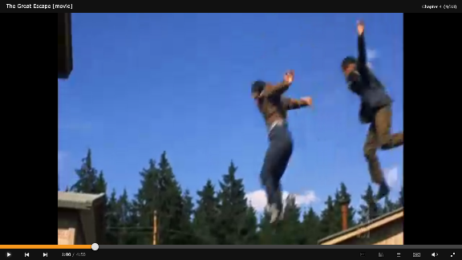 | Tracking Shot | When a few people try to escape through the trucks
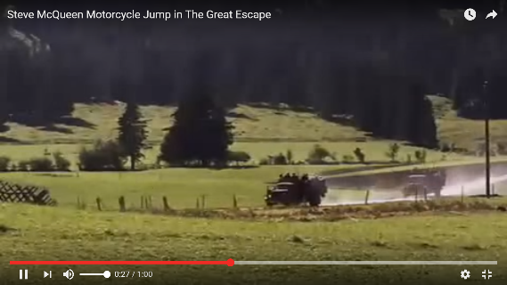 | Panning Shot | When the Hilts is being chased by the soldiers.
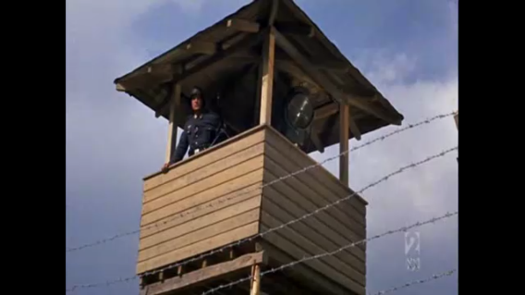 | Tilt – up Shot | The watch towers that are surrounding the army base.

