2015

VCE
Further Mathematics
Trial Examination 1



Kilbaha Multimedia Publishing  PO Box 2227  Kew Vic 3101  Australia | Tel: (03) 9018 5376  Fax: (03) 9817 4334  kilbaha@gmail.com  http://kilbaha.com.au

IMPORTANT COPYRIGHT NOTICE

- This material is copyright. Subject to statutory exception and to the provisions of the relevant collective licensing agreements, no reproduction of any part may take place without the written permission of Kilbaha Multimedia Publishing.
- The contents of this work are copyrighted. Unauthorised copying of any part of this work is illegal and detrimental to the interests of the author.
- For authorised copying within Australia please check that your institution has a licence from http://copyright.com.au. This permits the copying of small parts of the material, in limited quantities, within the conditions set out in the licence.

Reproduction and communication for educational purposes. The Australian Copyright Act 1968 (the Act) allows a maximum of one chapter or 10% of the pages of this work, to be reproduced and/or communicated by any educational institution for its educational purposes provided that educational institution (or the body that administers it) has given a remuneration notice to Copyright Agency Limited (CAL) under the Act.

For details of the CAL licence for educational institutions contact
CAL, Level 15, 233 Castlereagh Street, Sydney, NSW, 2000
Tel: (02) 9394 7600
Fax: (02) 9394 7601
Email: info@copyright.com.au

- All of these pages must be counted in Copyright Agency Limited (CAL) surveys

- This file must not be uploaded to the Internet.

These questions have no official status.

While every care has been taken, no guarantee is given that these questions are free from error. Please contact us if you believe you have found an error.

CAUTION NEEDED!
All Web Links when created linked to appropriate Web Sites. Teachers and parents must always check links before using them with students to ensure that students are protected from unsuitable Web Content. Kilbaha Multimedia Publishing is not responsible for links that have been changed in this document or links that have been redirected.

VICTORIAN CERTIFICATE OF EDUCATION
2015

FURTHER MATHEMATICS

Trial Written Examination 1 (Facts, skills and applications)

Reading time: 15 minutes
Total writing time: 1 hour 30 minutes

MULTIPLE-CHOICE QUESTION BOOK

Structure of book

Section | Number of  questions | Number of questions  to be answered | Number of modules | Number of modules to be answered | Number of marks
A | 13 | 13 |  |  | 13
B | 54 | 27 | 6 | 3 | 27
 |  |  |  |  | Total 40

- Students are permitted to bring into the exam room: pens, pencils, highlighters, erasers, sharpeners, rulers, one bound reference, one approved graphics calculator or approved CAS calculator or CAS software and, if desired, one scientific calculator. Calculator memory DOES NOT need to be cleared.
- Students are NOT permitted to bring into the examination room: blank sheets of paper and/or white out liquid/tape.

Materials supplied
- Question book of 57 pages.
- Answer sheet for multiple-choice questions.
- There is a sheet of miscellaneous formula supplied.
- Working space is provided throughout the book.

Instructions
- Detach the formula sheet from the book during reading time.
- Check that your name and student number as printed on your answer sheet for multiple-
choice questions are correct, and sign your name in the space provided to verify this.
- Unless otherwise indicated, the diagrams in this book are not drawn to scale.

At the end of the examination
- You may keep this question book.

Students are NOT permitted to bring mobile phones and/or any other unauthorised electronic devices into the examination room.
© KILBAHA PTY LTD 2015
VCE FURTHER MATHEMATICS 2015
Trial Written Examination 1
ANSWER SHEET

NAME: ______________________________________________________

STUDENT ______________________________________________________
NUMBER

SIGNATURE ______________________________________________________

Instructions

- Write your name in the space provided above.

- Write your student number in the space provided above. Sign your name.

- Use a PENCIL for ALL entries.
If you make a mistake, ERASE it - DO NOT cross it out.

- Marks will NOT be deducted for incorrect answers.

- NO MARK will be given if more than ONE answer is completed for any question.

- All answers must be completed like THIS example.

A | B | C | D | E

VCE FURTHER MATHEMATICS 2015
Trial Written Examination 1
ANSWER SHEET

NAME: ______________________________________________________

STUDENT ______________________________________________________
NUMBER

SIGNATURE ______________________________________________________

Instructions

- Write your name in the space provided above.

- Write your student number in the space provided above. Sign your name.

- Use a PENCIL for ALL entries.
If you make a mistake, ERASE it - DO NOT cross it out.

- Marks will NOT be deducted for incorrect answers.

- NO MARK will be given if more than ONE answer is completed for any question.

- All answers must be completed like THIS example.

A | B | C | D | E

Section A

1 | A | B | C | D | E
2 | A | B | C | D | E
3 | A | B | C | D | E
4 | A | B | C | D | E
5 | A | B | C | D | E
6 | A | B | C | D | E
7 | A | B | C | D | E
8 | A | B | C | D | E
9 | A | B | C | D | E
10 | A | B | C | D | E
11 | A | B | C | D | E
12 | A | B | C | D | E
13 | A | B | C | D | E
Please turn over . . .
VCE FURTHER MATHEMATICS 2015
Trial Written Examination 1
ANSWER SHEET
Section B
(Shade the boxes of the three modules selected. There are a total of six from which to choose)

 | Module 1  Number patterns | 1 | A | B | C | D | E
 | Module 1  Number patterns | 2 | A | B | C | D | E
 | Module 1  Number patterns | 3 | A | B | C | D | E
 | Module 1  Number patterns | 4 | A | B | C | D | E
 | Module 1  Number patterns | 5 | A | B | C | D | E
 | Module 1  Number patterns | 6 | A | B | C | D | E
 | Module 1  Number patterns | 7 | A | B | C | D | E
 | Module 1  Number patterns | 8 | A | B | C | D | E
 | Module 1  Number patterns | 9 | A | B | C | D | E
 | Module 2  Geometry and trigonometry | 1 | A | B | C | D | E
 | Module 2  Geometry and trigonometry | 2 | A | B | C | D | E
 | Module 2  Geometry and trigonometry | 3 | A | B | C | D | E
 | Module 2  Geometry and trigonometry | 4 | A | B | C | D | E
 | Module 2  Geometry and trigonometry | 5 | A | B | C | D | E
 | Module 2  Geometry and trigonometry | 6 | A | B | C | D | E
 | Module 2  Geometry and trigonometry | 7 | A | B | C | D | E
 | Module 2  Geometry and trigonometry | 8 | A | B | C | D | E
 | Module 2  Geometry and trigonometry | 9 | A | B | C | D | E
 | Module 3  Graphs and relations | 1 | A | B | C | D | E
 | Module 3  Graphs and relations | 2 | A | B | C | D | E
 | Module 3  Graphs and relations | 3 | A | B | C | D | E
 | Module 3  Graphs and relations | 4 | A | B | C | D | E
 | Module 3  Graphs and relations | 5 | A | B | C | D | E
 | Module 3  Graphs and relations | 6 | A | B | C | D | E
 | Module 3  Graphs and relations | 7 | A | B | C | D | E
 | Module 3  Graphs and relations | 8 | A | B | C | D | E
 | Module 3  Graphs and relations | 9 | A | B | C | D | E

Please turn over . . .
VCE FURTHER MATHEMATICS 2015
Trial Written Examination 1
ANSWER SHEET
Section B
(Shade the boxes of the three modules selected. There are a total of six from which to choose)

 | Module 4  Business-related mathematics | 1 | A | B | C | D | E
 | Module 4  Business-related mathematics | 2 | A | B | C | D | E
 | Module 4  Business-related mathematics | 3 | A | B | C | D | E
 | Module 4  Business-related mathematics | 4 | A | B | C | D | E
 | Module 4  Business-related mathematics | 5 | A | B | C | D | E
 | Module 4  Business-related mathematics | 6 | A | B | C | D | E
 | Module 4  Business-related mathematics | 7 | A | B | C | D | E
 | Module 4  Business-related mathematics | 8 | A | B | C | D | E
 | Module 4  Business-related mathematics | 9 | A | B | C | D | E
 | Module 5  Networks and decision mathematics | 1 | A | B | C | D | E
 | Module 5  Networks and decision mathematics | 2 | A | B | C | D | E
 | Module 5  Networks and decision mathematics | 3 | A | B | C | D | E
 | Module 5  Networks and decision mathematics | 4 | A | B | C | D | E
 | Module 5  Networks and decision mathematics | 5 | A | B | C | D | E
 | Module 5  Networks and decision mathematics | 6 | A | B | C | D | E
 | Module 5  Networks and decision mathematics | 7 | A | B | C | D | E
 | Module 5  Networks and decision mathematics | 8 | A | B | C | D | E
 | Module 5  Networks and decision mathematics | 9 | A | B | C | D | E
 | Module 6  Matrices | 1 | A | B | C | D | E
 | Module 6  Matrices | 2 | A | B | C | D | E
 | Module 6  Matrices | 3 | A | B | C | D | E
 | Module 6  Matrices | 4 | A | B | C | D | E
 | Module 6  Matrices | 5 | A | B | C | D | E
 | Module 6  Matrices | 6 | A | B | C | D | E
 | Module 6  Matrices | 7 | A | B | C | D | E
 | Module 6  Matrices | 8 | A | B | C | D | E
 | Module 6  Matrices | 9 | A | B | C | D | E

Please DO NOT fold, bend or staple this form

FURTHER MATHEMATICS

Written examinations 1 and 2

FORMULA SHEET

Directions to students

Detach this formula sheet during reading time.

This formula sheet is provided for your reference.

FURMATH EX 1&2 2
Further Mathematics Formulas

Core: Data analysis

standardised score: 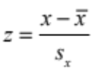

least squares line: 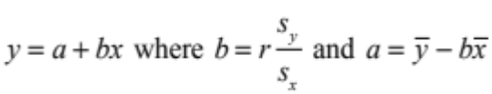

residual value: residual value = actual value – predicted value

seasonal index: 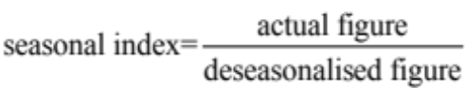

Module 1: Number patterns

arithmetic series: 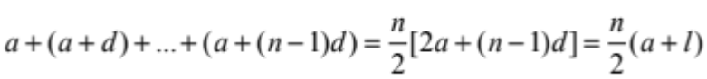
geometric series: 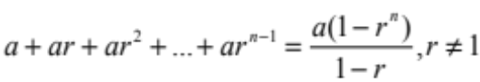

infinite geometric series: 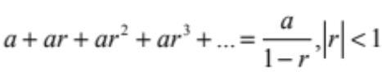

Module 2: Geometry and trigonometry
area of a triangle: 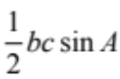

Heron’s formula: 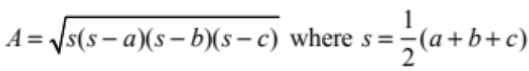

circumference of a circle: 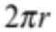

area of a circle: 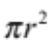

volume of a sphere: 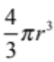
surface area of a sphere: 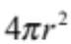

volume of a cone: 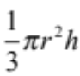
volume of a cylinder: 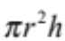

volume of a prism: area of base × height
volume of a pyramid: area of base × height
FURMATH EX 1&2 3

Pythagoras’ theorem: 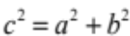

sine rule: 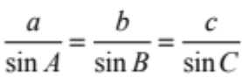

cosine rule: 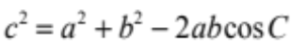

Module 3: Graphs and relations

Straight line graphs

gradient (slope): 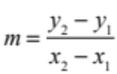

equation: 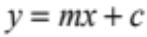

Module 4: Business-related mathematics
simple interest: 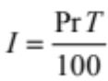

compound interest: 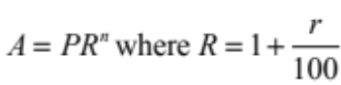

hire purchase: effective rate of interest 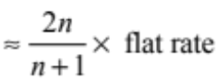

annuities: 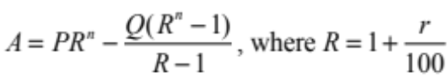

Module 5: Networks and decision mathematics

Euler’s formula: 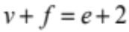

Module 6: Matrices

determinant of a 2 × 2 matrix: 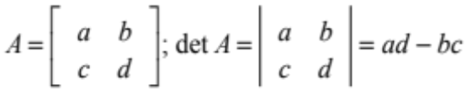

inverse of a 2 × 2 matrix: 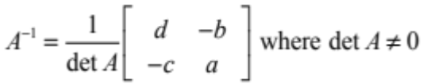

END OF FORMULA SHEET

Core

Specific Instructions for Section A
Section A consists of 13 questions
Answer all questions in this section.
A correct answer scores 1 mark, an incorrect answer scores 0. No mark will be given for a question if two or more letters are shaded for that question. Marks will not be deducted for incorrect answers and you should attempt every question.

Core

Question 1

How many of the following represent categorical data?

- Language spoken at home.
- Arm span
- Time taken to travel to school
- Eye colour
- Post codes
- Birth dates

A. 1

B. 2

C. 3

D. 4

E. 5

Core

Question 2

Twenty-five people competed in a gymnastics competition. The points awarded to the competitors are given in the stem and leaf below.

Stem | Leaf
88 | 1
89 | 8 | 8 | 9
90 | 4 | 5 | 5 | 7 | 7  Key 88/1= 88.1
91 | 3 | 4 | 7 | 9
92 | 1 | 2 | 5 | 8
93 | 2 | 6 | 6
94 | 1 | 2 | 9
95 | 8
96 | 2

The top 25% of competitors achieved a score greater than

A. 90.5

B. 90.7

C. 91.9

D. 93.6

E. 94.2

Core

Question 3

The number of goals kicked by a team in the first nine weeks of a soccer season is listed in the table below.

Game | Number of Goals
1 | 3
2 | 4
3 | 1
4 | 2
5 | 6
6 | 2
7 | 8
8 | 4
9 | 5

If the team wants to kick an average of 4.3 goals for the ten-week season, how many goals will they need to kick in the next game?

A. 3

B. 4

C. 5

D. 7

E. 8

Core

Question 4

Students in Year 10 at a particular school have a choice of four sports for term 1. The number of girls and boys participating in the different sports is given in the graph below.

Cricket
Tennis
Golf
Swimming
20
40
60
80
100
120
140
Sport
Number of students

Boys
Girls

Of the students who chose swimming, the percentage who were boys is closest to

A. 42%

B. 43%

C. 50%

D. 54%

E. 55%

Core

Use this information to answer questions 5 and 6

The following graph gives the test scores of year 12 Chemistry students at Chancellery High.
10
20
30
40
50
60
70
80
90
100
0
1
2
3
4
5
6
7
8
9
10
Test Score
Frequency

Question 5

The number of year 12 students studying Chemistry at Chancellery High is

A. 9

B. 10

C. 45

D. 54

E. 100

Core

Question 6

Which one of the following statements is true?

A. The graph is negatively skewed with a spread of 90 and a median close to 70.

B. The graph is positively skewed with a spread of 90 and a median close to 70.

C. The graph is symmetrical with a spread of 100 and a median close to 80.

D. The graph is negatively skewed with a spread of 100 and a median close to 80.

E. The graph is positively skewed with a spread of 100 and a median close to 80.

Core

Question 7

1
2
3
4
5
6
0
20
40
30
60
70
90
10
50
80
100
Hours spent on homework
Test result (%)

If a 3-median line is fitted to the above scatter plot, then the gradient of the regression line is closest to

A. 5

B. 9

C. 11

D. 13

E. 16

Core

Use this information to answer questions 8 and 9

A factory manager examined the number of minor accidents incurred and the number of hours worked. She found that the standard deviation for the number of minor accidents and the number of hours worked was 1.98 and 13.18 respectively. She also found that the least squares regression line for the data was

Question 8

The number of hours you would expect an employee who has 8 minor accidents to have worked is closest to

A. 42

B. 44

C. 46

D. 48

E. 50

Question 9

The value of the Pearson’s correlation coefficient is closest to

A. 0.01

B. 0.02

C. 0.8

D. 1.1

E. 1.2

Core

Question 10
5
10
15
20
25
30
Sales ($’000)
4
2
6
8

10
12
14
Year

The four-mean moving sales for year 6 is closest to

A. $14,000

B. $14,700

C. $15,000

D. $15,200

E. $16,000

Core

Question 11

Table 1
Quarterly Sales Figures in dollars
Year | Spring | Summer | Autumn | Winter
2012 | 850 | 1200 | 980 | 720
2013 | 1210 | 1560 | 1340 | 1080
2014 | 1280 | 1590 | 1410 | 1170

Table 2
Quarter | Spring | Summer | Autumn | Winter
Seasonal Index | 1.14 | 1.2 | 0.91

Using the above tables, the deseasonalised quarterly sales figure for winter 2013 is closest to

A. $1440

B. $1480

C. $1520

D. $1550

E. $1560

Core

x
y

Question 12

The above graph has a coefficient of determination of 0.49. Which one of the following statements is true for the above graph?

A. There is a weak positive correlation between x and y.

B. There is a moderate positive correlation between x and y.

C. 49% of the variation in y is caused by the variation in x.

D. There is a weak negative correlation between x and y.

E. There is a moderate negative correlation between x and y.

Core

Question 13

Students who scored more than 95% on a test, which had a mean of 65% and a standard deviation of 10%, were awarded an A⁺ grade. If the scores gave a normal distribution and 6000 students sat the test, the number of students who scored an A⁺ was

A. 9

B. 125

C. 150

D. 170

E. 200

END OF SECTION A

Instructions for Section B

Select three modules and answer all questions within the modules selected, in pencil, on the answer sheet provided for multiple-choice questions.
Show the modules you are answering by shading the matching boxes on your multiple-choice
answer sheet.
Choose the response that is correct for the question.
A correct answer scores 1 mark, an incorrect answer scores 0.
Marks will not be deducted for incorrect answers.
No marks will be given if more than one answer is completed for any question.

Module Page

Module 1: Number patterns ……………………………… 14

Module 2: Geometry and trigonometry ……………………………… 20

Module 3: Graphs and relations ……………………………… 29

Module 4: Business-related mathematics ……………………………… 36

Module 5: Networks and decision mathematics ……………………………… 41

Module 6: Matrices ……………………………… 50

Module 1: Number patterns and applications

Before answering these questions you must shade the Number patterns box on the answer sheet for multiple-choice questions

Use this information to answer questions 1 and 2

Greg starts work on an annual salary of $38,000 in 2015. Each year his salary increases by $580. What will his annual salary be in 2017?

Question 1

A. $38,580

B. $39,160

C. $39,720

D. $39,740

E. $40,320

Question 2

The total amount that Greg will have earned at the end of five years is

A. the fifth term of an arithmetic sequence with a = 38,000 and d = 580.

B. the fifth term of a geometric sequence with a = 38,000 and r = 580.

C. the sum of five terms of an arithmetic sequence with d = 580 and n = 5.

D. the sum of five terms of an arithmetic sequence with a = 38,000 and n = 580.

E. the sum of five terms of a geometric sequence with a = 38000 and n = 5.

Module 1: Number patterns and applications

Question 3

An island has 800 rabbits at the start of 2015. It is known that the rabbits increase in number at a rate of 35% each year. If no rabbits on the island die in this time, then the number of rabbits on the island at the end of 2020 would be closest to

950

B 983

C 3587

D 4843

E 6034

Question 4

Which one of the following difference equations could generate the following sequence?

3, 7, 19, 55

A. 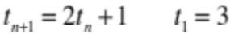

B. 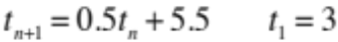

C. 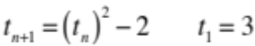

D. 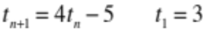

E. 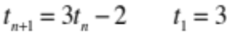

Module 1: Number patterns and applications

Question 5

Sophie plays one round of golf on each of the seven days in one particular week. Her score improves by 4 strokes each day that she plays and her total score for the week is 700. What was her score on the first day of the week?

A. 67

B. 88

C. 98

D. 107

E. 112

Module 1: Number patterns and applications

Question 6

1
2
3
4
12
6
2
4
8
10

n

Peter plots the above four points on his graph. If he continues plotting points in this way, then the sum of all the values would be closest to

A. 24

B. 36

C. 48

D. 72

E. 108
Module 1: Number patterns and applications

Question 7

The first term of a geometric sequence is f and the third term is 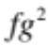. The sum of the first four terms is

A. 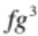

B. 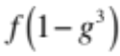

C. 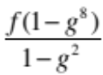

D. 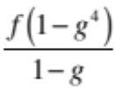

E. 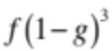

Question 8

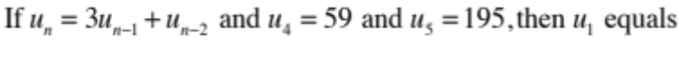

A. 3

B. 5

C. 18

D. 136

E. 254
Module 1: Number patterns and applications

Question 9

The half-life of a substance is the time it takes until there is only half of the original amount of the substance left. A certain radioactive element decays at a rate of 1% every 25 years. The half-life of this element in years is closest to

A. 69

B. 175

C. 1724

D. 1750

E. 3526

End of Module 1
Module 2: Geometry and trigonometry

Before answering these questions you must shade the Geometry and trigonometry box on the answer sheet for multiple-choice questions

Question 1

5 cm
15 cm
θ

The above rectangle has a length of 15 cm and a width of 5 cm. The size of angle θ is closest to

A. 18⁰

B. 19⁰

C. 54⁰

D. 71⁰

E. 72⁰

Module 2: Geometry and trigonometry

Question 2

B
A
C
9 cm
12 cm
35⁰

The length of AC in the above triangle is closest to

A. 2 cm

B. 7 cm

C. 10 cm

D. 48 cm

E. 101 cm

Question 3
A
B
1000 m
2000 m

The contour map above has contour intervals of 200 m. The horizontal distance between A and B is 1 km. The angle of elevation from point A to point B is closest to

A. 10⁰

B. 22⁰

C. 31⁰

D. 59⁰

E. 68⁰

Module 2: Geometry and trigonometry

Question 4
Meg
Peter
Flag

Meg and Peter, who are both the same height, are looking at a flag on top of a pole. Meg and Peter are 30m and 55 m respectively from the base of the pole. The angle of elevation from Meg’s eye to the flag is 28⁰. The angle of elevation from Peter’s eye to the flag is closest to

A. 15⁰

B. 16⁰

C. 40⁰

D. 48⁰

E. 61⁰
Module 2: Geometry and trigonometry

Question 5
A
64 cm
52⁰
20⁰
B
C
D
88⁰

In the above diagram, AD = 64 cm.

The length of BC is closest to

A. 78.5 cm

B. 82.4 cm

C. 93.8 cm

D. 102.4 cm

E. 135.5 cm

Module 2: Geometry and trigonometry

Question 6
12.8 m
3 m

A container is shaped like a cylinder with a cone on top. The volume of the container is 300 m³. The height of the container is 12.8 m and the height of the cone is 3 m. The radius of the cone is closest to

A 9 cm

B. 8 cm

C. 7.5 cm

D. 5 cm

E. 3 cm

Module 2: Geometry and trigonometry

Question 7
4.5 cm
11.3 cm
X
Y
Z

The area of triangle XYZ is 20 cm². If XZ = 11.3 cm and YZ = 4.5 cm, then the perimeter of triangle XYZ is closest to

A. 20 cm

B. 21 cm

C. 23 cm

D. 25 cm

E. 31 cm

Module 2: Geometry and trigonometry

Question 8

18⁰
P
Q
40 cm
24 cm

A cuboid box of length 24 cm and width 40 cm has an open lid. The lid makes an angle of 18⁰ with the horizontal. The angle that the diagonal PQ makes with the horizontal is closest to

A. 2⁰

B. 4⁰

C. 5⁰

D. 9⁰

E. 11⁰

Module 2: Geometry and trigonometry

Question 9
A
B
C
D

1.4 m

3.1 m

Ground

Two poles AB and CD are cemented to the ground. The heights of the poles are 1.4 m and 3.1 m respectively. Wires BC and AD help to secure the poles. How far above the ground do these wires meet?

A. 0.8 m

B. 0.9 m

C. 1 m

D. 1.1 m

E. 1-2 m

End of Module 2

Module 3: Graphs and relations

Before answering these questions you must shade the Graphs and relations box on the
answer sheet for multiple-choice questions

Question 1
x
(-2,6)
A
B
y

The equation of the line AB is

A. y = -2x + 6

B. x = 6

C. x = -2

D. y = 6

E. y = -2

Module 3: Graphs and relations

Use this information to answer questions 2 and 3
Jan
Feb
March
April
May
June
July
Aug
Sep
Oct
Nov
Dec
Month
10
20
30
40
Temperature ⁰C
Average Daily Maximum Temperature

Question 3

For how many months is the average maximum daily temperature between 15⁰C and 30⁰C?

A. 4

B. 5

C. 6

D. 7

E. 8

Module 3: Graphs and relations

Question 3

The greatest change in the average maximum daily temperature occurred between the months of

A. January and February.

B. May and June.

C. July and August.

D. August and September.

E. November and December.

Question 4

The equation of the line joining the points (-4,6) and (-6,-4) is

A. 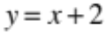

B. 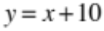

C. 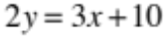

D. 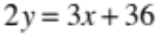

E. 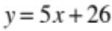

Module 3: Graphs and relations
(4,200)
p
q

Question 5

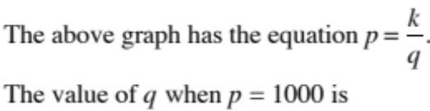

A. 0.8

B. 1.25

C. 2.25

D. 8

E. 18

Module 3: Graphs and relations

Question 6

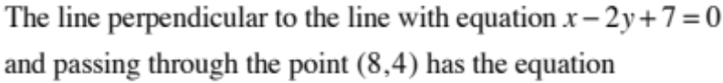

A. 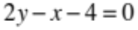

B. 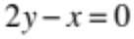

C. 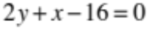

D. 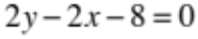

E. 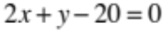

Module 3: Graphs and relations
x
y
Question 7

The given lines in the above graph have equations

A. 3

B. 4

C. 6

D. 8

E. 10

Question 8

The Clay Company produces urns for gardens. The fixed weekly cost for the company is $3000 and the cost to make each urn is $80. If the urns sell for $140 each and all urns are sold each week, which one of the following statements is false?

A. The company will break even is it makes 50 urns in a week.

B. When 80 urns are made in a week, the profit is $1800.

C. The profit, P, is given by the equation P = 60x + 3000 where x is the number of urns produced in a week.

D. The average cost of producing 100 urns in a week is $110.

E. To make a weekly profit of $21,000, the company would have to make 400 urns.

Module 3: Graphs and relations

Question 9

The values of a and b where the pairs of equations
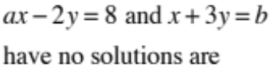

A. 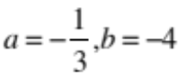

B. 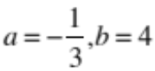

C. 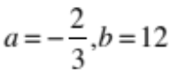

D. 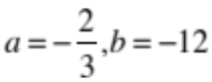

E. 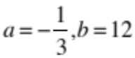

End of Module 3

Module 4: Business-related mathematics

Before answering these questions you must shade the Business-related mathematics box on the answer sheet for multiple-choice questions

Question 1

Luke invested $320 at 4% simple interest. The value of his investment at the end of 6 years is closest to

A. $76

B. $115.20

C. $352.20

D. $397

E. $404.90

Question 2

The quoted cost of having a heating system installed in a certain country is $5850 including 12½% added tax. The cost of the installation without the added tax would be

A. $731.25

B. $1462.50

C. $4820

D. $5118.75

E. $5200
Module 4: Business-related mathematics

Question 3

The cost of a cup of coffee is $4.80. If this price increases by 10% per year, then the price of a cup of coffee in fifteen years’ time will be closest to

A. $6

B. $12

C. $16

D. $20

E. $22

Question 4

A computer has a cash price of $2400. Kara buys it on hire purchase for a $300 deposit and monthly instalments of $110 for 2 years. The interest rate per annum is closest to

A. 12.9%

B. 11.25%

C. 8.5%

D. 5.7%

E. 5.2%

Module 4: Business-related mathematics

Question 5

The tax scale is set out in the table below

Gross income | Tax payable
0 - $18,200 | Nil
$18,201 - $37,000 | 19 cents for each $1 over $18,200
$37,001 - $80,000 | $3572 + 32.5 cents for each $1 over $37,000
$80,001 - $180,000 | $17,547 + 37 cents for each $1 over $80,000
$180,001 and over | $54,547 + 47 cents for each $1 over $180,000

Maya’s annual gross income is $78,000. If her income increases by 20%, her fortnightly take home pay after tax will increase by an amount which is closest to

A. $17.65

B. $176.50

C. $381.50

D. $460.20

E. $482

Question 6

A shredder reduces in value by 50 cents for every 5000 sheets shredded. If the shredder has an original value of $620, the value of the machine after 400,000 sheets have been shredded is

A. $220

B. $420

C. $580

D. $600

E. $610

Module 4: Business-related mathematics

Question 7

Brian invests $2000 in a bank and adds a further $150 at the end of each month. His interest rate is 6% per annum compounding monthly. The value of Brian’s investment after 8 years is closest to

A. $25,840

B. $21,653

C. $15,196

D. $3,303

E. $2,860

Question 8

Jane invests $200 at a simple interest of 3%. On the same day James invests $100 compounding yearly. If their investment accounts at the end of 20 years are the same value, then the interest rate that James received was closest to

A. 1%

B. 6%

C. 7%

D. 8%

E. 9%

Module 4: Business-related mathematics

Question 9

Nathan borrowed $132,000 to buy a home. The formula for his monthly repayments over 5 years is given by the equation

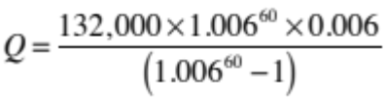
The interest rate per annum is closest to

A. 1%

B. 3%

C. 6%

D. 7.2%

E. 9%

End of Module 4

Module 5: Networks and decision mathematics

Before answering these questions you must shade the Networks and decision mathematics box on the answer sheet for multiple-choice questions.

Question 1

P
Q
R
S
T
U
V

For the above network to be traversable, a line could be added connecting

A. P to V.

B. T to S.

C. U to Q.

D. R to S.

E. R to T.

Module 5: Networks and decision mathematics

Question 2

Alex, Beth, Cara, Dana and Edward play in a tennis round robin. Each person plays every other person once. The network that represents this is

A. | B.
C. | D.
E.

Module 5: Networks and decision mathematics

Question 3
Start
Finish
A, 6
B, 4
C, 5
D, 8
E, 3
F, 1
G, 2
H, 4
I, 2
J, 8

The critical path for the above network is

A. B – D – H – I

B. A – C – H – I

C. B – D – G – J

D. B – E – F – J

E. B – E – F – G – H – I

Module 5: Networks and decision mathematics

Question 4

Adrian, Ben, Catherine and Dianna have to complete 4 jobs, P, Q, R and S. The time taken for them to complete these tasks is given in the table below.

 | Adrian | Ben | Catherine | Dianna
P | 120 | 80 | 95 | 100
Q | 85 | 55 | 30 | 60
R | 40 | 95 | 110 | 110
S | 85 | 75 | 75 | 50

If the tasks are to be completed in the minimum time then which one of the following statements is true?

A. Dianna does S and Catherine does P.

B. Catherine does S and Ben does Q.

C. Adrian does R and Catherine does P

D. Adrian does R and Ben does P.

E. Ben does P and Adrian does Q.

Module 5: Networks and decision mathematics

Question 5

Each of eight towns needs to be connected by cable to the internet. The network below gives the distance in kilometres between the towns. The company that is working on this project wants to use the least amount of cable so as to reduce costs. How many kilometres of cable will they use if they do this?
A
B

C

D

E

F

G

H

11
12

4
13
12
12
10
8
9
13
11
11
14

A. 62 km

B. 64 km

C. 67 km

D. 70 km

E. 71 km

Module 5: Networks and decision mathematics

Question 6

The following graph shows the number of litres of water that can travel along a system of pipes every minute.
15
13
5
10
15
5
18
2
8
Start
End

The maximum number of litres of water that can flow through this system of pipes in a minute is

A. 17

B. 19

C. 20

D. 25

E. 28

Module 5: Networks and decision mathematics

Question 7
A
B
C
D
E

Which one of the following statements is NOT true for the above network?

A. The graph is planar with 5 vertices.

B. The graph is planar with 10 faces.

C. Euler’s formula is true for this graph.

D. The graph is not degenerate.

E. The graph is not a complete graph.

Module 5: Networks and decision mathematics

Question 8

Which one of the following adjacency matrices represents a simple graph?

A.  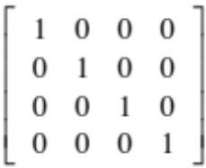 | B.  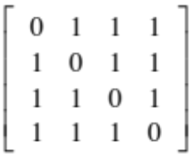
C.  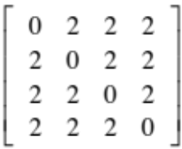 | D.  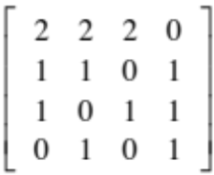
E.

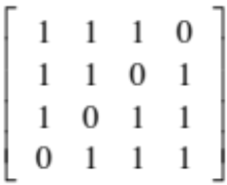

Module 5: Networks and decision mathematics

Question 9

Eight students, namely Pat, Quentin, Ray, Sam, Tess, Una, Victor and William overlap with one subject they study. The overlapping subjects are listed in the table below.

Subject | Students overlapping this subject.
Art | Pat | Victor
History | Pat | Quentin
Literature | Pat | Ray
French | Quentin | Ray
Biology | Ray | Victor
German | Ray | Sam
Maths | Ray | Una
Physics | Sam | Tess
Chemistry | Sam | Una
Geography | Una | Victor
Accounting | Victor | William

The person doing the timetable for the exams has to ensure that each student is timetabled for no more than one exam a day. What is the minimum number of days that the timetabler can use for these exams, which have overlapping students?

A. 4

B. 5

C. 6

D. 7

E. 8

End of Module 5

Module 6: Matrices

Before answering these questions you must shade the Matrices box on the answer sheet for multiple-choice questions.

Question 1
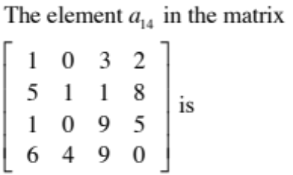

A. 2

B. 3

C. 4

D. 6

E. 8

Module 6: Matrices

Question 2

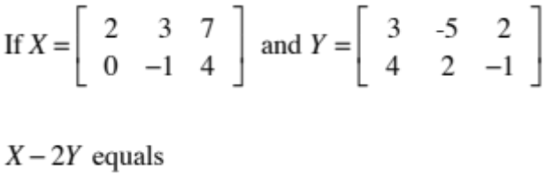

A. 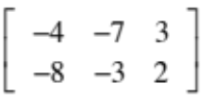

B. 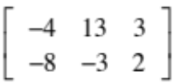

C. 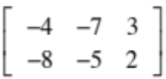

D. 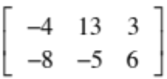

E. 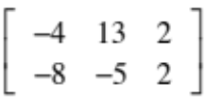

Module 6: Matrices

Question 3
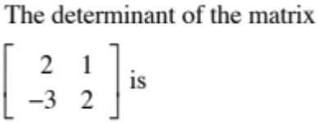

A. -3

B. 1

C. 2

D. 3

E. 7

Module 6: Matrices

Question 4

A corner store sells four types of milk, low-fat, skim, fat-free and organic. The prices of these different milks are $1.45, $1.60, $1.30 and $2.00 respectively.
The number of bottles of each type of milk sold on four days last week is listed in the table below.

 | Tuesday | Wednesday | Thursday | Friday
Low-fat | 20 | 14 | 10 | 24
Skim | 12 | 16 | 12 | 16
Fat-free | 8 | 10 | 11 | 8
Organic | 2 | 5 | 3 | 1

The revenue from Thursday’s sales is

A. $16.80

B. $54.00

C. $57.90

D. $72.80

E. $90.60

Module 6: Matrices

Question 5

Some customers change the dishwashing liquid they purchase from week to week. Others keep to the same brand. Their weekly choices of the three brands of dishwashing liquid available for purchase are given in the table below. The choices are Perfect (P), Quest (Q) and Rio (R).
60%
50%
70%
30%
20%
30%
P
Q
R

The transition matrix that describes this situation is

A.  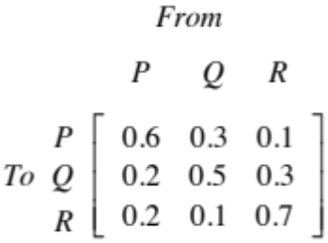 | B.  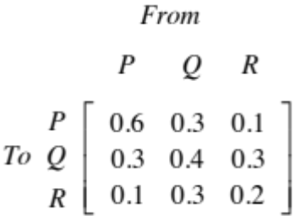
C.  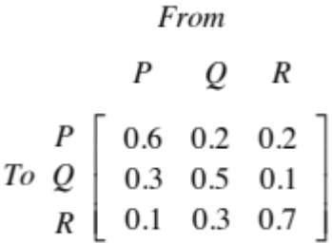 | D.  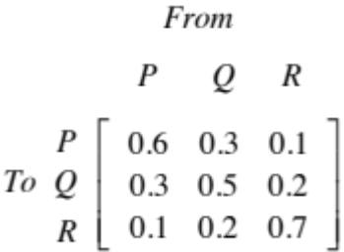
E.

Module 6: Matrices

Question 6

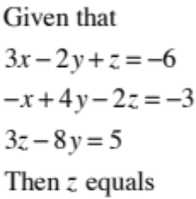

A. -2

B. 2

C. 3

D. 5

E. 7

Question 7

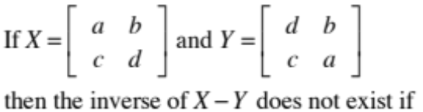

A. ad = bc

B. b = -c

C. b = c

D. a = d

E. a = -d

Module 6: Matrices

Question 8
Movie tickets cost $18 for adults, $12 for children and $10 for seniors. Last Saturday afternoon, twice as many children’s tickets as adult’s tickets were sold. The number of senior’s tickets sold was a quarter of the total number of adult and children’s tickets sold. The total amount of money taken for the sale of these tickets was $5,940. If x was the number of adult tickets sold, y the number of children’s tickets sold and z the number of senior tickets sold, then which one of the following could be used to find x, y and z?

A. 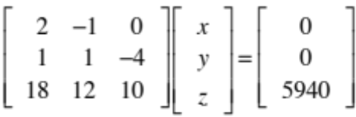

B. 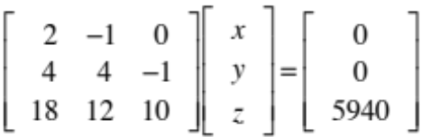

C. 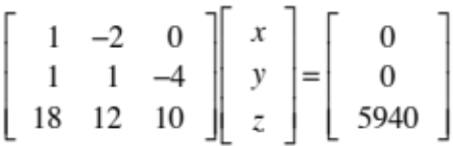

D. 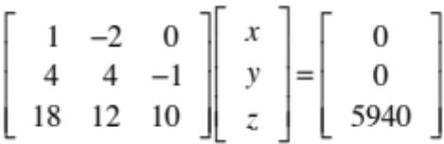

E. 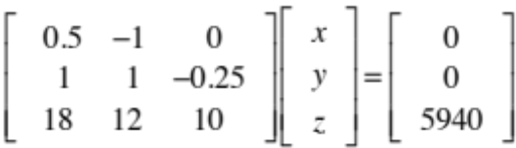

Module 6: Matrices

Question 9

Given that
A is a 4 × 3 matrix
B is a 2 × 2 matrix
C is an m × n matrix
D is an n × m matrix
E is an m × p matrix
F is an m × m matrix
Then which one of the following statements is FALSE?

A. 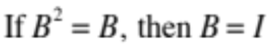

B. 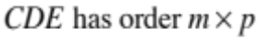

C. 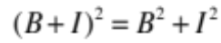

D. 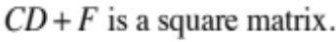

E.

End of Module 6

End of 2015 Further Mathematics Trial Examination 1

Multiple Choice Question Book

Kilbaha Multimedia Publishing  PO Box 2227  Kew Vic 3101  Australia | Tel: (03) 9018 5376  Fax: (03) 9817 4334  kilbaha@gmail.com  http://kilbaha.com.au

