2016

VCE
Further Mathematics
Trial Examination 1
Suggested Answers



Kilbaha Multimedia Publishing  PO Box 2227  Kew Vic 3101  Australia | Tel: (03) 9018 5376  Fax: (03) 9817 4334  kilbaha@gmail.com  http://kilbaha.com.au

IMPORTANT COPYRIGHT NOTICE

- This material is copyright. Subject to statutory exception and to the provisions of the relevant collective licensing agreements, no reproduction of any part may take place without the written permission of Kilbaha Multimedia Publishing.
- The contents of this work are copyrighted. Unauthorised copying of any part of this work is illegal and detrimental to the interests of the author.
- For authorised copying within Australia please check that your institution has a licence from http://copyright.com.au. This permits the copying of small parts of the material, in limited quantities, within the conditions set out in the licence.

Reproduction and communication for educational purposes The Australian Copyright Act 1968 (the Act) allows a maximum of one chapter or 10% of the pages of this work, to be reproduced and/or communicated by any educational institution for its educational purposes provided that educational institution (or the body that administers it) has given a remuneration notice to Copyright Agency Limited (CAL) under the Act.

For details of the CAL licence for educational institutions contact
CAL, Level 15, 233 Castlereagh Street, Sydney, NSW, 2000
Tel: (02) 9394 7600
Fax: (02) 9394 7601
Email: info@copyright.com.au

- All of these pages must be counted in Copyright Agency Limited (CAL) surveys

- This file must not be uploaded to the Internet.

These suggested answers have no official status.

While every care has been taken, no guarantee is given that these answers are free from error. Please contact us if you believe you have found an error.

CAUTION NEEDED!
All Web Links when created linked to appropriate Web Sites. Teachers and parents must always check links before using them with students to ensure that students are protected from unsuitable Web Content. Kilbaha Multimedia Publishing is not responsible for links that have been changed in this document or links that have been redirected.

Section A Core

Question 1 B  5 outlets sold more than 50 pairs of jeans.  % = 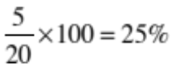 | Question 2 D  You could have two bars, one for ‘yes’ and one for ‘no’. This is categorical data. Then, you would have the frequencies for females stacked on top of the frequencies for males.  This is a segmented bar graph.  Histograms, scatter plots, box plots and stem and leaf plots are used when the independent variable is numerical.
Question 3 B  95% are within 2 standard deviations of the mean. This means that 95% lie between  170 – 10 and 170 + 10, between 160 and 180.  Greater than 160 would be the 95% up to 180 and the 2.5% greater than 180 = 97.5% | Question 4 A  For history, the IQR = 70 – 50 = 20.  1.5 × 20 = 30  50 – 30 = 20. Any score less than 20 would be an outlier, so A is not true.
Question 5 E  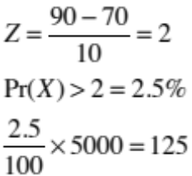 | Question 6 C  Two points on the line are (60,7) and (85,12)  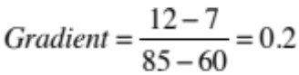  Rating = 0.2 × final exam result + b  7 = 0.2 × 60 + b  b = -5  Rating = 0.2 × final exam result -5
Question 7 A  The slope of the regression line is negative, so Pearson’s correlation coefficient will be negative.  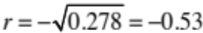  We cannot say that the variability is caused by anything. The relationship is negative and moderate. | Question 8 C  Could use log(y), log(x), 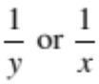 to linearise the given graph.

Section A Core

Question 9 E  Not A or C because they do not have 14 points shown.  When x = 2, the actual value – the predicted value has two positive points and one negative point, so not B or D. | Question 10 E  Use the 5 values for February, March, April, May, June. These are 6, 5, 2, 7, 4.  Writing them in ascending order we get  2, 4, 5, 6, 7. The median is the middle term, which is 5. The smoothed value for sales for April was $5000
Question 11 B  The seasonal indices add to 4.  4 – (0.89 + 1.06 + 1.13) = 0.92 | Question 12 C  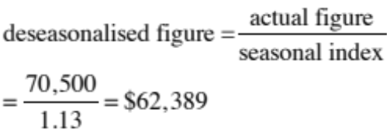
Question 13 E  Seasonal Index for summer  = Summer value ÷ season average  Season average  = (2073 + 2414 + 2339 + 1967) ÷ 4  = 2198.25  SI for summer = 2414 ÷ 2198.25 = 1.098  This is close to 1.10, which means the occupancy was about 0.1 or 10% above the average in this season. | Question 14 A  The values would be  1,1,1,1,1,1,1,1,2,2,2,2,2,2,2,2,2,3,3,3,3,3,4,4,4,4,4,5,5,9.  Median is 2, lower quartile is 1,  upper quartile is 4. Hence, not B or C.  IQR = 4 – 1 = 3  1.5 × 3 = 4.5.  4.5 + 4 = 8.5, so 9 is an outlier.
Question 15 A  Maths is the y axis and Biology is the x axis. Using the calculator we get the equation  Maths = 0.94 × Biology + 4.6. this means that when Biology = 10, Maths = 9.4 + 4.6 = 14. The gradient is positive. | Question 16 D  Put the y values and the x² values of 1, 4, 9, 16 and 25 into calculator. The linear regression line is y = -0.68 × x² + 21.5  This gives y = -0.68 × 3.2² + 21.5 = 14.5

Section A Core

Question 17 B  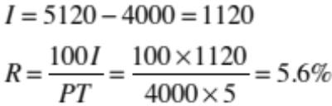 | Question 18 A  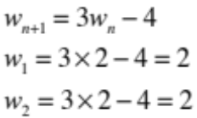  Each term will be 2.
Question 19 C  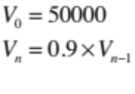  Use calculator and keep multiplying previous answer by 0.9 and count how many times you do this till you reach $23,914.85. This requires 7 multiplications. | Question 20 B  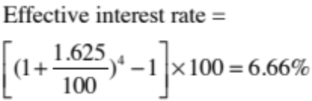
Question 21 D  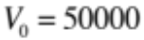 as seen on the graph so the choices are between D and E.  Graph decreases by 40,000 in 10 years, which is 4000 per year. Each term is 4000 less than the term before it. | Question 22 A  A perpetuity account keeps the amount invested forever, so E.
Question 23 C  Amount lost = $5000 for 100,000 km  = 5,000 ÷ 100,000 = 5 ÷ 100 = $0.05 per km | Question 24 B  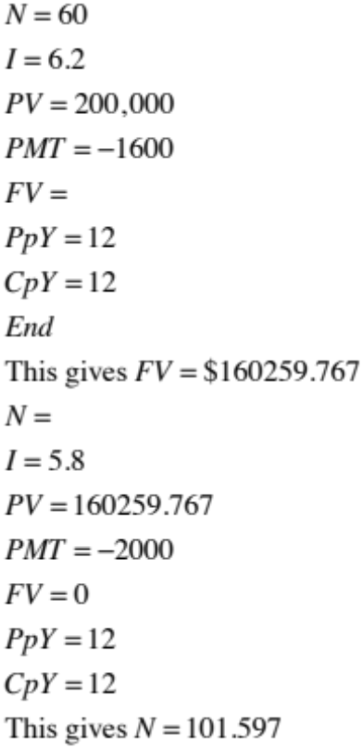  101.597 ÷ 12 = 8.5 years. The money would be paid back 9 years from 2016, which is 2025

Module 1 Matrices

Question 1 B  This is an upper triangular matrix because all the values below the main diagonal are zero | Question 2 E  For multiplication to be defined, the number of columns of the first matrix must equal the number of rows of the second matrix. P has 3 columns but R has only 2 rows.
Question 3 D  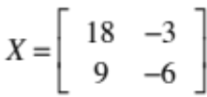  The determinant = 18 × -6 – 9 × -3 = -81  or you can use calculator.  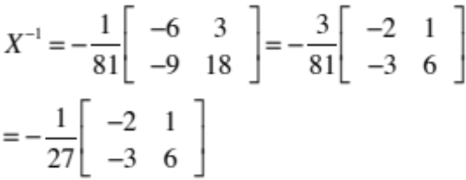 | Question 4 D  B and C cannot be multiplied since the number of columns of the first matrix does not equal the number of rows of the second matrix.  Since we multiply rows by columns, we want tomatoes, carrots, zucchinis, going across in the first matrix and tomatoes, carrots and zucchinis going down in the second matrix.
Question 5 C  Inconsistent means that the equations have no solution, i.e. they are parallel lines.  Start by checking the determinant for each set of equations. Use the calculator to do this. The first set, the third set and the fourth set of equations have the determinant = 0.  The first set can be written x + y = a constant,  where the constant is different for each equation.  This means that the lines are parallel and have no solution. The same is true for the third system of equations where x – 2y = a constant.  The fourth system of equations is not inconsistent because they are the same straight line and have an infinite number of solutions. | Question 6 C  R = 6P × Q must be a 3 × m × p × q  = 3 × q matrix.  R is a square matrix, so q = 3.  Q + S is defined, so p × 3 is same order as 2 × t  so t = 3 and p = 2  PQ = 3 × m × 2 × 3 = 3 × 3 matrix  so m = p = 2  R⁻¹ is of the same order as R, so it is 3 × 3

Module 1 Matrices

Question 7 B  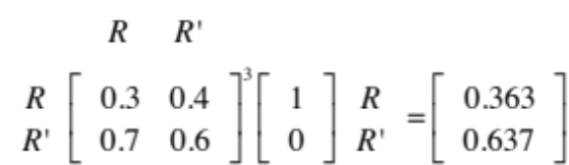  Probability it will rain on Thursday is 0.363 | Question 8 D  P gets 1 win, 0 draws and 3 losses so the first row of the matrix is 1, 0. 3.  Q gets 1 win, 1 draw and 2 losses so the second row of the matrix is 1, 1, 2.  R gets 2 wins, 0 draws and 2 losses so the third row of the matrix is 2, 0, 2.  S gets 2 wins, 1 draw and 1 loss so the fourth row of the matrix is 2, 1, 1. This must be multiplied by a column matrix that is 3 by 1.

Module 2 Networks and decision mathematics

Question 1 D  There are 9 edges, 6 vertices and 5 faces. There are 2 odd vertices and 4 even vertices. | Question 2 A  A tree has no loops or cycles.
Question 3 B  For an Eulerian circuit, all the vertices must be even. Only T and S are odd, so another road connecting these two points would make them even. | Question 4 E  P, Q, R and V all feed into W either directly or indirectly, so must all be finished before W begins. S, T and U do not have to be completed before W begins.
Question 5 E  P  8  5  1  2  2  U  Length of cable  8  Q  R  S  T  V  = 1 + 2 + 5 + 2 + 8 + 8 = 26 km | Question 6 B  Dianne must cycle. This means that Ben must swim. This leaves Carla to hurdle and then Adam must run.
  A | Swim
  B | Run
  C | Hurdle
  D | Cycle

Question 7 B
A
B
C
D
E
F
G
400
400
200
200
100
800
600
600
300
200

Minimum cut = Maximum flow.
400 + 200 + 100 = 700 litres.

Question 8 C
The critical path is ABDGHJ which takes 14 days
Activity I takes 1 day to complete, so the latest starting time for activity I is 14 – 1 = 13.
The earliest starting time for activity I is when ABDG is completed. This takes 9 days.
Float time = 13 – 9 = 4

Module 3 Geometry and measurement
A
B
C
11 km
9 km
70⁰
160⁰
20⁰
Question 1 D  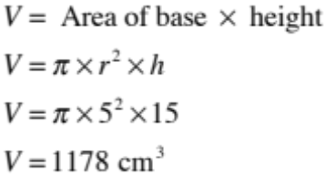 | Question 2 E  B  A  C  5 cm  8 cm  50⁰  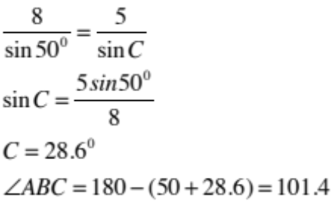  This is closest to 100⁰
Question 3 A  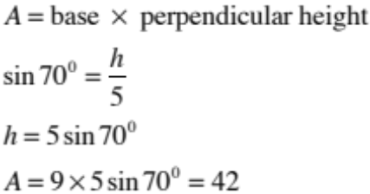 | Question 4 C  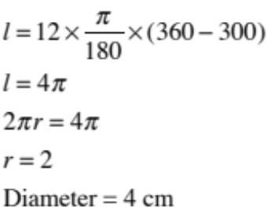
Question 5 D  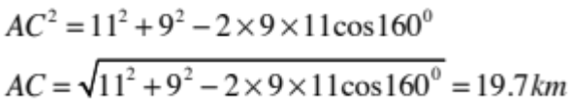 | Question 6 E  Ratio of volumes = 1 : 156 ÷ 22.4 = 1 : 6.964  Ratio of lengths = 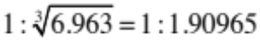  Ratio of areas = 1 : 1.90965² = 1 : 3.65  Surface area of A = 3.65 × 52 = 189.8 cm²

Module 3 Geometry and measurement

Question 7 B  48⁰  34 cm  P  Q  R  S  48⁰  66⁰  66⁰  QRS is an isosceles triangle and PQS and QSR are alternate angles, which are equal. This means that the other two angles in triangle QRS are equal to 66⁰  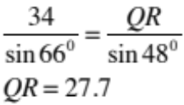  or  Use the cosine rule. | Question 8 B  35⁰  35⁰  6400  r  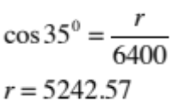  Radius of earth = 6400 km.  Angle between the 2 cities is 150 + 90 = 240 or going the other way, 360 – 240 = 120⁰. This latter angle will give the shorter distance.  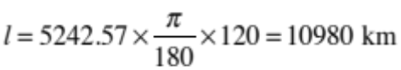

Module 4 Graphs and relations

Question 1 C  $50 for the 25 kg parcel and $30 for the 15 kg parcel = $80 | Question 2 D  Points on AB are (0, 0) and (1, -1).  Gradient of AB =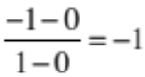  Equation of AB is y = -x  CD is parallel to this with a y intercept of 5, s its equation is y = -x + 5  x + y = 5
Question 3 B  speed = distance ÷ time = 30 ÷ 2 = 15 km/hr. | Question 4 E  x = 4 is the vertical line passing through (4,6). The shaded region is less than or equal to this line, so not A or D.  The line y = x – 2 is the line passing through  (0, -2) and (2, 0) The shaded region is greater than or equal to this line, so not C.  The remaining line is y = 10 – x. The shaded region is less than or equal to this line, so not B.
Question 5 E  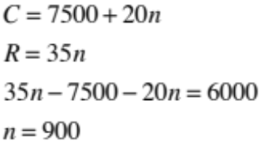 | Question 6 A  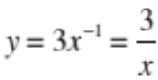
Question 7 C  Maximum value will occur at the last point that the line Z=0 would slide onto. This is R. | Question 8 B  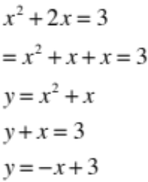

End of Suggested Solutions 2016 VCE Further Mathematics Trial Examination 1

Kilbaha Multimedia Publishing  PO Box 2227  Kew Vic 3101  Australia | Tel: (03) 9018 5376  Fax: (03) 9817 4334  kilbaha@gmail.com  http://kilbaha.com.au

