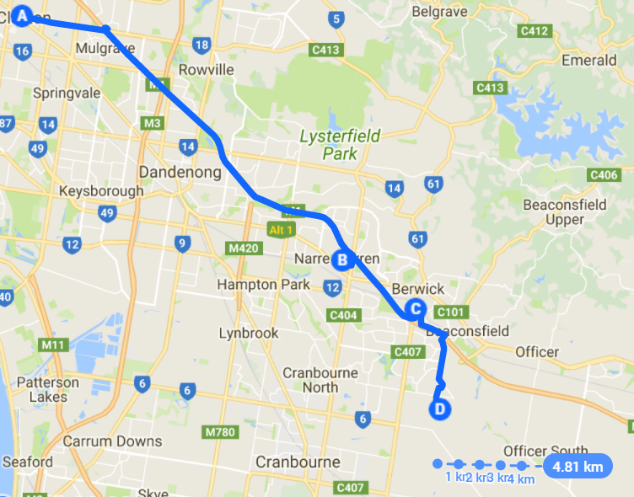
My Map

Location Sta

Legend:
- Point A – John Monash Science School
- Point B – Fountain Gate Shopping Centre
- Point C – McDonald’s Berwick
- Point D – 13 Elmtree Cresent, Clyde North, VIC, 3978 (MY HOUSE)

Source:
Google Maps

