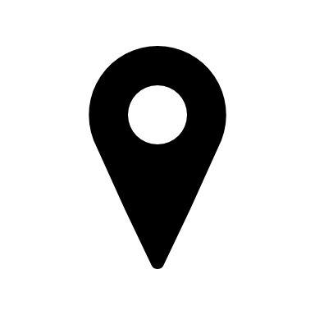
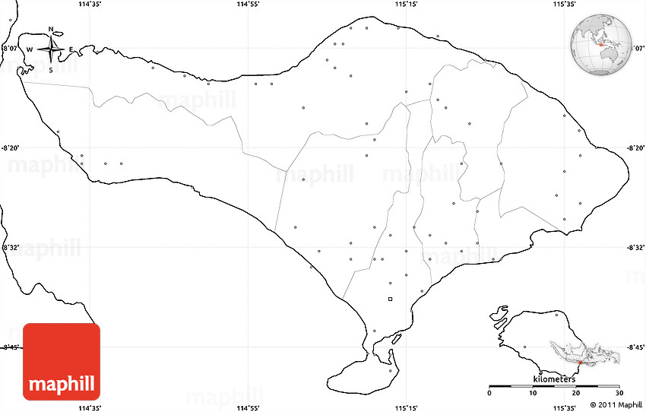

Bali bird park houses more than 1000 birds representing more than 250 species. It is located in Kabupaten, Gianyar.

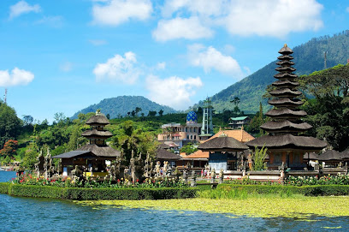
Legian is a place in Bali which has a beach, facilities for surfing, shopping, seafood and is suitable for honeymoon. This place is located in between Kuta and north Kuta.
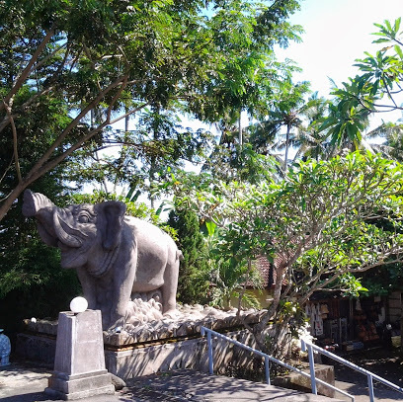
Goa Gajah is a cave formed for its ancient carvings. It is located at, Ubud, Bali Indonesia.
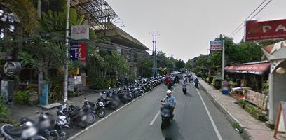
Puri Lukisan Museum has a sizable collection of Balinese artworks and is located in Ubud, Bali.
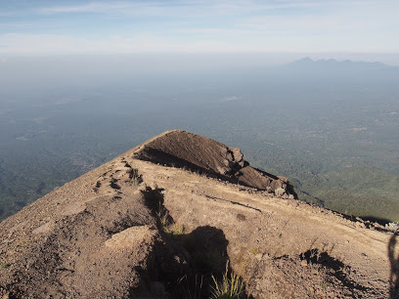
Mount Agung is a stratovolcano and it is the highest point in the whole island. It is located in Karangasem Regency.
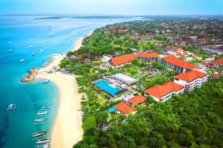
Sanur is a laid-back beach and houses a pura Blangong Temple. It is located near Denpasar Bali.
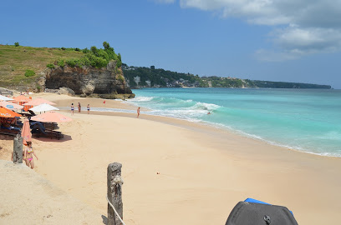
Dream Land beach is one of the most famous beaches in Bali. It is located in Kabupaten Badung, Bali.
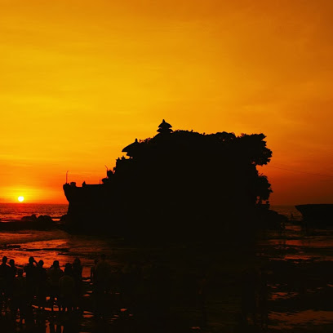
Tanah lot is a traditional Balinese temple located on a small, rocky island and offering water vistas. It is located in Beraban, Kediri.

