Who’s to Blame?
You have to convince the other students in the class as well as the teacher that it was not your fault for starting the war. You might also have to think of some points to defend yourself with.

Follow the steps below to prepare your argument.

Step 1: Chose one country from the list below to blame. (You can blame a combination of countries; just make sure you’re not involved)
- Austria-Hungary
- Britain
- France
- Germany
- Russia
- Serbia

Step 2: Choose 3 reasons why it is that country’s fault for starting the war.
Hint: Think about Imperialism, Militarisation, the Alliances, Nationalism, and the immediate lead up to the war.

Germany:
- The first country to act (attack).
- Invaded many countries, including neutral Belgium, Luxemburg and France. It is only after this that the United Kingdom declared war on Germany.
- Was in the motive of obtaining land.

Step 3: Choose a piece of evidence in this pack or from your notes to prove each of your points.
Remember: You are trying to not take the blame for the War at any cost.
Write a sentence for each of your points, using the sources as evidence.

Bonus: Think of 3 defences in case anybody blames you.
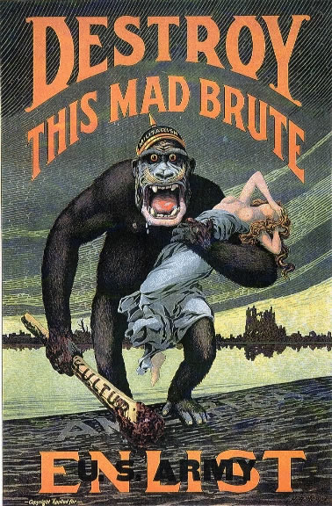

The Austrian Ultimatum

(1) To suppress any publication which incites to hatred and contempt of the Austro-Hungarian Monarchy and the general tendency of which is directed against its territorial integrity;
(2) To dissolve immediately the society styled "Narodna Odbrana," to confiscate all its means of propaganda, and to proceed in the same manner against other societies and their branches in Serbia which engage in propaganda against the Austro-Hungarian Monarchy. The Royal Government shall take the necessary measures to prevent the societies dissolved from continuing their activity under another name and form;
(3) To eliminate without delay from public instruction in Serbia, both as regards the teaching body and also as regards the methods of instruction, everything that serves, or might serve, to foment the propaganda against Austria-Hungary;
(4) To remove from the military service, and from the administration in general, all officers and functionaries guilty of propaganda against the Austro-Hungarian Monarchy whose names and deeds the Austro-Hungarian Government reserve to themselves the right of communicating to the Royal Government;
(5) To accept the collaboration in Serbia of representatives of the Austro-Hungarian Government for the suppression of the subversive movement directed against the territorial integrity of the Monarchy;
(6) To take judicial proceedings against accessories to the plot of the 28th of June who are on Serbian territory; delegates of the Austro-Hungarian Government will take part in the investigation relating thereto;
(7) To proceed without delay to the arrest of Major Voija Tankositch and of the individual named Milan Ciganovitch, a Serbian State employee, who have been compromised by the results of the magisterial inquiry at Serajevo;
(8) To prevent by effective measures the cooperation of the Serbian authorities in the illicit traffic in arms and explosives across the frontier, to dismiss and punish severely the officials of the frontier service at Shabatz Loznica guilty of having assisted the perpetrators of the Serajevo crime by facilitating their passage across the frontier;
(9) To furnish the Imperial and Royal Government with explanations regarding the unjustifiable utterances of high Serbian officials, both in Serbia and abroad, who, notwithstanding their official position, have not hesitated since the crime of the 28th of June to express themselves in interviews in terms of hostility to the Austro-Hungarian Government; and, finally,
(10) To notify the Imperial and Royal Government without delay of the execution of the measures comprised under the preceding heads.
The Austro-Hungarian Government expect the reply of the Royal Government at the latest by 5 o'clock on Saturday evening the 25th of July.
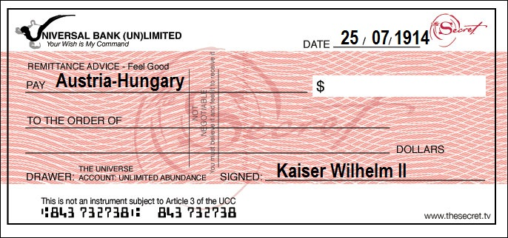
Created By Allegra Blain, 2012.

An Austrian Historian
“The Assassination of Archduke Ferdinand caused the war. The war would not have taken place if Princip had not assassinated the Archduke.”
(Heater, 1996)
A German Historian
“The war was caused by long term developments. War was unavoidable because too many powerful states were competing for colonies and building bigger armies and navies. Germany was only defending itself, not provoking a war. Germany had a responsibility to help its ally, Austria-Hungary. It was acting in self-defence and not in aggression.”
(Heater, 1996)

A French Historian
“The War was Germany’s fault. It already had plans to fight a war. The assassination of the Archduke simply gave it an excuse. In the summer of 1914, Germany was prepared to risk a war that involved all of Europe. When Austria-Hungary decided to take action against Serbia, Germany drew up ambitious war aims for land that it wanted to conquer.”
(Heater, 1996)

An American Historian
“War was fought because there was no attempt to use peaceful measures to resolve the conflict between Serbia and Austria-Hungary. All the countries involved did not take the war seriously. When war was declared in July 1914, many people in Europe believed what their governments told them, that it would be a short war.
(Heater, 1996)

On Militarisation
‘The Great armaments helped to keep the peace – so long as they were not used. But as soon as one power, in order to reinforce its diplomacy, began to mobilize, its action made military men everywhere jittery, for no general staff was willing to allow a rival to get a start. “Once the dice were set rolling,” as the German chancellor said, nothing could stop them.’
(Schmitt, 1958)

On the Alliances
‘It is often said that the relations between the Great European Powers were especially tense and strained in the early months of 1914 as a preliminary to the outbreak of war in August. This is totally inaccurate. The truth is the exact reverse: relations between the Great Powers had never been better…;

‘It is difficult, in fact, to discover any cause of hostility between the European Great Powers in the early summer of 1914. But there was one cause of estrangement. This was the system of alliances which distanced the Great Powers unnecessarily. These Alliances dragged Powers into wars which did not concern them. They were supposed to make Powers secure, the dragged them into danger.’
(Taylor, 1984)

On Train Timetables
‘All mobilization plans depended on railways. At that time the automobile was hardly used, certainly not as an instrument of mass transport, and railways demand time tables.

All the mobilization plans had been timed to the minute, months or even years before and they could not be changed. Modification in one direction would ruin them in every other direction. Any attempt for instance by the Austrians to mobilize against Serbia would mean that they could not then mobilize against Russian because two lots of trains would be running against each other. The same problem was to arise later for the Russians and in the end for the Germans who, having a plan to mobilize against France, could not switch round and mobilize again against Russia. Any alteration in the mobilization plan meant not a delay for 24 hours but for at least six months before the next lot of timetables were ready.’
(Taylor, 1977)

On the Arms Race
‘The public interest and involvement in the arms race, the curiosity about new weapons, even bigger and more fantastic, accustomed large segments of the population to the idea of war and created a wish to see its instruments in action. It may well be that, for reasons which the historian can only dimly perceive, Europe was deeply ready for war. It is not just that a generation “had been taught how to howl”. It may be that some profound boredom with the long years of peace and with the tedium of industrial life led men to volunteer for France and to find in that Hell a final confirmation of manhood. The sentiment I am trying to describe was well stated on 4 August by a German General, von Falkenhayn: “Even if we end in ruin, it was beautiful.” It was, “Vain Glory” but it was glory.’
(Steiner, 1977)

Bibliography

Arasumani, R. & Yeo, L. (2007). Crisis and Conflict an enquiry approach to modern world history. Singapore: Marshall Cavendish Education.
Duffy, M. (2009). First World War.com – Primary Documents – Austrian Ultimatum to Serbia, 23 July 1914. Retrieved from http://www.firstworldwar.com/source/austrianultimatum.htm.
Heater, D. (1996).Our World This Century. Oxford: Oxford University Press.

Hopps, H. R. (1917). Destroy this Mad Brute. US Army. Available from: http://en.wikipedia.org/wiki/File:%27Destroy_this_mad_brute%27_WWI_propaganda_poster_%28US_version%29.jpg

Schmitt, B. E. (1958). The Origins of the First World War. London: Routledge and Kegan Paul.

Steiner, Z. S. (1977). Britain and the Origins of the First World War. London: Macmillan Publishers.

Taylor, A.J.P. (1977). How Wars Begin. London: Hamish Hamilton Publishing.

Taylor, A.J.P. (1984, August 4). The Entente that ended in Slaughter. The Guardian.

