Student Worksheet
Stand up and fight
By the eleventh century, a new type of soldier was having a big influence on the outcome of a battle.
1 Compare Sources 1 and 2.
Source 2
Source 1
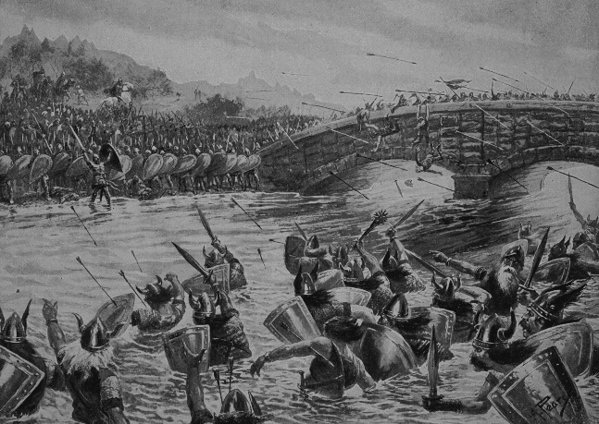
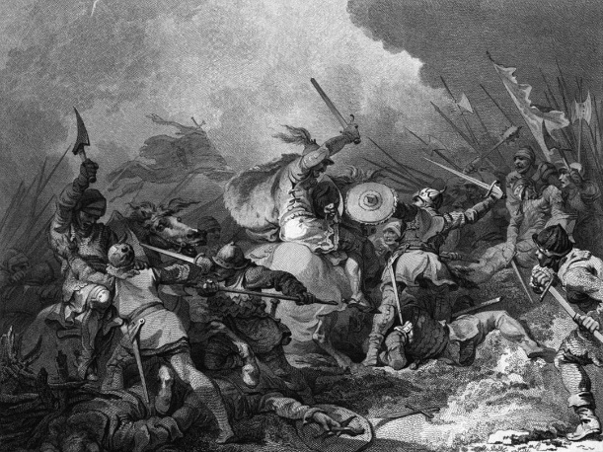
© Photolibrary/Bridgeman Art Library/
The Stapleton Collection

- What new inventions assisted a soldier in manoeuvring on horseback?
i A saddle
ii A stirrup
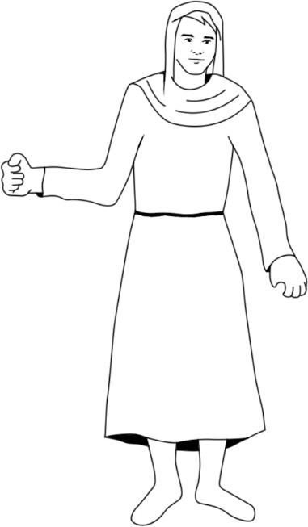
- Describe two ways in which these developments would give a soldier an advantage over his enemy.
i The stirrup secured the rider without falling of the horse when making sharp turns.
ii The saddle helped both the rider and the horse because it was more
omfortable for both of them

2 A knight would sometimes take his peasants into battle armed only with what they could grab from the farm. Arm this peasant appropriately with two items.
Spear
Shield

3 Monks could also be knights. Who and what do you think they might have to protect?
(Clue: Refer to the feudal social pyramid in your textbook and any other resources you can access.)
I think they protected the king and also their monastery.
4 Look carefully at Source 3 at the end of the document.
a What would have been the most vulnerable body part for a knight in the 1100s when fighting foot soldiers? Why?
Their face, because it was only partly covered.
b Why did a knight in the 1400s no longer need a shield?
Their armour was made with nothing but pure iron and they did not need any more protection.
5 a Why do you think a knight would have to train?
A knight would have to train before going to a war since if you want to win a war you must know the tricks.
b Describe a well-known training event.

6 a Although gunpowder had been invented, why didn’t medieval soldiers use guns very much before about 1500 CE?
Because they would have thought that swords and shields are better.
b What weapons were useful for long-range attacks?

Bow and arrow and spear.
c Why was it also important for soldiers to carry pikes, swords and axes?

They are used as a sub weapon and in case the enemy got too close they were used and if they ran out of arrows.
7 In your own words, write a short paragraph (two or three sentences) to describe a battlefield scene.

Blood shattered bodies dead. Arrows burring the land beneath them. Swords clashing and showers of arrows firing. Hundreds of people losing their lives in less than a minute. Flags rising and utter anger in the atmosphere. Different groups of people fighting. The kings falling.
8 What new technology helped end the usefulness of knights?
Bombs and guns.
9 By what century can we say that knights were 'history'?
By the century that we stopped using that thing (e.g. The century that we stopped using LP’s was on the 20th century, so we can say that LP’s are history.

Source 3 – Refer to question 4
