Feudalism in Medieval Europe

Describe what you see, think and wonder about the images in the source, at each level. Be descriptive.
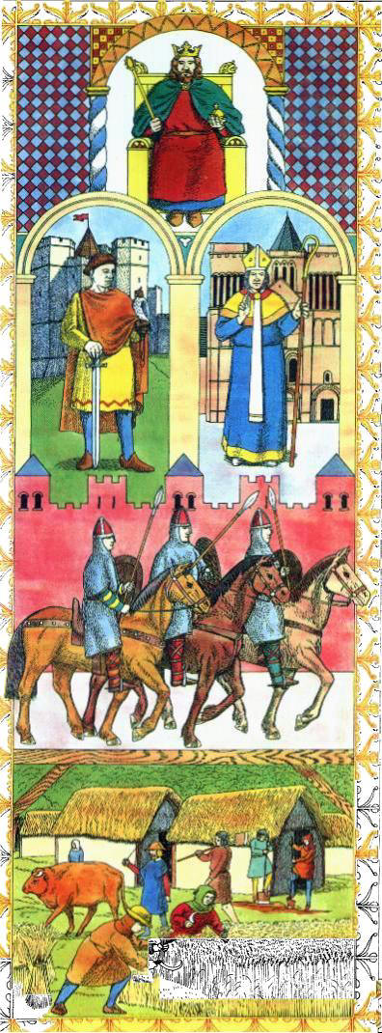
The King
This picture shows a king sitting at his throne.

The nobles and the Church.
This image shows a priest with a staff and a noble with a sword.

Knights (Lords).
This picture shows knights with sharp spears and shields riding on their horses maybe guarding the palace.

Peasants (Farmers and Fishermen)
This picture shows peasants gathering the crops which they were probably going to sell and keep some for them self.

Image source: http://publish.uwo.ca/~dmann/Feudalism%201.jpg

