 INFORMATION REPORT
When do I use it?
- To present information about a subject.
- To classify and /or describe using facts about the subject’s parts, behaviour and qualities.
- Reference articles, research assignments, lectures use this format.

SCAFFOLD

1. A general opening statement in the first paragraph

 This statement tells the audience what the text is going to be about.
 This can include a short description of the subject.
 This can include a definition of the subject.

2. A series of paragraphs about the subject

 Each paragraph starts with a topic sentence.
 The topic sentence at the beginning of each paragraph previews the information contained in the rest of the paragraph.
 Each paragraph should give information about one feature of the subject.
 These paragraphs may include technical language.

3. A concluding paragraph

 This paragraph signals the end of the text.
 It can summarise the report.



EXAMPLE OF INFORMATION REPORT
General classification
Butterflies are insects. With their almost endless variety of colours, shapes and sizes they are amongst the most beautiful and easily recognised of insects.
Written in the third person – e.g. their, they, the
Comparison
Like all insects they don’t have bones but they do have a light skeleton covering the outside of their bodies which are divided into three parts: a head, a thorax and an abdomen. They have six legs, two antennae, two eyes made up of lots smaller eyes. They breathe through small holes in their sides.
Sentences containing more than one fact
Topic sentence
Description written in related groups of information
Butterflies have four large wings: a pair in the front and a pair of back wings. These are generally brightly coloured and have different patterns on the top and the underneath. Although they rest with their wings folded up, butterflies often spread their wings to warm-up in the sun.
Action verbs
Written in past tense
All butterflies feed by drinking through a straw-like tube called a proboscis which is coiled when not in use. The proboscis is the elongated part of the mouth.
Specialised vocabulary
Source: Breihdahl
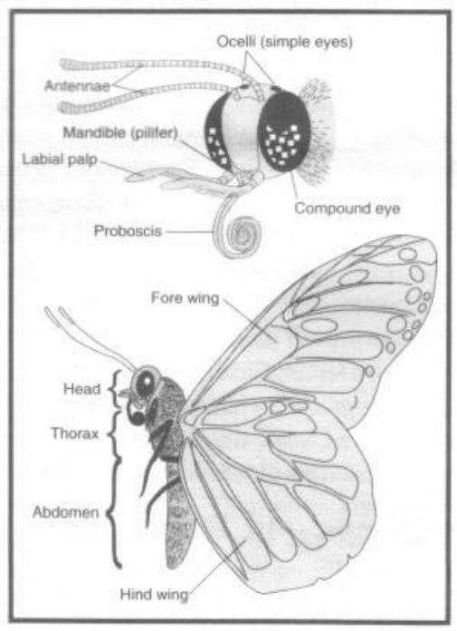
Factual and precise adjectives
Visual text (labelled diagram) to enhance written text

