DRAWING CONCLUSIONS ABOUT THE USEFULNESS OF SOURCES

A useful source will add to your understanding of a historical period or event. The source needs to be relevant to your investigation and reliable. Ask yourself the following questions to determine the usefulness of a source:

• What type of source is it?
• Who wrote or created the source?
• Why was it written or created?
• Is it balanced or does it present only one point of view?
• Is it based on fact or opinion?
• Is there enough information and detail for the source to be of use to my inquiry?
• Does the information support and reinforce evidence from other sources?

The Battle of Hastings
The Battle of Hastings is one of the most significant battles in medieval Europe. It took place at Hastings in the south of England on 14 October 1066. The forces of the newly crowned king of England, Harold Godwinson, and William, Duke of Normandy, fought for the English throne. Harold was killed, and William was crowned king. This marked an end to Anglo- Saxon rule and the start of Norman rule in England.

Norman rule changed England forever – there were changes to the government, the Church, language and everyday life.

There are a number of different primary and secondary sources that retell the events of the Norman invasion and the Battle of Hastings. Three of these are described here:

1 The Bayeux Tapestry
One of the best primary sources is a 70-metre embroidered cloth known as the Bayeux Tapestry. It is a valuable document for the study of medieval weapons, warfare, architecture and clothing. It tells a story that begins around 1064 and ends in October 1066, with the death of King Harold at the Battle of Hastings. The exact origin of the tapestry is not known. One story claims that Matilda, William the Conqueror’s wife, sewed the tapestry. Other accounts claim it was probably commissioned in the 1070s by Bishop Odo of Bayeux, half-brother of William the Conqueror.

2 The Anglo-Saxon Chronicle
Written between the 9th and 12th centuries, the Anglo- Saxon Chronicle is a collection of seven volumes written by Anglo-Saxon monks in England. The Chronicle is written in Old English (the language of the Anglo-Saxons).

It recounts events and tells the story of England. A few brief descriptions of the Battle of Hastings appear in the Chronicle, but in some cases the entries were made several years after the battle took place.

Source 7.41
William came against him [Harold] by surprise before his army was drawn up in battle array [formation]. But the king [Harold] nevertheless fought hard against him [William] … and there were heavy casualties on both sides.

Many English deserted from the line, and very few stood fi rm with him [Harold]: yet from the third hour of the day until evening he resisted his foes with the utmost courage ... But alas, after so many had fallen on both sides, Harold himself was slain [killed] as the evening and many good men. God granted the victory to the [Normans] because of the sins of the English people.

An extract from the Anglo-Saxon Chronicle, retelling the events leading up to the death of King Harold

Source 7.42 A section of the Bayeux Tapestry depicting William and his Norman troops fighting the English army
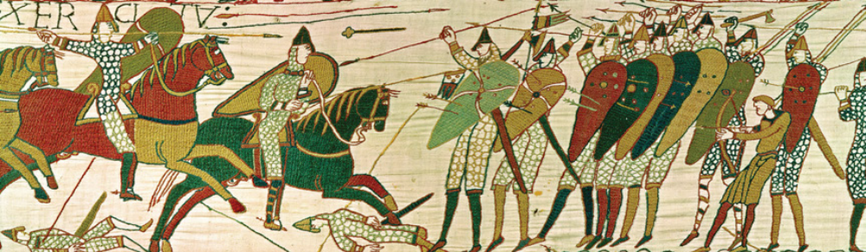
3 The writings of William of Poitiers
William of Poitiers served as a knight in Normandy before becoming a priest. When
William, the Duke of Normandy, became king of England in 1066, William of Poitiers was appointed his personal chaplain. In 1073, William wrote The History of William the Conqueror. The book contains the most detailed written account we have of the Battle of Hastings.

Source 7.43
[The Duke of Normandy] hastily built a fleet of three thousand ships. At length he brought this fleet to anchor at St Valery in Ponthieu [in France] where he filled it with mighty horses and most valiant men, with hauberks [armour] and helmets. Then when a favourable wind began to blow, he set sail, and crossing the sea he landed at Pevensey [in England] where he immediately built a castle with a strong rampart [defensive wall].

An extract from The History of William the Conqueror by William of Poitiers, retelling the events leading up to the Battle of Hastings January 1066

Apply the skill
Use the sources and information in this activity to draw conclusions about their usefulness and reliability. When examining a range of different sources, it is often helpful to gather your information into a table or graphic organiser.

- Use the table below to complete it using the information provided. Alternatively, create your own graphic organiser (such as a Venn diagram) to draw conclusions about the sources.

Source name | Source type  (primary/  secondary) | Key questions to determine the  usefulness of each source
Source 1:  The Bayeux  Tapestry | Type of source:  Primary. | • Who created the source?  William the conqueror’s wife.  • Why was it created?  To show the victory of the Normans over the Anglo-Saxons.  • Is it balanced or does it present only one point of view?  It only presents one point of view.
Source 2:  The Anglo-Saxon  Chronicle | Type of source:  Primary | • Who created the source?  It is not shown.  • Why was it created?  To tell the people about the history and battle.  • Is it balanced or does it present only one point of view?  It is balanced.
Source 3:  The writings of  William of Poitiers | Type of source: | • Who created the source?  William of Poitiers.  • Why was it created?  To tell the story of William the conqueror  • Is it balanced or does it present only one point of view?  It only presents one point of view.

- In what ways are the three sources similar? In what ways are they different?
They all are primary sources so they are all similar.
3 Based on your findings, which of the three sources provided do you think is the most reliable and useful? Give reasons for your answer.
The Anglo-Saxon chronicles, because people tell more than what actually happened in stories or paintings about war, but not when telling the story of a country.

