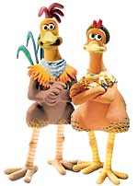

Planning Document- Creative Response to a Text
Choose the form you wish to write in. Letter Writing or News report?
Define the key words or phrases in the topic

If there is a tag word like “discuss” or “describe”
What is this asking you to do?

Reword the topic in your own words
Who is the audience for your writing?
What is the main idea you will write about?
What will the tone of your writing be? (e.g.. happy, victorious, angry)
Which characters will you include?
What setting descriptions will you use?
(What do you see, hear, feel, smell, taste?)
Outline 3 or 4  main ideas you will use to respond to the prompt | 1.  2.  3.  4.
What quotes will you use from the film?

