- 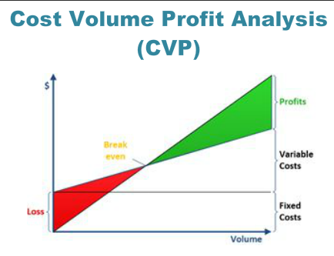

- Fixed costs are costs that remain the same in total (within a given range of activity and timeframe) irrespective of the level of activity.

- Variable costs are costs that change in total as the level of activity changes.

- Relevant range is the activity range over which the fixed costs remain constant.

- Mixed costs are costs that possess fixed and variable characteristics.

- Fixed cost behaviour

- 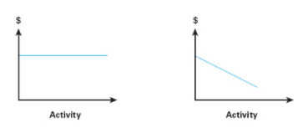

- Variable Cost behaviour

- 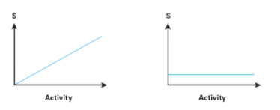

- Mixed cost Behaviour

- 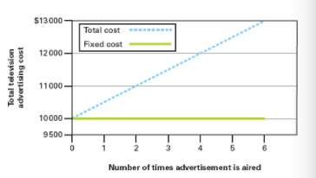

- examples of fixed/ variable and mixed costs

- fixed costs:- Insurance, administration costs, contracted cleaner, rent, managers salary

- Mixed costs:- Water

- Variable costs:- food packaging, food used in production, casual staff wages

- Breakeven: The point at which costs are covered by the income

- Contribution Margin= Selling price – Variable costs

- Contribution Margin ratio= contribution margin per unit
- Selling price per unit

- Breakeven calculation (in units)=
- Fixed costs $
- Contribution Margin per unit $

- Breakeven in sales ($)
- Fixed costs
- Contribution Margin

- Break even + target profit
- Fixed cost + Target profit ($)
- Contribution Margin per unit ($)

- Operating leverage= Mix between fixed and variable costs in the cost structure of an entity.

- High fixed costs than variable costs= high operating leverage
- Low fixed costs than variable costs= low operating leverage

