Marketing Tutorial Week 7

CLASSIFICATIONS OF A CONSUMER PRODUCT

- Convenience-
- Buyer behaviour- staple, impulse
- Price- low
- Promotion- intensive
- Distribution- mass distribution by manufacturer
- Shopping-
- Buyer behaviour- greater
- Price- higher
- Distribution- selective
- Promotion-
- Specialty-
- Buyer behaviour- unique benefits
- Price- price high for the category
- Distribution- exclusive
- Promotion- targeted
- Unsought-
- Buyer behaviour
- Price
- Distribution
- Promotion

SERVICE CHARACTERISTICS

- Intangible- service lacks physical substance/ element
- Inseparable- product and provider cannot be separated
- Variability/ Heterogeneity- the service provided varies each time it is provided based on who, when, where.
- Perishability- cannot be stored
- Customer contact- the level of interaction between service provider and customer needed to deliver the service
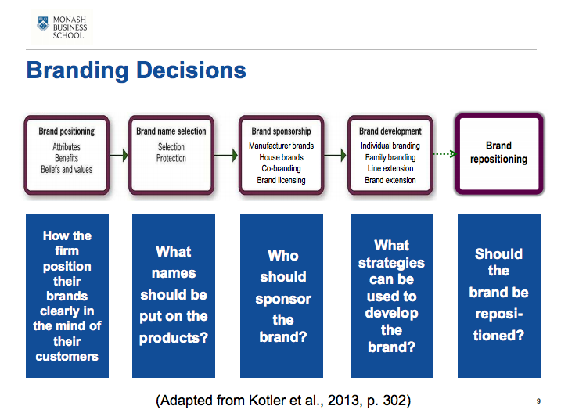

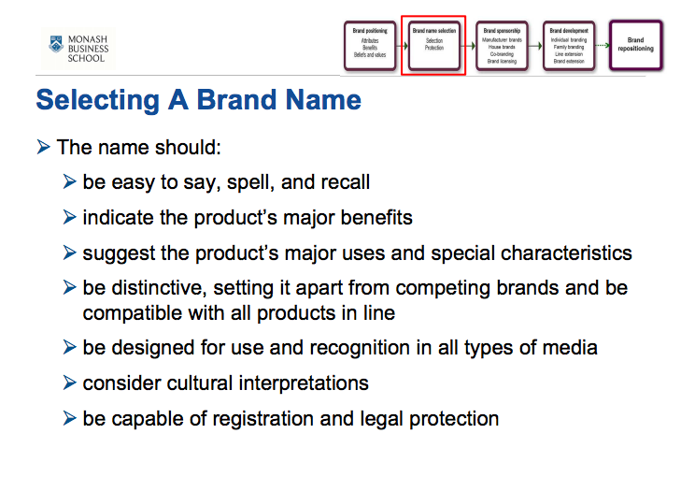
Difference between co-branding and brand licensing?

Co-branding
- Using two or more brands on one product
- The brands can be owned by the same company or different companies

Brand licensing
- An agreement whereby a company permits another permits another organisation to use its brand on other products for a licensing fee
- The brand licensee is responsible for all manufacturing, selling and advertising functions

COCO COLA LIFE

- Brand positioning- benefits based positioning
- Brand name- appropriate name as it insists that their product is more environmentally friendly, Coco calourie Cola would be more appropriate, they’ve changed the name to coco cola with stevia.
- Manufacturer brand
- Line extension

