
MARKETING STP ESSAY
FITBIT CHARGE 2
BY- POOJA SIVAKUMAR (28805925) WORD COUNT: TUTOR- JONATHON PURA

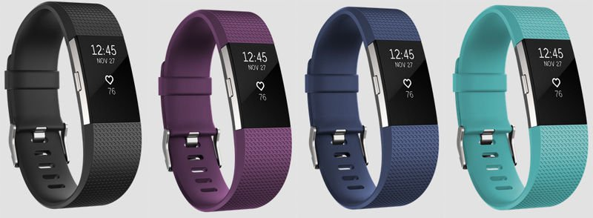
Introduction:

The purpose of this essay is to analyse Fitbit’s marketing strategy for its watches, in particular, Fitbit charge 2. Evaluating target segment profiles, target markets and examining the product positioning will enable to achieve the purpose of this essay.

“Sensors and wireless technology had advanced to a point where they could bring amazing experiences to fitness and health” (Appendix [1]); founders Eric Friedman and James Park took advantage of this and the “idea was born”. Fitbit rose to its prominence and sells award winning products carried in over 20,000 stores and 17 countries. Although they have developed many fitness apps and in built software within their fitness watches, they continuously face threats by the Jawbone and Apple’s fitness apps.

Marketing Strategy:

In order to market Fitbit watch range, they have adopted a concentrated marketing strategy. Adopting this strategy allows the company to specialise, which means the company “analyses characteristics and needs of a distinct customer group and then focuses all its energies and marketing effects on satisfying that group’s needs” (Pride, Ferrell, Lukas, Schembri, & Niininen, 2014, p.172). Marketing mixes varies based on the product features, promotion methods and prices. Though this is a risky type of strategy, as the company “puts all its eggs in one market” (Pride, Ferrell, Lukas, Schembri, & Niininen, 2014, p.173), meaning the amount of sales is directly dependent upon a single segment, if executed successfully the outcome of this strategy is enormous.

Wearable technology, like fitness trackers, smart watches, heart rate monitors and GPS tracking devices are taking the leading trend in the world (Thompson (2015)). Thus, Fitbit constantly develops new fitness trackers to capture the majority of the market.

Products are classified upon the fact when it was released to the market on their website, products range from as low as $79.95 (Fitbit Zip) to as high as $399.95 (Fitbit Surge). They have sub-headings under each watch which describe in a few words the purpose of fitness tracker, such as Fitbit charge 2 - heart rate + fitness wristband, gives the consumer an overview of what they can expect from this wearable.

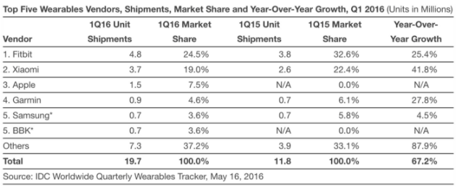
In 2016, while health is the main reason for the adoption of such wearables, another major reason was declared to be “social interaction” (Riccio, 2016). Fitbit shifts its focus from “fitness” to “fashion”, “[they] target fitness communities directly as the word - of - mouth buzz are crucial in growing trust in the brand” (Hobbs, 2016).
Fitbit remains as the top wearable, though it has “lost a significant amount of market share” (Fingas, 2016). The target market for Fitbit is primarily towards adults aged over 30-45 years and whose income is above the average Australian income. This market is also known to be tech-savvy, often those who are “fitness freaks” and hungry to find motivation. Their products meet the affordability range for markets outside their target market. The features that the Fitbit charge 2 encompasses, attracts their target market and persuades them to own a fitness tracker.

Hereafter, it can be comprehended that Fitbit is primarily focusing its products on adults aged over 30 to 45 years, whose income is above the average Australian income. In the words of Fitbit Marketing director, Lucy Sheehan, “We are focused on delivering the best technology but only on devices that people want to use…. Fitbit is just scratching the surface in bringing technology to the fitness sector” (Hobbs, 2016).

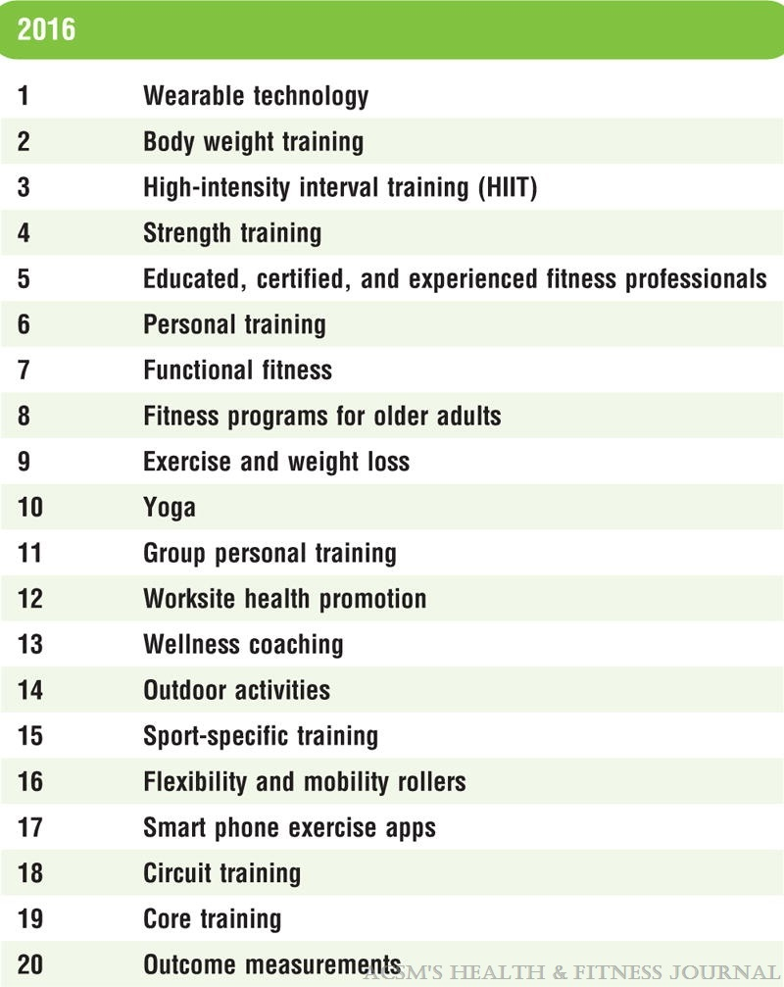
Fitbit’s Target Market
“Market segmentation is about dividing up the whole mass market into segments or groups of customers who have similar needs and wants” (Pride et.al, 2015).

Fitbit has a demand in the fitness wearable market, as people in Australia are becoming more health conscious and eager to keep up with the current trend. According to the worldwide survey of fitness trends 2016, wearable technology is the leading trend, meaning more than to stay healthy and being fit, people look at these variables as a tool which “aids social interaction” (Riccio, J. 2016.).

Many successful companies attribute their success to identifying and meeting the needs of certain kinds of customers (Dibbs &simkin, 1996, p. 4). The target market for Fitbit can be approximated to be adults aged between 22 to 45 years, who are earning income from USD$20,000 to $90,000 (Thompson, W, R. 2016).

References:
- Pride, W.M., Ferrell, O, C., Lukas, B, A., Schembri, S., & Niininen, O. (2015). Marketing Principles (2nd Asia Pacific edition). United Kingdom: Cengage Learning EMEA.
- Thompson, W, R. (2015). Worldwide survey of fitness trends for 2016: 10th anniversary edition. ACSM’S Health and Fitness Journal, 16(6), 9-18. DOI: 10.1249/FIT.0000000000000164
- Riccio, J. (2016). Report: rapid adoption of wearables, 2016. Retrieved from: https://www.digitalpulse.pwc.com.au/2016-wearable-statistics-report/
- Hobbs, T. (2016). Why Fitbit is shifting focus from fitness to fashion.
Retrieved from: https://www.marketingweek.com/2016/02/17/why-fitbit-is-shifting-focus-from-fitness-to-fashion/
- Fingas, J. (2016). Fitbit’s lead in the wearable world shrinks due to newcomers.
Retrieved from: https://www.engadget.com/2016/05/16/wearable-market-share-q1-2016/
- Dibb, S., & Simkin, L. (1996). The market segmentation Workbook: Target marketing for marketing managers. Retrieved from https://books.google.com.au/books?hl=en&lr=&id=1t5ftfVdKRcC&oi=fnd&pg=PR15&dq=related:7xqSYCZZH0YJ:scholar.google.com/&ots=ROvtDgrbg6&sig=ldwDJhOatoXogvuVLIktgwLDAz4#v=onepage&q&f=false

Appendix:
- Fitbit (https://www.fitbit.com/au/about
- https://www.fitbit.com/au/store
- https://www.youtube.com/watch?v=PxpxRoWmjq8&spfreload=5
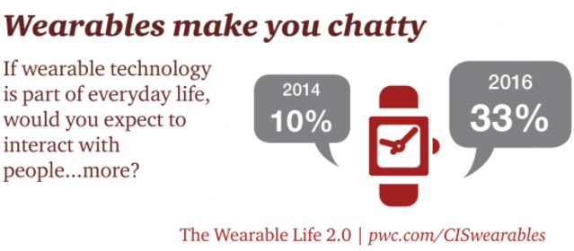
- Riccio, J. (2016). Report: rapid adoption of wearables, 2016. Retrieved from: https://www.digitalpulse.pwc.com.au/2016-wearable-statistics-report/

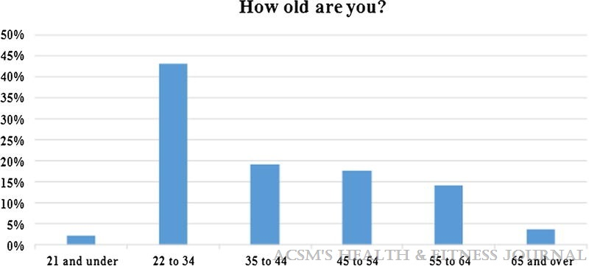
- Thompson, W, R. (2015). Worldwide survey of fitness trends for 2016: 10th anniversary edition. ACSM’S Health and Fitness Journal, 16(6), 9-18. DOI: 10.1249/FIT.0000000000000164

