
MARKETING STP ESSAY
FITBIT CHARGE 2
BY- POOJA SIVAKUMAR (28805925) WORD COUNT: 1658 words TUTOR- JONATHON PURA

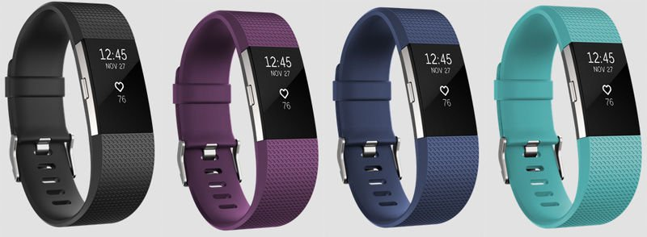
Introduction:

This essay analyses Fitbit’s marketing strategy for its watches, in particular, Fitbit charge 2. Evaluating target segment profiles, target markets and examining the product positioning will enable to achieve the purpose of this essay.

“Sensors and wireless technology had advanced to a point where they could bring amazing experiences to fitness and health” (Appendix [1]); founders Eric Friedman and James Park, took advantage of this and the “idea was born”. Fitbit rose to its prominence and sells award winning products carried in over 20,000 stores and 17 countries. Although they have developed many fitness apps and in built software within their fitness watches, they continuously face threats by the Jawbone and Apple’s fitness apps. Currently Fitbit charge 2 has taken predominance in the fitness wearables market, due to its prominent features and outlooks.

Targeting Strategy:

In order to market Fitbit watch range, they have adopted a concentrated marketing strategy. Adopting this strategy allows the company to specialise, which means the company “analyses characteristics and needs of a distinct customer group and then focuses all its energies and marketing effects on satisfying that group’s needs” (Pride, Ferrell, Lukas, Schembri, & Niininen, 2014, p.172). Marketing mixes varies, based on the product features, promotion methods and prices. Though this is a risky type of strategy, as the company “puts all its eggs in one basket” (Pride, Ferrell, Lukas, Schembri, & Niininen, 2014, p.173), meaning the amount of sales is directly dependent upon a single segment, if executed successfully the outcome of this strategy is enormous.

Wearable technology, like fitness trackers, smart watches, heart rate monitors and GPS tracking devices are taking the leading trend in the world (Thompson (2015)). Thus, Fitbit constantly develops new fitness trackers to capture the majority of the market.

Products are classified upon the fact when it was released to the market on their website, products range from as low as $79.95 (Fitbit Zip) to as high as $399.95 (Fitbit Surge), Fitbit charge 2 has a price of AUS $249.95. They have sub-headings under each watch which describe in a few words the purpose of fitness tracker, such as Fitbit charge 2 - heart rate + fitness wristband, gives the consumer an overview of what they can expect from this wearable.

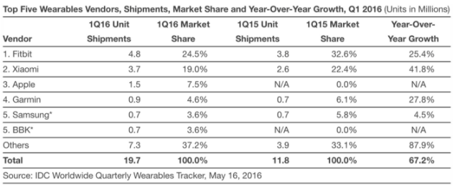
In 2016, while health is the main reason for the adoption of such wearables, another major reason was declared to be “social interaction” (Riccio, 2016). Fitbit shifts its focus from “fitness” to “fashion”, “[they] target fitness communities directly as the word - of - mouth buzz are crucial in growing trust in the brand” (Hobbs, 2016).
Fitbit remains as the top wearable, though it has “lost a significant amount of market share” (Fingas, 2016). The target market for Fitbit is primarily towards adults aged over 30-45 years and whose income is above the average Australian income. This market is also known to be tech-savvy, often those who are “fitness freaks” and hungry to find motivation. Their products meet the affordability range for markets outside their target market. The features that the Fitbit charge 2 encompasses, attracts their target market and persuades them to own a fitness tracker.

Hereafter, it can be comprehended that Fitbit is primarily focusing its products on adults aged over 22 to 45 years, whose income is above the average Australian income. In the words of Fitbit Marketing director, Lucy Sheehan, “We are focused on delivering the best technology but only on devices that people want to use…. Fitbit is just scratching the surface in bringing technology to the fitness sector” (Hobbs, 2016).

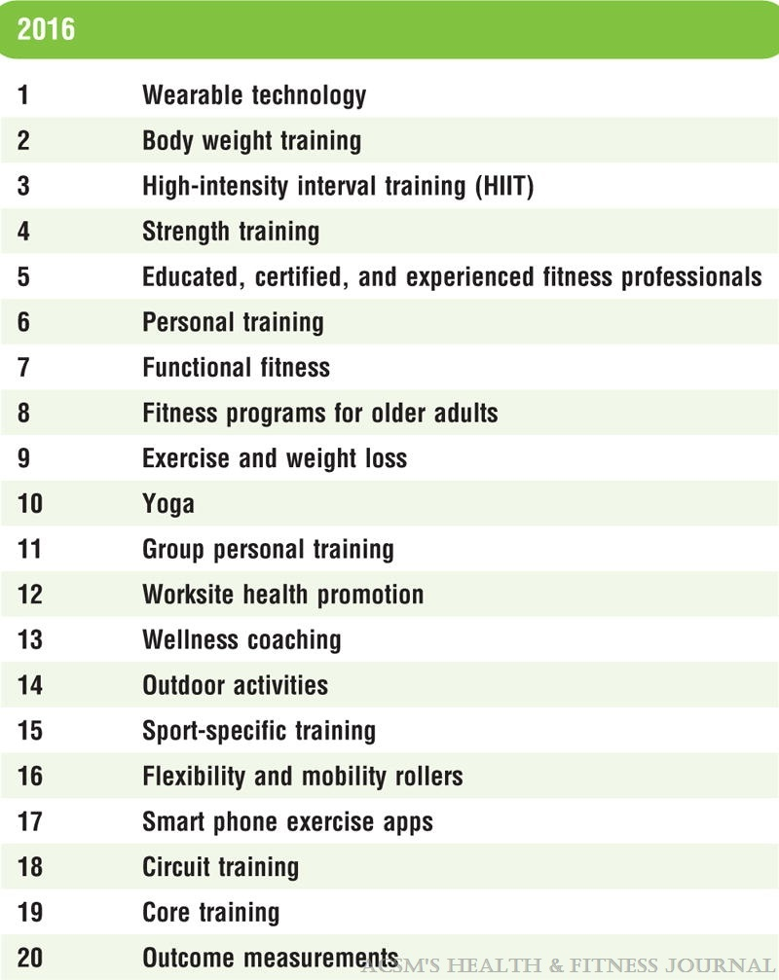
Fitbit’s Target Market

Sourced From (Thompson, W, R. 2015)

“Market segmentation is about dividing up the whole mass market into segments or groups of customers who have similar needs and wants” (Pride et.al, 2015). Given the current trends in the market, very few companies are able to meet the needs of their customers in their chosen target market (Dibb & Simkin, 1996, p.4).

Fitbit has a demand in the fitness wearable market, as people in Australia are becoming more health conscious and eager to keep up with the current trend. According to the worldwide survey of fitness trends 2016, wearable technology is the leading trend, meaning more than to stay healthy and being fit, people look at these variables as a tool which “aids social interaction” (Riccio, J. 2016.).
Many successful companies attribute their success to identifying and meeting the needs of certain kinds of customers (Dibbs & Simkin, 1996, p. 4). The target market for Fitbit can be approximated to be adults aged between 22 to 45 years, who are earning income from USD$20,000 or more (Thompson, W, R. 2016), (Appendix [5]). Fitbit has emphasised its features complementing the fitness lifestyle, pulse rate, cardiovascular fitness level, all-day activity tracking, auto sleep tracking, silent alarms, smart track, reminders to move, connected GPS and many more (Appendix [4]).
In order to compete with Apple Watch or iwatch, Fitbit surge (Fitness super watch), which displays additional features such as smartphone notifications, touch screen display, music control, multi-sport modes and GPS tracking, this allows Fitbit retain and retreat their current customers and new customers.
Fitbit’s marketing strategy targets employees from low income to medium-high income, and is now becoming an affordable option for tracking fitness (Jary, 2017).

Segmentation variables:

Segmentation “enables companies to target specific groups of customers, a customer segmentation model allows for the effective allocation of marketing resources and the maximization of cross- and up-selling opportunities” (Melnic. 2016).

Demographic segmentation is market segmentation based on age, gender, income, education and ethnicity, marketers rely on these demographic characteristics because they represent a connection between customers’ needs and purchasing behaviour (Pride et.al, 2015, p. 159). For Fitbit charge 2, the target market can be restricted by income and age, as the income for the target market is aimed to be USD $20,000 or more. The product is relatively expensive, priced at $249.95, hence employees below the target range may not wish to obtain this product due to restriction of prioritising the needs against the wants. The target market can be restricted by age, as fitness oriented adults aged between 22 years and 45 years tend to be the primary users. In the TV commercial ad, it portrays, individuals working out in the gym, sport players and business professionals; hence, it can be assumed that they earn a medium to high income.

Psychographic segmentation is a type of segmentation based on factors such as personality, lifestyles and motives (Pride et.al 2015). This is the most important segmentation method used by Fitbit. The lifestyle, vales and beliefs of consumers towards fitness are crucial for the promotion of this product. Throughout all the advertisings of Fitbit Charge 2, fitness is of key importance. Attitude towards keeping healthy and staying fit while keeping up the current trend is prominent and therefore, the current trends and the importance given to fitness by the Australian consumers is taken to the advantage and features that “aid in social interaction”, and personal wellbeing are innovated by Fitbit.

Product positioning:

Product positioning refers to the “creating and maintaining a certain concept of a product in customer’s minds” (Pride et.al 2015, p. 179); “there is a positive relationship between the positioning related decision and the brand success…” (Shrafat, 2014).

Fitbit has taken prominence in the fitness wearables industry and attempts to compete with brands like Garmin, Apple, Nike, Jawbone and Xiaomi Mi, it makes more effort in competing with the products with high brands, hence putting their rivalries in a “weak position” (Pride et.al 2015, p. 179). Hence, this gives Fitbit an opportunity to optimise their market share.

Three positioning strategies explored, are surrogate positioning strategy, direct benefit positioning and feature positioning strategy. Surrogate positioning strategy “emphasises on certain usage of brand”, feature-positioning strategy “emphasises mainly on features of the brand” (Shrafat, 2014), while brand positioning emphasises on the unique benefits of the product. On the other hand, according to Fuchs and Diamantopoulos (2010), the least efficient positioning is said to be feature positioning, therefore, direct benefit positioning strategy is said be the most effective.
Thus, Fitbit promotes Fitbit charge 2’s multi-sport mode, interchangeable band, connected GPS and long battery life (Appendix [3]).

The advantages of wearable lasting as long as 5 days tracking all day and night activity, provides the customers with a unique benefit. Fitbit constantly attempts to match its leading competitors or in most cases out match with features like auto sleep tracking and silent alarms, reminders to move, interchangeable bands, connected GPS, smartphone notifications and many more, which constantly proves them to be innovative and creative.

However, a misfortunate news in the media about Fitbit flex 2 exploding and causing second degree burns, has lead to the loss of trust in the brand and slight drop in sales.

Perceptual Mapping:
High capability

Apple watch
Garmin Vivosmart HR+

Fitbit charge 2

Xiaomi Mi Band 2
Low Price
High price

Nike Fuelband

Jawbone’s up

Low capability

In this map, fitness wearables, Apple watch, Garmin Vivosmart HR+, Nike fuelband, Jawbone’s up, Xiaomi Mi Band 2 and Fitbit charge 2 are ranked according to their price and capability (functional features of the wearable). These two are used as distinguishing variables among the top six fitness wearables in the market. As stated by Stables (2017), Fitbit charge 2 was on the verge of winning the fitness tracker of the year at the Wearable tech awards 2016, unfortunately due to issues with “screen responsiveness, a fiddly interface and flaky heart rate tracking….falls short for the more active user”.
The amount of features and the speed of the wearable had an impact on the price of the product (Stables, 2017).
Therefore, although not completely causational, the additional features on Fitbit charge 2 have to the higher price range compared to the other products. The strong features and tendency to “learn and innovate” (Appendix [1]) has made Fitbit charge 2 a vigorous competitor in the fitness wearable market.

Conclusion:

Therefore, the STP findings enhance the opportunity of an organisation to determine and sustain a healthy bond with customers. Fitbit Charge 2 through the use of their strategies cater for the needs of a specific segment of the market, they attempt in satisfying the unique needs of customers within the segment too.

References:

Dibb, S., & Simkin, L. (1996). The market segmentation Workbook: Target marketing for marketing managers. Retrieved from https://books.google.com.au/books?hl=en&lr=&id=1t5ftfVdKRcC&oi=fnd&pg=PR15&dq=related:7xqSYCZZH0YJ:scholar.google.com/&ots=ROvtDgrbg6&sig=ldwDJhOatoXogvuVLIktgwLDAz4#v=onepage&q&f=false

Fingas, J. (2016). Fitbit’s lead in the wearable world shrinks due to newcomers. Retrieved from: https://www.engadget.com/2016/05/16/wearable-market-share-q1-2016/

Hobbs, T. (2016). Why Fitbit is shifting focus from fitness to fashion.
Retrieved from: https://www.marketingweek.com/2016/02/17/why-fitbit-is-shifting-focus-from-fitness-to-fashion/

Jary, S. (2017). Fitbit vs Apple watch.
Retrieved from: http://www.pcadvisor.co.uk/feature/wearable-tech/fitbit-trackers-vs-apple-watch-2017-3612954/

Melnic, E, L. (2016). How to strengthen customer loyalty, using customer segmentation? Bulletin of the Transilvania University of Brasov. Series V: Economic Sciences, 9(2), 51-60. Retrieved from: http://web.a.ebscohost.com.ezproxy.lib.monash.edu.au/ehost/pdfviewer/pdfviewer?sid=691e7723-5766-40e4-8b9e-e54999e8de81%40sessionmgr4007&vid=8&hid=4109

Pride, W.M., Ferrell, O, C., Lukas, B, A., Schembri, S., & Niininen, O. (2015). Marketing Principles (2nd Asia Pacific edition). United Kingdom: Cengage Learning EMEA.

Riccio, J. (2016). Report: rapid adoption of wearables, 2016. Retrieved from: https://www.digitalpulse.pwc.com.au/2016-wearable-statistics-report/
Shrafat, A, S. (2014). Consumer psyche and positioning strategies. Pakistan Journal of Commerce & Social Sciences, 8(1), 58-73.
Retrieved from: http://web.a.ebscohost.com.ezproxy.lib.monash.edu.au/ehost/pdfviewer/pdfviewer?sid=610b54ea-50ba-4101-afdd-523f3e296e7b%40sessionmgr4009&vid=6&hid=4109

Stables, J. (2017). Best fitness trackers 2017: Fitbit, Garmin, Misfit, Withings and more.
Retrieved from: https://www.wareable.com/fitness-trackers/the-best-fitness-tracker

Thompson, W, R. (2015). Worldwide survey of fitness trends for 2016: 10th anniversary edition. ACSM’S Health and Fitness Journal, 16(6), 9-18. DOI: 10.1249/FIT.0000000000000164

Appendices:

- Fitbit official website, about their company.
Retrieved from: https://www.fitbit.com/au/about
- Fitbit official website: Fitbit variety of wearables.
Retrieved from: https://www.fitbit.com/au/store
- Fitbit official website: Fitbit charge 2. Retrieved from: https://www.fitbit.com/au/shop/charge2
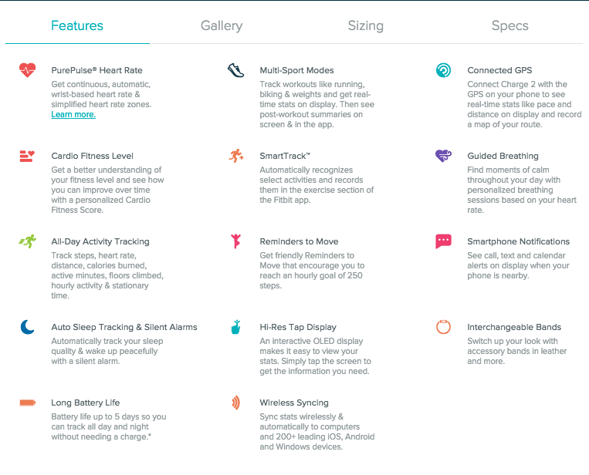
- https://www.youtube.com/watch?v=PxpxRoWmjq8&spfreload=5
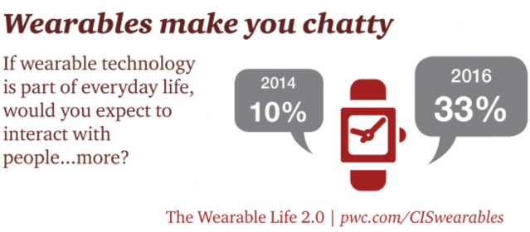
- Riccio, J. (2016). Report: rapid adoption of wearables, 2016. Retrieved from: https://www.digitalpulse.pwc.com.au/2016-wearable-statistics-report/

- Thompson, W, R. (2015). Worldwide survey of fitness trends for 2016: 10th anniversary edition. ACSM’S Health and Fitness Journal, 16(6), 9-18. DOI: 10.1249/FIT.0000000000000164

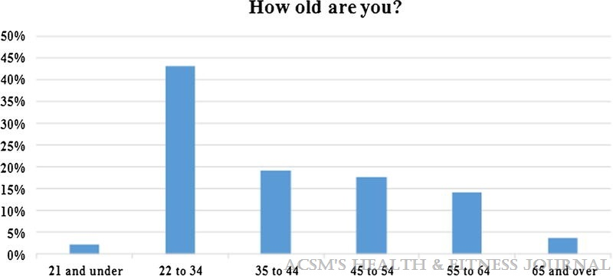

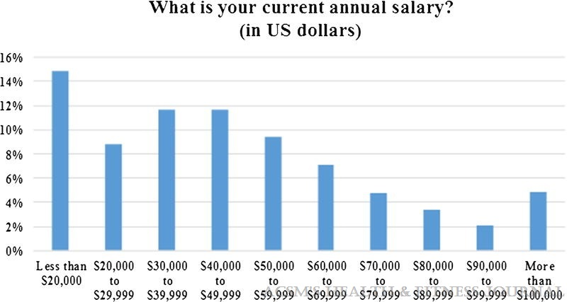
- Web staff. (2017). Fitbit investigating claim of explosion, injury to Milwaukee woman. Retrieved from:http://kdvr.com/2017/04/22/fitbit-investigating-claim-of-explosion-injury/

