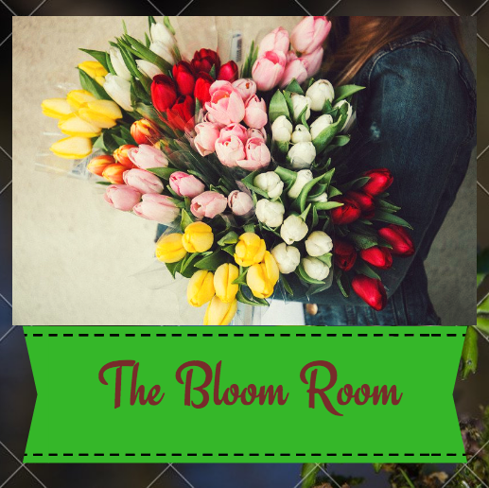
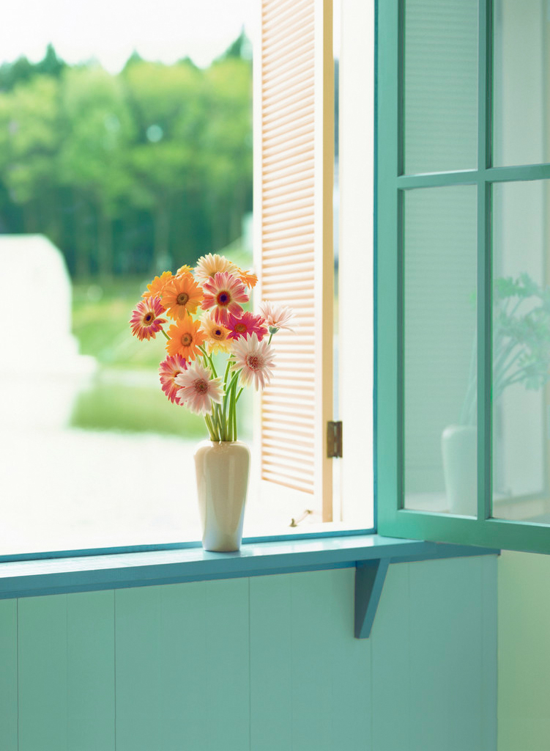
Hand picked flowers just for you….

BUSINESS PLAN
Marchella Davis, Pooja Sivakumar, Jack, Alice
THE BLOOM ROOM

The Bloom Room

Business structure

The name of our business is The Bloom Room, which signifies freshness and vibrancies in the flowers we sell. Our vision is to provide the best florist services in Melbourne for wedding and other events. The business structure we have chosen to adopt is a sole trader. Sole trader is a business structure whereby a person trading as an individual is legally responsible for all aspects of the business. This structure was deliberately chosen due to the advantages outweighing the disadvantages. It is beneficial to be a sole trader because the owner has complete control over the business decisions and it allows complete flexibility in terms of the hours worked. This enables the owner to work extended working hours without having to spend more on labour expenses. Also, initially to reduce the start-up costs this structure was the most efficient and effective. However, there are disadvantages to this strategy, there is no separation between the liabilities of the business and the owner, owner is completely accountable for the liabilities of the business even to the extend of his personal assets. In addition, as elder’s say, “two heads are better than one”, his time, knowledge and resources limit the owner. However, in this case, the most suitable structure would be the sole trader, despite of the disadvantages that lie beneath. Nevertheless, through careful planning and detailed analysis of the environments of the business, Freddy has the potential to run a very successful florist business.

Location

The Bloom Room Florist will be located in Essendon, in a large warehouse due to the high level of storage space we require to fulfill our services. It is economically unviable for us to operate in an inner-city suburb as the amount of land we require would be too expensive. We provide floral arrangements for large scale events rather than daily flower requirements, hence our location doesn't need to be in places with high density population. However the location of Essendon still allows us to be in a close proximity to the city and surrounding areas where events may be held. A major client of ours is Flemington racecourse as we have secured the contract to do their floral arrangements. As a result being located in Essendon will allow us to satisfy the demands of both our biggest and most profitable client. Another key aspect in our decision to operate out of Essendon is that We will purchase our property through a combination of capital contribution and bank loan rather than renting the space, and a property in Essendon fits in our budget.

Business plan

Executive summary

The main goal of The Bloom Room is to establish a small, private company that specialises in supplying flowers for Melbourne-based events, in particular weddings. We plan to begin through hiring 4 full time employees to work in a warehouse we have bought for $300,000 in Essendon. We also plan on hiring 2 casual delivery drivers. Our major expenses will include our wages, our raw materials, insurance, advertising and our non-current assets such as our warehouse and van.

Background

The Bloom Room exists to supply wholesale flowers and arrangements for large scale, high-end events, in particular, weddings. The company intends to become known as one of the largest and most sought after florists catering for wedding events in the Melbourne marketplace, supplying high quality and decadent flower arrangements to at least 224 weddings per year. We aim to employ at least 4 full time staff on a salary of $40,165 per annum. We will promote the interests of our employees by keeping them well motivated and well paid, offering secure employment as well as constant training and support. By advertising our products as a packaged deal for weddings, we are looking to minimize the stress for wedding goers whilst ensuring that all floral requirements are met. We want to be known for our quality and customer care, valuing the need to tailor each floral arrangement to the individual client, creating a business that customers can rely on. The business, owned by Freddy, will already have a built-up, high-profile clientele base due to Freddy’s wife’s 22-year history in event coordination, an industry where she is respected and trusted. Freddy also has over 10 years experience in retail floristry, thus providing a strong and knowledgeable leadership team for this business venture.

Marketing

The Australian Flower Industry comprises of a little under 900 flower farms and foliage growers, supplying almost 2000 florists and retailers. Majority of the retailers are in NSW (740) closely followed by VIC (526) (Australian Flower Industry, 2017). Event floristry is a type of Flower Retailing, which has a combined annual revenue of $692 million, and has shown a negative annual growth of 1.3% between 2012-2017 (Ibis World, 2016). Replacement competitors include the use of false flowers for events, and in terms of direct competitors there are many retail florists that double or specialise as event florists. For Freddie’s Flowers based in Melbourne, these competitor company’s include ‘Kate Hill Flowers’, ‘Melbourne Event Florals’, ‘Thrive Flowers & Events’ and ‘Botanics of Melbourne Florists’; all of which have an established position within various suburbs of Melbourne. Potential allies for The Bloom Room would include ‘The Pavilion Fitzroy Gardens’, ‘San Remo Ballroom’ , ‘The Point Albert Park’ , ‘Leonda By the Yarra’ and ‘Melbourne Town Hall’; which are all prime locations for weddings and events in Melbourne. There is seasonality in this industry as certain flowers only grow at specific times of the year depending on the amount of sunlight available, also more weddings tend to be over summer so the December to February period is a lot busier than June to September.

STRENGTHS  - Specialising in wedding and event floristry based on years of experience in retail floristry and events  - Warehouse location in North Melbourne making it easy to distribute flowers quickly and efficiently  - Supports local florist wholesalers | WEAKNESSES  - Due to using fresh and local flowers, and all boutiques and arrangements done by hand, can be costly for clients  - Small team of staff limiting the number of weddings that can be serviced  - Only one warehouse location making the geographic scope of delivery quite limited
OPPORTUNITIES  - Partnerships with high standing venues across Melbourne  - Extend the event floristry service beyond weddings  - The opening of a display suite in a busy Melbourne strip to access more clients | THREATS  - Existing competitors with large market share and established client base  - The false flower industry on the rise as a more cost-effective option  - Weather conditions in Melbourne could potentially damage/ flood the seasonal produce

Marketing plan

- Product Service
The Bloom Room provides a customised floral arrangement, set up and clean up service for weddings and events, with locally sourced flowers and arrangements made to the preference of the client.
- Target Market
Individuals between the age of 25-50 in the Melbourne area seeking an event or wedding florist, alongside event venues within the Melbourne area that are wanting to sign on a contracted florist for all events held there.
- Distribution
The Bloom Room has a warehouse in North Melbourne from which there are delivery drivers to take the products and staff to and from the event scheduled.

- Promotion, Advertising and ICT Strategy
Given The Bloom Room is a new business, there is a need to raise brand awareness to all potential clients so this company is within their consideration set when event floristry is needed. This awareness is to be raised by various promotional and advertising tools within a clear ICT strategy. Features of this strategy include:
- Website – The Bloom Room will have a website developed of which is predominantly visual, appealing to the consumer’s sense of aesthetics and visual appeasement. The website will have background information on the business establishing Freddy’s credibility as a retail florist and his wife as an event manager. The website will have testimonials, an enquiry form and sample price list so clients can evaluate their budget.
- Social media – The Bloom Room will have a strong presence on social media, including Twitter, Facebook and Instagram. The content will involve a lot of photography based on arrangements, and video montages of arrangements we have constructed at events. This is to engage consumers and to display our high-quality service. There will be two-way conversation with consumers on these platforms with quick response to questions in order to maintain positive brand image and good publicity. It will also promote Freddy’s Website.
- Business cards in event venues – The Bloom Room will have business cards printed and request they be displayed at the front desk of event venues to increase exposure to potential clients to both companies. This may also stimulate the potential partnership between Freddy and the event venue.
- Database email service – website subscribers will receive bi weekly personalised emails with a selection of tailored arrangements to preferences they entered upon their subscription. This will develop favourable brand associations and increase brand loyalty by strengthening the brand-consumer relationship.

Pricing Strategy

We charge a $3000 flat rate inclusive of all bridal party bouquet, table decoration displays inclusive of vase hire, and charge an extra $100 per table after 15 tables at the event. Our strategy is flexible for smaller events however for a standard wedding this is the going rate. It is a high quality service including all set-up and clean-up, and constant availability for client conversation and assistance.

Operations and Production

Legal and Licensing Requirements, it is critical that any legal business that operates in Australia has a clear legal structure, business name and an Australian business number. Our business name is “The Bloom Room” and we have an ABN # 76 293 357 412.

Organisational Structure is the way the business has arranged its labour and its resources in achieving its objectives. It is essential to include the management details in the business plan as well. The owners and management of ‘The Bloom Room’ are:
Names: Freddy Brown and Caroline Brown
Address: 512 Greenhill Drive, Essendon
Phone number: 0412 345 676
As part of abiding by law and to keep up with the statutory obligations, “The Bloom Room” has hired an advocate, James Parker. James will be reviewing the business on a quarterly basis and providing advice to Freddy and Caroline as to the amendments that are required to be made in the business. Fortunately, since Freddy has completed his Masters degree in commerce and has an experience of working in the accounting field for over 10 years, there is no need to hire an external accountant or outsource for accounting purposes. This enables the business to save a tremendous amount of money in outsourcing.
As our business is a sole trader, we are restrained by our hiring capacity, meaning we are not allowed to hire more than a certain number of people. Since Freddy and Caroline are willing to roster themselves in managing the business, just one additional staff on a casual basis would be sufficient to cover for days when both are unable to supervise the business. A casual staff has been arranged, Kevin May, he is a friend of Freddy and is willing to work for him on a casual basis for $19 per hour. In order for Freddy and Caroline to have a work life balance, they have collaboratively decided to take weekends off, meaning that they have arranged for Kevin to work on the weekends. In terms of the title within the business, Freddy is the Managing Director and Chief Financial Officer (CFO) whereas Caroline will be store manager.

Equipment required are to be arranged in the near future for telephone line, mobile phone, internet access and an interior office. Inventory (flowers) will be purchased from Tulip Resort on a weekly basis for $10 per box and will be bunched at our warehouse as per our client’s requirements and needs.

However, James, our legal advisor has suggested to take a liability insurance which ensures that Freddy and Caroline are not trapped in the unlimited liability of the business structure. Freddy has arranged for a meeting with the MLC Insurance to liaise and buy insurance for the business and for personal protection from the liability of the business.

Financial Projections

Our sales revenue has been calculated based on market research (IbisWorld, 2017) and our previous knowledge on flower prices from past business ventures. Our prices start at a flat rate of $3000. This includes bridal bouquets, ceremony flowers, table arrangements and all other standard floral needs. An additional $100 will be charged per table after 15 tables (Jones, L.G 2014). Assuming that 4 weddings will be catered for per week, thus 224 weddings provided for over 12 months, this will generate a total revenue of $672,000 per annum.

From past experience, our expected expense on raw materials per wedding will need to include all wholesale flowers, preservatives added and accessories. From market prices, our overall costs of goods sold is expected to be $1500 (Marinelli, K 2010). Therefore we will have a 100% markup on this price in order to charge $3000 per customer. Using these projections, Gross Profit can be calculated to be $336,000 ($672,000 - $336,000).

We will be purchasing a large warehouse in Essendon for $300,000 (Real Estate.com, 2017) using both our capital investment of $250,000 and $50,000 of our bank loan. The bank loan we have received is $80,000 in total with 1.5% interest per annum. We intend to repay $16,000 of the loan each year as well as the yearly interest (NAB, 2017). By purchasing the Warehouse outright it means that the warehouse is a non-current Asset, however the loan is a non-current liability. We need to ensure that the loan is carefully managed so that we are not required to pay more interest than anticipated, or are unable to repay the loan itself.

The expected advertising expense for our first year of operation is $50,000, however this cost is likely to decrease in the following years once our systems are established. Advertising is an operating expense of the business, including activities such as website development, customer database establishment, social media
advertising and business card production.

The contents of our Warehouse including assets such as our vans and computers are valued at $50,000, and our Stock value is at $10,000 including the daily flower deliveries and decorative items such as vases. We have ensured adequate security measure are in place around the building including swipe access on doors, fire sprinklers and working alarms which has helped our Insurance price. When we purchased the warehouse there was no swipe access doors so we spent $6,000 to install the system on two doors and one Roller Door (Costowl, 2017), so a one time security expense of $6,000 will appear on our income statement. As a result of all of this we have obtained a Business Insurance quote of $3,000 per annum (Aami, 2017). The insurance quote of $3,000 we have received is an expense that will appear on the income statement

In terms of wages expense, we will have four full time staff members who will source and construct the bouquet arrangements, and also be involved with the setup and cleanup of the event. Each full time employee will earn an estimated annual income of $40,165 per annum based upon estimates from FairWork, 2017, which we acknowledge is a steep expense but we value our staff and want to ensure their longevity in our business. We also employ two delivery men on a casual rate of $24.30 per hour (Fair Work, 2017) operating on the days of designated events to assist the transport of our floristry and our staff.

We will purchase two delivery vans at the price of $15,000 each (CarSales, 2017), using the remaining $30,000 of our loan. These Vans will appear as Non-Current Assets on our Balance Sheet. These vehicles will undergo depreciation using the straight line method, for which the expense will be approximately be $1000 per annum (estimated from a residual value of $5,000 and a useful life of 10 years). We will have insurance on these vans estimated to be $1000 each per annum (Aami, 2017), highlighting a combined $2,000 of prepaid insurance under our Current Assets on the Balance Sheet.

REFERENCES

http://flowersbyhelenbrown.com.au/pricing/
http://www.brideonline.com.au/wedding-venues/melbourne/
http://www.direct2florist.co.uk/pages/tips-to-manage-a-seasonal-workforce-199
https://www.ibisworld.com.au/industry-trends/market-research-reports/agriculture-forestry-fishing/agriculture/floriculture-production.html
https://www.ibisworld.com.au/industry-trends/market-research-reports/retail-trade/other-store-based-retailing/flower-retailing.html
http://australianflowerindustry.com.au/industry/data/
http://www.womangettingmarried.com/much-wedding-flowers-cost/
http://flirtyfleurs.com/pricing-strategy-for-retail-flower-shops/

https://www.business.gov.au/info/plan-and-start/start-your-business/business-structure/business-structures-and-types/sole-trader

