ACC1200- GROUP ASSIGNMENT 1
BY- POOJA SIVAKUMAR (28805925), PIERMON SCHWARZ (28782283), NICKY STEPHANOU (28780787), HUNXAN LIANG (28687566)

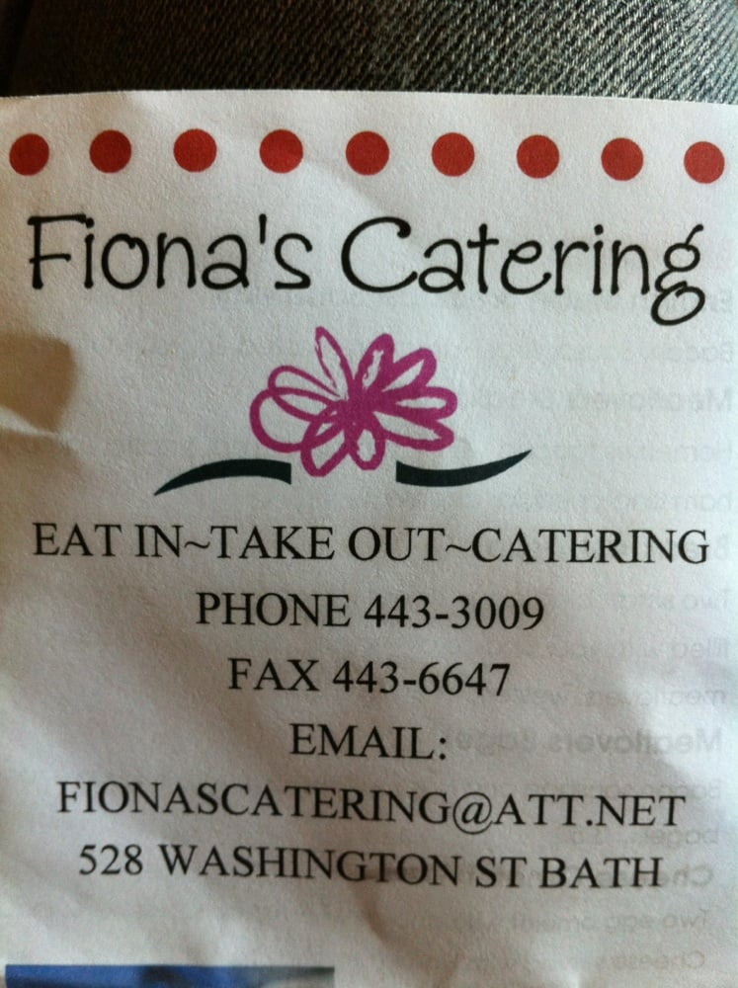

Fiona’s Fine Catering

Fiona’s Fine Catering was established in 2015 and founded by the owner Fiona, who has plenty of experience in terms of management and catering. Fiona finds that it is hard to find high-quality catering services in Melbourne. She thinks that Melbourne needs this, as it is one of the most liveable cities in the world. Therefore, Fiona is driven to open a catering business for Melbourne. The company was created in the beginning of 2015 and leased in an arena located near the CBD of Melbourne. Michelin Guide rewarded the chef of Fiona’s Fine Catering, Gordon Lambsy, as the “Rising chef of the year” in 2014.

The owner of the company Fiona says that “excellent foods are how the business attracts new customers, and services are how the restaurant keeps those people as regular customers.” Therefore, other than the high-quality of foods, Fiona’s Fine Catering also aims to provide the best service for their customers, to enhance their dining experience.

However, at the beginning of 2016, the company found that the efficiency of the cooking team is unacceptable and they were too slow for a high-quality restaurant. That caused a terrible experience for their customers and the company started seeing negative reviews on the Internet. They deduced that the reason for the low efficiency is due to the out-dated cooking equipment. The company then decided to sell all the old equipment and purchase new ones for the kitchen. The action taken by the company successfully increased the efficiency of the cooking team and has saved the reputation of the catering business.

Fiona’s fine catering is dedicated to creating the best dining experience around Melbourne, as well as become the most popular catering company. Currently, Fiona’s Fine Catering has received a 5-star rating on “Urbanspoon”, and the amount of positive feedback and reviews has increased. After a year of running, the company has started earning profit and has been fully booked for the next two weeks.

Analysing the business reports of Fiona’s Catering Services will aid in gauging the financial performance of the business.

An income statement shows a company’s revenues less their costs and expenses over a given period of time. The conclusion of an income statement shows the company’s net income (or net loss). The income Statement, for the year ended 30 June 2016, shows various sales and expenses, which, in turn, are highly indicative of the activities performed during this period. The statement shows that the business has had a net loss of $5,600; this can be explained by the following reasons:

Firstly, the business has had to pay $20,000 in interest due to the large loan of $800,000 made in 2015. The following year shows, within the statement of cash flows, that only $40,000 has been paid. This high interest payment has undoubtedly contributed to the net loss. Furthermore, the presence of bad debts adds to the expenses of the business, Fiona was unable to recover $18,000 from her debtors, she must take corrective action to reduce or omit bad debts, and business is losing on potential cash. The large amount paid for advertising, $56,000, may be due to the business attempting to improve sales and customer base, however, Fiona must ensure that she is able to recover the expense and generate greater revenue to make the advertising expense valuable. The wages expense for the period is high, $362,400, this expense may be incurred due to employees working extended hours. However, through proper rostering and allocation Fiona can reduce the labour costs. The Loss on sale of equipment is due to the depreciation method. Depreciation is the allocation of the cost of the non-current asset over its useful life. The residual value and the useful life of the asset may have been overstated, or it maybe due to the demand, quality or condition of the equipment sold.

Over the financial year, Fiona has studied and theorised the current value of the business premises, and has found that it has depreciated significantly in value. This may be due to the type of depreciation adopted by the business.
In order to move forward and improve the efficiency of operations, Fiona may have invested in new food preparation equipment. This is highlighted by the fact that there was a significant increase ($200,000) in the value of kitchen equipment over 2015-2016, indicating a new purchase. Therefore the older equipment may have been sold. However due to depreciation of the equipment, the sale has shown a loss of $4,000.

Balance sheet is the statement of the assets, liabilities, and capital of a business at a point in time. Dealing the balance of income and expenditure over the preceding period.
Assets are resources controlled by the entity, which are a result of the past action and of which future economic benefit is expected to flow to the business. Current assets are the referred to the assets that provide future economic benefit to the business within the next 12 months. Over 2015 to 2016 the business has drawn into an overdraft. This is potentially due to the purchase of new equipment and a bulk amount of cash drawing by the owner. The decrease in prepaid expenses are due to the transformation process of the current assets, these now transformed into as expense, as they were used up by the business. The business has purchased more inventories, which is crucial for the business sales, having enough to sell is the key to making profits. Non- current assets are referred to as the assets that are not to be consumed within the next 12 months. The business has purchased new equipment for cash, this maybe due to the business requiring a new upgrade or due to a replacement of faulty equipment.

Liabilities present a future obligation to the business, which is a result of the past action. The settlement of which results in an outflow of economic benefit. Current liabilities are an obligation, which is to be settled within the next 12 months. The bank overdraft of $63,600, this may be due to the purchase of new assets. The business has an accrued wages; labour used up but not yet paid for. Account payable, also known as Creditors, has decreased from $29,200 to $14,400 this probably due to payment to the creditor or finding a cheaper supplier without sacrificing on quality. Non- current liabilities are is a future obligation, which is not expected to be settled within the next 12 months. This only consists of the loan of $800,000 of which $40,000 has been paid; this may be obtained as a start up from a financial institution to finance the business.

Equity is the residual interest in the assets of the business after deducting the liabilities. The owner has contributed $268,800 to begin the business, however, he has withdrawn $128,000 cash for this financial year. This may have an effect on other aspects of the reporting process. Overall, Fiona’s Fine Catering has a convincing balance sheet, but the other reports have to be analysed to thoroughly assess the financial position of the business.

The statement of cash flows is a financial statement that provides an overview of the cash inflows and outflows of the business during a certain period of time. The Cash Flow Statement provided for Fiona’s Fine Catering is separated into the three components of Cash Flow; Operating, Investing and Financing activities and includes information relating to the period ending on the 30th of June 2016.
Overall, Fiona’s Fine Catering had positive cash flow of $156,400 from its Operating Activities (inflows and outflows which are from the day-to-day trading activities of the business), which means the business was to generate enough cash flows from operating activities to meet the day-to-day trading expenses of the business. From the Cash Flow Statement and Income statement provided, we are able to deduce that the majority of sales are cash sales rather than credit sales since the cash received from customers was $1,112,000, and the total sales on the Income Statement were worth $1,122,000. Fiona’s catering paid many of its expenses in cash during this period, such as the wages to employees, suppliers, advertising, interest and utilities costs. After all of these day to day costs had been dealt with, Fiona had $156,400 left over which is a positive result for the new company.

Furthermore, after a year of operating, Fiona decided to sell some of the equipment used in operations, such as one of the ovens used in the kitchen. This may have been because a new model had been released, or the item had been faulty. The item was sold for $84,000, but the new equipment bought cost $312,000, which left a negative cash flow of $228,000. It is common for many business to have a negative investing net cash flow, as it is healthy for business to expand on their assets rather than sell the existing ones.
The third component of the Cash Flow Statement, Financing Activities, is also negative, mainly due to the cash drawing made by the owner of $128,000, which may have gone towards repaying Fiona’s personal loan, which she had used to start the business in the previous year. Also, $40,000 was paid towards the business loan of $800,000. Overall, the financing activities of Fiona’s had a negative net cash flow of $168,000.
In conclusion, although Fiona’s Fine Catering received many cash sales, they did not manage their cash well and were left with a significantly lower cash balance at the end of June 2016, compared to the previous year. The business has poor expense control and decision-making skills in regards to their cash expenditures.

Ultimately, all the three reports produced by Fiona are interrelated and the results of each report impacts the other. The net loss of $5,600 caused an impact on the balance sheet; net loss was deducted from the capital. The cash balance calculated by the cash flow statement directly impacts the cash recorded in the balance sheet. Since there was a deficit of $238,600 and insufficient cash, the business had to arrange for external finance, overdraft, and in the balance sheet the overdraft amount is equivalent to the cash balance at end amount in the cash flow,

From an investor perspective, the items that would be relevant for decision making purposes are inventory on hand, creditors, debtors, cash balance, profit for the period, prepayments made towards expenses, facilities owned by the business, business plan, capital contribution, liabilities the business owes other financial institutions. The inventory highlights if the business has enough stock to serve customers, debtors show the asset that is close to liquidating, cash position represents the most liquid asset, investors are likely to assess if the business is able to meet its short term debts immediately with the cash on hand. Profit for the period explains if the business has been successful in executing its business plan, Creditors are a current liability to the business, an investor would thoroughly assess the capability of the business to meet its liabilities. Capital contribution shows how much of the business is controlled by the owner’s contribution. All these are key elements that a potential investor would look for.

Some of the strategies that could be used to improve on the financial performance of Fiona’s Fine Catering are, Fiona must take corrective action by adopting new strategies that will improve her business. These may be to cut on the wage cost by employing high school graduates that will lower the minimum pay per employee. This will also enhance the reputation of Fiona’s Catering, as she is able to generate more jobs for the young people and acting in an ethical and socially responsible manner, which benefits the Australian community. This provides Fiona’s catering with two-fold benefit, opportunity to meet financial and social objectives simultaneously. From the reports, it can be highlighted that the business is selling non-current assets; this may be due to faults or replacement for newer equipment. In order to improve the financial performance of the business, the business must rather repair to fix any faults with the equipment, or they must defer the capital expenditures at this point in time. Fiona must understand the critical position of her newly started catering service and allow the business time to stabilise; she must not draw excessive cash from the business for her personal use. Alternatively, Fiona could browse the market to find a cheaper supplier of goods, however, quality must not be sacrificed, as this would cause detriment to the business. Carefully choosing credit customers would enable Fiona to improve on her debt collections. The bad debts are mainly due to bad debt collection policies. Hence, Fiona must participate in sending prompt invoicing to her debtors, timely reminders and finally notices of taking legal action if debtor does not respond. She could also provide discounts on early payments to encourage prompt payments from debtor, but this would increase “discount expense”, meaning it would cause a reduction in the inflow of economic benefit to the business.

