Topic 2 – Business Transactions
Recall that the primary purpose of accounting is to provide information to users to enable them to make informed decisions.
Those decisions may be made within the business, by internal users, or may be made by parties external to the business.
Accounting information is even used in everyday decisions of individuals that have no relation to a business.
The Conceptual Framework provides:
Objective
Qualitative characteristics
Elements
External users need valuable information to help them make decisions, and the only information they are able to access is of a financial accounting nature.
Certain entities must prepare a set of ‘General Purpose Financial Statements’ (GPFS) which outline how the business performed financially, what it owes, its cash flows etc.
These statements or reports are released every six months by reporting entities, and are all that external users have access to assist in their decision making.
? Why can’t external users rely on management accounting information to help them with decision making?

? Can internal users use financial accounting information as well as management accounting for their decision making?

The Conceptual Framework provides guidance about the qualitative characteristics that the GPFSs should have in order to make them as helpful as possible for users’ decision making.
These include providing relevant and faithfully represented data, presenting the reports in an understandable way, ensuring the contents are verifiable and comparable, and releasing the reports as soon as possible after the accounting period has ended.
The creation of these reports is made possible by a complex yet efficient recording system.
Accounting recording systems vary depending on the size and complexity of each entity.
Some systems need to manage many hundreds of thousands of transactions on a daily basis, while others can be more simplified.
It is important to understand which transactions are recorded in an entity’s accounting system.
Under what is known as the ‘entity’ concept, business owners must keep their personal affairs separate from the affairs of any businesses they own.
For example, a personal bank account cannot be used for business purposes. A new account must be opened to keep the business money completely separate from the owner’s personal money.
An entity’s accounting system should only record business transactions, and not personal transactions.
? What is the nature of each type of transaction?
- Business transactions
- Personal transactions
- Cash transactions
- Credit transactions
It is important to be aware of the distinction between transactions and events.
A transaction is an exchange between two parties, and one of those parties must be the entity for it to be recorded in the business accounting system.
An event, however, may or may not be recorded.
? Some events, such as enquiring about the purchase of a new machine, do not justify recording. Why?

Other types of events are recorded, even though they seem to only affect the business.
For example, a business may pay for rent of their office several months in advance.
According to the framework elements, this would be classified as an asset and recorded as a transaction when paid. However, it cannot remain an asset because as each month passes, the asset diminishes as the rent is consumed.
This event must be recorded in the accounting records to enable a true representation of the business to be presented to users.
? How can a transaction that does involve a business owner, still be correctly recorded in the business records?

Complete the following (Group Activity):
- Provide five examples of personal transactions involving a business owner that would not be recorded in the business records.

- Provide five examples of cash business transactions, each one involving a different accounting element (A, L, OE, I, E).

- Provide five examples of credit business transactions.

The five elements of accounting have an important relationship with one another, known as the Accounting Equation.
The accounting equation may be expressed in simple form, including three of the elements:
Assets = Liabilities + Owner’s Equity

Alternatively, the extended equation takes into account all five elements:
Assets = Liabilities + Owner’s Equity + Income – Expenses

These equations are based on the concept of Double Entry Accounting, which means that whenever a transaction or event is recorded by the business, it must affect the equation in at least two ways. For example, if one side of the equation increases, so must the other (unless the same side decreases again).
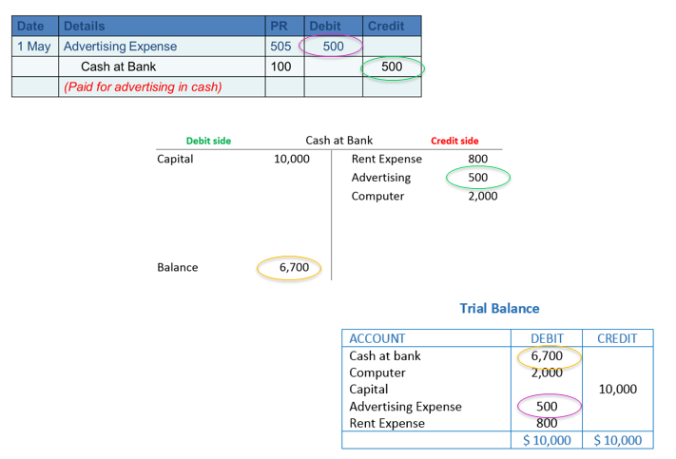
An accounting recording system is based on journals and ledgers, and the accuracy of recording is checked by preparing a trial balance. These are not covered in Accounting for Managers.

To recognise the impact of decisions on business, it is important to understand the effect of transactions and events on the accounting equation.
While not part of formal recording, this can be done by using worksheets.
Worksheets are arranged based on the accounting equation, and each time a transaction or event is recorded, the equation must remain in balance.
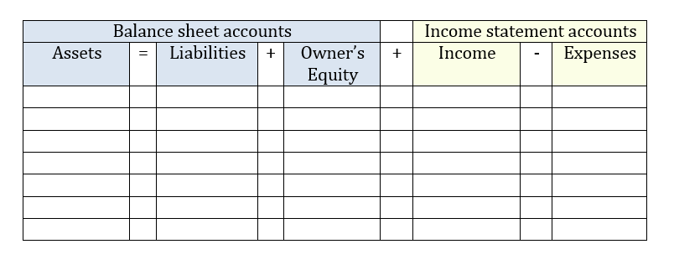

** Handout ** Completing a worksheet

As a double entry approach is used in recording, error detection is made possible. Errors include:
Type of error | Description
Single entry error

Transposition error

Incorrect entry

? What are the characteristics of each type of error?

** Handout ** Detecting errors in a worksheet

** Handout ** Individual questions on the topic

