Foundations of Finance: The RBA interest Rate prediction.
Decision: Increase the Cash rate from 1.5% to 1.75%

What is the relationship between employment and the raise in inflation rate?

Each month the board of directors of RBA meet to decide on the monetary policy for the current month. This process of configuring the monetary policy also includes setting the Official Cash Rate for the month. Official Cash Rate (OCR), rate of interest that the central bank charges on overnight loans to commercial banks. When the RBA increases the cash rate, interest rates on deposits usually rise too, this encourages people to save rather than spend. However, when the interest rates decreases, it is more rewarding to spend rather than save. Moreover, the interest rates alone are not the factor which determine the level of spending in the economy, there are many other key factors like circumstances an individual is in and their personal financial decision making process. Cash rate increase has an effect on the employment in Australia. The increase in cash rate means that the banks are charged higher interest rates, which means the cost of debt for the economy rises, as the banks transfer the higher cash rate on interest rate charged on loans and mortgages. When the interest rates increase, people in the economy are not willing to borrow, including corporations and organisations. Organizations and corporations are forced to borrow due to financial circumstances of the business requiring funding. Hence, as part of the cost cutting mechanism, businesses are likely to reduce their wages expense, which results in redundancies. Overall, this is likely to increase the unemployment rate in Australia, as many people are jobless.

The increase in cash rate of 25 basis-point would stabilise the overall economy in Australia. Specifically, lowering cash rate to stimulate demand is not necessary, and raising cash rate would remove the potential risk in the economy.

Table 1: demand and output growth (per cent)
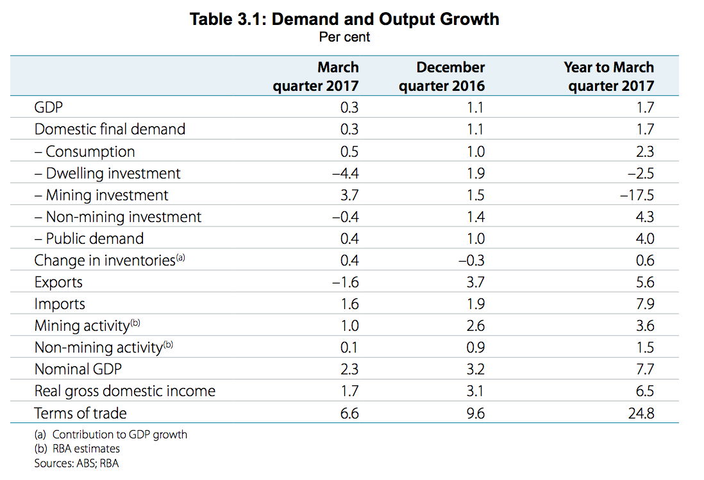
As shown by recent data in table 1, it is suggested that the overall economic condition in Australia has been improved in the June quarter. There is a strong development in the retail market, in regards to the improvement of business condition and increased conditions. Besides, the condition in labour market has become better in the June quarter, strong decrease in unemployment rate has been recorded over last months because growing wages level even though it is remain lower compared to historical standards. As the economy constantly growing in Australia, all of the records show that the economy are strong enough to allow RBA to reject emergency stimulating policy, there is no necessarily need to boost the economy, but it is more important to be aware of the downside risk existing in the economy, eliminating the demand for ultra-low cash rate (Yeates, 2017). The following statement would adjuify the need of removing potential risk.

