Debate Summary
MGX3100- CORPORATE SOCIAL RESPONSIBILITY AND BUSINESS ETHICS
Poojitha Sivakumar AND Bhagya Karunaratne

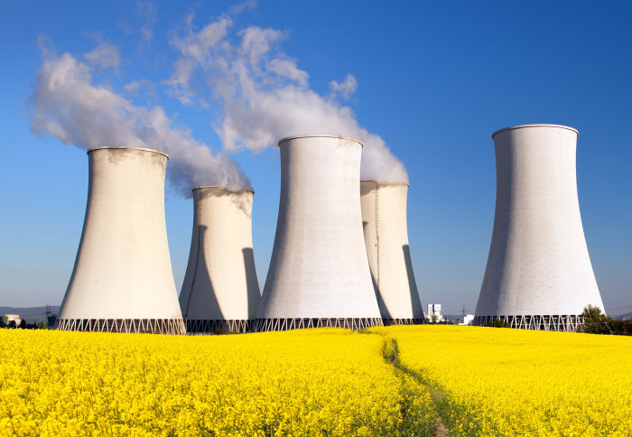

INTRODUCTION

Due to the increasing pressure of climate change, the need for government and corporations to actively reduce carbon emissions is imminent. One of the major ways to tackle climate change is to move away from our dependency on fossil fuels for energy to other energy sources. The most economically viable and practical alternative is nuclear energy. In comparison to coal and other types of fossil fuels, nuclear energy has been proven to be the most energy efficient and beneficial for our country. Today we would like to pose our arguments and judgements in support of transitioning from coal dependency to nuclear power.

Low Greenhouse Gas Emissions.

Compared to coal, gas, and other electric-generating plants, nuclear offers the lowest by far in greenhouse gas release. Carbon dioxide and similar gases, known for depleting Earth’s atmosphere, have notoriously been an issue in the climate change debate. Due to this fact, nuclear energy has once again been looked at for power production. According to the Nuclear Energy Institute (NEI), nuclear energy produces more clean-air energy than any other source. It produces 62 percent of all emission-free electricity in the United States. In nuclear reactors that utilize large cooling towers, it’s a common misconception that pollution is massively dumped into the air. The large clouds you see leaving the smokestacks are nothing more than vaporized water.
High Power Output.
One of the most appealing reasons for nuclear energy is it’s incredibly high fuel to power output ratio. It has the capacity to meet city and industrial needs with just one reactor, let alone multiple. A relatively small amount of uranium can be used to fuel a 1000 Megawatts electric plant, providing enough electricity to power a city of about half a million people. Renewable sources, such as solar and wind, provide only enough power to meet residential or office needs. They don’t yet have the capacity of nuclear to handle large-scale power needs, especially in the manufacturing world.
Rule Utilitarianism argues that rules should be those that overall and in the long run generate the best consequences.
Utilitarianism, the morally correct is that action with most good consequences and least bad consequences where all of the consequences and all of those affected by the action are taken into account.

REBUTTAL:

Inexpensive Electricity
It can be regarded that the initial costs to build nuclear plants are high relative to coal plants. That said, nuclear power produces very inexpensive electricity once up and running. Electricity generated by nuclear reactors is cheaper than gas, coal, or any other fossil fuel plants. Also, uranium is a fairly cheap and an effective source where a little uranium can produce massive power. The resource is also found in abundance in Australia. when combining all these cost efficiencies with an average lifecycle of 40-60 years of uranium power plants, the low operating costs far outweigh the high upfront costs to build. Hence, the opposing team’s statement of nuclear power being extremely expensive can be rebutted with fair disagreement.

Economic impact on economy
Nuclear power provides a vast array of benefits to the economy. Local communities are, more often than not, pro-nuclear due to the amount of jobs and prosperity a new plant brings.
According to the NEI, one new nuclear plant creates 400 to 700 permanent jobs, not to mention thousands of others during its construction. Most nuclear sites have at least 2 plants. This is comparable to just 90 jobs for a coal plant, and 50 for a natural gas plant.
The main reason local communities are so ecstatic over nuclear plants is that each facility generates close to $500 million annually in sales of goods and services. More workers at plants means more people who need lunches and more people with money to spend.
Further, despite coal being the largest export income for Australia, Uranium is the second largest income we generate. The demand for uranium is forecasted to steadily increase in the next 10 years. This gives us a huge competitive advantage, as we have large amounts of uranium deposits meaning we will be able to increase our production of uranium to combat the decrease of income from reduction in coal production and exports.

Therefore, we can rebut the fact that switching from coal to nuclear could have an impact on Australia’s economy. This is also related to the theory of Ethical relativism which states that attributes of ethical rightness or wrongness are not absolute but always relative to a particular culture. switching to nuclear energy is the most effective way to reduce carbon footprint for Australia whilst ensuring energy stability and financially viable solution because we have the biggest uranium deposits.

Stakeholder perspective

Edward Freeman’s stakeholder theory holds that a company’s stakeholders include just about anyone affected by the company and its workings. That view is in opposition to the long-held shareholder theory proposed by economist Milton Friedman that in capitalism, the only stakeholders a company should care about are its shareholders - and thus, its bottom line. Friedman’s view is that companies are compelled to make a profit, to satisfy their shareholders, and to continue positive growth.

There are 3 scopes of emissions. Scope 1 and 2 are emissions directly emitted from the operations of the coal mine, whereas scope 3 are emissions the those that get emitted from combustion of extracted coal that gets exported
- Moving away from usage of fossil fuels because of the high greenhouse Emissions
- The current source of power is very beneficial for the shareholders of coal mines and other indirect company shareholders, but does not think about the effect it has on the environment and society from scope 3 emissions
- jobs, it creates more jobs
- According to the NEI, one new nuclear plant creates 400 to 700 permanent jobs, not to mention thousands of others during its construction. Most nuclear sites have at least 2 plants. This is comparable to just 90 jobs for a coal plant, and 50 for a natural gas plant.
- The main reason local communities are so ecstatic over nuclear plants is that each facility generates close to $500 million annually in sales of goods and services. More workers at plants means more people who need lunches and more people with money to spend

Shareholder perspective

It is beneficial for the shareholders as this is a more sustainable option which means it will attract customers from environmental freaks to environmentally friendly customers. This will increase the customer base which will lead to the increase in revenue. The success of the business is the success of the shareholders. Once the revenue of the business starts increasing, the shareholders will benefit in terms of the dividends and returns.

Therefore, nuclear energy is not only beneficial to the stakeholders of the company but also to the shareholders.

