A new economy

A new economy

1. Your overall feelings and reaction towards the content of the film
- It was an eye opener as I did not expect the short stories about the seven organisations to be so powerful
- Initially it did create a slight bit of boredom however that only lasted until I saw the broader perspective of the movie and I was thrilled
- It was unbelievable for me to hold the thought that an economy can rely so much upon collaboration and still thrive
- The movie definitely enabled my thought process to be a little bit more broader and made my thinking multi-dimensional

2. What core issues / points of tension does the film raise for the way the economy operates?
- No hierarchy with no managers as they call it a collaborative space
- They do not highlight the difficulties of a collaborative workstyle
- In The Red Victorian organisation, it is said that

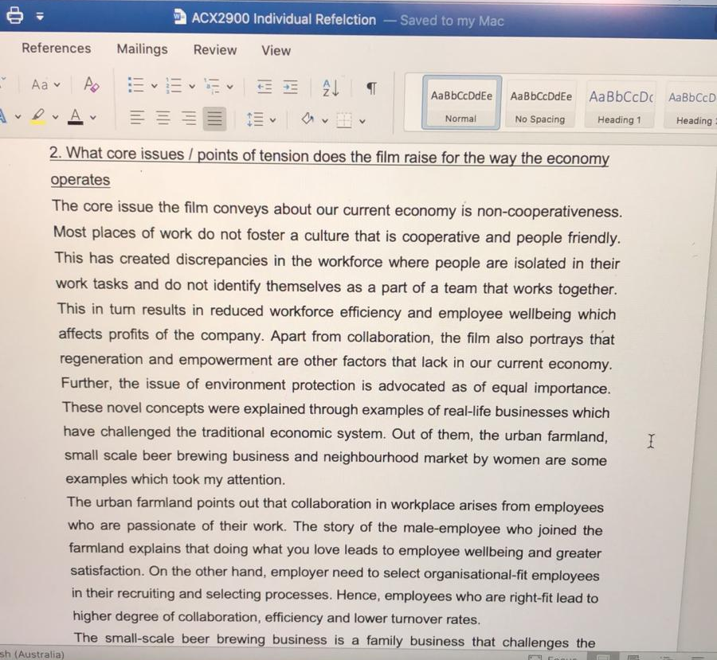

3. What is the impact of this on accounting, accounting systems and the way we report information?
4. Anything you may have learnt when making a comparison between the poster you designed and the content of the film
5. Anything you found difficult to process or comprehend when reviewing the film?
6. Anything that may have struck you as unexpected from the film?
7. What this means for ways of accounting in the future?
8. Should an economy have a goal?
9. When is economic growth useful? When is it problematic?

