Retro Snow Inc. – December 31, 2018

Disaggregated Revenue analytics
To: Manager
From: Poojitha Sivakumar
Purpose: The purpose of this memo is to document plausible trends and expectations for disaggregated revenue data and to identify specific days and locations that warrant further substantive investigation.
Data: We obtained a listing of daily sales by location from the client’s IT system. We tested the details for mathematical accuracy, as summarized in the table below:
 | Total Sales, 2017 | Total Sales, 2018
Store Type 1 | $10,756,103 | $10,627,616
Store Type 2 | $12,901,932 | $12,738,054
Store Type 3 | $26,108,368 | $25,872,832
Total | $49,766,403 | $49,238,502
Procedures: Based on our risk assessment process, we identified the following assertions as significant risks related to revenues/sales:
- Recorded sales occurred.
- Sales are accurately recorded.
- Sales are recorded in the proper period.
Because Retro Snow’s operations are solely in the state of North Carolina, we obtained disaggregated data that reports daily sales by store location and store type. Based on discussions with management and our review of the board of director minutes, we are unaware of any new store locations or other major changes to operations during the year. Therefore, we expect prior year to be a reasonable baseline expectation for this year’s revenues (e.g., similar seasonal trends). Because the business can also be impacted by weather conditions, which vary by year, we also perform analyses that consider changes in weather patterns to predict expected changes from the prior year’s sales. We performed several analytics to identify unusual trends compared to the prior year’s sales, taking weather conditions into consideration. The purpose of these analytics is to identify specific observations (or specific sets of observations) to select for further substantive testing. The analytics that we performed are as follows:
- Visualization Analysis #1:
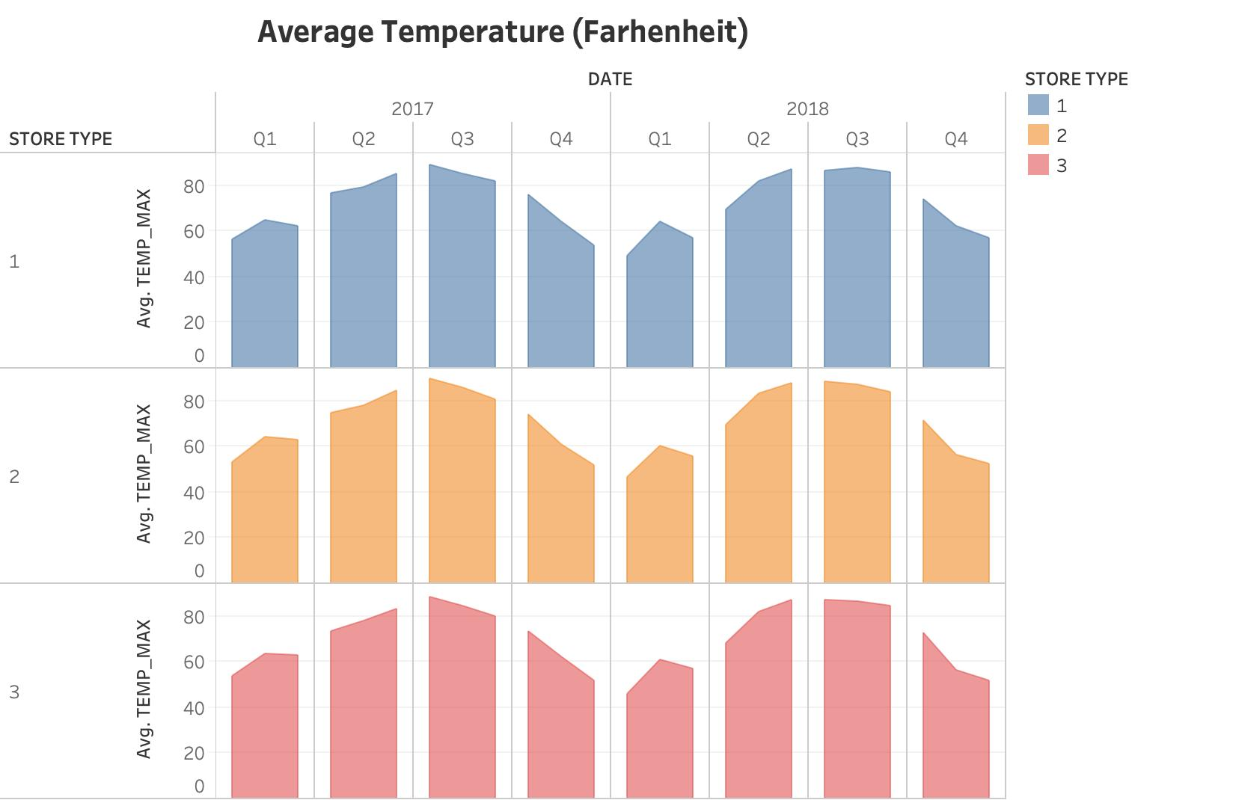
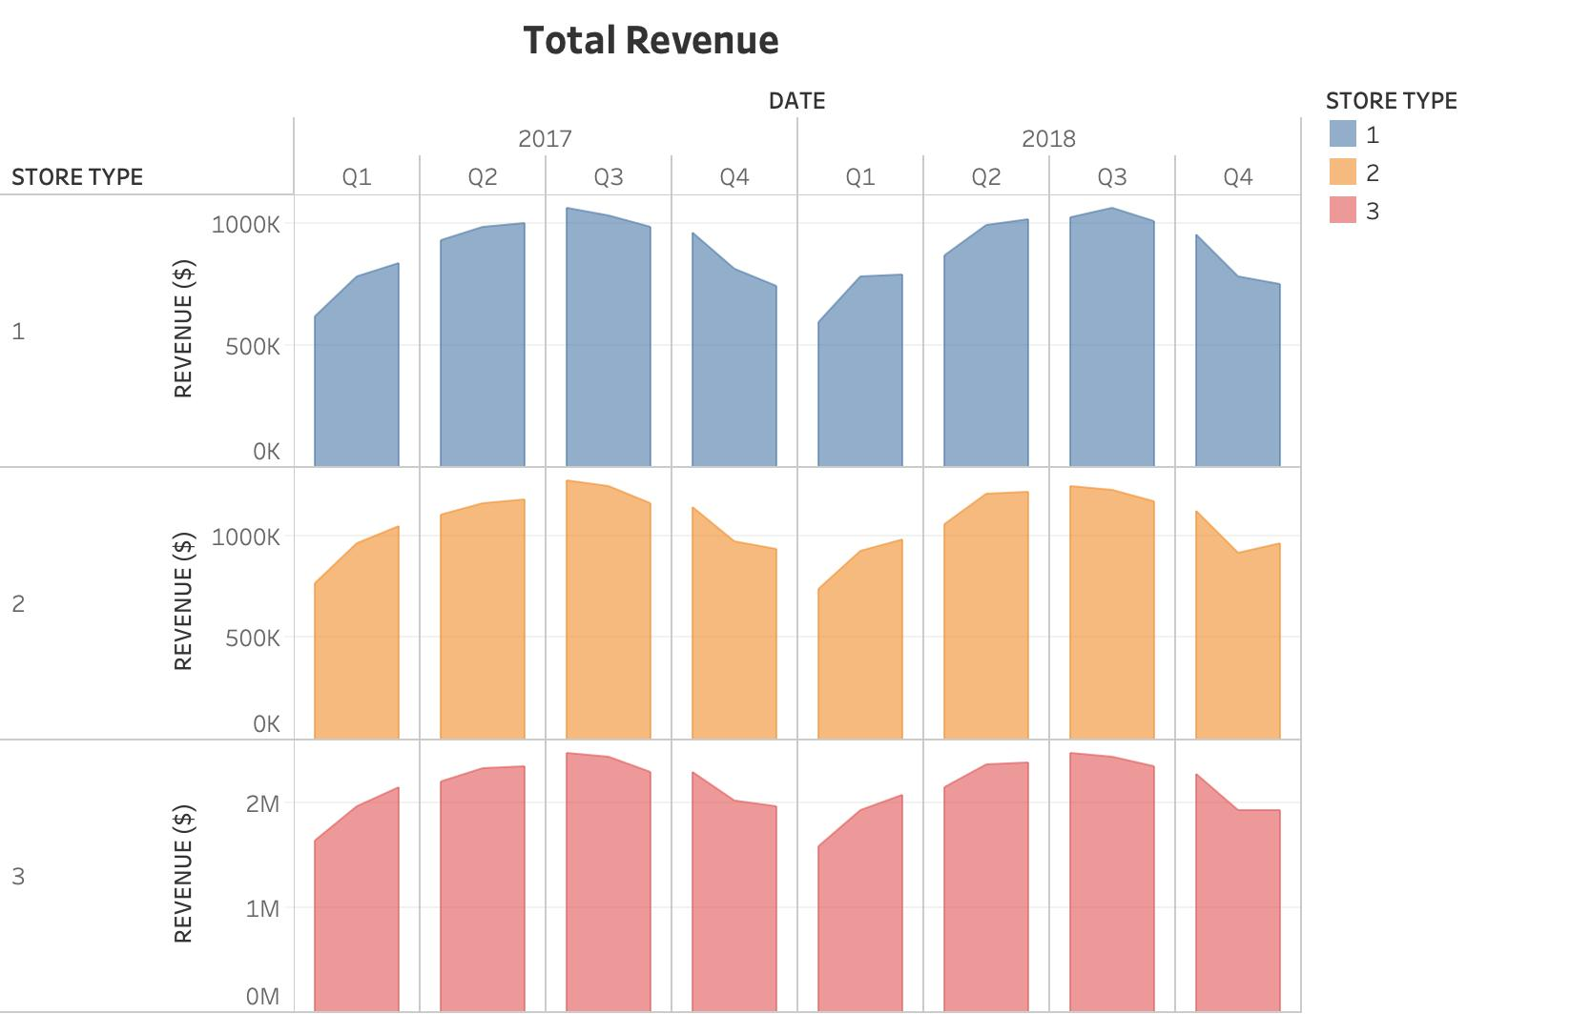
Revenue and average temperature by quarter
Results: Before analysing for potentially fraudulent activity, I checked whether the client calculations of total revenue match the calculation from provided data. I noticed that there was a $100,000 discrepancy in 2018 specifically for store type 3. Initially, I was drawn to suspect that there could be risky unusual revenue in store type 3 locations. By observing the total revenue and the average maximum temperature, we can see there is a positive linear correlation.
Using this knowledge, figure 1 was used to see if the trend in revenue matches the trend average maximum temperature. It is clear from the figure that the trends are correlated for store types 1 and 3, this eliminates the suspicion on the discrepancy store 3 had. It could have just been a mistake in calculation or recording.
However, it is to be noted that store type 2, has an unusual spike in total revenue in 4th quarter 2018 which cannot be explained by the temperature data for the same period. For the remaining report we will be focusing on this anomaly.

- Visualization Analysis #2:
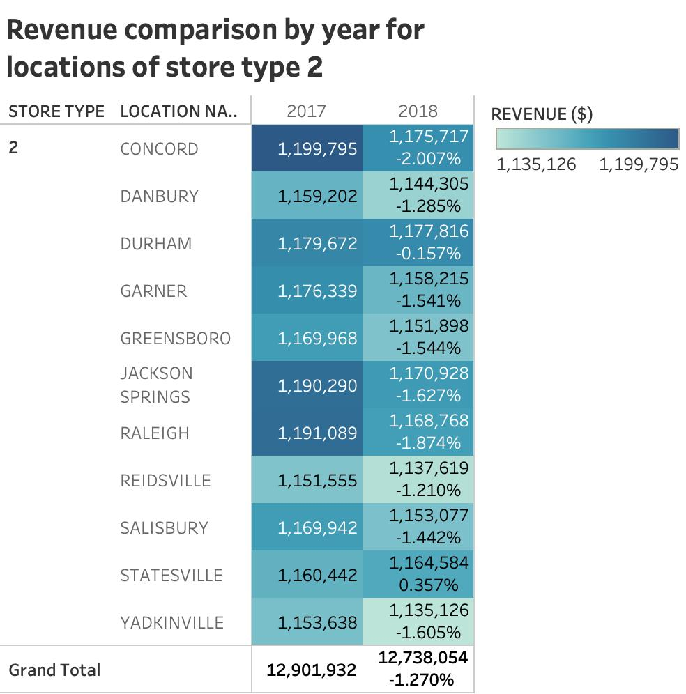
Revenue comparison by year for store type 2 locations

Results: To perform deeper analysis of the unusual spike in store type 2, revenue comparison by year for each of the locations under this type was done to see percentage change in revenue from 2017 to 2018. In figure 2, it can be observed that all locations under store type have a decline in revenue from 2017 to 2018 of 1% and above, except for two locations. Statesville and Durham had 0.357% and -0.157% percentage difference in total revenue respectively. This led to specific suspicion on these two locations, hence, to led to further analysis to determine abnormalities.

- Visualization Analysis #3:
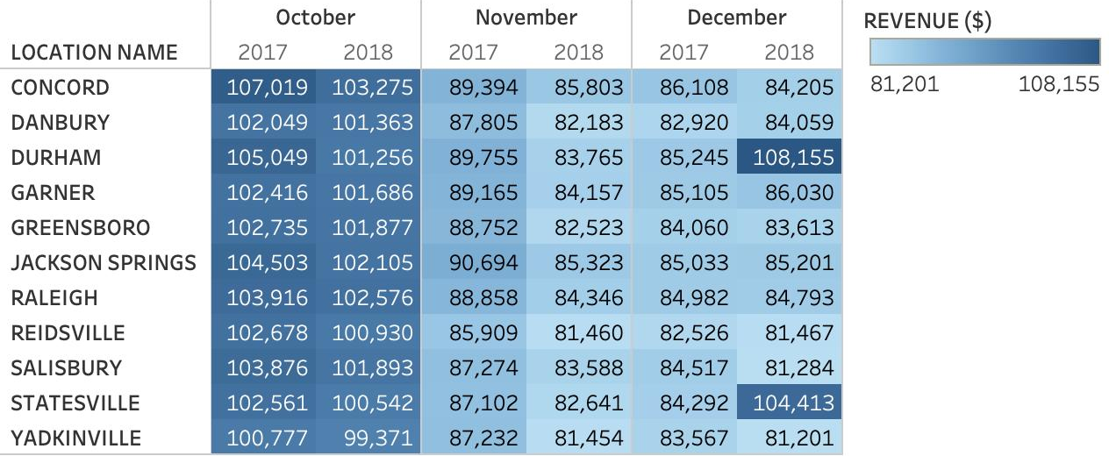
Monthly sales comparison by location for last quarter

Results: The objective of conducting this part of analysis was to determine which location and month had the unusually high total revenue. In figure 3, we can validate that there is a clearly a suspicious hike in total revenue for Durham and Statesville which needs further investigation. From this table, we can determine that the specific time period to perform analysis will be in December 2018. The other locations in store type 2 were performing relative to the temperature maximum and did not have disoriented revenue amounts.

- Visualization Analysis #4:
Weekly revenue and average temperature for Durham and Statesville
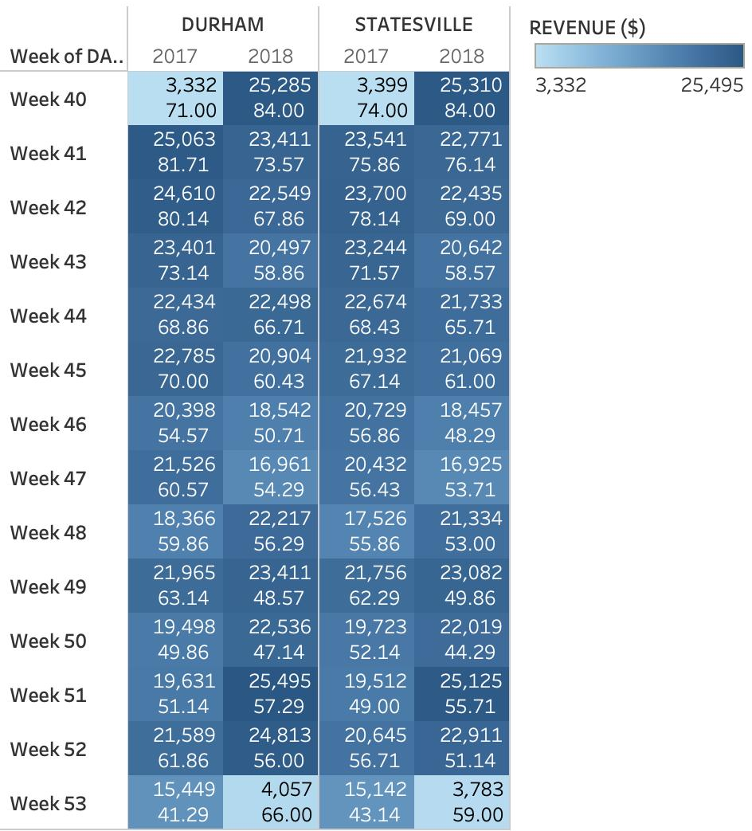
Results: Despite the decrease in average maximum temperature for these weeks across 2017 and 2018, we can see an increase in total revenue. Since this does not match the relationship between maximum temperature and revenue, they have been flagged as suspicious. These weeks will require further investigation to identify any fraudulent activity.

Conclusion: Based on the procedures described above, the audit team will pull supporting sales information to substantively test transactions from the following locations and days:
Statesville (1024): Quarter 4- Weeks 48, 49, 50 and 52
Durham (1031): Quarter 4- Weeks 48, 49, 50 and 52
PART 1:
As noted in the case, auditing standards specifically require auditors to identify revenue recognition as a fraud risk in most audits. Based on your understanding of the company, what factors may increase the risk of fraudulent financial reporting in Retro Snow’s 2018 revenues?
ASA 240- This Auditing Standard deals with the auditor’s responsibilities relating to fraud in an audit of a financial report.
This requires the auditors to classify revenue recognition as a fraud risk.
Retro Snow Inc sells shaved cream restaurant which has its presence in various locations in North Carolina. The company employs three main managers who manage the three different store types (1, 2 and 3).
There are several factors that increase the risk of fraudulent reporting. Firstly, the managers of respective store types know their local market well and have great flexibility to advertise and offer promotions at their convenience with the objective to increase total revenue over the years. The autonomy managers have in this regard leads to increased zone of ambiguity and error as to how managers utilize the power and authority.
Secondly, the new incentive plan which has been introduced attracts managers to report fraudulent figures in the reporting in order to gain the incentive. Hence, this may be the intention behind why the manager for store type 2 chose to report fake hikes in total revenue for 2018.
Thirdly, the debt covenants might be another reason why there is a fraud risk. Due to a declining trend in total revenue from 2017 to 2018, it might increase the pressure faced by the employees to ensure their pre-tax income for each quarter is reported as high as possible to avoid the consequences of not meeting the requirement.
Therefore, the reasons above indicate clearly that there are several factors in Retro Snow Inc that increase the risk of fraudulent financial reporting.

REFERENCES
Christensen, B., R. Elder, and S. Glover. 2015. Behind the numbers: Insights into large audit firm sampling policies. Accounting Horizons 29 (1): 61-81.
Auditing Standards on Auditor’s Responsibility to Consider Fraud in a Financial Report Audit
U.S. standard referred to in this assignment (AU-C Section 240) – Available here:
https://www.aicpa.org/Research/Standards/AuditAttest/DownloadableDocuments/AU-C-00240.pdf
Australian-equivalent standard (ASA240) - Available here: https://www.legislation.gov.au/Details/F2006L01368

