Section | Instructions
Your name  Name of the Company | Poojitha Sivakumar  Aussies Phones and Accessories Pty Ltd
Data Validation rules  - How you inserted the data validation rules  - Logic behind the first data validation rule | Data Validation 1- List criteria in Sales Quantity (Cells; B70:B74)  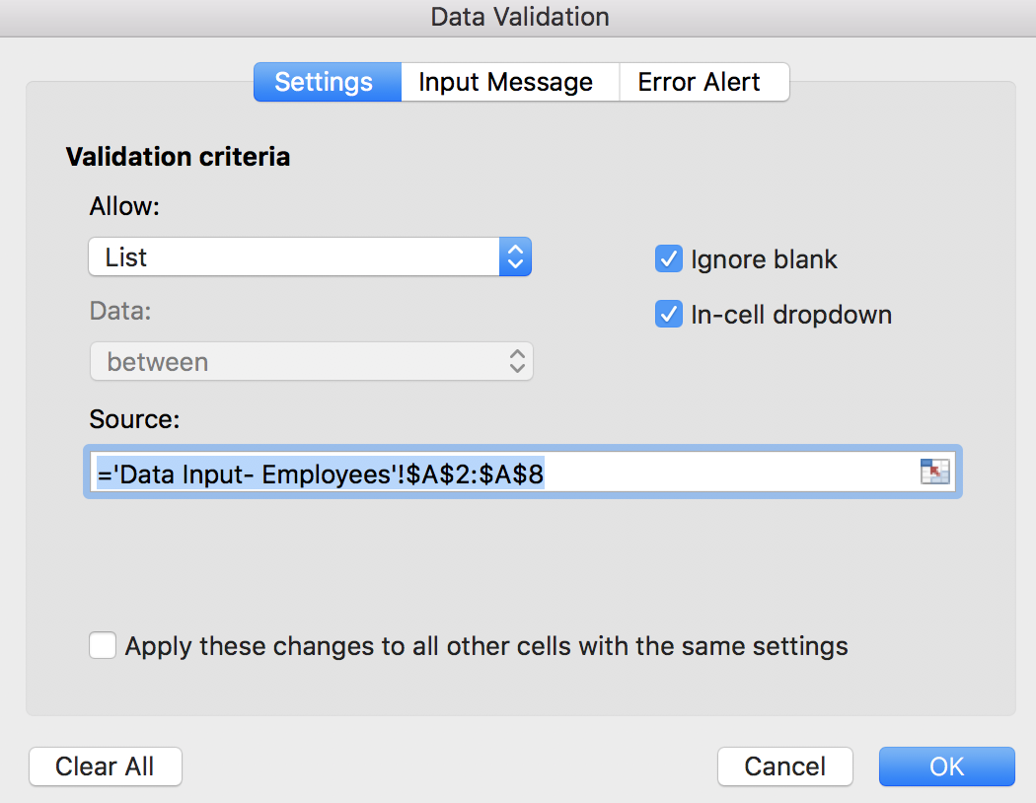  Figure 1: Data validation 1  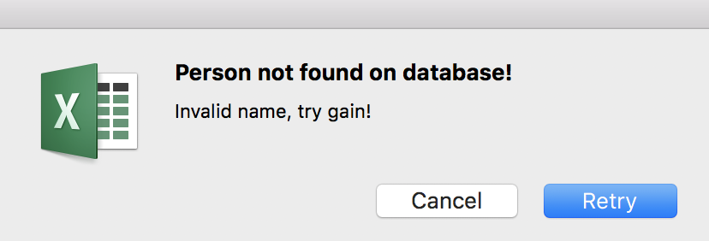  Figure 2: Error message from Data Validation 1  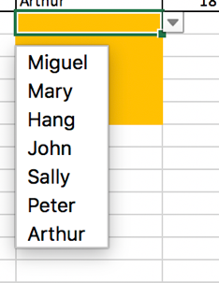  Figure 3: Drop list from Data Validation rule 1  The first data validation prevents a person from entering a name that is not part of the employee list in the first data input sheet-employees. This validation was inserted by Selecting the names from the Employees worksheet and applying it to the ‘Data Input- Sales quantity’!B70:B74. Which then creates a drop list with the only possible options and when is not one of the options in the list. The user encounters an error message to try again, like in image 2. The logic behind the first validation rule narrows the possibilities of wrong data input, prevents data being entered in the wrong column.  Data Validation 2: ‘Data-input- Products’!A17:A21  The second validation rule is created in the ‘Data-input- Products’!A17:A21 , this creates a rule that the user cannot enter duplicate product ID.  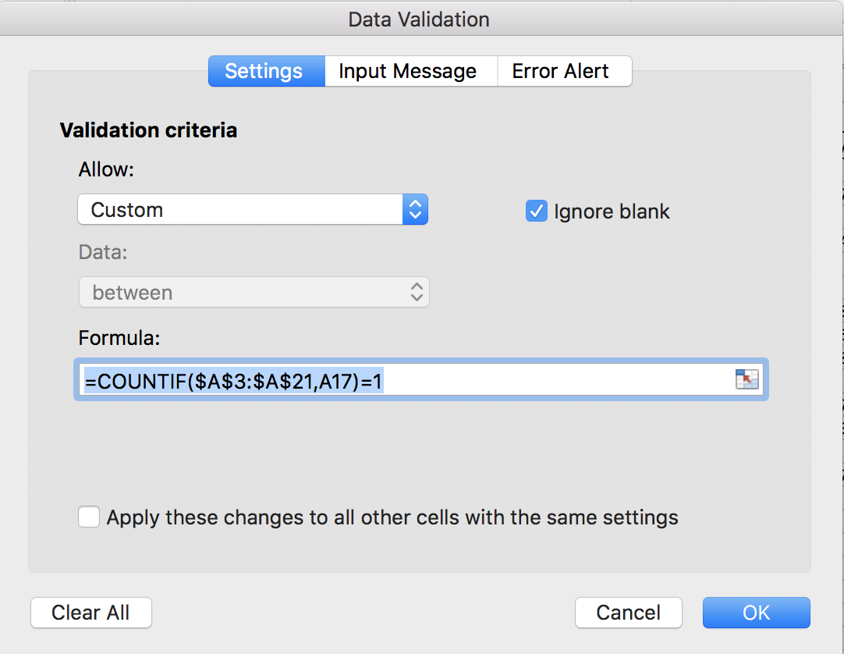  Figure 4: Data Validation 2  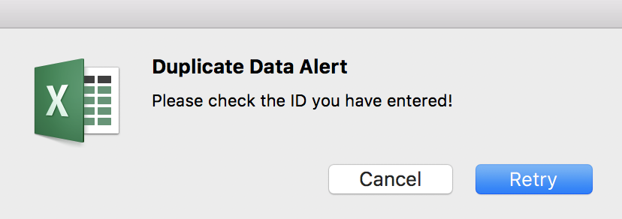  Figure 5: Message Alert  This validation rule means that the user cannot enter a line item that already exists, for example; if a user enters the product ID for “Samsung Galaxy Note 9” as a new line item, it will not allow for that as this means it creates duplicate line items.  Data Validation 3: ‘Data-input- Products’!A22:A26  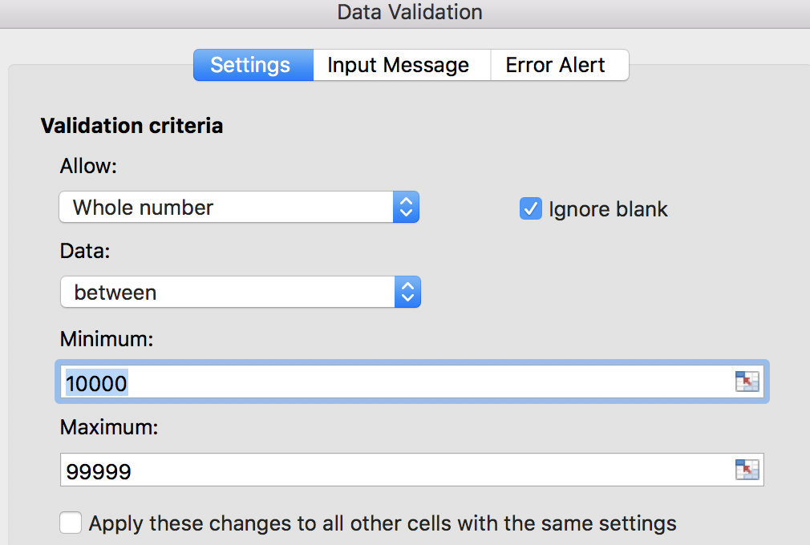  Figure 6: Data Validation 3  This rule enables the user to enter only a whole digit number that is 5 digits long. Therefore, a rules has been inserted for whole number and between 10000 and 99999.
Reason for the choice of the three ratios | - Why you chose these three ratios among the rest  - What is the logic behind it  Gross Profit margin  Inventory turnover  Sales growth.  There is a linear relationship between the three ratios calculated in the worksheet.  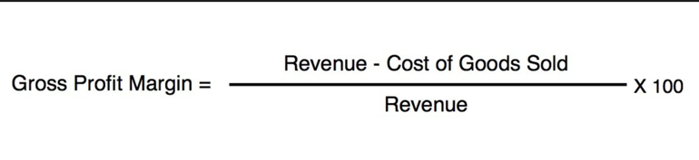  It is obtained by dividing the gross profit of each product to its net sales. With this ratio, the product with the highest and lowest profitability can be determined and further strategies can be implemented  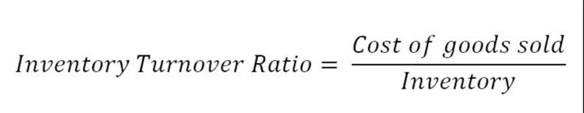
Logic behind the dashboard created | - Why you chose to include that information in your dashboard AND/OR why you decided to present it that way
Internal Memorandum | - 2 interesting findings that you identified when analysing the data  - Include reference, example; see panel or cells or screenshot  - MUST include 2 recommendations to the CEO based on your analysis of the data

