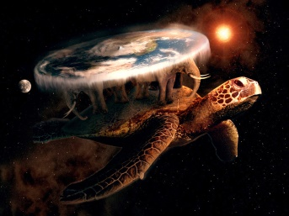
Understanding Paradigms; General Knowledge
In your group, see what your members know about the following
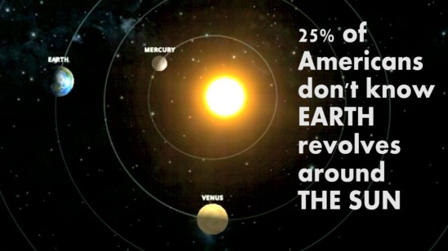
1. When did these “Paradigms” change (i.e. A Paradigm Shift)?
a. General
The Ancient?
The Earth is flat & supported by giant elephants & a turtle.
Hindu mythology, Chinese mythology and the mythologies of the indigenous people of the America.
The sun revolves around the earth.
Copernicus, Galileo and Kepler
Of Modern Times?
Waste is normal; a result of increasing wealth/manufacturing.
Many industrialists and politicians today- third world
Mass production to tailored and individualized products/services. Industry 4.0
Slow to fast-fashion. H&M, Inditex-Zara, Uniqlo
The marketing of existing stocks (push) to manufacturing on demand (pull). Big Data? Factory-direct KMART and BIGW
The future of our country’s “seniors” is a problem. Today’s Australians?
b. Specific to Business
Of Modern Times?
Video hire- Netflix Vs. Blockbuster/video-ezy
Taxis uber vs driverless cars
Hotels and tourist accommodation Air B&B, Webjet etc
The Stock Broker vs. on-line OTC
The Fax machine (vs the telegraph beforehand) Vs Mobile/cell phones-pads
A mechanical wrist watch- Vs Quartz Vs Digital

2. What products/services did the following companies originally sell?
Kleenex Hand disposable towels
Toyota knitting looms
3M mining
Avon door to door books (with a perfume incentive)
Wrigley door to door soaps (with a chewing gum incentive)
Nokia bulk paper (Mills)

3. Can you guess what the “original paradigm” was for the following (see the PPTs):
A. Some oldies to warm us up:
A Factory A suburban house
A desk computer the typewriter QUANTUM COMPUTER
B. Some “newies” to challenge us:
A bike (could you redesign it?) A horse

4. Does your “paradigm” for good managerial design include ‘elements’ of any of the following? Why?
The Classical School
The Human Relations School
Contingency Theory
The Cultural- Excellence Approach
The Japanese “way”
Organisational learning Approach

