What is change? Why is change necessary?
“To flourish over the long run, most companies need to maintain a variety of [incremental] innovation efforts” (O’Reilly and Tushman, 2018).
Organisational change is depicted as the “movement of an organisation from one state of affairs to another” (Organisational behaviour textbook). Changes can happen in many forms, it may be in the form of the company’s structure, strategy, policies, procedures, culture and many more. Often organisations plan in advance for the change they predict is going to happen in the future, however, when there is a sudden shift in the environments of the organisation, change could be forced upon in order for the organisation to remain competitive. The fundamental nature of change is radical and alters the way an organisation operates at different levels. There are many forces due to which an organisation undergoes change; workforce demographics, technology, globalization, market conditions, organisation growth and poor performance. One of the major forces that causes radical change in organisations in the current context is technology. Some changes are inspired by the organisations due to the technological developments (Organisational Behaviour Textbook). Change is often brought about from the external environments of the organisation. Therefore, it is not feasible for an organisation to rest back on their well-planned change process. The ability to adapt to change lies in the flexibility of the organisation and how well it is able to channel the flow to its advantage.

Different models of change
For an organisation to survive, it needs to evolve according to the change it is exposed to. In order to manage change, it is necessary to use a change management model, which the business thinks suit their current process of change. There are many theoretical models of change such as Lewin’s change management model, the McKinsey 7-S model, Kotter’s theory and many more. Lewin’s models of change are explored due to the relevance to the organisational study of Telstra.

Force Field Analysis
“Change occurs when the forces shift, thus causing a disruption in the system’s equilibrium” (Brager, G., & Holloway, S., 1992). When an organisation does not understand the need for change or the urgency to change, they could use Kurt Lewin’s Force Field Analysis.
The force-field is seen as the equilibrium in between the forces favourable and against change. In order to conduct a force field an organisation should define the change it wants to embed, then brainstorm the driving forces and the restraining forces. Once the forces are listed on either side of the equilibrium then it needs to evaluate each force between 1 to 5, where a score of 1 means that the change is weak and a score of 5 means the change is strong. Once they are scored and reviewed, organisation needs to strategize, either to weaken the restraining forces or to strengthen the driving forces (

Lewin’s Change Management Model
Kurt Lewin’s three-stage model assumes for any given change there is likely to be resistance (Lewin 1951). Hence, it is not wise to execute change before preparation as it may lead to change failure (Organisational Behaviour, 2017).

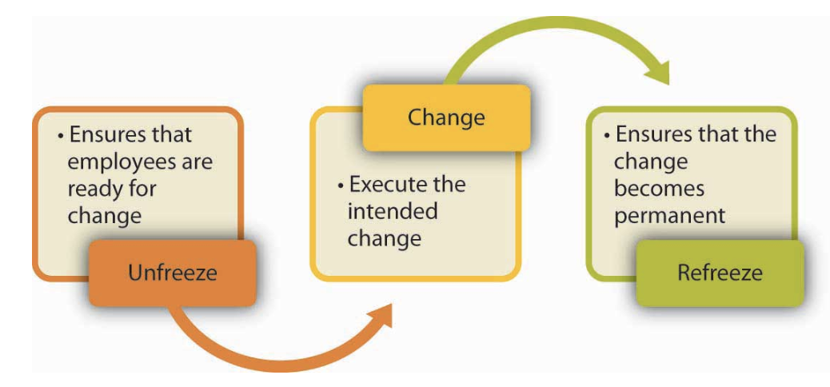
Lewin’s model comprises of three stages; unfreeze, make changes and refreeze.

Stage 1: Unfreezing, to make sure that “organisational members are ready for and receptive to change” (Organisational Behaviour, 2017).
Unfreezing the perception and process of the organisation. This stage is about removing the rules and boundaries of the business and seeing the natural flow within the organisation. The sort of actions an organisation is likely to take in this stage is to create a vision for change, communicating to all members the plan for the change, highlighting the need for change, building a coalition (Organisational Behaviour, 2017).
Stage 2: Making the changes
The second stage is about implementing the change model. In this stage the organisation implements the changes across its resources, structure, procedures and processes. However, how to implement change is subjective and depends on the approach the organisation pursues to take and the frequency of the change (Organisational Behaviour, 2017). Creating small wins, continuously providing support and eliminating obstacles are a few steps the organisation could take.
Stage 3: Refreezing.
In this stage the change is transformed to be permanent and “the new habits, rules or procedures become the norm” (Organisational Behaviour, 2017).
This stage is crucial as the success of the process of change depends how far the efforts of the organisation work to make the change part of its culture.

Ambidextrous Organisations
The Harvard Business Review examines the nature of “Ambidextrous organisations” through the lens of exploitation and exploration (O’Reilly and Tushman, 2018). Organizations have been “successful at …exploiting the present and exploring the future” (O’Reilly and Tushman, 2018), these types of organisations share features in common. They distinguish their traditional exploitative units from their exploratory new units, this enables them to encompass different initiatives and processes as part of their structure and culture, simultaneously senior level managers ensure that “tight links” (O’Reilly and Tushman, 2018) across the both units are maintained. These sorts of organisations are called Ambidextrous organisations, it is believed that they provide both theoretical and practical model for “forward-looking executives” who are pursuing to initiate radical change or embed disruptive technologies while achieving incremental gains (O’Reilly and Tushman, 2018). At Telstra, their tra

Organisational Example
Telstra is a telecommunications company, which offers a range of communications services and competing in all telecommunications markets. They are said to be “Australia’s leading telecommunications and technology company” (Telstra Website). Provide 17.7 million retail mobile services, 4.9 million retail fixed voice services and 3.6 million retail fixed broadband services.
“To create a brilliant connected future for everyone” (Telstra website)
Telstra has five core values;
- Care for their people
- Team work and working together
- Trust on each other to deliver
- To make the complex simple
- The courage to find
Telstra- Past
Telstra origin dates back to 1901, when the postmaster- General’s Department (MG) was established by the Commonwealth Government to manage all domestic telephone, telegraph and postal services. It was called the Australian Telecommunications Corporation or Telcom, in 1991, it became an Australian public limited liability company.
Telstra- Present
Telstra locator service Telstra locator tag
Bluetooth
LTE tags
IOT

Telstra- Future
Andrew Penn- CEO Telstra
new strategy for Telstra called Telstra 2022
connecting people for more than 100 years
Firstly, with fixed lines then with mobiles then to the internet
Connectivity has become more important than it has ever been, will continue to be so in the future
Telstra has been the leader in technology innovation and providing great connectivity
However, the telecommunications sector has never been under so much pressure with the development of the NBN, very significant increase in competition
A lot of pressure to invest in terms of investing in these technologies
Great news is two years ago we announced that we will be increasing our capital investment by an additional $3 billion dollars to create the platforms we would need for the future and without those investments we would not be announcing what we are announcing this morning, which is a new strategy for Telstra.

Which is at its heart first and foremost radically simplifying and change the nature of telecommunication products and services for all customers in Australia because we know that there are many pain points in the telecommunication products that customers receive today, and our commitment is to eliminate them.

We are also taking a similarly radical approach to the simplification of our business;
- we will reduce the number of layers of management by 2 to 4 layers across the organisation
- further accelerate new ways of working in the company
- introducing new structures that will enable us to consolidate a lot of the large-scale back office processes that a large company like Telstra has today.
All of the simplification enables us to increase our productivity by an extra billion dollars to 2.5 billion dollars but what it does mean is, it is a very difficult news, it reduces the number of jobs at Telstra and we anticipate that about 8000 roles net will leave the company over the next 3 years.
Family of people
But if we are going to be competitive and deliver the sort of products and services to our customers, if we are going to deliver for our shareholders, I have to be authentic and I have to transparent that, that is the scale of change Telstra needs today.

We are setting up funds and support for the people who are affected, we will of course communicate more about that over the next three years as we roll out the changes.
Establishment of a new business unit within Telstra to house our fixed infrastructure assets because of the value of these assets which will enable us to better manage those assets and give us optionality in the future, particularly post NBN world.

How and why did the major change come about?

Disruptive technologies
In a latest “Ovum’s ICT Enterprise Insights program the telecoms sector is one of the most mature industries in the drive for digital transformation” (Tan, 2017). A global survey from the CRO’s and CIO’s including those of Vodafone, Telenor Group and Telstra, it was informed from EY that “growth in mobile phone applications as opening the market to disruptive technologies in the telecommunications industry” (Tan, 2017).
This graph represents the significant challenges for the telecommunications industry.
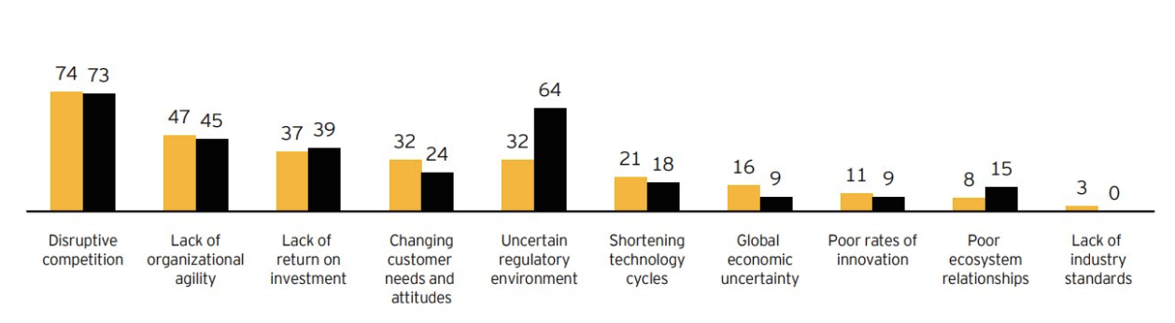
Sudeep Gantori, Equity Analyst, UBSAG, stated that due to the disruptive technologies there is a decrease in SMS revenues as people are leaning towards social media platforms. He highlights the eSIM innovation.

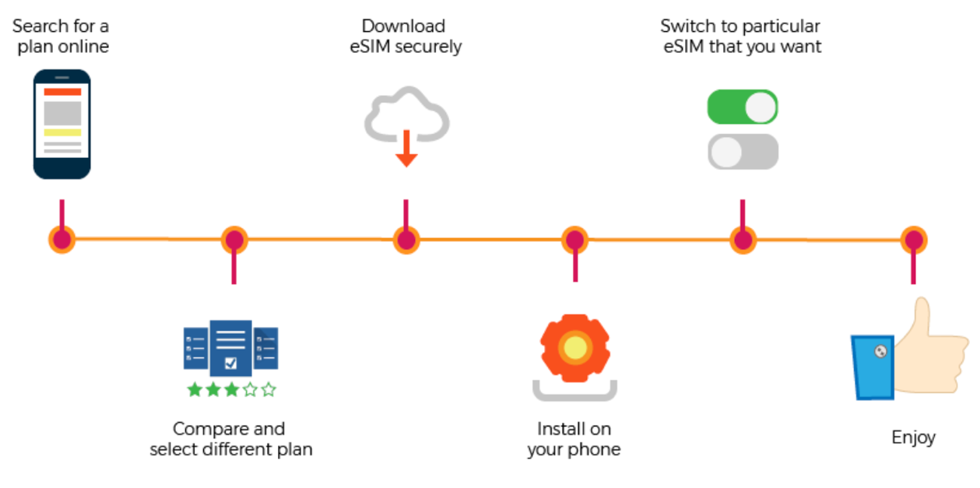

Bibliography
In text citation (Financial Review, 2018)
- Financial Review. (2018). What Telstra's strategy changes mean for consumers. [online] Available at: https://www.afr.com/technology/what-telstras-strategy-changes-mean-for-customers-20180620-h11lz9 [Accessed 7 Sep. 2018].
(O’Reilly and Tushman, 2018).
- O’Reilly, C. and Tushman, M. (2018). The Ambidextrous Organization. [online] Harvard Business Review. Available at: https://hbr.org/2004/04/the-ambidextrous-organization [Accessed 8 Sep. 2018].
(Burnes, 2017)
- Burnes, B. (2017). Managing Change. 7th ed. Harlow, England: Pearson, pp.326- 343.
(Farquhar, 2018)
- Farquhar, P. (2018). How CBA, Domino’s, Telstra and other big Australian companies are making the jump to digital and winning. [online] Business Insider Australia. Available at: https://www.businessinsider.com.au/the-microsoft-report-30-australian-leaders-share-their-thoughts-about-digital-transformation-2016-11 [Accessed 9 Sep. 2018].
- Lewin K. (1951). Field theory in social science. New York: Harper & Row.
- Organisational Behaviour Textbook 2017
- Brager, G., & Holloway, S. (1992). Assessing Prospects for Organizational Change: The Uses of Force Field Analysis. Administration in Social Work, 16(3-4), 15-28.
- Penn, A. (2018). Telstra2022 - our plan to lead | Telstra Exchange. [online] Telstra Exchange. Available at: https://exchange.telstra.com.au/telstra2022-our-plan-to-lead/ [Accessed 9 Sep. 2018].
- Tan, A. (2017). Telecoms: ripe for disruption in 2018. [online] Telecomasia.net. Available at: https://www.telecomasia.net/content/telecoms-ripe-disruption-2018 [Accessed 8 Sep. 2018].

