Change is often presented as rational and a well-planned process, but real-world examples suggest that this is simply not the case.
“To flourish over the long run, most companies need to maintain a variety of [incremental] innovation efforts” (O’Reilly and Tushman, 2018). Organisational change is depicted as the “movement of an organisation from one state of affairs to another” (Organisational behaviour textbook). Changes can happen in many forms such as changes to the company structure, strategy, policies, procedures, and culture. These alter the way an organisation operates at different levels. There are many forces due to which an organisation undergoes change; workforce demographics, technology, globalization, market conditions, organisation growth and poor performance. Technology and competitors are the major forces that create the necessity to change. Some changes are inspired by the organisations due to the technological developments, which are mandated for the business to survive (Organisational Behaviour, 2017). Often, organisations plan changes based on predictions extrapolated from past and current trends. However, the fundamental nature of change is radical and cannot be always predicted. Therefore, it is not feasible for an organisation to rest back on their well-planned change process (Farquhar, 2018). The ability to adapt to change lies in the flexibility of the organisation and how well it is able to channel the flow to its advantage (Organisational Behaviour, 2017). In this essay, the advantages and disadvantages of different models of change are discussed using changes implemented by Telstra as part of their Telstra 2022 strategy.
Telstra’s history

In 1901, the Australian Postmaster-General's Department was established to manage all major forms of communication. In 1946, the Overseas Telecommunication Commission was setup to manage international telecommunications whilst a separate entity, Australian Telecommunications Commission known to be as trading as Telecom Australia, was established to maintain national telecommunication systems. The telecommunication market was liberalized in 1991. The AOTC connected 218 destinations spread across 185 countries. The following year, the AOTC was renamed as Telstra Limited corporation. The main competitors of Telstra at this period were Optus communications, a conglomerate made up of Bell South, Cable and Wireless, Mayne Nickless, and institutional investors.

Telstra’s Present and Future

Today, Telstra is “Australia’s leading telecommunications and technology company” (Telstra, 2018). Telstra is a telecommunications company, which offers a range of communications services and is competing in all telecommunications markets. It provides 17.7 million retail mobile services, 4.9 million retail fixed voice services and 3.6 million retail fixed broadband services. Telstra’s purpose is “to create a brilliant connected future for everyone” (Telstra, 2018). There are five core values of the organisation they are, Care for their people, teamwork, trust on each other to deliver, to make the complex simple, courage to find.
The rapid advancement in technology has urged Telstra to “invest in the advancements” (Carey, 2018). Since the internet is becoming more accessible, the cost of connecting is decreasing significantly, many innovations from Apple watches to Google glasses have created the “perfect storm for the IoT” (Morgan, 2018). IoT is the concept of connecting devices with a off and on switch to the internet. The scope of items range from coffee makers to wearable devices (Morgan, 2018). IoT has the capacity to connect people-to-people, machine-to-people or even machine-to-machine. Telstra is actively connecting its businesses and customers to a range of things through their Telstra IoT platform which enables users to use it as a “one-stop platform” for data collection, visualisation and device management. Telstra is divulging into 5G network which it launched in Gold Coast, as a marker on their upcoming strategy “Telstra 2022”. The consistency Telstra maintains with the core values and the actions undertaken to continuously provide a better service for its customers and clients has meant that it’s “time for a new innovation” (Telstra, 2018).
Due to the rollout of the NBN, this has increased the pressure on the telecommunications sector upto unprecedented levels (Financial Review, 2018). Telstra CEO, Andrew Penn, has announced their “Telstra 2022” strategy, to combat this. There are four pillars to the change strategy.
Firstly, to radically simplify their structure, both in terms of the way they operate and their internal management. By 2022, Telstra aims to reduce the layers of management from six to four across the organisation. This is to introduce new “cloud computing” processes that will consolidate back office data information and analysis. Secondly, it aims to establish a “standalone fixed assets infrastructure unit” (Telstra Exchange, 2018), Telstra InfraCo, which will comprise “high quality fixed network infrastructure”. It includes domestic fibre, subsea cables, ducts, pipes and poles. This is then sold to Telstra, NBN Co and wholesale customers. This is expected to assist Telstra in their 5G rollout across Australia. Thirdly, “Leading cost reduction Program”, their goal is to “monetise assets up to $2 billion” (Telstra Exchange, 2018). This is to simplify, digitise and automate the current products. Finally, greatly simplify their plans from 1800 to 20. For creating a consumer convenience.

The four pillars together enable the business to “be Australia’s next generation network” and “create new digital platforms” (Telstra, 2018). Hence, leads Telstra into delivering extraordinary customer service, convenient yet simple products, “network superiority” 5G and many more aspiring goals.

Reason for change
The change in Telstra has occurred due to a significant amount of increase in competition. Initially when Telstra was invented, they had only one major competitor, OPTUS (Telstra, 2018). Now Telstra competes with many other telecommunication giants such as Vodafone, Optus and TPG. However, the telecommunications sector has never been under so much pressure with the development of the NBN, this has led to a significant increase in competition. In addition, the disruptive technologies like IoT, Virtual reality have come into play, which means that an organisation as vast as Telstra needs to adapt and embed the technology to survive in the industry (Burnes, 2017).
Disruptive technologies
“Disruptive” suggests an interruption or abnormality to a systematic progression
(National Research Council, 2010). In a latest “Ovum’s ICT Enterprise Insights program the telecoms sector is one of the most mature industries in the drive for digital transformation” (Tan, 2017). A global survey from the CRO’s and CIO’s including those of Vodafone, Telenor Group and Telstra, it was reported from EY that “growth in mobile phone applications as opening the market to disruptive technologies in the telecommunications industry” (Tan, 2017).
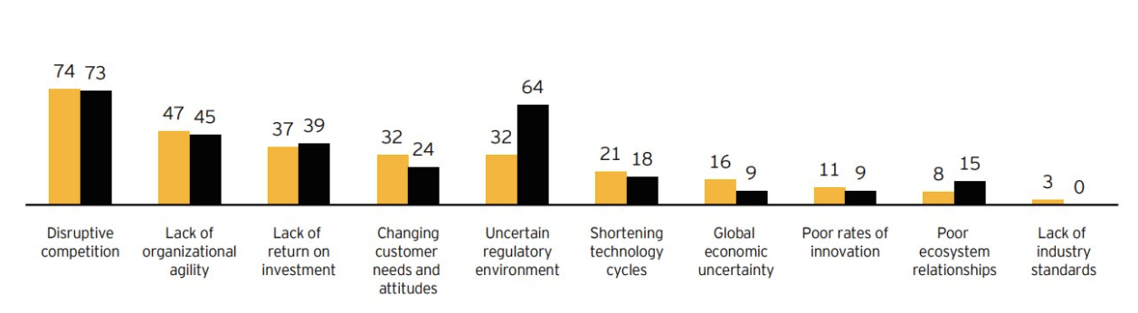
This graph represents the significant challenges for the telecommunications industry.

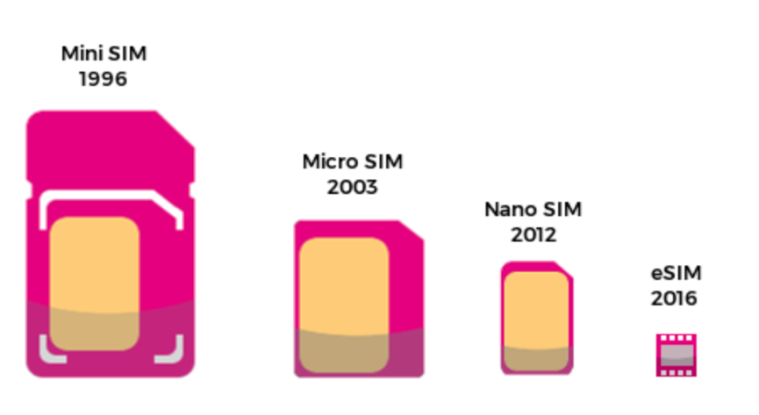
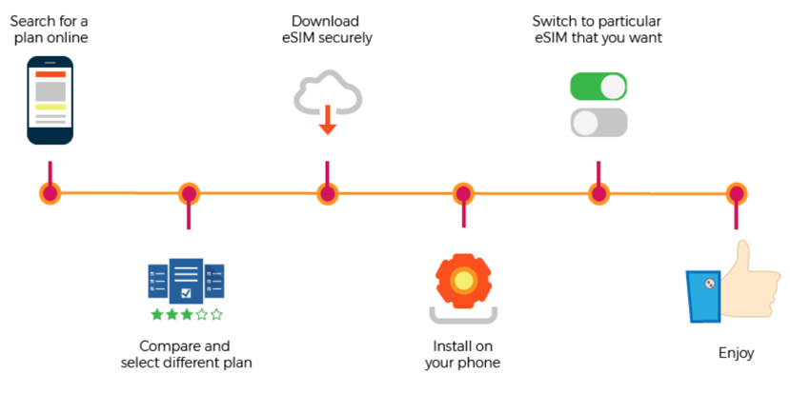
Sudeep Gantori, Equity Analyst, UBSAG, stated that due to the disruptive technologies there is a decrease in SMS revenues as people are leaning towards social media platforms.

Evolution of sim cards: FORBES 2018 Process of eSIM: FORBES 2018

Force Field Analysis
“Change occurs when the forces shift, thus causing a disruption in the system’s equilibrium” (Brager, G., & Holloway, S., 1992). When an organisation does not understand the need for change or the urgency to change, they could use Kurt Lewin’s Force Field Analysis.

The force-field is seen as the equilibrium in between the forces favourable and against change. In order to conduct a force field an organisation should define the change it wants to embed, then brainstorm the driving forces and the restraining forces. Once the forces are listed on either side of the equilibrium then it needs to evaluate each force between 1 to 5, where a score of 1 means that the change is weak and 5 is strong. Once they are scored and reviewed, organisation needs to strategize, either to weaken the restraining forces or to strengthen the driving forces (Brager, G., & Holloway, S., 1992). According to this framework the force-field analysis has been conducted for Telstra 2022 to determine whether there is a need for change.

Forces FOR Change | Score | Change Proposal | Score | Forces AGAINST Change
Simplification enables customers to understand the products more.  1800 plans to 20 plans. | 5 | Telstra 2022   | 5 | The transfer to new technology stacks of their entire customer base might be rushed for time.
Eliminates the need for customer calls by two thirds within 2022. | 4 |  | 4 | Job cuts of 8000 might mean that the staff morale within the company is quite fragile and sensitive.
Standalone infrastructure, increased performance and provides optionality into the future. | 4 |  | 3 | Costly, painful and disruptive. Means that Telstra needs to liquidate its assets to fund for its investments.
Monetising up to $2.5 billion assets by 2020 | 3 |  | 3 | Customers are not keen for the change to take place or don’t see a need.
Reducing two to four management layers in the organisation. | 3 |  | 3 | Potential loss of $500 million of revenue due to diversion of the new strategy.
TOTAL | 19 |  | 18 | TOTAL
The forces for and against change have been listed and scored. The driving forces has a score of 19 while the restraining forces have a total of 18. The forces for changes outweigh the forces against change, hence Telstra 2022 is a change that is necessary for the organisation and its people (Telstra, 2018).

Lewin’s Change Management Model
Kurt Lewin’s three-stage model assumes for any given change there is likely to be resistance (Lewin 1951). Hence, it is not wise to execute change before preparation as it may lead to change failure (Organisational Behaviour, 2017).
Lewins model comprises of three stages; unfreeze, make changes and refreeze.
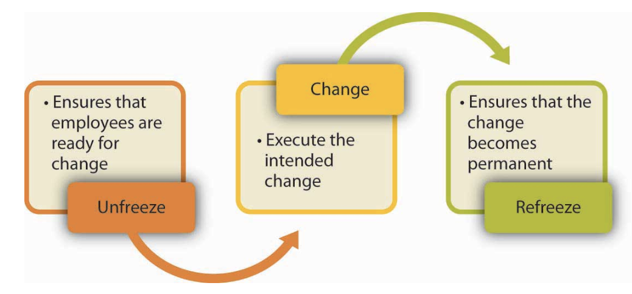

Organisational Behaviour Textbook, 2017, chp 14

Stage 1: Unfreezing, to make sure that “organisational members are ready for and receptive to change” (Organisational Behaviour, 2017).
Unfreezing the perception and process of the organisation. This stage is about removing the rules and boundaries of the business and seeing the natural flow within the organisation. The sort of actions an organisation is likely to take in this stage is to create a vision for change, communicating to all members the plan for the change, highlighting the need for change, building a coalition (Organisational Behaviour, 2017). Telstra’s current vision, purpose, mission statements and its processes need to be put on halt to see the natural flow in the organisation.
Stage 2: Making the changes
The second stage is about implementing the change model. In this stage the organisation implements the changes across its resources, structure, procedures and processes. However, how to implement change is subjective and depends on the approach the organisation pursues to take and the frequency of the change (Organisational Behaviour, 2017). Creating small wins, continuously providing support and eliminating obstacles are a few steps the organisation could take. Telstra should implement the change with a purpose, values and mission statement that align with their strategy and should be communicated to all the employees and stakeholders.
Stage 3: Refreezing.
In this stage the change is transformed to be permanent and “the new habits, rules or procedures become the norm” (Organisational Behaviour, 2017).
This stage is crucial as the success of the process of change depends how far the efforts of the organisation work to make the change part of its culture. Telstra should now emphasise on maintaining and retaining the change embedded by focusing on making the change the norm and part of their habits.

Recommendations- Ambidextrous Organisations
The Harvard Business Review examines the nature of “Ambidextrous organisations” through the lens of exploitation and exploration (O’Reilly and Tushman, 2018). Organizations have been “successful at …exploiting the present and exploring the future” (O’Reilly and Tushman, 2018), these types of organisations share features in common. They distinguish their traditional exploitative units from their exploratory new units, this enables them to encompass different initiatives and processes as part of their structure and culture, simultaneously senior level managers ensure that “tight links” (O’Reilly and Tushman, 2018) across the both units are maintained. These sorts of organisations are called Ambidextrous organisations, it is believed that they provide both theoretical and practical model for “forward-looking executives” who are pursuing to initiate radical change or embed disruptive technologies while achieving incremental gains (O’Reilly and Tushman, 2018). Telstra should embrace its past and the footsteps it has travelled on while emphasis should be placed on exploring future opportunities that assist Telstra in remaining “Australia’s leading telecommunications and technology company” (Telstra, 2018). The implementation of change has meant that Telstra has diverted its focus from core operations to solely focus on change. Telstra has lost $500 million sales due to its deviation into Telstra 2022, despite the efforts taken by the organisation to implement change, it should also maintain its competitive edge.

In conclusion, implementing and maintaining a change can lead to optimal outcomes but this lies in the ability of the organisation to predict future disruptive technologies. Given that the Industrial Revolution Version 4.0 is having a great impact on organisations today and into the future. Telstra 2022 is a radical change that is likely to influence the phase of operations in the telecommunications industry. Although the organisation has planned and rationalised the change process, it will be challenged with forces that are unexpected from the dynamic business environments (Pieterse, Caniëls and Homan, 2012). Telstra’s strategy and goals were explained through the use of two models; Kurt Lewin’s Force-field analysis and Change management model. This was further represented through direct application of these theories to Telstra and the change it has proposed. Suggestion was given as to how organisations could be ambidextrous and how it can optimise its operations while targeting for change aspirations. Conclusively, this essay exposes the expansion as to “change is not always rational and well planned”, therefore success of an organisation lies in how well it is able to adapt and modify operations according to the needs (Pieterse, Caniëls and Homan, 2012).

Bibliography
- Brager, G., & Holloway, S. (1992). Assessing Prospects for Organizational Change: The Uses of Force Field Analysis. Administration in Social Work, 16(3-4), 15-28.
- Burnes, B. (2017). Managing Change. 7th ed. Harlow, England: Pearson, pp.326- 343.
- Carey, S. (2018). Telstra turns on 5G on the Gold Coast. [online] Telstra.com.au. Available at: https://www.telstra.com.au/aboutus/media/media-releases/Telstra-turns-on-5G-on-the-Gold-Coast [Accessed 9 Sep. 2018].
- Farquhar, P. (2018). How CBA, Domino’s, Telstra and other big Australian companies are making the jump to digital and winning. [online] Business Insider Australia. Available at: https://www.businessinsider.com.au/the-microsoft-report-30-australian-leaders-share-their-thoughts-about-digital-transformation-2016-11 [Accessed 9 Sep. 2018].
- Financial Review. (2018). What Telstra's strategy changes mean for consumers. [online] Available at: https://www.afr.com/technology/what-telstras-strategy-changes-mean-for-customers-20180620-h11lz9 [Accessed 7 Sep. 2018].
- O’Reilly, C. and Tushman, M. (2018). The Ambidextrous Organization. [online] Harvard Business Review. Available at: https://hbr.org/2004/04/the-ambidextrous-organization [Accessed 8 Sep. 2018].
- Lewin K. (1951). Field theory in social science. New York: Harper & Row.
- Morgan, J. (2018). A simple explanation of 'The internet of things'. [online] Forbes.com. Available at: https://www.forbes.com/sites/jacobmorgan/2014/05/13/simple-explanation-internet-things-that-anyone-can-understand/#636cc9de1d09 [Accessed 9 Sep. 2018].
- National Research Council. Committee on Forecasting Future Disruptive Technologies. (2010). Persistent forecasting of disruptive technologies. Washington, D.C.: National Academies Press.
- Organisational Behaviour Textbook 2017
- Penn, A. (2018). Telstra2022 - our plan to lead | Telstra Exchange. [online] Telstra Exchange. Available at: https://exchange.telstra.com.au/telstra2022-our-plan-to-lead/ [Accessed 9 Sep. 2018].
- Pieterse, J., Caniëls, M. And Homan, T. (2012). Professional discourses and resistance to change. [online] Available at: https://www.ou.nl/Docs/Faculteiten/MW/artikelen%20Thijs%20Homan/PIETERSE%20CANIELS%20AND%20HOMAN%202012%20-%20JOCM%2025(6).pdf [Accessed 9 Sep. 2018].
- Reference for business.com. (2015). Telstra Corporation Limited - Company Profile, Information, Business Description, History, Background Information on Telstra Corporation Limited. [online] Available at: https://www.referenceforbusiness.com/history2/66/Telstra-Corporation-Limited.html [Accessed 9 Sep. 2018].
- Tan, A. (2017). Telecoms: ripe for disruption in 2018. [online] Telecomasia.net. Available at: https://www.telecomasia.net/content/telecoms-ripe-disruption-2018 [Accessed 8 Sep. 2018].
- Telstra (2018). Cloud Based Internet of Things Platform - Telstra Enterprise. [online] Available at: https://www.telstra.com.au/business-enterprise/solutions/internet-of-things/platforms-and-services/iot-platform [Accessed 9 Sep. 2018].
- Telstra Exchange. (2018). Telstra 2022 - our plan to lead | Telstra Exchange. [online] Available at: https://exchange.telstra.com.au/telstra2022-our-plan-to-lead/ [Accessed 9 Sep. 2018].
- Telstra.com.au. (2018). Telstra - Our company. [online] Available at: https://www.telstra.com.au/aboutus/our-company [Accessed 9 Sep. 2018].

