POOJITHA SIVAKUMAR- 28805925

REalfood ltd. case study
ACC2200- INTRO TO MANAGEMENT ACCOUNTING
Table of Contents
Section 1- Value of Cost Classifications and effect on decision-making process 2
Section 2- Activity based costing relevance to RealFoods 3
Section 3- Advantages and Disadvantages of ABC method 6
References 7

Section 1- Value of Cost Classifications and effect on decision-making process
Cost is a measurement, in monetary terms, of the amount of resources used for the purpose of production of goods or rendering services (Cooper & Kaplan, 1992). Cost classification is pivotal to the decision-making process in a business (Cooper & Kaplan, 1992). It assists in profit planning by enabling the organisation to identify the behaviours of the costs incurred during the production process and subsequently distinguish the costs based on those behaviours (Reyhanoglu, 2004). By determining the different costs and classifying them, the business can identify inefficient processes and refine them to minimise expense and maximise profits (Reyhanoglu, 2004). In addition, application of a costing method is crucial in decision making, decision making that is related to setting the selling prices, determining the volume of sales required, highlights the unnecessary costs of the business and how it could be avoided. By identifying the costs the business can make useful decisions in relation to the product mix and or expansion decisions. Each organisation has a unique nature of operations for which it is likely to incur multiple costs. Depending upon the needs of the manager of the business, the classification of the cost varies to facilitate the decision-making process. The ultimate aim of a business is to accurately determine the product cost. To obtain the product cost the business has to be able to allocate its indirect costs and overhead costs, includes all business expenses except direct labour or materials (Mishra & Vaysman, 2001) to the product using costing methods. The traditional costing methods include process costing, job costing and hybrid costing (Mishra & Vaysman, 2001). All these costs involve creating a cost pool with a volume based cost driver and allocating it to the volume of products produced. However, the modern approach to costing is Activity-based costing, is distinctive to the traditional methods of costing. In ABC costing, the business creates a cost pool with a cost driver but there are multiple cost pools created based on the activities (a unit of work performed within the organisation) of the business (Collins, 1991).

Section 2- Activity based costing relevance to RealFoods
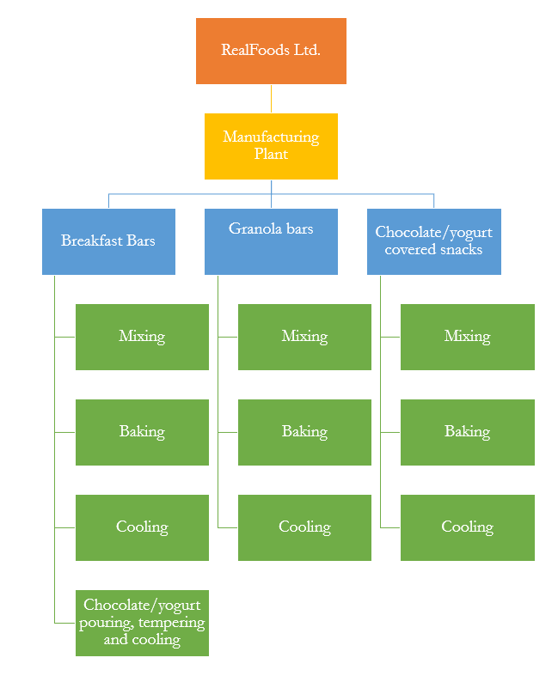
RealFoods current costing system has many flaws, it is not aiding the manager in product related decision-making. Due to RealFood’s underdeveloped system, it is not possible for the business to determine the actual costs per unit which means that the manager is estimating the cost of each product based on background knowledge about the prices of the ingredients, hence, the business does not know whether or not an order is profitable.
Figure 1: Structure of RealFood Ltd.

Activity based costing is a method that can be used to measure both the cost of cost objects and the performance of activities (Collins, 1991). ABC is a method that assigns costs to overhead activities and then allocate it to the products (Staff, 2018). Due to the lack of methods in cost accounting to allocate the indirect costs and overhead, this method is useful for the business. The purpose of ABC method of costing is to allocate the indirect costs based on activities and to link the cost and cost object (Fei & Isa, 2010). For ABC costing, the business must first identify distinct activities and classify them into either unit level, batch level, product level or facility level.

RealFood’s should recruit a team of people to examine and identify all the distinct cost activities within its manufacturing plant and facility level operations. The activities should be divided into subcategories and the cost driver should be allocated for each. Following this, the cost related to each activity should be pooled together which leads to multiple cost pools should be formed. Then the activity expense should be divided by the activity cost driver quantity to determine the activity cost driver rate. The activity cost driver rate is applied to cost objects based on the activity usage. The sum of the cost objects from all activities used to produce one unit will form as part of the product cost (Collins, 1991). The steps have been outlined in the figure 2. Additionally, Table 1 has been included to tabulate the product cost using ABC model.
Figure 2: Five Steps to implementing ABC method and example

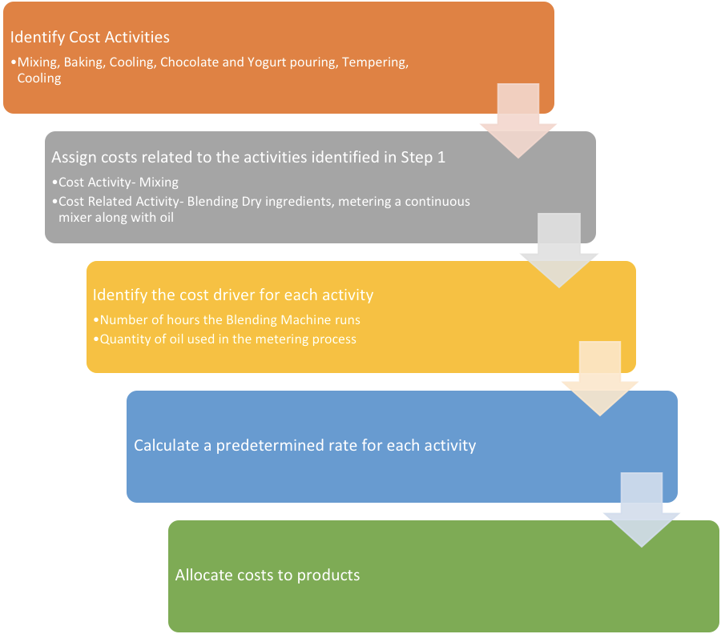

Table 1: Format for calculating product cost using ABC model
Activity Level | Activity | Cost per unit of activity driver | Annual quantity of cost driver consumed | Annual Cost | Cost per unit or product
Unit
Batch
Product
Facility
Total activity cost (annual and per unit)
Direct Material Cost
Total product cost per unit

The Activity-based costing method is superior to other costing methods as it takes direct and indirect costs into account whilst the other methods only take direct costs into account. Using the ABC method, allows the organisation to accurately ascertain the cost of producing a product or rendering services (Mishra & Vaysman, 2001). This information is vital in the decision-making process about expansion, budgeting, increasing revenue and minimising process dependant costs. Meanwhilst, traditional costing methods considers only the cost dependant on labour and material used which often underestimates the organisation’s expense.
“TheABC model reduces the dimensionality of the decisions to where the cash flow consequences from only a few alternatives need to be examined closely” (Cooper & Kaplan, 1992).

Section 3- Advantages and Disadvantages of ABC method
This assists the business to identify inefficient departments, product lines and activities. Therefore, the business has a clear picture of the where the investments need to be directed to maximise profits, meaning the production manager will be able to pick up on the popular product lines and least performing product lines to take further action (Tippett & Hoekstra, 1993). The unnecessary costs that could be reduced can be identifying by implementing the ABC costing method (Fei & Isa, 2010).

Despite the ABC costing and its relevance to management decisions, it does have flaws. The process of implementing the ABC costing system can be quite time consuming and expensive. Activity based costing requires the pooling of similar costs together, this accumulation can be expensive and means the business needs systems to crunch big data into manageable information. When the business does not have significant overhead costs in proportion to the operation cost, this method of costing may not be as useful. ABC costing is a method that “converts large indirect costs into direct costs of production”. Implementing the ABC system can be “time consuming and expensive to maintain” but it provides business with value as it proven to increase the effectiveness and efficiency of the activities of the business and increase individual product line’s profit margin.

References
Collins, F. (1991). Implementing activity-based costing. New York, N.Y.: Executive Enterprises Publications.
Cooper, R., & Kaplan, R. S. (1992). Activity-based systems: Measuring the costs of resource usage. Accounting Horizons, 6(3), 1. Retrieved from https://search-proquest-com.ezproxy.lib.monash.edu.au/docview/208915804?accountid=12528
EduPristine. (2018). Costing Methods and Important Costing Terms. Retrieved from https://www.edupristine.com/blog/costing-methods
Fei, Z., & Isa, C. (2010). Factors Influencing Activity-Based Costing Success: A Research Framework. International Journal Of Trade, Economics And Finance, 1(2), 144-150. doi: 10.7763/ijtef.2010.v1.26
Mishra, B., & Vaysman, I. (2001). Cost-System Choice and Incentives-Traditional vs. Activity-Based Costing. Journal Of Accounting Research, 39(3), 619-641. doi: 10.1111/1475-679x.00031
Reyhanoglu, M. (2004). Activity-Based Costing System Advantages and Disadvantages. SSRN Electronic Journal. doi: 10.2139/ssrn.644561
Staff, I. (2018). Activity-Based Costing (ABC). Retrieved from https://www.investopedia.com/terms/a/abc.asp
Tippett, D., & Hoekstra, P. (1993). Activity-Based Costing: A Manufacturing Management Decision-Making Aid. Engineering Management Journal, 5(2), 37-42. doi: 10.1080/10429247.1993.11414729

