Chapter 20: Consolidation: intragroup transactions
Question 20.2 Intragroup transactions
Numbat Ltd owns all of the shares of Goanna Ltd. In relation to the following intragroup
transactions, all parts of which are independent unless specified, prepare the consolidation
worksheet adjusting entries for preparation of the consolidated financial statements as at 30
June 2016.
Assume an income tax rate of 30%.
(a) On 1 July 2015, Numbat Ltd sold an item of plant costing $15 000 to Goanna Ltd for $18
000. Numbat Ltd had not charged any depreciation on the plant before the sale. Both
entities depreciate assets at 10% p.a. on cost.
(b) On 1 January 2014, Goanna Ltd sold a new tractor to Numbat Ltd for $30 000. This had
cost Goanna Ltd $24 000 on that day. Both entities charged depreciation at the rate of 10%
p.a. on cost.
(c) On 1 July 2015, Numbat Ltd sold an item of machinery to Goanna Ltd for $9000. This item
had cost Numbat Ltd $6000. Numbat Ltd regarded this item as inventory whereas Goanna
Ltd intended to use it as a non-current asset. Goanna Ltd charges depreciation at the rate
of 10% p.a. on cost.
(d) In February 2015, Numbat Ltd sold inventory to Goanna Ltd for $9000, at a mark-up of
20% on cost. One-quarter of this inventory was unsold by Goanna Ltd at 30 June 2015.
(e) Goanna Ltd sold land to Numbat Ltd in December 2015. The land had originally cost
Goanna Ltd $20 000, but was sold to Numbat Ltd for only $16 000. To help Numbat Ltd
pay for the land, Goanna Ltd gave Numbat Ltd an interest-free loan of $9000, and the
balance was paid in cash. Numbat Ltd has as yet made no repayments on the loan.
(f) On 1 July 2014, Goanna Ltd rented a spare warehouse to be used jointly by Numbat Ltd
and Galah Ltd with each company paying half the agreed rent to Goanna Ltd. The rent
paid to Goanna Ltd in the 2014–15 year was $300 while the rent paid in the 2015–16 year
was $350.
9; <  !! ) A
  !  5
   /
OR
 !! ) /
   /
)$  ) 8
+$$   8
! ) /
)$   /
90$./##;
+$$  ) 8
)$   8
9; 6 9=7=5; ) E(
)$  ) A
  :
! ) 5
)$   :
6 9=7=5;  8
Question 20.2

- Proceeds on sale of plant dr 18,000
Carrying amount of asset sold cr 15,000
Asset cr 3,000

- Retained earnings (1/7/15) dr 4,200
Deferred Tax asset dr 1,800
Tractors cr 6,000

Accumulated Depreciation dr 1,500
Depreciation Expense cr 600
Retained earnings (1/7/15) cr 900
(10% X $6,000 p.a. for 2.5 years)
Take into account last years’ depreciation and this year’s

Income Tax Expense dr 180
Retained Earnings (1/7/15) dr 270
Deferred Tax Asset cr 450

- Sales Revenue dr 9,000
Cost of Sales cr 6,000
Machinery cr 3,000

Deferred Tax Asset dr 900
Income Tax Expense cr 900

Accumulated Depreciation dr 300
Depreciation Expense cr 300
(10% X 3000 p.a.)

Income Tax Expense dr 90
Deferred Tax Asset cr 90

Question 20.5
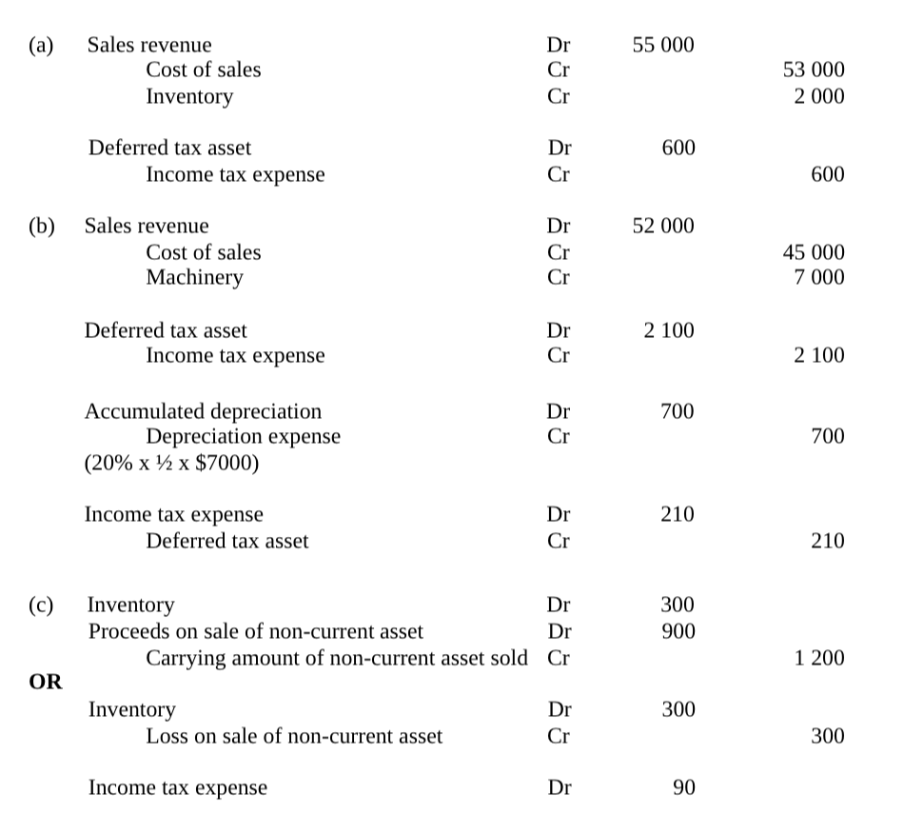

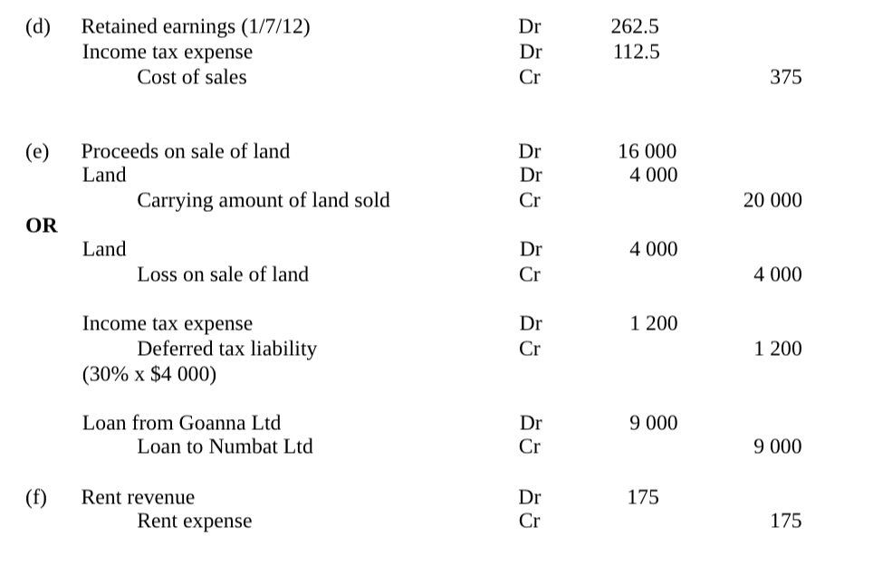

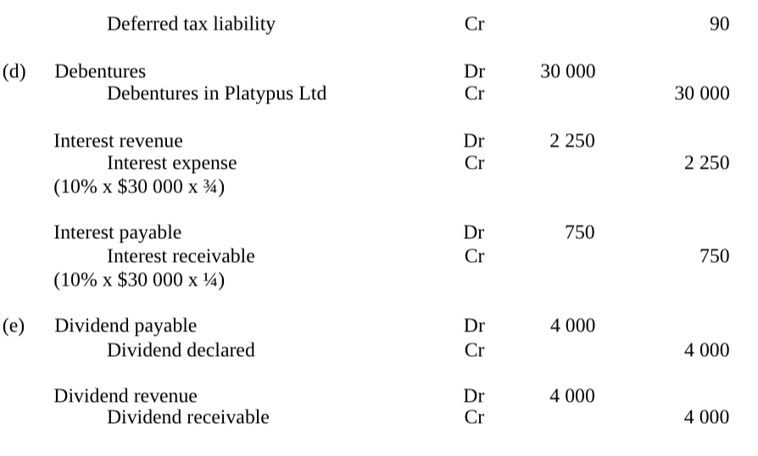

Question 20.8 exam style question

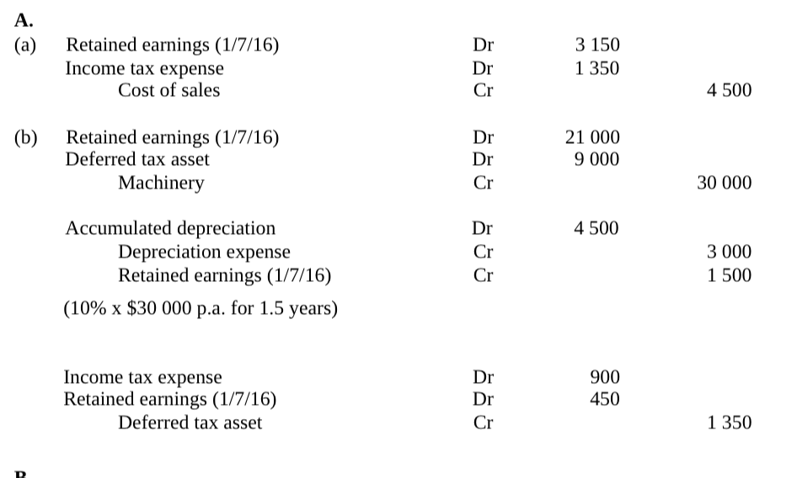
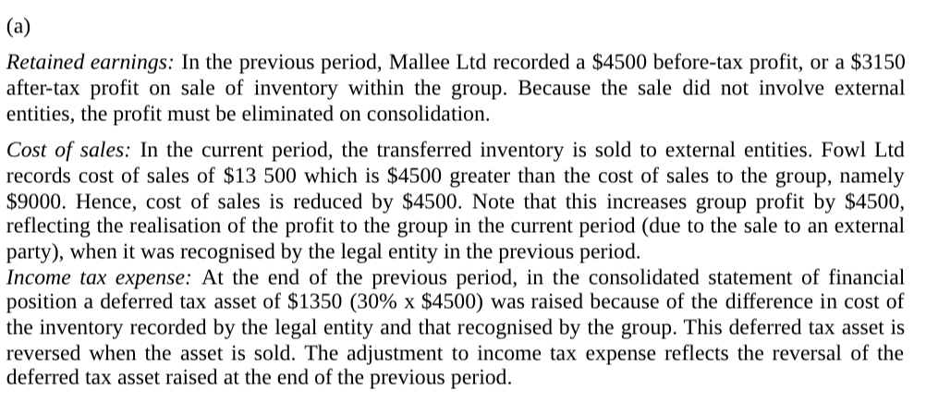
Sales

Same year:

Remain on Hand-

Dr sales
Cr COGS
Cr Inventory
Dr DTA
Cr ITE

Sold-

Dr Sales
Cr COGS

Different year:

Remain on hand-
Dr RE
Dr DTA
Cr Inventory

Sold-
Dr RE
Dr ITE
Cr COGs

Original cost of the inventory with the inventory mark up

Selling Cost
Mark-up (1 + mark-up)

Question 20.10

Acquisition analysis
FVINA= Equity + Increase/ decrease in the assets

Consideration transferred
Goodwill

BCVR entries

Acc. Dep
Plant

Plant
DTL
BCVR

Inventory
DTL
BCVR

BCVR
DTA
Contingent Liability

Pre acquisition entries

Share capital
General Reserve
Asset Revaluation surplus
Retaines earnings
Goodwill
BCVR
Shares in Son Ltd

Bonus shares
Share Capital Dr
General Reserve Cr

Question 20.10 EXAM style question

Question 20.10 c
Dividend payable
Dividend declared

Dividend revenue
Dividend receivable

Can revalue land separately, but there is no entry or adjustment made.

