Assessment task title: Individual Reflections on Change Journal
Due Date: Due week 12
Weighting/Value: 25%
Submission: Hard-copy submission in your allocated workshop.

Word limit: 3,500 words (approximately 350-400 words x 8 weeks, and a final summary of approx. 500 words)

Details of Task:

This is an individual assessment task. The aim of this task is to get students to reflect on the change literature from both a practical and theoretical perspective.

Students are directed to reflect on any of the relevant material, concepts, readings, media, experiential activities, class discussion, group work and self-assessments covered over the course of the semester.

The individual reflection of change needs to be more than just a diary of your experiences. It should explicitly discuss
- how your experiences in the unit, in life and at work relate to theories you have learnt
- your attitudes/thoughts on these theories and
- how these impact upon your decision making.

You may want to reflect on all aspects of your education and
- how your experiences have changed you. It is expected that you
- reflect on areas directly related to work and employment (i.e. team work, technology, communication etc.).

The individual reflection of change must include:

- Materials from 8 TOPICS discussed during the semester between Weeks 1
and 10;
  - Can include, but not limited to: A critical analysis of the readings; what relationships exist between the readings? What patterns have emerged in the development of the theories? How do the ideas and concepts in the readings interrelate? What has been revealed in organisations and management by the use of multiple perspectives?
  - See Reflections forum for more suggestions

- You must also provide a response to the question posted on Moodle about organisational learning;
  - Your understanding of your own learning over the semester and the implications for organisational learning;

- And a personal learning statement of your experiences in working on the group project. As with other pieces of work, this needs to provide a link between theory and practice, but from a truly deep personal perspective.
  - How have you changed as a result of this experience?
  - What has this experience taught you about change?
  - Has this changed how you would approach organisational change?
There is a suite of resources available on Moodle to assist you with the reflective writing process.

Only the Lecturer and Chief Examiner will have access to these journals, so please be frank, thoughtful and genuine.

Reflection is an essential component of the learning process.
In order to assist you with your learning, you were required to create and maintain a Reflections on Change or "ROC" Journal in the form of a diary or portfolio of your change experiences throughout the semester.
Each week of the journal we provided a "prompt question" to start your writing for the week (beginning of each lecture/tut…go & have a look AGAIN)
You could also relate an experience or recall a change event or issue from your workplace or a current business situation in the media for your journal.
You should describe, analyse and (most importantly) reflect upon it, in your journal.
1. Before the semester started – past (why chosen?; prior-perceptions?; what were your expectation? = be honest)
2. During the semester classes - present (Diarised & other experiences-events)
First class – week?; assessments, text-sources, processes, outlines
In-class – lectures? Workshops?; useful-less? Future-friendly? Repete? Easy-medium challenge-impossible tasks? Well/poorly managed & the effects they had on you during the semester & going forward
3. Anticipated Future – where to now? Did the experience help or hinder; - +ve or –ve & why? Things that YOU NEED TO NOW (& will) CHANGE? Self-Efficacy? (So, looking back I’ve learned……)

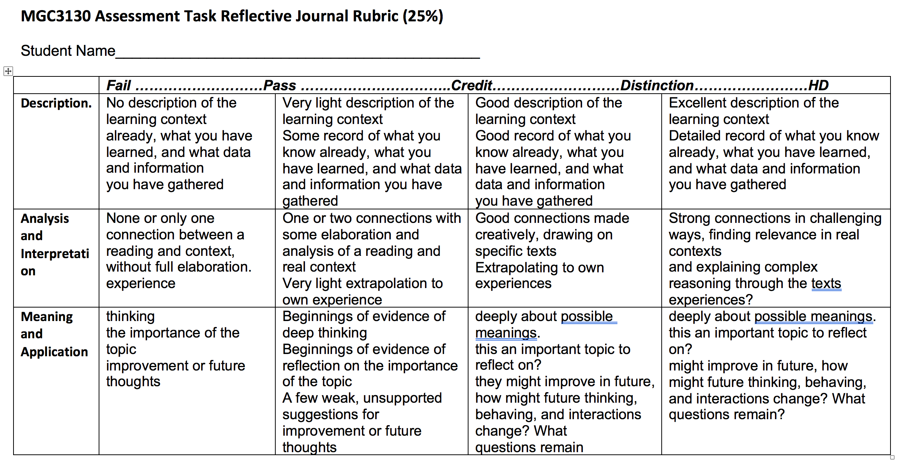

Word limit: 3,500 words (approximately 350-400 words x 8 weeks, and a final summary of approx. 500 words)
(375 words x 8 weeks = 3000 words + 500 summary = 3500 words).

