Acc2200- Week 12 tutorial questions

EXERCISE 21.23 - Net present value: not-for-profit organisation

Cost of new water tank (time 0) $(14 125)
Present value of annual savings: ($2500 ×7.360*) 18 400
Net present value $4 275 *
r= 0.06 and n= 10.
The management committee should approve the new water tank, because the project’s net present value is positive.

EXERCISE 21.24- Internal rate of return: not-for-profit organisation

Annuity discount factor associated with the IRR:
=initial cash outflow
annual cost savings
=$14 125
$2 500
= 5.650

This annuity discount factor falls in the 12 per cent column. Thus, the project’s internal rate of return is 12 per cent. Based on the financial analysis, the management committee should approve the new water tank, because the project’s internal rate of return is greater than the hurdle rate of 6 per cent.

EXERCISE 21.27- Payback period; net present value; uneven cash flows publishing company

- Payback period = 3 years
The accumulated incremental cash flows total $’65 500 in the first three years, as the following table shows ($50 000 + $55 000 + $60 500), which equals the initial investment in advertising of $’65 500.
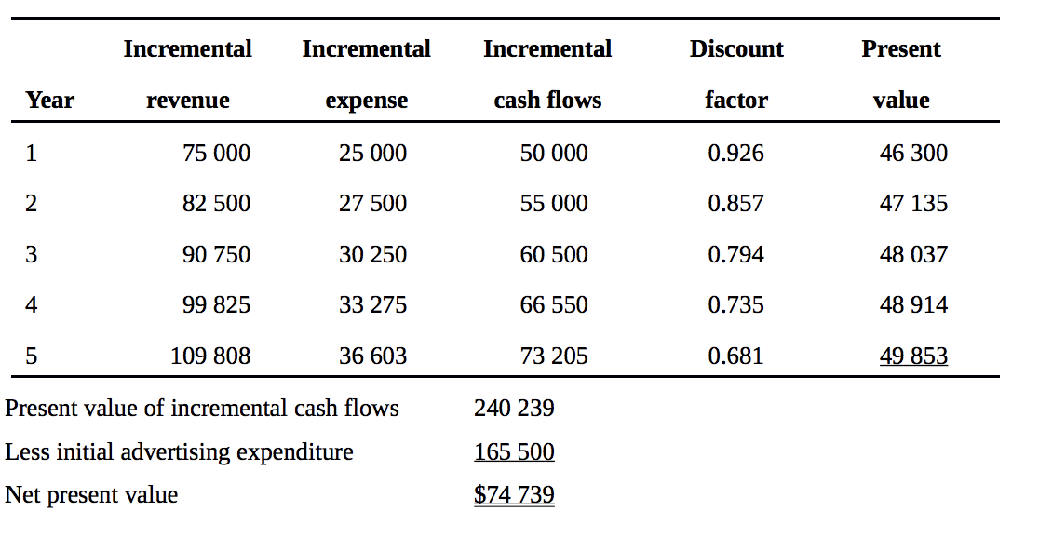
EXERCISE 21.28- Accounting rate of return: manufacturer

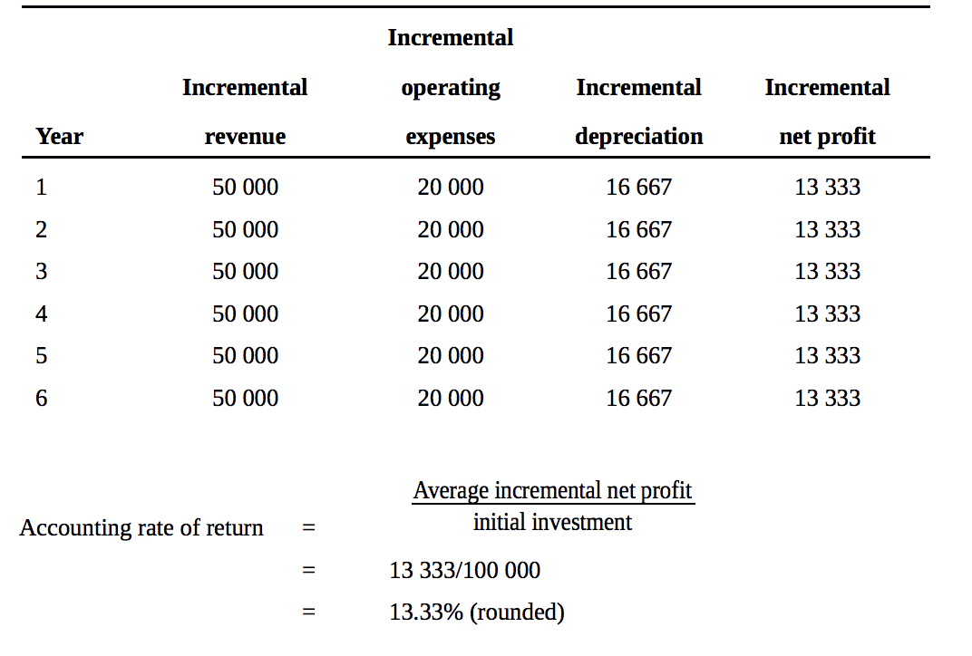

EXERCISE 21.30- After-tax cash flows; profit or loss on disposal: manufacturer

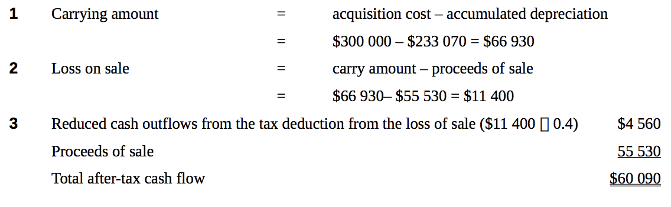

In class question 21.34- Net Present Value

Capital expenditures are long term decision making that involve large amounts of money.
Use annuity table for even cash flows
- Net present value analysis:
Retain old machine:
Annual costs:
Variable 300,000 X $0.38 $114,000
Fixed $21,000
Total $135,000
Annuity discount factor (r=12%; n=6) X 4.111
Present value of annual costs $554,985
Salvage value, end of Year 10 $7,000
Discount factor X0.507
Present value of salvage value (3,549)
Net present value of costs $ 551,436

- Net present value analysis:
Retain new machine:
Annual costs:
Variable 300,000 X $0.38 $87,000
Fixed $11,000
Total $98,000
Annuity discount factor (r=12%; n=6) X 4.111
Present value of annual costs $402,878
Salvage value, end of Year 10 $20,000
Discount factor X0.507
Present value of new machine’s salvage value (10,140)
Salvage value of old machine, end of year 4 (40,000)
Acquisition cost of new machine 120,000
Net present value of costs $472,738
Purchase the new machine because the net present value of relevant costs is lower than with the old machine.

