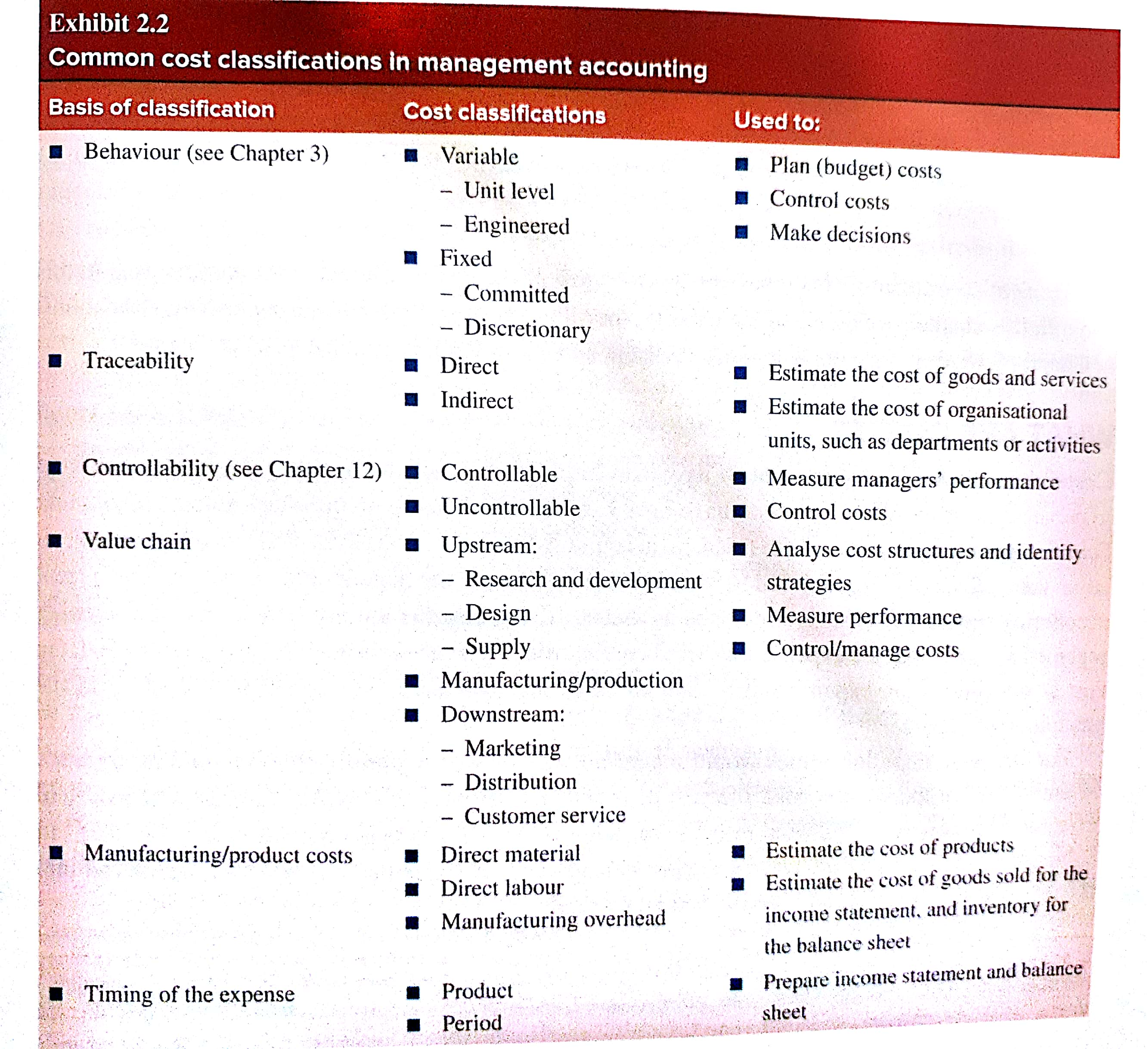
MANAGEMENT ACCOUNTING- Week 3 Tutorial Homework

Exercise 2.5 (learning objective 2.3)
What is meant by the phrase different costs for different purposes?
Depending upon “how managers use this information”, different costs are used for different purposes. Some costs may be relevant for managers as they will have to understand this to manage the level of resources to create value for customers and shareholders. Costs may be relevant to multiple areas such as; product costing affects determining product profitability or costs relevant to planning has an effect on future operations. Based on the situation and the needs of the manager, costs relevant to it should be provided by management accountants.

Exercise 2.6 (learning objective 2.4)
Traditional management accounting systems classify costs as fixed and variable. Define these terms and provide three examples of each for the Commonwealth Bank.
Fixed cost is a cost that remains unchanged in total despite changes in the level of activity. Variable cost is a cost that changes, in total, in direct proportion to a change in the level of activity.
Fixed costs of Commonwealth Bank:
- Renting of premises
- Admin expenses
- Depreciation of computer and equipment
Variable costs of Commonwealth Bank
- Cost of funding
- Interest on loans
- Commission expense

Exercise 2.7 (learning objective 2.4)
When analysing cost behaviour, what do we mean by level of activity?
Level of activity refers to the level of work performed in the organisation. Hence, the activity causes the cost and therefore is called the cost driver, which is any activity or factor that causes costs to be incurred. The activity can be expressed in different units, such as kilometres, pages printed, and hours worked based on the type of organisation being looked at in the scenario.

Exercise 2.22 (learning objective 2.5, 2.6)
Classifying product and period costs, variable and fixed costs, manufacturing costs
For each of the costs listed below, indicate whether it is:
- A product or period cost
- A variable or fixed cost
- A manufacturing or non-manufacturing cost
You may wish to use the following table format in answering this question.
Cost No. | Product/ period cost? | Variable or fixed cost? | Manufacturing/ non-manufacturing cost?
Advertising costs of Nike | Period costs | Fixed costs | Non-manufacturing
Straight-line depreciation on mining machinery of BHP Billiton | Period costs | Fixed costs | Non-manufacturing
Wages of assembly line personnel of Mack Trucks | Product costs | Variable costs | Manufacturing costs
Delivery costs on customer shipments of Streets ice-cream | Product costs | Variable costs | Non-manufacturing
Newsprint consumed in printing The Sydney Morning Herald | Product costs | Variable costs | Manufacturing costs
Plant insurance costs of Levi Strauss | Period costs | Fixed costs | Non-manufacturing costs
Glass costs incurred in cookware produced by Pyrex | Product costs | Variable costs | Manufacturing costs
Tyre costs incurred by Subaru | Product costs | Variable costs | Manufacturing costs
Sales commissions paid to the sales force of Dell Inc | Product costs | Variable costs | Manufacturing costs
Wood glue consumed in the manufacture of Fantastic Furniture wardrobes | Period costs | Variable costs | Manufacturing costs
Hourly wages of refinery security guards employed by BP | Period costs | Fixed costs | Non-manufacturing costs
The salary of a financial vice president of Microsoft | Period costs | Fixed costs | Non-manufacturing costs

Tutorial Question- Exercise 2.41
Required:
Michael Halls asks you to review the results for the month and evaluate the company’s approach to estimating product costs. In doing so, you should:
- Comment on the cost classifications used in CTC’s income statement.
The bookkeeper has clearly not distinguished between the costs.
- He has charged the entire purchases as an expense while there was still a few remaining on hand

- Estimate the cost of goods manufactured and sold
Colonial Tap company
Schedule of cost of goods manufactured for the month ended
Direct Material: | $ | $
Raw material inventory
Add purchases of raw material
Raw material available for use
Deduct Raw material inventory
Raw material used
Direct Labour
Manufacturing Overhead:
Indirect material
Indirect labour
Depreciation of factory
Depreciation of equipment
Electricity
Insurance
Total manufacturing overhead
Total manufacturing costs
Work in progress inventory
Subtotal
Deduct work in process inventory
Cost of goods manufactured

Schedule of costs of goods sold for the month ended
Finished goods inventory
Add cost of goods manufactured
Costs of goods available for sale
Deduct finished goods inventory
Cost of Goods sold

- Prepare a revised income statement for the month.
Income statement for the month ended
Sales Revenue
Less Costs of Goods Sold
=Gross Profit
Selling and administrative expenses
Profit before taxes
Income tax expenses
Net profit

- Explain the difference between your income statement and the above one.

- If possible suggest a more useful format for analysing costs that that used in your revised income statement.

- Evaluate the usefulness of product costs based on direct materials and direct labour for determining selling prices.

- Make recommendations for changes to be made to the company’s approach to product costing and reporting profit.

