TUTORIAL QUESTIONS
Readings: Chapters 1, 2 (not 2.3 or 2.8 onwards), 3 Accounting Standards: AASB Framework, AAS B 101
Tutorial Questions:
C h 1 RQ 10, 13, 15
C h 2 RQ 1, 7, 9, 10 and PQ 2.1, 2.3, 2.5*, 2.6, 2.13* C h 3 RQ 12 and PQ 3.1
*Prepare journal entries, not ledger accounts

Chapter 1
Review Question 10
What are the main reasons for the development of accounting regulations?
Main reasons for change was to
- Express the law in simple English
- Make the law more efficient in a competitive marketplace
- Elimination of ambiguity

Review Question 13
What are the current arrangements for setting accounting standards in order to show a ‘true and fair view’ of its financial affairs? Discuss.
- International organisation identifies a technical issue, issue may be identified by the international Accounting Standards Board (IASB) or the IFRS interpretations committee (IFRIC) or AASB identifies a technical issue or the Australian organisation/ individual identifies a technical issue.
- Adds issue to the agenda, the AASB will develop a project proposal. The project proposal contains an assessment of the potential benefits of undertaking the project, the costs of not undertaking it and the resources available and the likely timing. The AASB reviews the proposal to decide whether the project is worthwhile and should be placed on its agenda.
- Research and consider issue, once it is added to the agenda, it addresses the scope of issues, alternative approaches and timing of outputs.
- Consult with stakeholders, once research has been completed it makes documents available for public comment and discussion with stakeholders via exposure drafts (EDs), invitations to comment (ITCs), draft interpretations, discussion papers (DPs). The methods the AASB uses to consult with stakeholders may also include roundtable discussions, focus groups, project advisory panels, interpretation advisory panels
- Issue standard or other pronouncement, result of the AASB’s consideration of an issue may be the issuance of a standard, an interpretation or a conceptual framework document.
- Submissions to international organisation (IASB), for them to contribute to the setting of high-quality international accounting standards.
- Comments from stakeholders in Australia
- Implementation and compliance
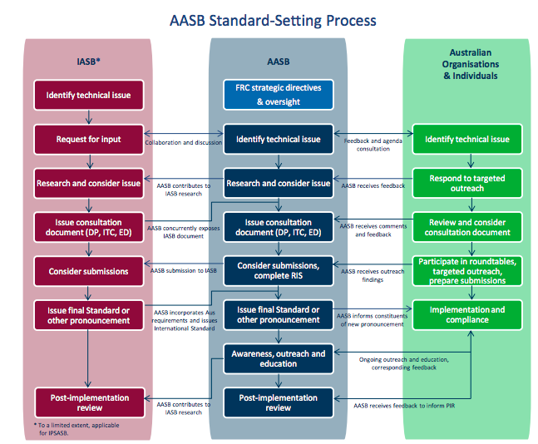
Review Question 15

To which entities do accounting standards apply? Discuss the nature of a reporting entity, and consider reasons for the concept being replaced.
Not all companies are requires to prepare financial reports that comply with accounting standards. There are two types of reports; general purpose financial reports (GPFRs) and special purpose financial reports (SPFRs).
In AASB SAC 1, definition of reporting entity, the GPFR is one intended to meet the common information of users who are unable to command the preparation of reports tailored to satisfy their information needs. All GPFRs are prepared in accordance with accounting standards and are directed towards information needs of users who lack power to obtain such information themselves.

Reporting entities are all entities (including economic entities) in respect of which it is reasonable to expect the existence of users who rely on the entity’s general purpose financial report for information that will be useful to them for making and evaluating decisions about the allocation of scarce resources.

Chapter 2

Review question 1
Explain the nature of a share. Distinguish between an ordinary share and a preference share.
A share is simply part ownership of a business, a company’s’ way of raising money to finance its business by ‘going public’. Which means that the company is listed on the Australian Securities exchange. By paying for shares, each investor buys part ownership of the company’s business and becomes a shareholder in the company. The money the business raises in this form is called the ‘share capital’.
Both ordinary and preference share illustrate a claim in the corporate earnings and assets. Dividends for ordinary shares may be irregular and indefinite whereas preference shareholders will receive a fixed dividend which will accrue usually if the payments are not made in one term. Ordinary shareholders are in a riskier position that preference shareholders since they are the last to receive their share in the event of liquidation; however, they also are open to the possibility of a higher dividend during times when the firm is doing well. The ownership of preference shares offers advantages and disadvantages in terms of higher claims on earnings and assets and fixed dividends as opposed to limited voting rights and limited possibility for growth in dividends in times when the company is financially sound.
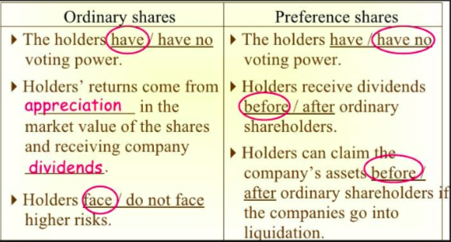

Review question 7
What is a rights issue? Distinguish between renounceable and non-renounceable rights issue. How would a company account for such issues?
The rights issue is an issue of new shares with the terms of issue giving all existing shareholders in a particular class of shares the right to an additional number of shares in a same proportion as their current shareholdings. IF all the existing shareholders exercise their rights and take up new shares, there is no change in each shareholder’s percentage ownership interest in the company. Rights issue may be ‘renounceable’ or ‘non-renounceable’.
If renounceable, existing shareholders have three options; 1. They may exercise their rights and acquire more shares in the company, 2. They may decline to exercise their rights and let them lapse, 3. They may sell their rights on a securities exchange and alloq other investors to acquire the company’s shares.
If non-renounceable, shareholders are not allowed to sell their rights and must accept or reject the offer to acquire new shares in the company.

Review question 9
What is a share option? How does a company account for share options that lapse?
A share option is an instrument that gives the holder the right to buy or sell shares in the company by a specified date at a stipulated price.
For example; In February 2016, Sigma Ltd issued to existing shareholders 36 000 options to buy 36 000 ordinary shares. Each option costs 50c and entitles the holder to one ordinary share in Sigma Ltd at a price of $1.50 per share, exercisable between 23 November 2018 and 20 December 2018. Options not exercised by 20 December 2018 will lapse.

On issue:
Details | Dr/Cr | Amount | Amount
Cash  Share options | DR  CR | 18000 | 18000
Lapsed options:
Details | Dr/Cr | Amount | Amount
Cash  Share capital  (issue of 30,000 shares on payment of $1.50 per share) | DR  CR | 45000 | 45000
Share options  Share capital  Lapsed options reserve  (Write-off of share options, reflecting 30,000 options exercised and 6,000 lapsed) | DR  CR  CR | 18000 | 15000  3000

Review question 10
Detail the characteristics of redeemable preference shares recognised as liabilities rather than equity.

Practice question 2.1- oversubscription on share issue, payable in full on application
Maple Ltd was registered on 1 March 2017. Directors decided to issue 500 000 ordinary shares on 31 March 2017, payable in full on application at an issue price of $2.
The company received applications for 560 000 shares, sent letters of regret to applicants for 10 000 shares and the remaining applicants received partial allotments by issue of 10 shares for every 11 shares applied for, making the total allotment 500 000 shares. Legal costs of issuing the shares, $12 000, were paid.
Date | Details | Dr/Cr | DR | CR
31/03 | Cash Trust  It is an asset account  Application  It is a liability account  (money received on application)  Application  Cash Trust  (Refund to unsuccessful applicants for 10,000 shares)  Application  Share capital- ordinary  Application  Cash Trust  Cash  Cash Trust  Share issue costs/ shared capital * (should write both)  Cash | DR  CR  DR  CR  Dr  Cr  Dr  Cr  Dr  Cr  DR  CR | 1,120,000  20,000  1,000,000  100,000  1,000,000  12,000 | 1,120,000  20,000  1,000,000  100,000  1,000,000  12,000

Practice question 2.3- share issue, payment by instalments
On 1 July 2017, Pine Ltd issued a prospectus inviting applications for 600 000 ordinary shares, at an issue price of $7, payable $2.50 on application, $1.50 on allotment, and $3 on future call(s), dates to be determined by the directors. By 1 September, applications were received for 620 000 shares with $3 paid. On 6 September, the directors allotted 600 000 shares. Refunds were made to applicants for 20 000 shares. Share issue costs of $12 400 were also paid on the same date. All of the allotment money was received by 1 October. On 1 February 2018, a first and final call for $3 was made. All of the call money was received by 1 March 2018.

Required
Prepare journal entries to record the above transactions.
Date | Details | Dr | Cr
1/09  6/09  1/02 | Cash trust  Application  620,000 shares at @2.50 per share  Application  Allotment  Share capital  Issue of 600,000 shares  Application  Cash Trust  Refund unsuccessful applicants 20,000 shares at @2.50  Share capital/share issue costs  Cash  Cash trust  Cash  Call  Share capital  Cash  Call | 1,550,000  1,500,000  900,000  50,000  12,400  1,800,000 | 1,550,000  2,400,000  50,000  12,400  1,800,000

- Distinction between share issue costs and formation costs is most important as they must be treated differently under Accounting standard
- Share issue costs, including underwriters commission treated as a reduction in quity
- Contra account to share capital account used
- Deduct from share capital to determine amount of equity raised from the issue of shares
- Formation costs, involved in getting the business up and running (start-up costs) i.e., legal, accounting, registration, start-up costs are an EXPENSE

Practice question 2.5- issue of shares by instalments; ledger accounts
On 30 September 2016, Jacaranda Ltd issued a prospectus calling for applications for 600 000 ordinary shares at an issue price of $3, payable $1.50 on application and $1.50 on allotment. By the closing date of 31 October 2016, the company had received the following application money:
From applicants for 500 000 shares | $750 000
From applicants for 120 000 shares | 360 000
On 15 November, it was decided to allot to applicants who paid more than the application money the number of shares applied for, and to applicants who paid only the application money 480 000 shares. Application money was refunded to 20 000 unsuccessful applicants.
The constitution gives the directors the power to apply excess application money to allotment. All other allotment money was received by 31 December 2016.

Required
Prepare the necessary ledger accounts to record the above transactions.
Date | Details | Dr | Cr
31/10 | Cash Trust  Application  Receipt of $360,000 + $750,000 | 1,110,000 | 1,110,000
15/11 | Application  Allotment  Share Capital  Application  Cash Trust | 900,000  900,000  30,000 | 1,800,000  30,000
15/11 | Application  Allotment  Transfer of excess money to allotment: 120000 X $1.50 | 180,000 | 180,000
 | Cash  Cash Trust | 1,080,000 | 1,080,000
31/12 | Cash  Allotment | 720,000 | 720,000

Practice question 2.6- rights issues and private placements
The equity of Ash Ltd on 30 June 2017 was:
Share capital (issued at $4, fully paid) | $1 200 000
Asset revaluation surplus | 700 000
Retained earnings | 400 000
The following transactions occurred during the year ended 30 June 2018.
- On 1 August 2017, a 1-for-4 rights offer was made to existing shareholders. The issue price was $4 per share payable in full on allotment, and rights were transferable. Shares issued under the offer were to rank equally with existing shares as from 1 August 2017. The issue 83was underwritten for a commission of $8000. The issue closed fully subscribed on 31 August, the holders of 50 000 shares having transferred their rights. Directors proceeded to allotment. The underwriting commission was paid on 7 September.
- On 1 March 2018, 220 000 shares were privately placed with Blossom Investments Ltd at $4 per share.

Required
- Prepare general journal entries to record the above transactions.
- Prepare the equity section of the statement of financial position as it would appear at 30 June 2018, assuming a profit for the year of $50 000.

Date | Details | DR | CR
31/08 | Cash  Share capital  Rights issue for 75,000 shares issued at $4 | 300,000 | 300,000
7/09 | Share issue costs/ share capital  Cash  Payment of underwriting | 8,000 | 8,000
1/03 | Cash  Share capital  Private placements of 220,000 shares at $4 each | 880,000 | 880,000

Ash ltd
Equity
As at 30 june 2018
Contributed equity
595000 ordinary shares issued at $4 2 380 000
Less share issue costs (underwriting) 8000

Retained earnings 3,522,000

Subsequent issue of equity shares
3 ways to increase share capital
  - Rights issue
  - Private placement- issue of shares privately usually to institutional investors such as life insurance companies
  - Bonus issue- issue of additional shares to existing shareholders at no cost to those shareholders
Difference between issue of shares to public and rights issue
Public- offer comes from applicant- company can accept/reject
Rights issue- company informs existing shareholders of their right to purchase additional shares in proportion to their current shareholding- constitutes an offer
Usually set below market price of company’s shares
Acceptance is then part of allotment
As no money is received before allotment, no need to raise a cash trust account
NO NEED FOR CASH TRUST ACCOUNT

Renounceable- shareholder has 3 options
- Exercise their rights and acquire more shares
- Decline to exercise their rights and let offer lapse
- Sell rights on securities Exchange. Allow other investors to buy
Non-renounceable rights issue
- Shareholders are not allowed to sell their rights
- Must either accept or reject

Practice question 2.13- Ordinary shares, redeemable preference shares and options
Prepare ledger accounts to record the following transactions for Poplar Ltd, ignoring preference share interest payments:
2015
July | 1 | A disclosure document was issued inviting applications for 100 000 ordinary shares at an issue price of $3, payable in full on application. The disclosure document also offered 50 000 10% redeemable preference shares at $2, fully payable on application. The issue was underwritten at a commission of $6500.
 | 21 | Applications closed with the ordinary issue oversubscribed by 20 000 and the preference shares undersubscribed by 15 000.
 | 31 | All shares were allotted with application money being refunded to unsuccessful applicants for ordinary shares.
Aug. | 14 | The underwriter paid amounts due less commission.
Dec. | 1 | The directors resolved to give each ordinary shareholder, free of charge, one option for every two shares held. The options are exercisable on 1 May 2018 and allow each holder to acquire one ordinary share at an exercise price of $2.70. Options not exercised on that date will lapse.86
2018
March | 1 | A disclosure document was issued inviting applications for 100 000 ordinary shares at an issue price of $2.50, payable in full on application. The main purpose of the issue was to fund the redemption of the preference shares.
March | 31 | The issue was fully subscribed and all money due was received. The shares were then allotted.
April | 10 | The preference shares were redeemed at a price of $2.10 per share. The shares had been classified as equity in the financial statements.
May | 1 | The holders of 35 000 options elected to exercise those options and 35 000 ordinary shares were issued and cash received. All other options lapsed.

Date | Details | DR | CR
21/7/15 | Cash trust  Application- ordinary  Application- preference  Receipt of application for 120,000 ordinary shares paid to $3 and 35,000 redeemable preference (undersubscribed) share paid to $2 | 430,000 | 360,000  70,000
31/7/18 | Application- ordinary  Share capital- ordinary | 300,000 | 300,000
 | Application- ordinary  Cash trust  Refund to unsuccessful applicants 20,000 X $3 | 60,000 | 60,000
 | Application- preference  Share capital- preference  Allotment of 50,000 redeemable preference shares paid to $2 (due to the underwriter) | 100,000 | 100,000
 | Cash (300,000 + 70,000)  Cash Trust | 370,000 | 370,000
14/8 | Cash  Share capital (share issue costs)  Application- preference  Receipt of amounts due from underwriter (undersubscribed shares purchased by underwriter) | 23,500  6,500 | 30,000
31/3/18 | Cash trust  Application- ordinary | 250,000 | 250,000
 | Application- ordinary  Share capital- ordinary | 250,000 | 250,000
 | Cash  Cash Trust | 250,000 | 250,000
10/4 | Share capital- preference  Retained earnings (preminum)  Shareholder’s redemption  Redemption of 50,000 preference shares for $2.10 per share- share capital must not be reduced | 100,000  5,000 | 105,000
 | Shareholders redemption  Cash  Payment to shareholders | 105,000 | 105,000
1/5/18 | Cash  Share capital- ordinary | 94,500 | 94,500

Share options
- Is an instrument that gives the holder the right to buy or sell shares in the company by a specific date at a stipulated price
- Options can be issued for a price or at no cost to the recipient
- Where share options are issued at no cost to shareholder, recorded in way as rights issue
- Any amount issued by a company on issue of options transferred to share capital account

