Despite the effort of modern era to tackle gender stereotypes, it miserably fails to prevent the formation of gendered organisations due to the convenience of classifying people based on gender.
In this website, the above notion is explored through how gender roles are portrayed in the pop culture movie, “The Intern”. By drawing upon academic articles, it aims to analyse the ideas of how gender is reflected and reinforced in the popular culture. "The Intern" is a movie about a 70-year-old widower, Ben Whittaker (Robert De Niro) who craves to get back into the game after being retired as a "senior intern" at an online fashion site. Jules Ostin (Anne Hathaway) experiences multiple obstacles in the growth of her career, few of which are the glass ceiling, gender characterisation and stereotypical femininity and masculinity. This movie highlights the life of women in leadership in the 21st century and the transformation stages that women have to go through in order to "be in the game".

Popular Culture
A retired 70-year-old widower, Ben (Robert De Niro), is unable to deal with the boredom from his retired life. Hence, he applies to be a senior intern at an online fashion retailer, About the Fit, and gets the position. The CEO and founder of “About the Fit”, Jules Ostin, is a tireless, driven, demanding workaholic. Ben gets the opportunity to work with her directly, but it is a nominal role- as she isn’t intending to give him any work and it’s just for the sake of window dressing that Ben comes to work each day. Ben doesn’t hear from her for a few days. Nevertheless, he makes himself productive, by learning about the technology and by getting to know the ropes, since he helps people in need, Cameron fondly names him Mr Congeniality. Ben notices that Jules’s driver drinks while on job and tells him to step down from his job. Ben takes over. Meanwhile, Cameron discusses with Jules regarding the perspective of the investors, and that they think that “it’s all too fast for About the Fit and a seasoned CEO could handle affairs better and help them keep up with the success”. Throughout the struggle between marital life and professional life of Jules, Ben proves to be quite useful and more than that, he proves a source of support and wisdom. Throughout the movie Jules is seen to have a reclusive nature, as she faces hurdle in her career and a downfall with her marital relationship with Matt.
The downfall of her marriage acts as an indicator of the difference in support men provide compared to women. Although Matt is portrayed as a supportive husband and a caring father, he does become tired of the process and
https://www.washingtonpost.com/news/on-leadership/wp/2017/06/07/the-number-of-women-ceos-in-the-fortune-500-is-at-an-all-time-high-of-32/?noredirect=on&utm_term=.ada698378526

Women in Leadership: Glass Ceilings and Glass Escalators
“Glass ceiling is the phenomenon in which women disappear as one looks up through the levels of the organisational hierarchy” (Fernandez, R & Campero, S. 2016). Glass ceiling is seen to be more severe at the top of the reward distribution (Cotter, David, Joan, Hermsen, Seth Ovadia and Reeve Vannenman, 2001).
Government statistics show that women only represent 15.4% of CEOs in Australia with 25.1% of organisations having no key female managers at all (Working Gender Equality Agency, 2016).
Fortune Magazine released its 2017 Fortune 500 list, which ranks major U.S. companies by their fiscal 2016 revenues, and 32 of the companies, or 6.4 percent, were run by female CEO’s.
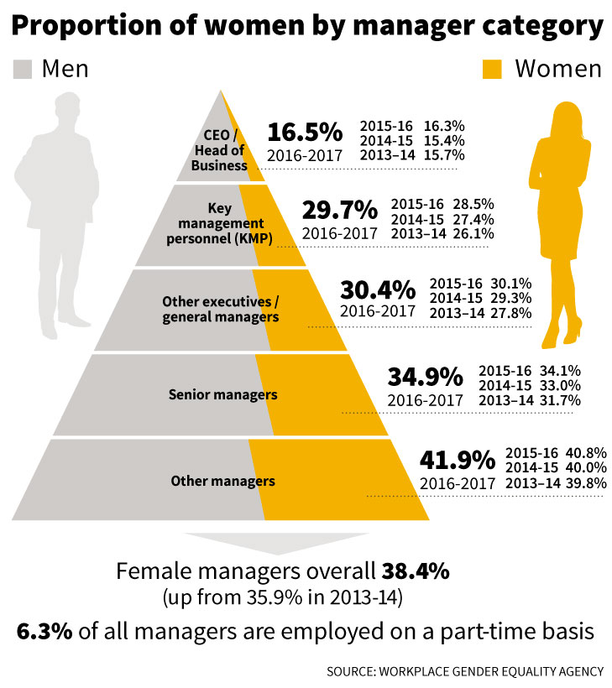
The increased efforts organisations take to promote diversity and inclusion within organisations does not seem to fix the problem of the lack of female leaders. Managers often learn about managing from literature which disdains gender, are hence are unaware of the inherent issues arising from gendered differences within an organisation. Organisational theories pose an idealistic image of the “ideal workers” as presented in the movie “The Intern”. There is a continued masculine outlook dominating contemporary mainstream theory, which then results in lack of female leaders in senior management positions (Mavin, Brians and Waring, 2004). Study conducted by Smith, R, A (2011) hypotheses that there are two different concepts to be taken into consideration that barriers women from progressing in the organisational ladder; which are glass ceiling and glass escalator. It was concluded from his study that the concept of glass escalator is more predominant in the organisations than glass ceilings, due to quotas for women in the workplace, there are women in lower and higher levels of management. However, the proportion of women being hired for the next level of management is much fewer in comparison to the progress men are able to make in their career ladder.
When two different gendered candidates attend an interview with the same qualifications, why does one candidate get a biological advantage over the other just based on their gender? Kanter’s theory highlights that male tokens working in female dominated jobs do not experience the same kind of discrimination women face when they are tokens working in male dominated jobs (Williams, C, 1995). After the screening process in “The Intern”, they hire four candidates of which three are male and one is female. This highlights that slowly women are making progress into the organisations, but the glass escalator concept continues to retain the disproportionate numbers of males and females within an organisation. Nevertheless, women are breaking the traditional ceiling and reaching their desired destinations with due sacrifices, but once they reach their destination, do they reinforce the glass ceiling themselves?
Jules, who has broken out of the shell of glass ceiling, underestimates the effort of junior women within her organisation. Becky who has been her personal assistant for nine months and has been working for extended hours to keep up to Jules’ schedule does not get appreciated or noticed. Hence, the opportunity to grow is very stagnant for Becky and she does not seem to have any progress in her career direction.
In a study conducted by Faniko, K., Ellemers, N., Derks, B., and Lorenzi-Cioldi, F (2017), a female senior manager stated her opinion regarding gender quotas.
“I’m against gender quotas. I can’t understand why we need to roll out the red carpet for young women and to make their life easy while I made a lot of sacrifices for my career success and I didn’t have such a privilege.” Their study revealed that women make ample of personal sacrifices in order to climb the organisational hierarchy, hence, do not sustain the ease other women receive at present from gender equality schemes (Faniko et al. 2017).
Her personal assistant Becky who has graduated from Penn and has a business degree is never appreciated or “never noticed” by Jules Ostin despite all the relentless efforts she puts in working for “14 hours a day” for the past nine months.
https://www.youtube.com/watch?v=K7upi4JqT0I (Becky scene)
https://www.youtube.com/watch?v=N4CSxGYVPf8 (Intro about the senior intern program to Jules)
https://www.youtube.com/watch?v=c9Tiqy03XZA
“One of your own out there every day, crashing the glass ceiling of the tech world”
Those women who break the gender barriers posed by our society and organisations tend to reinforce those for the junior women who are facing the same barriers.

Gender stereotypes and their implications on workplace culture
Gender stereotypes are overgeneralised, preordained beliefs about the paradigms on the appropriate mannerism and attitude a person should uphold during different situations based on their biological sex (Stroker, J., Van Der zvelde, M. and Lammers, J. 2011). In our everyday interactions, gender stereotypes influence our judgements and evaluations such that, ultimately women and men are treated differently. Why are men treated differently to women?
In the movie “The Intern”, there seems to be prescribed format as to what a good manager or a good employee should look, sense, behave like. These stereotypes impact each and every aspect of a person’s life-from how to dress to political and moral decisions. Whilst stereotypes are useful to classify people and make immediate assumptions, it fails to address the individual characteristics of a person and causes the organisations and at large the society to stagger by underestimating or overestimating the interpersonal resources (such as creativity, compassion and so on) of a specific gender (Acker, J. 1990). The reality is these stereotypes are becoming irrational to the point of absurdity and outdated as the society is evolving (Stroker et al. 2011). However, the evolution of the society and its people are not reflected by organisations as they are guided by executives who follow literature that disdains to credit differences within individuals but rather expects uniformity among all staff.
“How in one generation have men gone from guys like Jack Nicholson and Harrison Ford to…” –Jules Ostin.
This comical remark by the drunk Jules Ostin referring to the poorly dressed men in front of her reflects how gender stereotypes are reflected in the work culture. Despite serving as the backbone of the company, “About the Fit”, these IT department men are viewed lower than the well-groomed intern, Ben. Furthermore, the doubtful nature of the investors willing to bring a new CEO instead of Jules reinforces the idea. They plan to hire a more “seasoned CEO” to give her “CEO lessons” as they believe she is a working mother and cannot manage both. This reinforces the Kanter’s tokenism theory again, with respect to interaction- effect. Males appreciate feminine traits in leaders only when they know that their role is secure and represented in the organisation (Stroker et al. 2011).
“Mark Zucerberg never bought in a CEO and he was a teenager”
Since About the fit sells clothes, a potential CEO candidate called the company a “Chick site”.
Jules fears her marital life with Matt once she knows the affair between Matt and another woman. Although she initially is resilient to the change of CEO and the entire process, she does get involved decently and travels all the way to California to seek for a new candidate.
These evidences clearly display how Jules reinforces the gender stereotypes that gender stereotypes can grossly underestimate or overestimate a person’s capacity and thus disable or enable to progress further in their career. In the real world, women are thought to be better at interpersonal communication but lacks dominance and that their compassion will hinder their ability to take the “right call”.

Research has found that this tends to manifest itself in the replication of the societal norm that “men are the actors, women the emotional support” (Acker, 1990, p. 147).

Thus, although organisations attempt to represent themselves as gender-neutral, the established hierarchies and norms predispose individuals in organisations to interact in manner in which masculinity overrides femininity. Scrubs uses these interactions in a type of surreal parody, overtly exhibiting the male dominance in organisations through the callousness of its male characters.

x

References

- Stoker, J., Van der Velde, M. and Lammers, J. (2011). Factors Relating to Managerial Stereotypes: The Role of Gender of the Employee and the Manager and Management Gender Ratio. Journal of Business and Psychology, 27(1), pp.31-42.
- Acker, J. (1990). Hierarchies, jobs, bodies: A theory of gendered organisations. Gender & Society, 4(2), 139-158
- Agars, M. (2004). Reconsidering the Impact of Gender Stereotypes on the Advancement of Women in Organizations. Psychology of Women Quarterly, 28(2), pp.103-111.
- Faniko, K., Ellemers, N., Derks, B. and Lorenzi-Cioldi, F. (2017). Nothing Changes, Really: Why Women Who Break Through the Glass Ceiling End Up Reinforcing It. Personality and Social Psychology Bulletin, 43(5), pp.638-651.
- Smith, R. (2011). Money, Benefits, and Power. The ANNALS of the American Academy of Political and Social Science, 639(1), pp.149-172.
- Fernandez, R. and Campero, S. (2016). Gender Sorting and the Glass Ceiling in High-Tech Firms. ILR Review, 70(1), pp.73-104.
- Cotter, David A., Joan M. Hermsen, Seth Ovadia, and Reeve Vanneman. 2001. The glass ceiling effect. Social Forces 80: 655–81.
- Booth, Alison L., Marco Francesconi, and Jeff Frank. 2003. A sticky floors model of promotion, pay, and gender. European Economic Review 47: 295–322.
- Ragins, Belle Rose, Bickley Townsend, and Mary Mattis. 1998. Gender gap in the executive suite: CEOs and female executives report on breaking the glass ceiling. Academy of Management Executive 12(1): 28–42
- Petersen, Trond, and Ishak Saporta. 2004. The opportunity structure for discrimination. American Journal of Sociology 109: 852–901.
- Kanter, R. (1977). Men and Women of the Corporation. New York: Basic.
- Mavin, S. Bryans, P. and Waring, T. (2004). Unlearning gender blindness: new directions in management education. Management Decision, 42(3/4), 565-578. doi: http://dx.doi.org/10.1108/00251740410522287
- Workplace gender equality agency. (2016). Gender workplace statistics at a glance. Retrieved from: https://www.wgea.gov.au/sites/default/files/Stats_at_a_Glance.pdf

