Glass ceiling and glass escalators

Article 1: Money, Benefits, and Power: A Test of the Glass Ceiling and Glass Escalator Hypotheses By Ryan A. Smith
http://journals.sagepub.com.ezproxy.lib.monash.edu.au/doi/pdf/10.1177/0002716211422038
Smith, R. (2011). Money, Benefits, and Power. The ANNALS of the American Academy of Political and Social Science, 639(1), pp.149-172.
- the concept of the glass ceiling has now been extended to include not only women but also racial minorities, and not employees only at the upper levels of corporations but throughout the lower and middle occupational ranks as well (Federal Glass Ceiling Commission 1995)
- In the past quarter-century, two dominant metaphors have come to symbolize the processes and outcomes associated with workplace inequality: glass ceilings and glass escalators. While originally conceived as blocked promotional
- With less fanfare and far less empirical scrutiny, the concept of the glass escalator has influenced the way social scientists have come to understand the differential workplace rewards men and women receive when they work in predominantly female occupations (Budig 2002; Huffman 2004; Hultin 2003; Maume 1999; Williams 1992, 1995)
- Christine Williams (1992, 1995) argued, contrary to Kanter’s theory of tokenism, that male tokens working in female-dominated jobs do not experience the same kind of discrimination women face when they are tokens working in male-dominated jobs. In fact, Williams argued that men working in female-dominated jobs (e.g., nurses, elementary school teachers, librarians, and social workers) experience a certain amount of favoritism at the point of hire and in promotions to higher-paying, more prestigious positions.

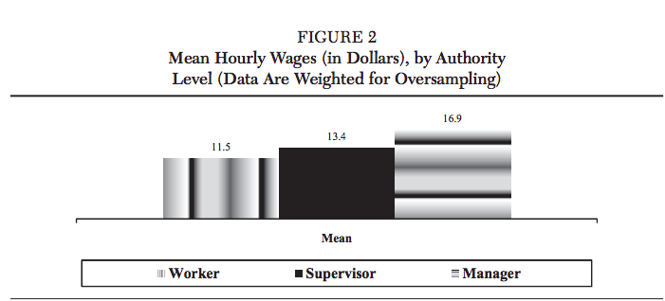

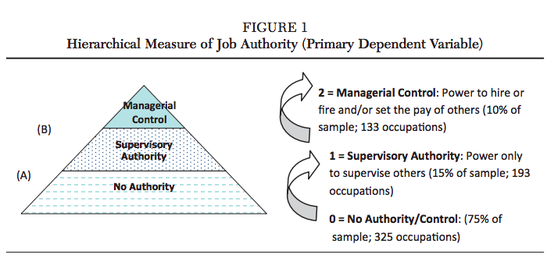

Article 2- Nothing Changes, Really: Why Women Who Break Through the Glass Ceiling End Up Reinforcing It
http://journals.sagepub.com.ezproxy.lib.monash.edu.au/doi/pdf/10.1177/0146167217695551
Faniko, K., Ellemers, N., Derks, B. and Lorenzi-Cioldi, F. (2017). Nothing Changes, Really: Why Women Who Break Through the Glass Ceiling End Up Reinforcing It. Personality and Social Psychology Bulletin, 43(5), pp.638-651.

- women who have been successful in male-dominated organizations do not support the advancement of junior women
- Personal sacrifices women managers reported having made for career success predicted self-distancing from junior women and opposition to gender quotas targeting these women.
- women managers oppose quotas for junior women, while supporting quotas for women in the same rank.
- I’m against gender quotas. I can’t understand why we need to roll out the red carpet for young women and to make their life easy while I made a lot of sacrifices for my career success and I didn’t have such a privilege. —Female senior manager
- women working at higher levels in male-dominated organizations have been found to deny that gender discrimination exists and to oppose actions that would improve opportunities for junior women (Derks, Van Laar, Ellemers, & De Groot, 2011).
- women’s reluctance to support gender quotas (prescribing that 30% of leadership positions in organizations are reserved for women, as has been proposed in the national contexts examined here is part of a more general psychological phenomenon documented among some highly successful women
- the Queen Bee (QB)- phenomenon. This indicates that female leaders have critical attitudes and distance themselves from junior women to overcome gender stereotypical expectations at work (see Derks, Van Laar, & Ellemers, 2016; Ellemers, Rink, Derks, & Ryan, 2012)
- there is more criticism and competition between women than between men, and that women will not allow other women to be successful (e.g., Sheppard & Aquino, 2013)
- rather than revealing increased competition among women, these results suggest that relevant career experiences of women (and other minorities at work) induce them to distance themselves from others in their group to overcome negative expectations and improve individual opportunities.
- As exemplified by the opening quote recorded from one participant in this study, and supported by our quantitative findings, the way senior women perceive junior women and react toward quotas targeting this group of women may also reflect motivation for fairness. That is, some senior women who have made difficult choices on their way up the organizational ladder may expect that junior women should make similar sacrifices for their career success

- Derks, B., Van Laar, C., & Ellemers, N. (2016). The Queen Bee phenomenon: Why women leaders distance themselves from junior women. The Leadership Quarterly, 27, 456-469. doi:10.1016/j.leaqua.2015.12.007
- Derks, B., Van Laar, C., Ellemers, N., & De Groot, K. (2011). Gender bias primes elicit Queen Bee responses among senior police women. Psychological Science, 22, 1243-1249. doi:10.1177/0956797611417258
- Ellemers, N., Rink, F., Derks, B., & Ryan, M. (2012). Women in high places: When and why promoting women into top positions can harm them individually or as a group (and how to prevent this). Research in Organizational Behavior, 32, 163-187. doi:10.1016/j.riob.2012.10.003

Article 3: Beneath the glass ceiling: Explaining gendered role segmentation in call centres
http://journals.sagepub.com.ezproxy.lib.monash.edu.au/doi/pdf/10.1177/0018726711416265

- call centre is an important organizational setting, for despite being a major locus of female employment, men appear over-represented in higher-level positions
- Women with high levels of human capital may be less likely to advance than equivalent men. One reason is the unequal effect of domestic life, several aspects of which can interfere with women’s, but not men’s career paths once employed. Family structure (e.g. being married or having domiciled children) is related to advancement or career continuity for both sexes (Stroh et al., 1992; Tharenou, 1999) but more negatively for women. Having a spouse and children has no impact on, or may even benefit, men’s careers (Kirchmeyer, 2006; Landau and Arthur, 1992), while women who advance are less likely to be married or have children than men who advance (Tharenou and Conroy, 1994). Women also continue to bear a greater burden of domestic labour, irrespective of employment status or educational level (Breen and Cooke, 2005; Dex, 2003) compared with men in similar domestic circumstances.
- This article demonstrates that for many women in call centres, employment is shaped by a pre-existing disadvantage resulting from constrained educational capital and domestic freedom
- women still experience the ambiguity of opportunity
- Inevitably, some women have achieved ‘better’ jobs; but equally, women’s progression has been hindered by the complex interaction of low human capital, domestic responsibilities and difficulties accessing social capital that confine many for long periods to more routinized roles.

Article 4: Gender Sorting and the Glass ceiling in High Tech firms
http://web.b.ebscohost.com.ezproxy.lib.monash.edu.au/ehost/pdfviewer/pdfviewer?vid=5&sid=3edc5584-15de-4844-9e8f-f2cf02df813d%40sessionmgr101
Fernandez, R. and Campero, S. (2016). Gender Sorting and the Glass Ceiling in High-Tech Firms. ILR Review, 70(1), pp.73-104.
- ‘‘glass ceiling,’’ the phenomenon in which women disappear as one looks up through the levels of the organizational hierarchy
- past research on gender and hierarchy documents that the proportion of women declines as one examines the upper levels of organizations (Ragins, Townsend, and Mattis 1998; Blau et al. 2006)
- the glass ceiling describes a vertical form of job sex segregation, and as such can be influenced by the same allocative processes (Petersen and Saporta 2004) that might produce other forms of gender segregation of jobs. Definition
- other studies have reported results consistent with the glass ceiling notion that gender inequality is more severe at the top of the reward distribution (e.g., Cotter et al. 2001),
- evidence of ‘‘sticky floors,’’ wherein women’s disadvantages are most pronounced at lower levels of the reward hierarchy (e.g., Booth, Francesconi, and Frank 2003; Zeng 2011)
- recruitment and outreach policies aimed at producing less-gendered candidate pools for jobs at various levels of the hierarchy are likely to pay the biggest dividends for organizations seeking to produce a more equitable distribution of men and women across their ranks.

In text (in text) citiations
- Cotter, David A., Joan M. Hermsen, Seth Ovadia, and Reeve Vanneman. 2001. The glass ceiling effect. Social Forces 80: 655–81.
- Booth, Alison L., Marco Francesconi, and Jeff Frank. 2003. A sticky floors model of promotion, pay, and gender. European Economic Review 47: 295–322.
- Ragins, Belle Rose, Bickley Townsend, and Mary Mattis. 1998. Gender gap in the executive suite: CEOs and female executives report on breaking the glass ceiling. Academy of Management Executive 12(1): 28–42
- Petersen, Trond, and Ishak Saporta. 2004. The opportunity structure for discrimination. American Journal of Sociology 109: 852–901.

