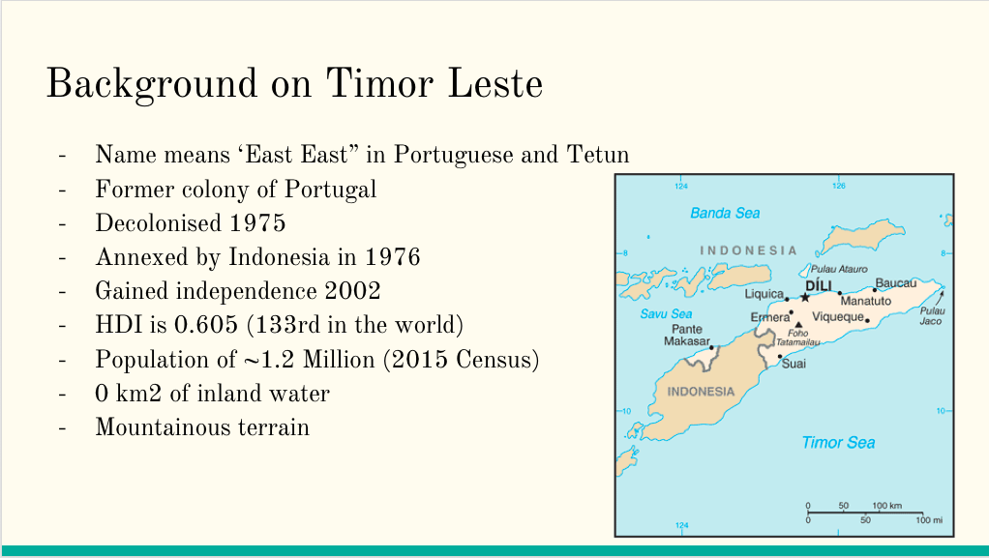
Au gdp is 1.205 trillion per capita (~50,000 usd per capita)
HDI - Human Development index: takes into account GDP, Education and Access to healthcare
The ability to “be and do” - signifies opportunities
AU HDI is 0.939 (2nd in the world)
Could lead to complications with logistics
Lack of access to clean water

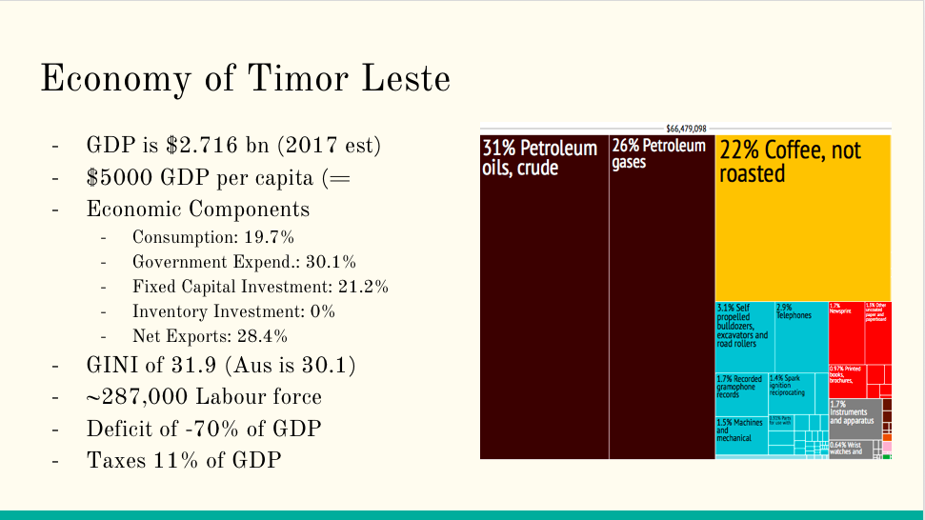

Low consumption is hallmark of underdeveloped economy
High relative capital investment speaks to rapid industrialisation
Export based economy
Gini is measure of income inequality, similarity to australia indicates a low level of income inequality
Aus is -1.7%
Aus is 33%
#1 in world is Slovenia with 24.4
In this case, low GINI indicates relatively universal level of low income

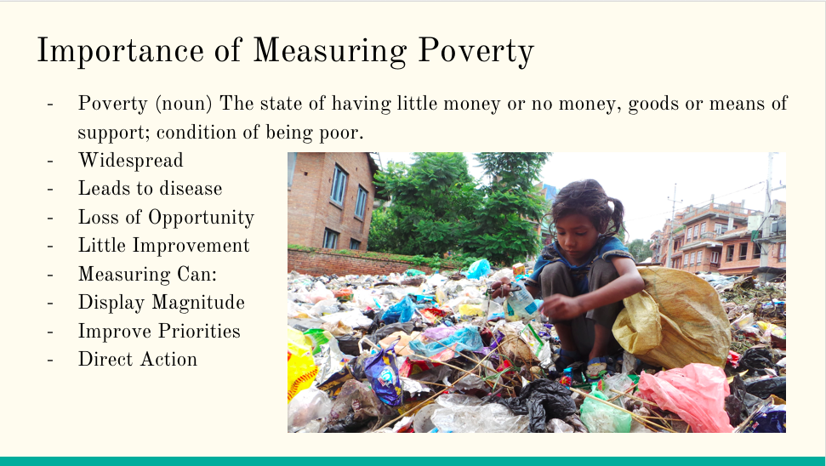

- 80% of people on planet earth live below $10 a day
3 billion people on planet earth live below $2.50 a day

- Many diseases are preventable
- 18% of health burden on countries comes from HIV/AIDS, TB and Malaria, all are preventable with education (WHO)
- One DALY can be thought of as one lost year of "healthy" life.
- The sum of these DALYs across the population, or the burden of disease, can be thought of as a measurement of the gap between current health status and an ideal health situation
- Treatable childhood diseases such as polio, measles and pertussis, account for only 0.2 per cent of Disability Adjusted Life Years (DALYs) in high-income countries, while they account for 5.2 per cent of DALYs in high mortality lowincome countries.13 Vaccines for these diseases have existed for at least 50 years, yet only 53 per cent of children in sub-Saharan Africa were immunised with the diphtheria-tetanuspertussis (DTP) jab in 2000.14 (WHO)

- “Single best predictor of outcomes”
“Prototypical risk factor” for infants

- If china is excluded from analysis, poverty (below $2.50 a day) remains constant at 50% between 1985 and 2005

